Coulbourn GraphicState4 Program: gsGoNogoTestSlave.gsprt (Kenta)  
Updated KT 2014.10.14

## Protocol Configuration

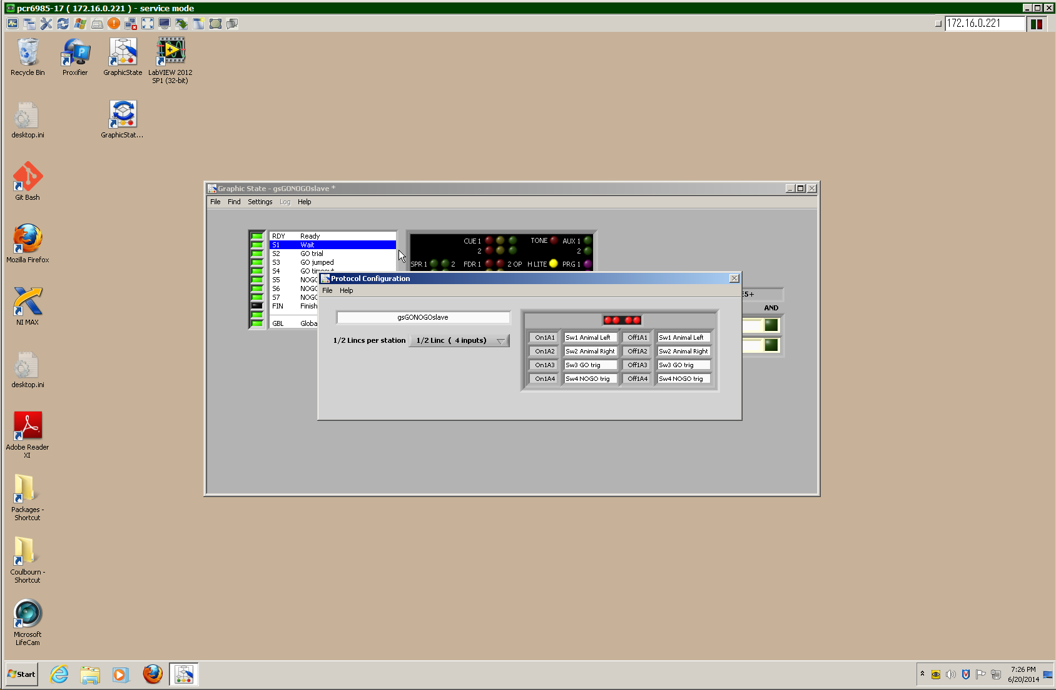

## Registers

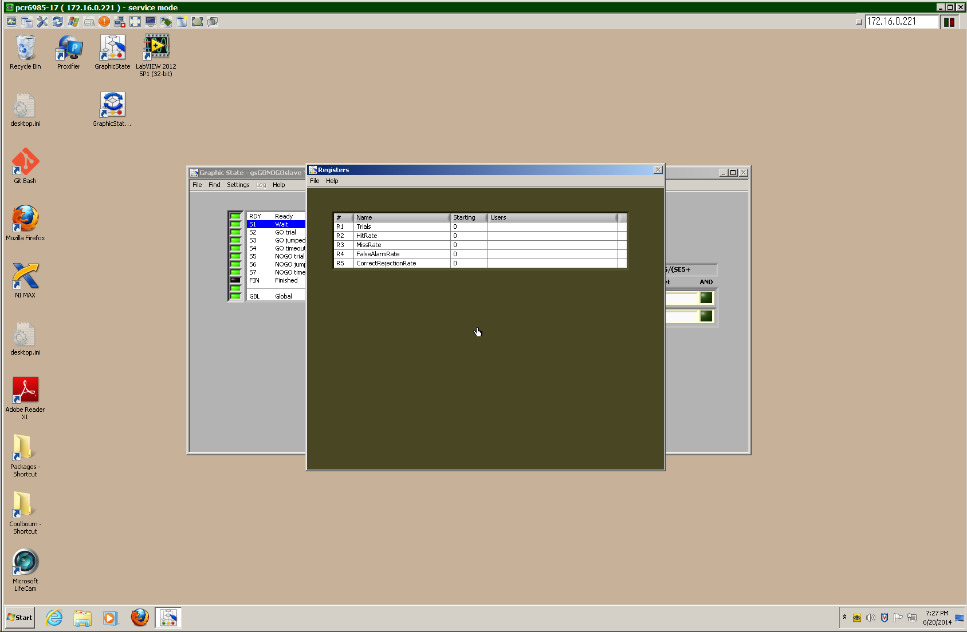

**Run-Time Display**

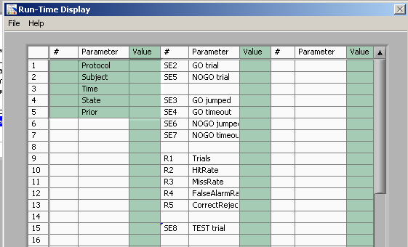

**Inputs**

Sw3: GO trigger  
Sw4: NOGO trigger  
Sw3 + Sw4: TEST trial trigger

## Outputs

H LITE: Task in progress  
TONE: tone gate (not currently used given 1 FM sweep, can be used in future to gate sweep train for easier training task)  
AUX 1: Shocker

Bit 0 to 2: CUE1-1 to CUE1-3  
Bit 3 to 5: CUE2-1 to CUE2-3  
Bit 6: SPR1  
Bit 7: SPR2

**Flow Chart**

(each state is prepended by an empty state to set the port output to zero)  
(S1 is prepended by >0 ms of S14, S2 by S15, ….)

To S1 or S13

To S1 or S13

To S1 or S13

S4  
GO trial

S5  
GO jumped

S6  
GO timeout

S7  
NOGO trial

S8  
NOGO jumped

S9  
NOGO timeout

S10  
TEST trial

S11  
TEST jumped

S12  
TEST timeout

Sw 3/4

RDY  
Ready

S1  
Wait

S13  
Jumped

S2  
Wait Sw1

S3  
Wait Sw2

# Preparation code

## RDY: "Ready" [Bit code 511 = 11 111 111]

|  |  |  |  |  |  |  |  |  |  |  |  |  |
| --- | --- | --- | --- | --- | --- | --- | --- | --- | --- | --- | --- | --- |
|  |  |  | CUE 1 |  |  | TONE |  | AUX 1 |  |  |  | |
|  |  |  | 2 |  |  |  |  | 2 |  |  |  | |
| SPR 1 |  | 2 | FDR 1 |  | 2 OP | H LITE |  | PRG 1 |  |  |  |
| 3 |  | 4 | 1 |  | 2 ML |  |  | 2 |  |  |  |

|  |  |  |  |  |  |  |  |
| --- | --- | --- | --- | --- | --- | --- | --- |
| **Goto#** | **R** | **Parameter** | **Comp.** | **Exit Criterion** | **P(%)** | **Target** | **AND** |
| 1 |  | ms | >= | 0 | 100 | 14 |  |

## S1 (pre is S14): "Wait" [Bit code 1 = 00 000 001]

|  |  |  |  |  |  |  |  |  |  |  |  |  |
| --- | --- | --- | --- | --- | --- | --- | --- | --- | --- | --- | --- | --- |
|  |  |  | CUE 1 |  |  | TONE |  | AUX 1 |  |  |  | |
|  |  |  | 2 |  |  |  |  | 2 |  |  |  | |
| SPR 1 |  | 2 | FDR 1 |  | 2 OP | H LITE |  | PRG 1 |  |  |  |
| 3 |  | 4 | 1 |  | 2 ML |  |  | 2 |  |  |  |

SE4+SE7+SE10>>Trials;   
SE5/(SE4+0.000000001)>>HitRate; SE6/(SE4+0.000000001)>>MissRate;  
SE8/(SE7+0.000000001)>>FalseAlarmRate; SE9/(SE7+0.000000001)>>CorrectRejectionRate;

|  |  |  |  |  |  |  |  |
| --- | --- | --- | --- | --- | --- | --- | --- |
| **Goto#** | **R** | **Parameter** | **Comp.** | **Exit Criterion** | **P(%)** | **Target** | **AND** |
| 1 |  | Sw3 GO trig | >= | 1 | 100 | 23 | [1] |
| 2 |  | Sw4 NOGO trig | >= | 1 | 100 | 23 | [1] |
| 3 | ☒ | Sw3 GO trig | >= | 1 | 100 | 17 |  |
| 4 |  | Sw4 NOGO trig | >= | 1 | 100 | 20 |  |
| 5 | ☒ | Sw1 Animal Left | >= | 1 | 100 | 15 |  |
| 6 |  | Sw2 Animal Right | >= | 1 | 100 | 16 |  |

## S2 (pre is S15): "Wait Sw1" [Bit code 2 = 00 000 010] (Sw1 has been triggered)

|  |  |  |  |  |  |  |  |  |  |  |  |  |
| --- | --- | --- | --- | --- | --- | --- | --- | --- | --- | --- | --- | --- |
|  |  |  | CUE 1 |  |  | TONE |  | AUX 1 |  |  |  | |
|  |  |  | 2 |  |  |  |  | 2 |  |  |  | |
| SPR 1 |  | 2 | FDR 1 |  | 2 OP | H LITE |  | PRG 1 |  |  |  |
| 3 |  | 4 | 1 |  | 2 ML |  |  | 2 |  |  |  |

|  |  |  |  |  |  |  |  |  |  |  |  |  |  |  |  |  |  |
| --- | --- | --- | --- | --- | --- | --- | --- | --- | --- | --- | --- | --- | --- | --- | --- | --- | --- |
| **Goto#** | | | **R** | | | **Parameter** | | **Comp.** | | **Exit Criterion** | | **P(%)** | | **Target** | | **AND** | |
| 1 | | |  | | | Sw3 GO trig | | >= | | 1 | | 100 | | 23 | | [1] | |
| 2 | | |  | | | Sw4 NOGO trig | | >= | | 1 | | 100 | | 23 | | [1] | |
| 3 | | | ☒ | | | Sw3 GO trig | | >= | | 1 | | 100 | | 17 | |  | |
| 4 | | |  | | | Sw4 NOGO trig | | >= | | 1 | | 100 | | 20 | |  | |
| 6 | |  | | | | Sw1 Animal Left | | >= | | 1 | | 100 | | 15 | | ☐ | |
| 5 | | |  | | Sw2 Animal Right | | | >= | | 1 | | 100 | | 16 | |  | |

## S3 (pre is S16): "Wait Sw2" [Bit code 3 = 00 000 011] (Sw2 has been triggered)

|  |  |  |  |  |  |  |  |  |  |  |  |  |
| --- | --- | --- | --- | --- | --- | --- | --- | --- | --- | --- | --- | --- |
|  |  |  | CUE 1 |  |  | TONE |  | AUX 1 |  | ***Records shuttling during wait period*** |  | |
|  |  |  | 2 |  |  |  |  | 2 |  |  |  | |
| SPR 1 |  | 2 | FDR 1 |  | 2 OP | H LITE |  | PRG 1 |  |  |  |
| 3 |  | 4 | 1 |  | 2 ML |  |  | 2 |  |  |  |

|  |  |  |  |  |  |  |  |  |  |  |  |  |  |  |  |
| --- | --- | --- | --- | --- | --- | --- | --- | --- | --- | --- | --- | --- | --- | --- | --- |
| **Goto#** | | **R** | | **Parameter** | | **Comp.** | | **Exit Criterion** | | **P(%)** | | **Target** | | **AND** | |
| 1 | |  | | Sw3 GO trig | | >= | | 1 | | 100 | | 23 | | [1] | |
| 2 | |  | | Sw4 NOGO trig | | >= | | 1 | | 100 | | 23 | | [1] | |
| 3 | | ☒ | | Sw3 GO trig | | >= | | 1 | | 100 | | 17 | |  | |
| 4 | |  | | Sw4 NOGO trig | | >= | | 1 | | 100 | | 20 | |  | |
| 5 | |  | | Sw1 Animal Left | | >= | | 1 | | 100 | | 15 | |  | |
| 6 | |  | | Sw2 Animal Left | | >= | | 1 | | 100 | | 16 | |  | |

# S4/GO trials

## S4 (pre is S17): "GO trial" [Bit code 4 = 00 000 100]

|  |  |  |  |  |  |  |  |  |  |  |  |  |
| --- | --- | --- | --- | --- | --- | --- | --- | --- | --- | --- | --- | --- |
|  |  |  | CUE 1 |  |  | TONE |  | AUX 1 |  |  |  | |
|  |  |  | 2 |  |  |  |  | 2 |  |  |  | |
| SPR 1 |  | 2 | FDR 1 |  | 2 OP | H LITE |  | PRG 1 |  |  |  |
| 3 |  | 4 | 1 |  | 2 ML |  |  | 2 |  |  |  |

|  |  |  |  |  |  |  |  |
| --- | --- | --- | --- | --- | --- | --- | --- |
| **Goto#** | **R** | **Parameter** | **Comparison** | **Exit Criterion** | **P(%)** | **Target** | **AND** |
| 1 |  | Sw4 NOGO trig: | >= | 1 | 100 | 8 |  |
| 1 |  | Sw1 Animal Left | >= | 1 | 100 | 18 |  |
| 2 |  | Sw2 Animal Right | >= | 1 | 100 | 18 |  |
| 3 |  | sec | >= | 4 | 100 | 19 |  |

# Animal Jumped

## S5 (pre is S18): "GO jumped" (aka Hit) [Bit code 5 = 00 000 101]

|  |  |  |  |  |  |  |  |  |  |  |  |  |
| --- | --- | --- | --- | --- | --- | --- | --- | --- | --- | --- | --- | --- |
|  |  |  | CUE 1 |  |  | TONE |  | AUX 1 |  |  |  | |
|  |  |  | 2 |  |  |  |  | 2 |  |  |  | |
| SPR 1 |  | 2 | FDR 1 |  | 2 OP | H LITE |  | PRG 1 |  |  |  |
| 3 |  | 4 | 1 |  | 2 ML |  |  | 2 |  |  |  |

|  |  |  |  |  |  |  |  |
| --- | --- | --- | --- | --- | --- | --- | --- |
| **Goto#** | **R** | **Parameter** | **Comparison** | **Exit Criterion** | **P(%)** | **Target** | **AND** |
| 1 |  | Sw1 Animal Left | >= | 1 | 100 | 26 |  |
| 2 |  | Sw2 Animal Right | >= | 1 | 100 | 26 |  |
| 3 |  | ms | >= | 0 | 100 | 14 |  |

# Animal Didn't Jump

## S6 (pre is S19): "GO timeout" (aka Miss) [Bit code 4 = 00 000 100]

|  |  |  |  |  |  |  |  |  |  |  |  |  |
| --- | --- | --- | --- | --- | --- | --- | --- | --- | --- | --- | --- | --- |
|  |  |  | CUE 1 |  |  | TONE |  | AUX 1 |  |  |  | |
|  |  |  | 2 |  |  |  |  | 2 |  |  |  | |
| SPR 1 |  | 2 | FDR 1 |  | 2 OP | H LITE |  | PRG 1 |  |  |  |
| 3 |  | 4 | 1 |  | 2 ML |  |  | 2 |  |  |  |

|  |  |  |  |  |  |  |  |
| --- | --- | --- | --- | --- | --- | --- | --- |
| **Goto#** | **R** | **Parameter** | **Comparison** | **Exit Criterion** | **P(%)** | **Target** | **AND** |
| 1 |  | Sw1 Animal Left | >= | 1 | 100 | 26 |  |
| 2 |  | Sw2 Animal Right | >= | 1 | 100 | 26 |  |
| 3 |  | sec | >= | 6 | 100 | 14 |  |

# NOGO trials

## S7 (pre is S20): "NOGO trial" [Bit code 5 = 00 000 101]

|  |  |  |  |  |  |  |  |  |  |  |  |  |
| --- | --- | --- | --- | --- | --- | --- | --- | --- | --- | --- | --- | --- |
|  |  |  | CUE 1 |  |  | TONE |  | AUX 1 |  |  |  | |
|  |  |  | 2 |  |  |  |  | 2 |  |  |  | |
| SPR 1 |  | 2 | FDR 1 |  | 2 OP | H LITE |  | PRG 1 |  |  |  |
| 3 |  | 4 | 1 |  | 2 ML |  |  | 2 |  |  |  |

|  |  |  |  |  |  |  |  |
| --- | --- | --- | --- | --- | --- | --- | --- |
| **Goto#** | **R** | **Parameter** | **Comparison** | **Exit Criterion** | **P(%)** | **Target** | **AND** |
| 1 |  | Sw3 GO trig | >= | 1 | 100 | 8 |  |
| 1 |  | Sw1 Animal Left | >= | 1 | 100 | 21 |  |
| 2 |  | Sw2 Animal Right | >= | 1 | 100 | 21 |  |
| 3 |  | sec | >= | 4 | 100 | 22 |  |

# Animal Jumped

## S8 (pre is S21): "NOGO jumped" (aka False Alarm) [Bit code 6 = 00 000 110]

|  |  |  |  |  |  |  |  |  |  |  |  |  |
| --- | --- | --- | --- | --- | --- | --- | --- | --- | --- | --- | --- | --- |
|  |  |  | CUE 1 |  |  | TONE |  | AUX 1 |  |  |  | |
|  |  |  | 2 |  |  |  |  | 2 |  |  |  | |
| SPR 1 |  | 2 | FDR 1 |  | 2 OP | H LITE |  | PRG 1 |  |  |  |
| 3 |  | 4 | 1 |  | 2 ML |  |  | 2 |  |  |  |

|  |  |  |  |  |  |  |  |
| --- | --- | --- | --- | --- | --- | --- | --- |
| **Goto#** | **R** | **Parameter** | **Comparison** | **Exit Criterion** | **P(%)** | **Target** | **AND** |
| 1 |  | Sw1 Animal Left | >= | 1 | 100 | 26 |  |
| 2 |  | Sw2 Animal Right | >= | 1 | 100 | 26 |  |
| 3 |  | sec | >= | 6 | 100 | 14 |  |

# Animal Didn't Jump

## S9 (pre is S22): "NOGO timeout" (aka Correct Rejection) [Bit code 7 = 00 000 111]

|  |  |  |  |  |  |  |  |  |  |  |  |  |
| --- | --- | --- | --- | --- | --- | --- | --- | --- | --- | --- | --- | --- |
|  |  |  | CUE 1 |  |  | TONE |  | AUX 1 |  |  |  | |
|  |  |  | 2 |  |  |  |  | 2 |  |  |  | |
| SPR 1 |  | 2 | FDR 1 |  | 2 OP | H LITE |  | PRG 1 |  |  |  |
| 3 |  | 4 | 1 |  | 2 ML |  |  | 2 |  |  |  |

|  |  |  |  |  |  |  |  |
| --- | --- | --- | --- | --- | --- | --- | --- |
| **Goto#** | **R** | **Parameter** | **Comparison** | **Exit Criterion** | **P(%)** | **Target** | **AND** |
| 1 |  | Sw1 Animal Left | >= | 1 | 100 | 26 |  |
| 2 |  | Sw2 Animal Right | >= | 1 | 100 | 26 |  |
| 3 |  | ms | >= | 0 | 100 | 14 |  |

**TEST trials**

**S10** **(pre is S23): "TEST trial" [Bit code 8 = 00 001 000]**

|  |  |  |  |  |  |  |  |  |  |  |  |  |
| --- | --- | --- | --- | --- | --- | --- | --- | --- | --- | --- | --- | --- |
|  |  |  | CUE 1 |  |  | TONE |  | AUX 1 |  |  |  | |
|  |  |  | 2 |  |  |  |  | 2 |  |  |  | |
| SPR 1 |  | 2 | FDR 1 |  | 2 OP | H LITE |  | PRG 1 |  |  |  |
| 3 |  | 4 | 1 |  | 2 ML |  |  | 2 |  |  |  |

|  |  |  |  |  |  |  |  |
| --- | --- | --- | --- | --- | --- | --- | --- |
| **Goto#** | **R** | **Parameter** | **Comparison** | **Exit Criterion** | **P(%)** | **Target** | **AND** |
| 1 |  | Sw1 Animal Left | >= | 1 | 100 | 24 |  |
| 2 |  | Sw2 Animal Right | >= | 1 | 100 | 24 |  |
| 3 |  | sec | >= | 4 | 100 | 25 |  |

**Animal Jumped**

**S11** **(pre is S24): "TEST jumped" [Bit code 9 = 00 001 011]**

|  |  |  |  |  |  |  |  |  |  |  |  |  |
| --- | --- | --- | --- | --- | --- | --- | --- | --- | --- | --- | --- | --- |
|  |  |  | CUE 1 |  |  | TONE |  | AUX 1 |  |  |  | |
|  |  |  | 2 |  |  |  |  | 2 |  |  |  | |
| SPR 1 |  | 2 | FDR 1 |  | 2 OP | H LITE |  | PRG 1 |  |  |  |
| 3 |  | 4 | 1 |  | 2 ML |  |  | 2 |  |  |  |

|  |  |  |  |  |  |  |  |
| --- | --- | --- | --- | --- | --- | --- | --- |
| **Goto#** | **R** | **Parameter** | **Comparison** | **Exit Criterion** | **P(%)** | **Target** | **AND** |
| 1 |  | Sw1 Animal Left | >= | 1 | 100 | 26 |  |
| 2 |  | Sw2 Animal Right | >= | 1 | 100 | 26 |  |
| 3 |  | ms | >= | 0 | 100 | 14 |  |

**Animal Didn't Jump**

**S12** **(pre is S25): "TEST timeout" [Bit code 12 = 00 001 100]**

|  |  |  |  |  |  |  |  |  |  |  |  |  |
| --- | --- | --- | --- | --- | --- | --- | --- | --- | --- | --- | --- | --- |
|  |  |  | CUE 1 |  |  | TONE |  | AUX 1 |  |  |  | |
|  |  |  | 2 |  |  |  |  | 2 |  |  |  | |
| SPR 1 |  | 2 | FDR 1 |  | 2 OP | H LITE |  | PRG 1 |  |  |  |
| 3 |  | 4 | 1 |  | 2 ML |  |  | 2 |  |  |  |

|  |  |  |  |  |  |  |  |
| --- | --- | --- | --- | --- | --- | --- | --- |
| **Goto#** | **R** | **Parameter** | **Comparison** | **Exit Criterion** | **P(%)** | **Target** | **AND** |
| 1 |  | Sw1 Animal Left | >= | 1 | 100 | 26 |  |
| 2 |  | Sw2 Animal Right | >= | 1 | 100 | 26 |  |
| 3 |  | ms | >= | 0 | 100 | 14 |  |

**Jump Marker**

**S13** **(pre is S26): "Jumped during marker block" [Bit code 13 = 00 001 101]**

|  |  |  |  |  |  |  |  |  |  |  |  |  |
| --- | --- | --- | --- | --- | --- | --- | --- | --- | --- | --- | --- | --- |
|  |  |  | CUE 1 |  |  | TONE |  | AUX 1 |  |  |  | |
|  |  |  | 2 |  |  |  |  | 2 |  |  |  | |
| SPR 1 |  | 2 | FDR 1 |  | 2 OP | H LITE |  | PRG 1 |  |  |  |
| 3 |  | 4 | 1 |  | 2 ML |  |  | 2 |  |  |  |

|  |  |  |  |  |  |  |  |
| --- | --- | --- | --- | --- | --- | --- | --- |
| **Goto#** | **R** | **Parameter** | **Comparison** | **Exit Criterion** | **P(%)** | **Target** | **AND** |
| 1 | ☒ | Sw1 Animal Left | >= | 1 | 100 | 26 | ☐ |
| 2 | ☒ | Sw2 Animal Right | >= | 1 | 100 | 26 | ☐ |
| 3 | ☒ | ms | >= | 0 | 100 | 14 | ☐ |

**Zero reset trials**

## S14: "Pre S1" [Bit code 0 = 00 000 000]

|  |  |  |  |  |  |  |  |
| --- | --- | --- | --- | --- | --- | --- | --- |
| **Goto#** | **R** | **Parameter** | **Comparison** | **Exit Criterion** | **P(%)** | **Target** | **AND** |
| 1 | ☒ | ms | >= | 0 | 100 | 1 | ☐ |

## S15: "Pre S2" [Bit code 0 = 00 000 000]

|  |  |  |  |  |  |  |  |
| --- | --- | --- | --- | --- | --- | --- | --- |
| **Goto#** | **R** | **Parameter** | **Comparison** | **Exit Criterion** | **P(%)** | **Target** | **AND** |
| 1 | ☒ | ms | >= | 0 | 100 | 2 | ☐ |

## S16: "Pre S3" [Bit code 0 = 00 000 000]

## S17: "Pre S4" [Bit code 0 = 00 000 000]

## S18: "Pre S5" [Bit code 0 = 00 000 000]

## S19: "Pre S6" [Bit code 0 = 00 000 000]

## S20: "Pre S7" [Bit code 0 = 00 000 000]

## S21: "Pre S8" [Bit code 0 = 00 000 000]

## S22: "Pre S9" [Bit code 0 = 00 000 000]

## S23: "Pre S10" [Bit code 0 = 00 000 000]

## S24: "Pre S11" [Bit code 0 = 00 000 000]

## S25: "Pre S12" [Bit code 0 = 00 000 000]

## S26: "Pre S13" [Bit code 0 = 00 000 000]

|  |  |  |  |  |  |  |  |  |  |  |  |  |
| --- | --- | --- | --- | --- | --- | --- | --- | --- | --- | --- | --- | --- |
|  |  |  | CUE 1 |  |  | TONE |  | AUX 1 |  |  |  | |
|  |  |  | 2 |  |  |  |  | 2 |  |  |  | |
| SPR 1 |  | 2 | FDR 1 |  | 2 OP | H LITE |  | PRG 1 |  |  |  |
| 3 |  | 4 | 1 |  | 2 ML |  |  | 2 |  |  |  |