Coulbourn GraphicState4 Program: discr-two-way-60trials.gsprt (Andreas)  
Analyzed KT 2014.06.20

## Protocol Configuration

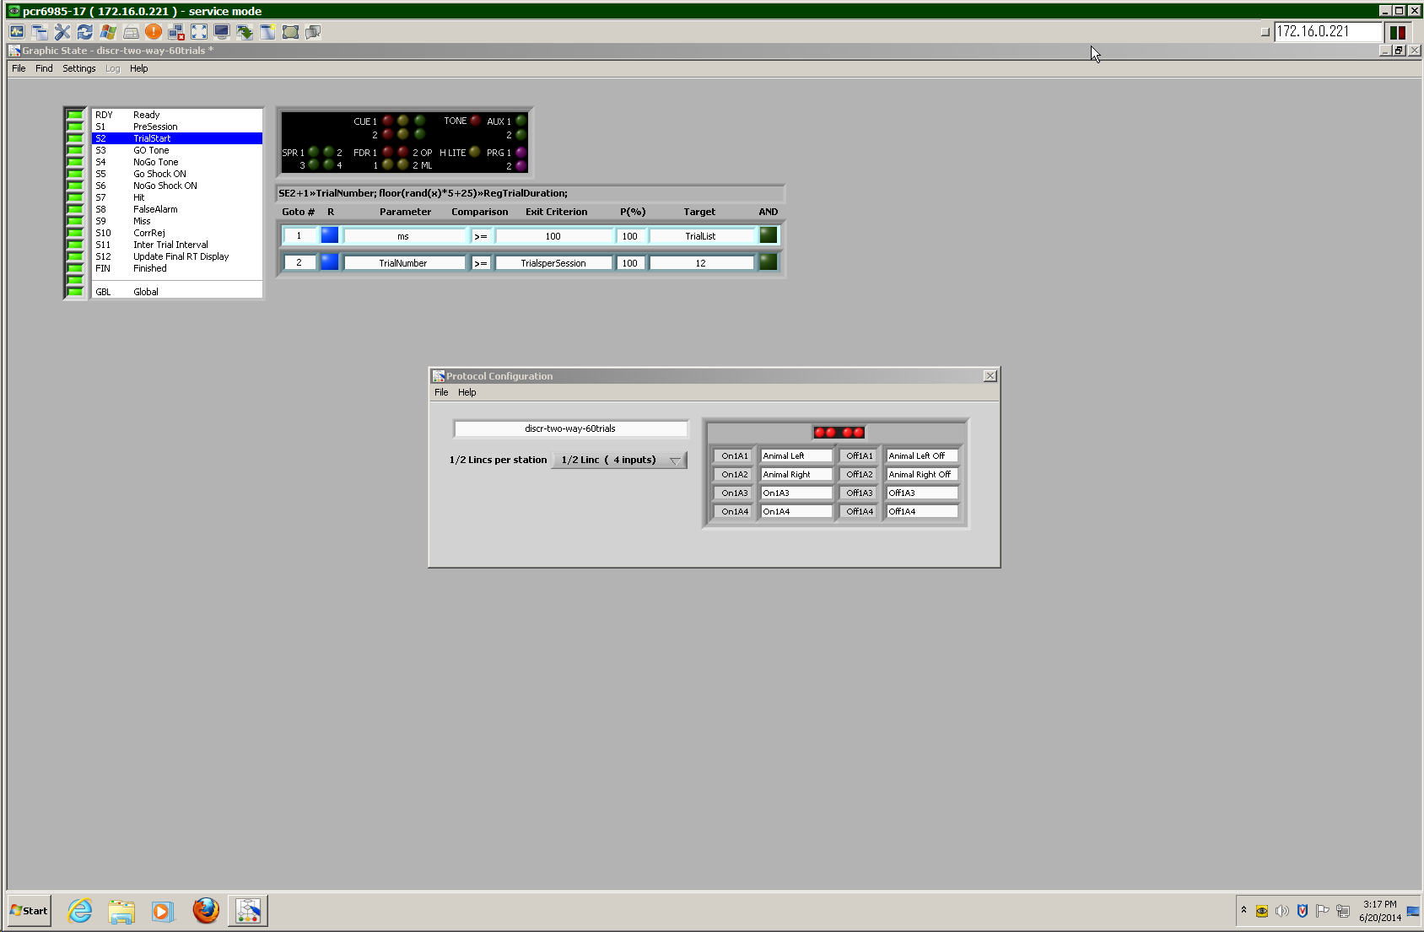

## Run-Time Display

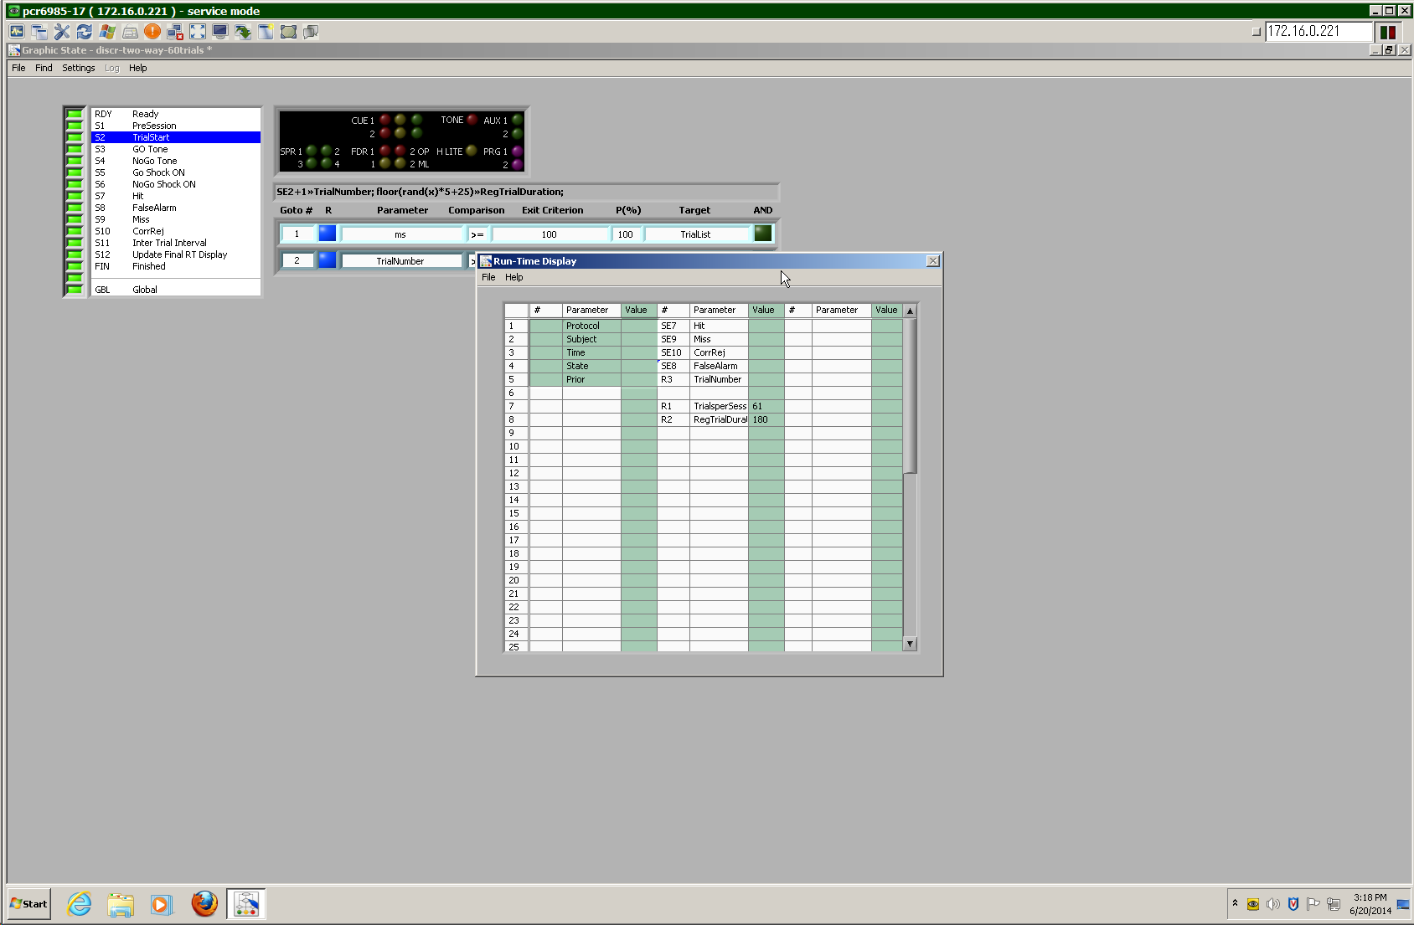

## Registers

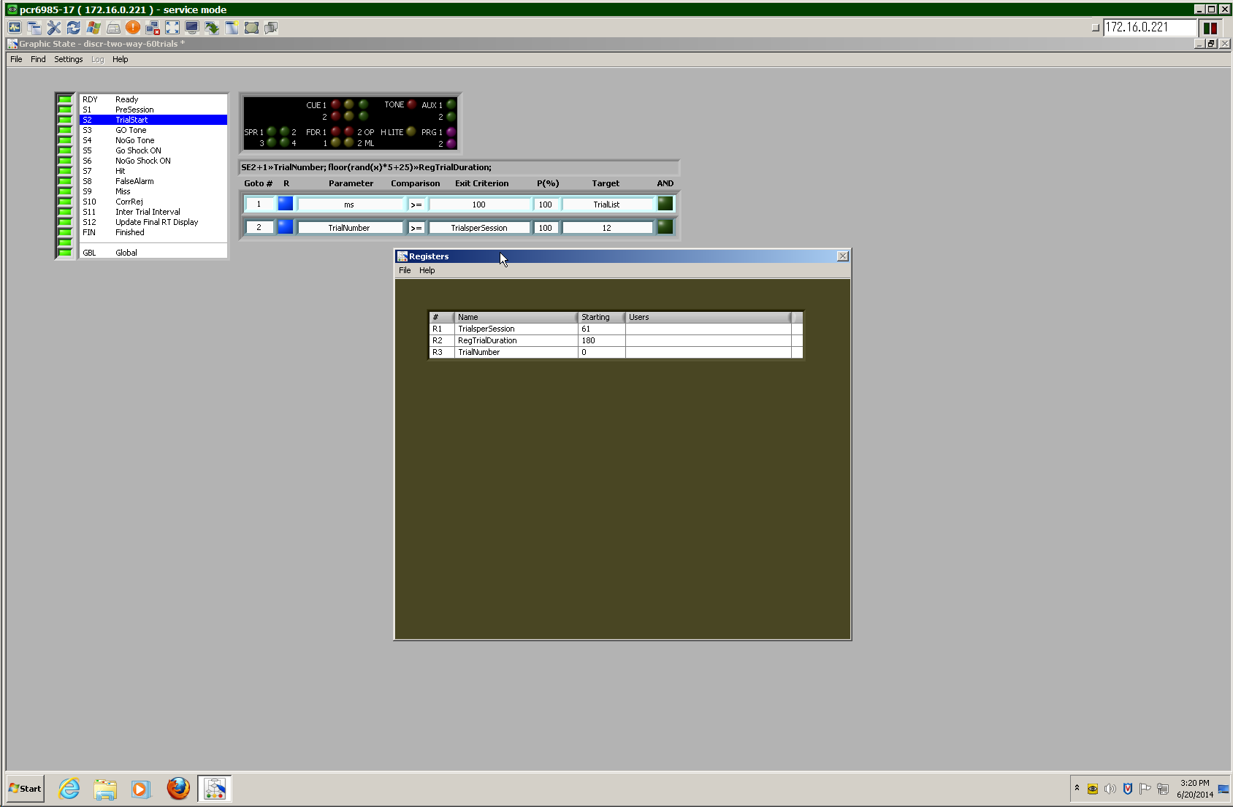

R2:RegTrialDuration is a key registry variable used here to time trials. The first trial comes 180s after starting the script, subsequently, the length is re programmed in S2 (25-30s)

## Outputs

TONE: tone gate  
SPR 1: NOGO marker (off on GO trials)  
AUX 1: Shocker

# Preparation code

## RDY: "Ready"

|  |  |  |  |  |  |  |  |  |  |  |  |  |
| --- | --- | --- | --- | --- | --- | --- | --- | --- | --- | --- | --- | --- |
|  |  |  | CUE 1 |  |  | TONE |  | AUX 1 |  |  |  | |
|  |  |  | 2 |  |  |  |  | 2 |  |  |  | |
| SPR 1 |  | 2 | FDR 1 |  | 2 OP | H LITE |  | PRG 1 |  |  |  |
| 3 |  | 4 | 1 |  | 2 ML |  |  | 2 |  |  |  |

|  |  |  |  |  |  |  |  |
| --- | --- | --- | --- | --- | --- | --- | --- |
| **Goto#** | **R** | **Parameter** | **Comp.** | **Exit Criterion** | **P(%)** | **Target** | **AND** |
| 1 |  | sec | >= | 1 | 100 | 1 |  |

## S1: "PreSession"

|  |  |  |  |  |  |  |  |  |  |  |  |  |
| --- | --- | --- | --- | --- | --- | --- | --- | --- | --- | --- | --- | --- |
|  |  |  | CUE 1 |  |  | TONE |  | AUX 1 |  |  |  | |
|  |  |  | 2 |  |  |  |  | 2 |  |  |  | |
| SPR 1 |  | 2 | FDR 1 |  | 2 OP | H LITE |  | PRG 1 |  |  |  |
| 3 |  | 4 | 1 |  | 2 ML |  |  | 2 |  |  |  |

floor(rand(x)*5+25) >> RegTrialDuration;

|  |  |  |  |  |  |  |  |
| --- | --- | --- | --- | --- | --- | --- | --- |
| **Goto#** | **R** | **Parameter** | **Comp.** | **Exit Criterion** | **P(%)** | **Target** | **AND** |
| 1 |  | hr | >= | 1 | 100 | 2 |  |

## S2: "TrialStart"

|  |  |  |  |  |  |  |  |  |  |  |  |  |
| --- | --- | --- | --- | --- | --- | --- | --- | --- | --- | --- | --- | --- |
|  |  |  | CUE 1 |  |  | TONE |  | AUX 1 |  |  |  | |
|  |  |  | 2 |  |  |  |  | 2 |  |  |  | |
| SPR 1 |  | 2 | FDR 1 |  | 2 OP | H LITE |  | PRG 1 |  |  |  |
| 3 |  | 4 | 1 |  | 2 ML |  |  | 2 |  |  |  |

SE2+1 >> TrialNumber; floor(rand(x)*5+25) >> RegTrialDuration;

|  |  |  |  |  |  |  |  |
| --- | --- | --- | --- | --- | --- | --- | --- |
| **Goto#** | **R** | **Parameter** | **Comp.** | **Exit Criterion** | **P(%)** | **Target** | **AND** |
| 1 | ☒ | ms | >= | 100 | 100 | L1:TrialList | ☐ |
| 2 |  | R3:Trial Number | >= | R1:TrialsperSession | 100 | 12 |  |

Jump to S3 or S4, depending upon the next L1:TrialList element   
(as long as the R3:TrialNumber < R1:TrialsperSession).  
Stimulus presentations are pre-programmed in this script!

# S3/GO trials

## S3: "GO Tone"

|  |  |  |  |  |  |  |  |  |  |  |  |  |
| --- | --- | --- | --- | --- | --- | --- | --- | --- | --- | --- | --- | --- |
|  |  |  | CUE 1 |  |  | TONE |  | AUX 1 |  |  |  | |
|  |  |  | 2 |  |  |  |  | 2 |  |  |  | |
| SPR 1 |  | 2 | FDR 1 |  | 2 OP | H LITE |  | PRG 1 |  |  |  |
| 3 |  | 4 | 1 |  | 2 ML |  |  | 2 |  |  |  |

|  |  |  |  |  |  |  |  |
| --- | --- | --- | --- | --- | --- | --- | --- |
| **Goto#** | **R** | **Parameter** | **Comparison** | **Exit Criterion** | **P(%)** | **Target** | **AND** |
| 1 |  | Animal Left | >= | 1 | 100 | 7 |  |
| 2 |  | Animal Right | >= | 1 | 100 | 7 |  |
| 3 |  | sec | >= | 6 | 100 | 5 |  |

# Animal Jumped

## S7: "Hit" //Just for counting, run-time statistics

|  |  |  |  |  |  |  |  |  |  |  |  |  |
| --- | --- | --- | --- | --- | --- | --- | --- | --- | --- | --- | --- | --- |
|  |  |  | CUE 1 |  |  | TONE |  | AUX 1 |  |  |  | |
|  |  |  | 2 |  |  |  |  | 2 |  |  |  | |
| SPR 1 |  | 2 | FDR 1 |  | 2 OP | H LITE |  | PRG 1 |  |  |  |
| 3 |  | 4 | 1 |  | 2 ML |  |  | 2 |  |  |  |

|  |  |  |  |  |  |  |  |
| --- | --- | --- | --- | --- | --- | --- | --- |
| **Goto#** | **R** | **Parameter** | **Comparison** | **Exit Criterion** | **P(%)** | **Target** | **AND** |
| 1 |  | ms | >= | 50 | 100 | 11 |  |

# Animal Didn't Jump

## S5: "Go Shock ON"

|  |  |  |  |  |  |  |  |  |  |  |  |  |
| --- | --- | --- | --- | --- | --- | --- | --- | --- | --- | --- | --- | --- |
|  |  |  | CUE 1 |  |  | TONE |  | AUX 1 |  |  |  | |
|  |  |  | 2 |  |  |  |  | 2 |  |  |  | |
| SPR 1 |  | 2 | FDR 1 |  | 2 OP | H LITE |  | PRG 1 |  |  |  |
| 3 |  | 4 | 1 |  | 2 ML |  |  | 2 |  |  |  |

|  |  |  |  |  |  |  |  |
| --- | --- | --- | --- | --- | --- | --- | --- |
| **Goto#** | **R** | **Parameter** | **Comparison** | **Exit Criterion** | **P(%)** | **Target** | **AND** |
| 1 |  | Animal Left | >= | 1 | 100 | 9 |  |
| 2 |  | Animal Right | >= | 1 | 100 | 9 |  |
| 3 |  | sec | >= | 4 | 100 | 9 |  |

## S9: "Miss" //Just for counting, run-time statistics

|  |  |  |  |  |  |  |  |  |  |  |  |  |
| --- | --- | --- | --- | --- | --- | --- | --- | --- | --- | --- | --- | --- |
|  |  |  | CUE 1 |  |  | TONE |  | AUX 1 |  |  |  | |
|  |  |  | 2 |  |  |  |  | 2 |  |  |  | |
| SPR 1 |  | 2 | FDR 1 |  | 2 OP | H LITE |  | PRG 1 |  |  |  |
| 3 |  | 4 | 1 |  | 2 ML |  |  | 2 |  |  |  |

|  |  |  |  |  |  |  |  |
| --- | --- | --- | --- | --- | --- | --- | --- |
| **Goto#** | **R** | **Parameter** | **Comparison** | **Exit Criterion** | **P(%)** | **Target** | **AND** |
| 1 |  | ms | >= | 50 | 100 | 11 |  |

S11 is a holding pattern  
(overridden by GBL, which triggers S2: "TrialStart")

# S4/NOGO trials

## S4: "NoGo Tone"

|  |  |  |  |  |  |  |  |  |  |  |  |  |
| --- | --- | --- | --- | --- | --- | --- | --- | --- | --- | --- | --- | --- |
|  |  |  | CUE 1 |  |  | TONE |  | AUX 1 |  |  |  | |
|  |  |  | 2 |  |  |  |  | 2 |  |  |  | |
| SPR 1 |  | 2 | FDR 1 |  | 2 OP | H LITE |  | PRG 1 |  |  |  |
| 3 |  | 4 | 1 |  | 2 ML |  |  | 2 |  |  |  |

|  |  |  |  |  |  |  |  |
| --- | --- | --- | --- | --- | --- | --- | --- |
| **Goto#** | **R** | **Parameter** | **Comparison** | **Exit Criterion** | **P(%)** | **Target** | **AND** |
| 1 |  | Animal Left | >= | 1 | 100 | 6 |  |
| 2 |  | Animal Right | >= | 1 | 100 | 6 |  |
| 3 |  | sec | >= | 10 | 100 | 10 |  |

# Animal Jumped

## S6: "NoGo Shock ON"

|  |  |  |  |  |  |  |  |  |  |  |  |  |
| --- | --- | --- | --- | --- | --- | --- | --- | --- | --- | --- | --- | --- |
|  |  |  | CUE 1 |  |  | TONE |  | AUX 1 |  |  |  | |
|  |  |  | 2 |  |  |  |  | 2 |  |  |  | |
| SPR 1 |  | 2 | FDR 1 |  | 2 OP | H LITE |  | PRG 1 |  |  |  |
| 3 |  | 4 | 1 |  | 2 ML |  |  | 2 |  |  |  |

|  |  |  |  |  |  |  |  |
| --- | --- | --- | --- | --- | --- | --- | --- |
| **Goto#** | **R** | **Parameter** | **Comparison** | **Exit Criterion** | **P(%)** | **Target** | **AND** |
| 1 |  | Animal Left | >= | 1 | 100 | 8 |  |
| 2 |  | Animal Right | >= | 1 | 100 | 8 |  |
| 3 |  | sec | >= | 4 | 100 | 8 |  |

## S8: "FalseAlarm" //Just for counting, run-time statistics

|  |  |  |  |  |  |  |  |  |  |  |  |  |
| --- | --- | --- | --- | --- | --- | --- | --- | --- | --- | --- | --- | --- |
|  |  |  | CUE 1 |  |  | TONE |  | AUX 1 |  |  |  | |
|  |  |  | 2 |  |  |  |  | 2 |  |  |  | |
| SPR 1 |  | 2 | FDR 1 |  | 2 OP | H LITE |  | PRG 1 |  |  |  |
| 3 |  | 4 | 1 |  | 2 ML |  |  | 2 |  |  |  |

|  |  |  |  |  |  |  |  |
| --- | --- | --- | --- | --- | --- | --- | --- |
| **Goto#** | **R** | **Parameter** | **Comparison** | **Exit Criterion** | **P(%)** | **Target** | **AND** |
| 1 |  | ms | >= | 50 | 100 | 11 |  |

# Animal Didn't Jump

## S10: "CorrRej" //Just for counting, run-time statistics

S11 is a holding pattern  
(overridden by GBL, which triggers S2: "TrialStart")

|  |  |  |  |  |  |  |  |  |  |  |  |  |
| --- | --- | --- | --- | --- | --- | --- | --- | --- | --- | --- | --- | --- |
|  |  |  | CUE 1 |  |  | TONE |  | AUX 1 |  |  |  | |
|  |  |  | 2 |  |  |  |  | 2 |  |  |  | |
| SPR 1 |  | 2 | FDR 1 |  | 2 OP | H LITE |  | PRG 1 |  |  |  |
| 3 |  | 4 | 1 |  | 2 ML |  |  | 2 |  |  |  |

|  |  |  |  |  |  |  |  |
| --- | --- | --- | --- | --- | --- | --- | --- |
| **Goto#** | **R** | **Parameter** | **Comparison** | **Exit Criterion** | **P(%)** | **Target** | **AND** |
| 1 |  | ms | >= | 50 | 100 | 11 |  |

# Wait code, preparation code

## GBL: "Global"

|  |  |  |  |  |  |  |  |  |  |  |  |  |
| --- | --- | --- | --- | --- | --- | --- | --- | --- | --- | --- | --- | --- |
|  |  |  | CUE 1 |  |  | TONE |  | AUX 1 |  |  |  | |
|  |  |  | 2 |  |  |  |  | 2 |  |  |  | |
| SPR 1 |  | 2 | FDR 1 |  | 2 OP | H LITE |  | PRG 1 |  |  |  |
| 3 |  | 4 | 1 |  | 2 ML |  |  | 2 |  |  |  |

|  |  |  |  |  |  |  |  |
| --- | --- | --- | --- | --- | --- | --- | --- |
| **Goto#** | **R** | **Parameter** | **Comp.** | **Exit Criterion** | **P(%)** | **Target** | **AND** |
| 1 |  | sec | >= | R2: RegTrialDuration | 100 | 2 |  |

## S11: "Inter Trial Interval" //This will usually not exit, but will be overridden by GBL

|  |  |  |  |  |  |  |  |  |  |  |  |  |
| --- | --- | --- | --- | --- | --- | --- | --- | --- | --- | --- | --- | --- |
|  |  |  | CUE 1 |  |  | TONE |  | AUX 1 |  |  |  | |
|  |  |  | 2 |  |  |  |  | 2 |  |  |  | |
| SPR 1 |  | 2 | FDR 1 |  | 2 OP | H LITE |  | PRG 1 |  |  |  |
| 3 |  | 4 | 1 |  | 2 ML |  |  | 2 |  |  |  |

|  |  |  |  |  |  |  |  |
| --- | --- | --- | --- | --- | --- | --- | --- |
| **Goto#** | **R** | **Parameter** | **Comparison** | **Exit Criterion** | **P(%)** | **Target** | **AND** |
| 1 |  | hr | >= | 1 | 100 |  |  |

# Final Cleanup

## S12: "Update Final RT Display"

|  |  |  |  |  |  |  |  |  |  |  |  |  |
| --- | --- | --- | --- | --- | --- | --- | --- | --- | --- | --- | --- | --- |
|  |  |  | CUE 1 |  |  | TONE |  | AUX 1 |  |  |  | |
|  |  |  | 2 |  |  |  |  | 2 |  |  |  | |
| SPR 1 |  | 2 | FDR 1 |  | 2 OP | H LITE |  | PRG 1 |  |  |  |
| 3 |  | 4 | 1 |  | 2 ML |  |  | 2 |  |  |  |

|  |  |  |  |  |  |  |  |
| --- | --- | --- | --- | --- | --- | --- | --- |
| **Goto#** | **R** | **Parameter** | **Comparison** | **Exit Criterion** | **P(%)** | **Target** | **AND** |
| 1 |  | ms | >= | 50 | 100 | FIN |  |