Coulbourn GraphicState4 Program: gsGoNogoTestSlave.gsprt (Kenta)  
Updated KT 2014.08.07

## Protocol Configuration

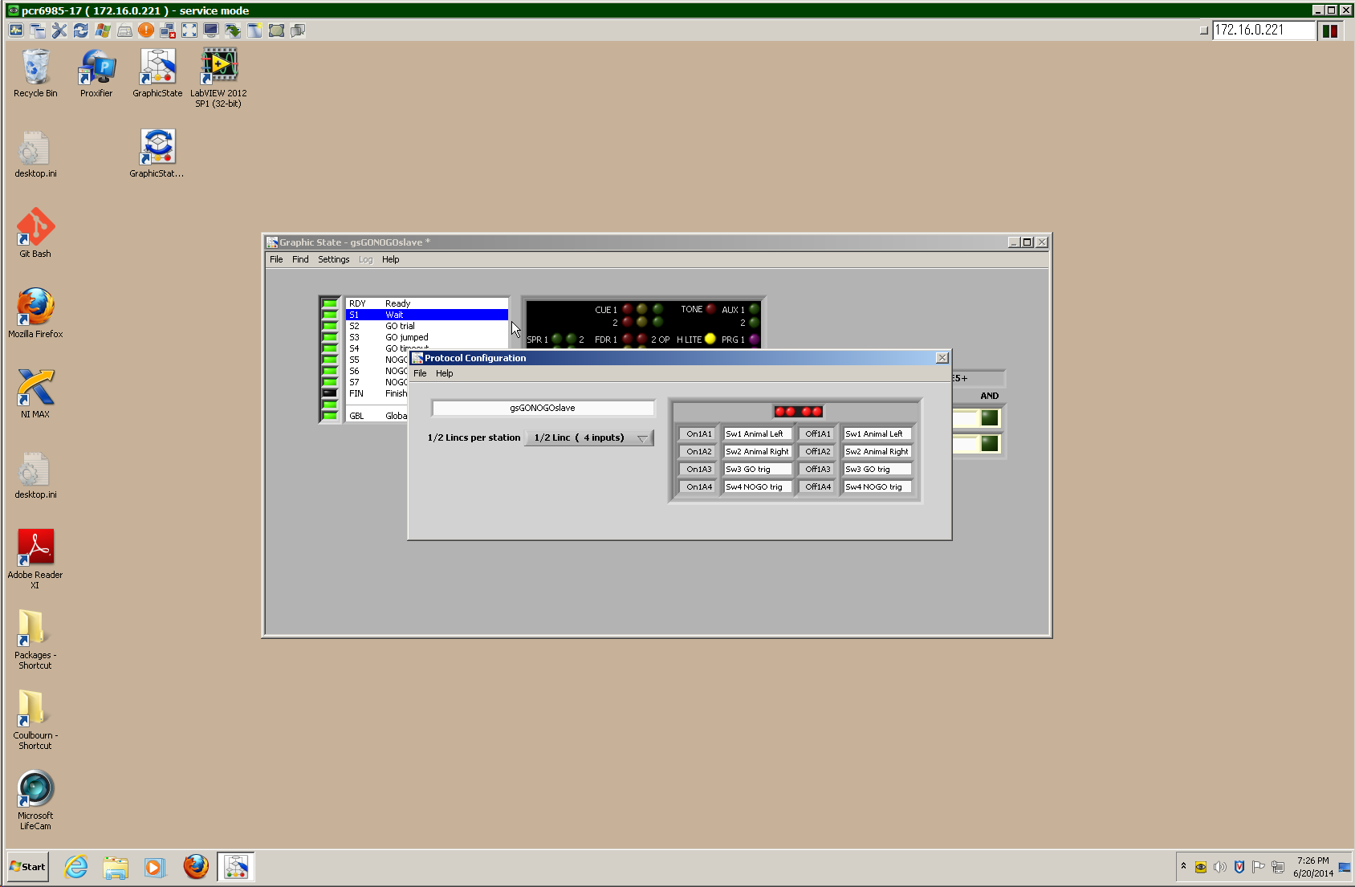

## Registers

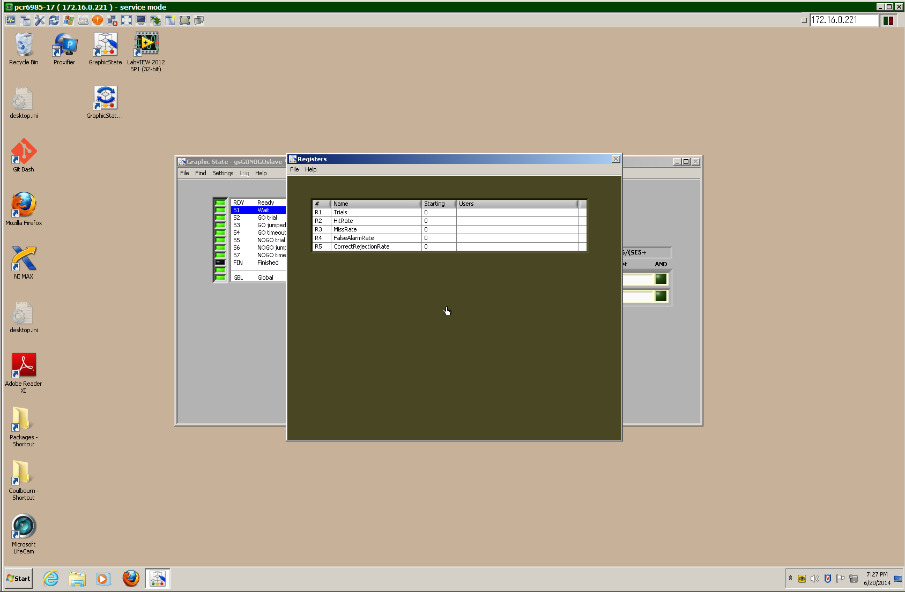

**Run-Time Display**

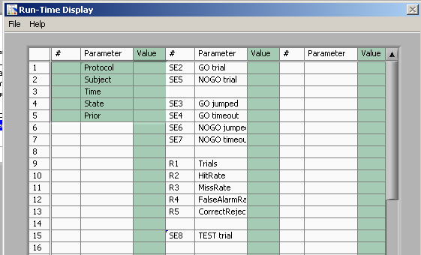

**Inputs**

Sw3: GO trigger  
Sw4: NOGO trigger  
Sw3 + Sw4: TEST trial trigger

## Outputs

H LITE: Task in progress  
TONE: tone gate (not currently used given 1 FM sweep, can be used in future to gate sweep train for easier training task)  
AUX 1: Shocker

Bit 0 to 2: CUE1-1 to CUE1-3  
Bit 3 to 5: CUE2-1 to CUE2-3  
Bit 6: SPR1  
Bit 7: SPR2

# Preparation code

## RDY: "Ready"

|  |  |  |  |  |  |  |  |  |  |  |  |  |
| --- | --- | --- | --- | --- | --- | --- | --- | --- | --- | --- | --- | --- |
|  |  |  | CUE 1 |  |  | TONE |  | AUX 1 |  |  |  | |
|  |  |  | 2 |  |  |  |  | 2 |  |  |  | |
| SPR 1 |  | 2 | FDR 1 |  | 2 OP | H LITE |  | PRG 1 |  |  |  |
| 3 |  | 4 | 1 |  | 2 ML |  |  | 2 |  |  |  |

|  |  |  |  |  |  |  |  |
| --- | --- | --- | --- | --- | --- | --- | --- |
| **Goto#** | **R** | **Parameter** | **Comp.** | **Exit Criterion** | **P(%)** | **Target** | **AND** |
| 1 |  | sec | >= | 1 | 100 | 1 |  |

## S1: "Wait" [Bit code 1 = 00 000 001]

|  |  |  |  |  |  |  |  |  |  |  |  |  |
| --- | --- | --- | --- | --- | --- | --- | --- | --- | --- | --- | --- | --- |
|  |  |  | CUE 1 |  |  | TONE |  | AUX 1 |  |  |  | |
|  |  |  | 2 |  |  |  |  | 2 |  |  |  | |
| SPR 1 |  | 2 | FDR 1 |  | 2 OP | H LITE |  | PRG 1 |  |  |  |
| 3 |  | 4 | 1 |  | 2 ML |  |  | 2 |  |  |  |

SE2+SE5>>Trials;   
SE3/(SE2+0.000000001)>>HitRate;   
SE4/(SE2+0.000000001)>>MissRate;  
SE6/(SE5+0.000000001)>>FalseAlarmRate;  
SE7/(SE5+0.000000001)>>CorrectRejectionRate;

|  |  |  |  |  |  |  |  |
| --- | --- | --- | --- | --- | --- | --- | --- |
| **Goto#** | **R** | **Parameter** | **Comp.** | **Exit Criterion** | **P(%)** | **Target** | **AND** |
| 1 |  | Sw3 GO trig | >= | 1 | 100 | 8 | [1] |
| 2 |  | Sw4 NOGO trig | >= | 1 | 100 | 8 | [1] |
| 3 | ☒ | Sw3 GO trig | >= | 1 | 100 | 2 |  |
| 4 |  | Sw4 NOGO trig | >= | 1 | 100 | 5 |  |

# S2/GO trials

## S2: "GO trial" [Bit code 2 = 00 000 010]

|  |  |  |  |  |  |  |  |  |  |  |  |  |
| --- | --- | --- | --- | --- | --- | --- | --- | --- | --- | --- | --- | --- |
|  |  |  | CUE 1 |  |  | TONE |  | AUX 1 |  |  |  | |
|  |  |  | 2 |  |  |  |  | 2 |  |  |  | |
| SPR 1 |  | 2 | FDR 1 |  | 2 OP | H LITE |  | PRG 1 |  |  |  |
| 3 |  | 4 | 1 |  | 2 ML |  |  | 2 |  |  |  |

|  |  |  |  |  |  |  |  |
| --- | --- | --- | --- | --- | --- | --- | --- |
| **Goto#** | **R** | **Parameter** | **Comparison** | **Exit Criterion** | **P(%)** | **Target** | **AND** |
| 1 |  | Sw4 NOGO trig: | >= | 1 | 100 | 8 |  |
| 2 |  | Sw1 Animal Left | >= | 1 | 100 | 3 |  |
| 3 |  | Sw2 Animal Right | >= | 1 | 100 | 3 |  |
| 4 |  | sec | >= | 4 | 100 | 4 |  |

# Animal Jumped

## S3: "GO jumped" (aka Hit) [Bit code 3 = 00 000 011]

|  |  |  |  |  |  |  |  |  |  |  |  |  |
| --- | --- | --- | --- | --- | --- | --- | --- | --- | --- | --- | --- | --- |
|  |  |  | CUE 1 |  |  | TONE |  | AUX 1 |  |  |  | |
|  |  |  | 2 |  |  |  |  | 2 |  |  |  | |
| SPR 1 |  | 2 | FDR 1 |  | 2 OP | H LITE |  | PRG 1 |  |  |  |
| 3 |  | 4 | 1 |  | 2 ML |  |  | 2 |  |  |  |

|  |  |  |  |  |  |  |  |
| --- | --- | --- | --- | --- | --- | --- | --- |
| **Goto#** | **R** | **Parameter** | **Comparison** | **Exit Criterion** | **P(%)** | **Target** | **AND** |
| 1 |  | sec | >= | 4 | 100 | 1 |  |

# Animal Didn't Jump

## S4: "GO timeout" (aka Miss) [Bit code 4 = 00 000 100]

|  |  |  |  |  |  |  |  |  |  |  |  |  |
| --- | --- | --- | --- | --- | --- | --- | --- | --- | --- | --- | --- | --- |
|  |  |  | CUE 1 |  |  | TONE |  | AUX 1 |  |  |  | |
|  |  |  | 2 |  |  |  |  | 2 |  |  |  | |
| SPR 1 |  | 2 | FDR 1 |  | 2 OP | H LITE |  | PRG 1 |  |  |  |
| 3 |  | 4 | 1 |  | 2 ML |  |  | 2 |  |  |  |

|  |  |  |  |  |  |  |  |
| --- | --- | --- | --- | --- | --- | --- | --- |
| **Goto#** | **R** | **Parameter** | **Comparison** | **Exit Criterion** | **P(%)** | **Target** | **AND** |
| 1 |  | Sw1 Animal Left | >= | 1 | 100 | 1 |  |
| 2 |  | Sw2 Animal Right | >= | 1 | 100 | 1 |  |
| 3 |  | sec | >= | 4 | 100 | 1 |  |

# NOGO trials

## S5: "NOGO trial" [Bit code 5 = 00 000 101]

|  |  |  |  |  |  |  |  |  |  |  |  |  |
| --- | --- | --- | --- | --- | --- | --- | --- | --- | --- | --- | --- | --- |
|  |  |  | CUE 1 |  |  | TONE |  | AUX 1 |  |  |  | |
|  |  |  | 2 |  |  |  |  | 2 |  |  |  | |
| SPR 1 |  | 2 | FDR 1 |  | 2 OP | H LITE |  | PRG 1 |  |  |  |
| 3 |  | 4 | 1 |  | 2 ML |  |  | 2 |  |  |  |

|  |  |  |  |  |  |  |  |
| --- | --- | --- | --- | --- | --- | --- | --- |
| **Goto#** | **R** | **Parameter** | **Comparison** | **Exit Criterion** | **P(%)** | **Target** | **AND** |
| 1 |  | Sw3 GO trig | >= | 1 | 100 | 8 |  |
| 2 |  | Sw1 Animal Left | >= | 1 | 100 | 6 |  |
| 3 |  | Sw2 Animal Right | >= | 1 | 100 | 6 |  |
| 4 |  | sec | >= | 4 | 100 | 7 |  |

# Animal Jumped

## S6: "NOGO jumped" (aka False Alarm) [Bit code 6 = 00 000 110]

|  |  |  |  |  |  |  |  |  |  |  |  |  |
| --- | --- | --- | --- | --- | --- | --- | --- | --- | --- | --- | --- | --- |
|  |  |  | CUE 1 |  |  | TONE |  | AUX 1 |  |  |  | |
|  |  |  | 2 |  |  |  |  | 2 |  |  |  | |
| SPR 1 |  | 2 | FDR 1 |  | 2 OP | H LITE |  | PRG 1 |  |  |  |
| 3 |  | 4 | 1 |  | 2 ML |  |  | 2 |  |  |  |

|  |  |  |  |  |  |  |  |
| --- | --- | --- | --- | --- | --- | --- | --- |
| **Goto#** | **R** | **Parameter** | **Comparison** | **Exit Criterion** | **P(%)** | **Target** | **AND** |
| 1 |  | Sw1 Animal Left | >= | 1 | 100 | 1 |  |
| 2 |  | Sw2 Animal Right | >= | 1 | 100 | 1 |  |
| 3 |  | sec | >= | 4 | 100 | 1 |  |

# Animal Didn't Jump

## S7: "NOGO timeout" (aka Correct Rejection) [Bit code 7 = 00 000 111]

|  |  |  |  |  |  |  |  |  |  |  |  |  |
| --- | --- | --- | --- | --- | --- | --- | --- | --- | --- | --- | --- | --- |
|  |  |  | CUE 1 |  |  | TONE |  | AUX 1 |  |  |  | |
|  |  |  | 2 |  |  |  |  | 2 |  |  |  | |
| SPR 1 |  | 2 | FDR 1 |  | 2 OP | H LITE |  | PRG 1 |  |  |  |
| 3 |  | 4 | 1 |  | 2 ML |  |  | 2 |  |  |  |

|  |  |  |  |  |  |  |  |
| --- | --- | --- | --- | --- | --- | --- | --- |
| **Goto#** | **R** | **Parameter** | **Comparison** | **Exit Criterion** | **P(%)** | **Target** | **AND** |
| 1 |  | sec | >= | 4 | 100 | 1 |  |

**TEST trials**

**S8: "TEST trial" [Bit code 8 = 00 001 000]**

|  |  |  |  |  |  |  |  |  |  |  |  |  |
| --- | --- | --- | --- | --- | --- | --- | --- | --- | --- | --- | --- | --- |
|  |  |  | CUE 1 |  |  | TONE |  | AUX 1 |  |  |  | |
|  |  |  | 2 |  |  |  |  | 2 |  |  |  | |
| SPR 1 |  | 2 | FDR 1 |  | 2 OP | H LITE |  | PRG 1 |  |  |  |
| 3 |  | 4 | 1 |  | 2 ML |  |  | 2 |  |  |  |

|  |  |  |  |  |  |  |  |
| --- | --- | --- | --- | --- | --- | --- | --- |
| **Goto#** | **R** | **Parameter** | **Comparison** | **Exit Criterion** | **P(%)** | **Target** | **AND** |
| 1 |  | Sw1 Animal Left | >= | 1 | 100 | 9 |  |
| 2 |  | Sw2 Animal Right | >= | 1 | 100 | 9 |  |
| 3 |  | sec | >= | 4 | 100 | 10 |  |

**Animal Jumped**

**S9: "TEST jumped" [Bit code 9 = 00 001 001]**

|  |  |  |  |  |  |  |  |  |  |  |  |  |
| --- | --- | --- | --- | --- | --- | --- | --- | --- | --- | --- | --- | --- |
|  |  |  | CUE 1 |  |  | TONE |  | AUX 1 |  |  |  | |
|  |  |  | 2 |  |  |  |  | 2 |  |  |  | |
| SPR 1 |  | 2 | FDR 1 |  | 2 OP | H LITE |  | PRG 1 |  |  |  |
| 3 |  | 4 | 1 |  | 2 ML |  |  | 2 |  |  |  |

|  |  |  |  |  |  |  |  |
| --- | --- | --- | --- | --- | --- | --- | --- |
| **Goto#** | **R** | **Parameter** | **Comparison** | **Exit Criterion** | **P(%)** | **Target** | **AND** |
| 1 |  | sec | >= | 4 | 100 | 1 |  |

**Animal Didn't Jump**

**S10: "TEST timeout" [Bit code 10 = 00 001 010]**

|  |  |  |  |  |  |  |  |  |  |  |  |  |
| --- | --- | --- | --- | --- | --- | --- | --- | --- | --- | --- | --- | --- |
|  |  |  | CUE 1 |  |  | TONE |  | AUX 1 |  |  |  | |
|  |  |  | 2 |  |  |  |  | 2 |  |  |  | |
| SPR 1 |  | 2 | FDR 1 |  | 2 OP | H LITE |  | PRG 1 |  |  |  |
| 3 |  | 4 | 1 |  | 2 ML |  |  | 2 |  |  |  |

|  |  |  |  |  |  |  |  |
| --- | --- | --- | --- | --- | --- | --- | --- |
| **Goto#** | **R** | **Parameter** | **Comparison** | **Exit Criterion** | **P(%)** | **Target** | **AND** |
| 1 |  | sec | >= | 4 | 100 | 1 |  |