OrbitalWatch: Kosmos 2612 and ICEYE-X36, Combined Findings
Khadija Taki · October 21, 2026 · Preliminary, not peer reviewed

Key findings
- Clear maneuvers. Kosmos 2612 made a large orbit raise on Sep 30, a plane change on Oct 7, a descent on Oct 12, and several small burns Oct 15–20.
- Directed at ICEYE-X36. Before Sep 30 the two satellites were drifting apart. The maneuvers brought Kosmos 2612 into ICEYE-X36's orbit.
- Close approach. Kosmos 2612 came within a few kilometers of ICEYE-X36 on Oct 16–18, then stepped back to a steady ~475 km.
- Open data is enough. All of this was detected with free public data and standard, reproducible methods.

Timeline
Date (2026) | Kosmos 2612 action | Distance to ICEYE-X36
Aug 1 – Sep 29 | No maneuvers; slow drag decay | Growing, 2,800 → 8,300 km
Sep 30 | Orbit raised ~46 km | Begins repositioning
Oct 5 | Coasting in higher orbit | Passes within ~55 km
Oct 7 | Small plane change (~0.03°) | Fine alignment
Oct 12 | Orbit lowered to ICEYE's altitude | Passes within ~55 km, then settles
Oct 13–14 | Holding | Steady ~430–450 km
Oct 15–18 | Small burns | Closes to within a few km
Oct 19–21 | Small burns | Backs off to steady ~475 km

Data and method
Public orbit records (TLEs) from Space-Track.org, August 1 to October 21, 2026: 279 records for Kosmos 2612 (NORAD 68762) and 322 for ICEYE-X36 (NORAD 59103). Altitude comes from each record's mean motion. Positions were computed with the standard SGP4 model every 2 minutes, always using the most recent record for each satellite, and the distance between them was measured at each step.

Finding 1: Kosmos 2612 maneuvered several times
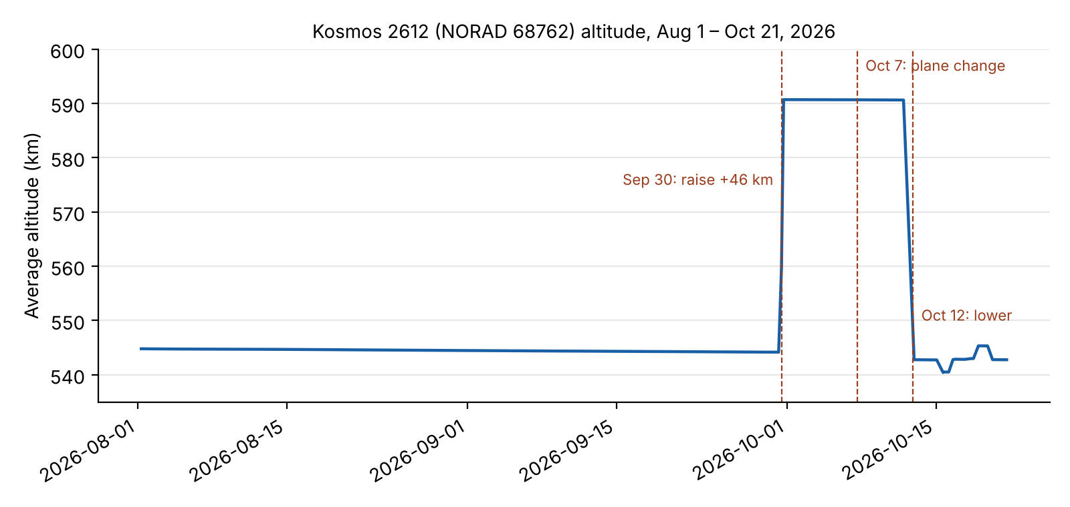
- Aug 1 – Sep 30: quiet. Altitude slowly drops about half a kilometer from atmospheric drag. This is the normal baseline.
- Sep 30: large orbit raise. Altitude jumps about 46 km (≈544 to ≈591 km) within a day. Drag cannot do this, so it is a deliberate engine burn.
- Oct 7: plane change. Altitude stays the same, but inclination shifts about 0.03°. A second, quieter maneuver.
- Oct 12: orbit lowered. Altitude drops back to about 543 km, close to ICEYE-X36's altitude.
- Oct 15–20: small adjustments. Several burns move it a few kilometers up and down.

Finding 2: The maneuvers brought it to ICEYE-X36
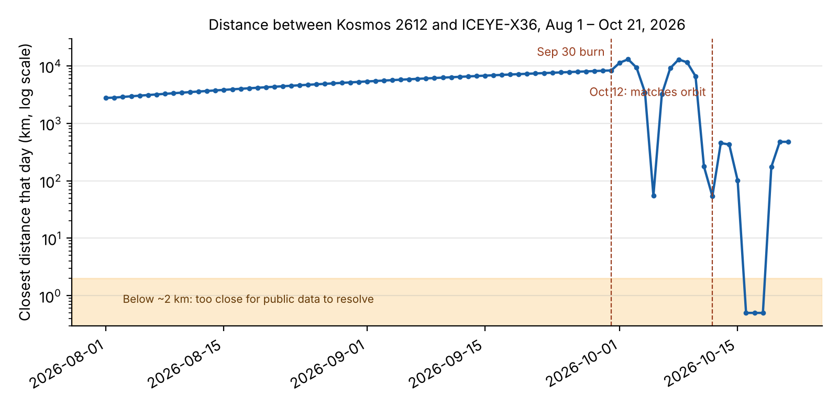
The two satellites share almost the same orbital plane, so the distance mainly reflects how far apart they are along the same path.
- Aug 1 – Sep 29: drifting apart. Distance grows steadily from about 2,800 km to 8,300 km. No sign of interest in ICEYE-X36.
- Sep 30 – Oct 11: catching up. The higher orbit is slower, which lets Kosmos 2612 change its position along the path relative to ICEYE-X36. The swings in the graph come from the two satellites passing each other at different altitudes, with closest daily distances of about 55 km on Oct 5 and Oct 12.
- Oct 12: matching orbits. Kosmos 2612 drops to ICEYE-X36's altitude. From Oct 13 to 14 it holds steady about 430–450 km away, its daily average barely changing. Satellites don't stay that steady relative to each other by accident.
- Oct 15–18: close approach. Distance closes to under about 2 km on Oct 16–18. Public orbit records carry errors of roughly a kilometer or more, so the exact closest distance cannot be resolved. The defensible claim is that Kosmos 2612 came within a few kilometers of ICEYE-X36.
- Oct 19–21: backing off. Kosmos 2612 moves back out to about 475 km and holds there.

What this shows
Using only free public data, the analysis shows a clear sequence: a baseline with no interest, a deliberate orbit raise, a coordinated drift toward ICEYE-X36, a matched orbit, a close approach within a few kilometers, and a step back to a steady standoff distance. This is consistent with co-orbital shadowing behavior.

Limits
- Accuracy. TLE-based positions are only accurate to roughly 1 km or more. Distances below ~2 km should be read as "very close," not exactly.
- Maneuver days. On days when a satellite burns, the record before the burn becomes wrong. Some daily numbers around Sep 30, Oct 7, and Oct 12 are rough.
- Intent. The data shows behavior, not purpose. It cannot say why Kosmos 2612 approached.
- First pass. These numbers come from a quick analysis. The full OrbitalWatch pipeline should confirm exact maneuver times and sizes.

Next steps
- Run the full OrbitalWatch pipeline to confirm maneuver times automatically and classify approach phases.
- Compare it with the public timeline from tracking firms and press reports: how early would open data have flagged this?
- Test for false alarms by running the same analysis on ordinary satellite pairs.

