
Group Project Assignment on Nike
MKT 306.02E

Due date: April 26, 2025
Prof. Yazan Kakish
East Texas A&M University
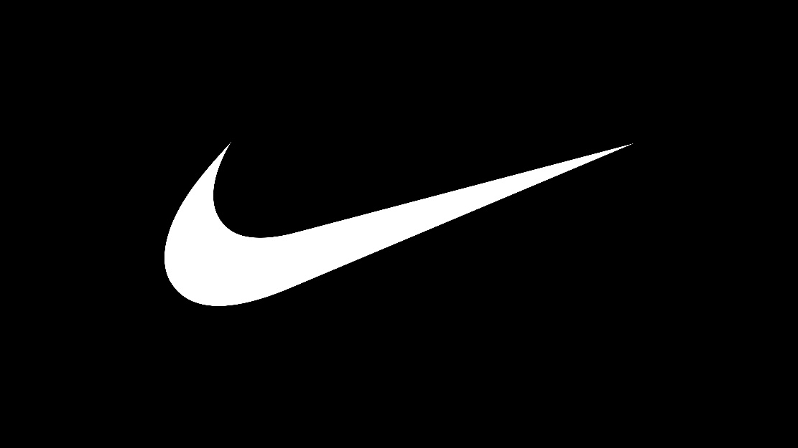
Situational Analysis
Nike, Inc. is one of the biggest names in the athletic footwear, apparel, and equipment market. This space mainly includes products for activities like running, training, basketball, and even outdoor sports like hiking. In 2023, Nike’s total revenue hit around 51.2 billion USD, with 13.8 billion USD coming from apparel sales and about 2.1 billion USD from equipment sales. Meanwhile, the whole global athletic apparel and equipment market was valued at about 210 billion USD during the same year. Looking ahead, experts are predicting a compound annual growth rate (CAGR) of roughly 6.5% through 2032.
Nike continues to dominate, especially in North America, which made up close to 40% of its overall revenue in 2023. In terms of global market share, Nike captured about 27% of the athletic footwear market and somewhere between 10% to 12% of the broader athletic apparel and equipment market. These numbers were put together based on data recorded from around 2018 to 2023.
With its huge 51.2 billion USD in sales last year, Nike clearly holds a strong position compared to its competitors. If a visual chart were shown here, it would display Nike’s market share towering above many others in the industry.

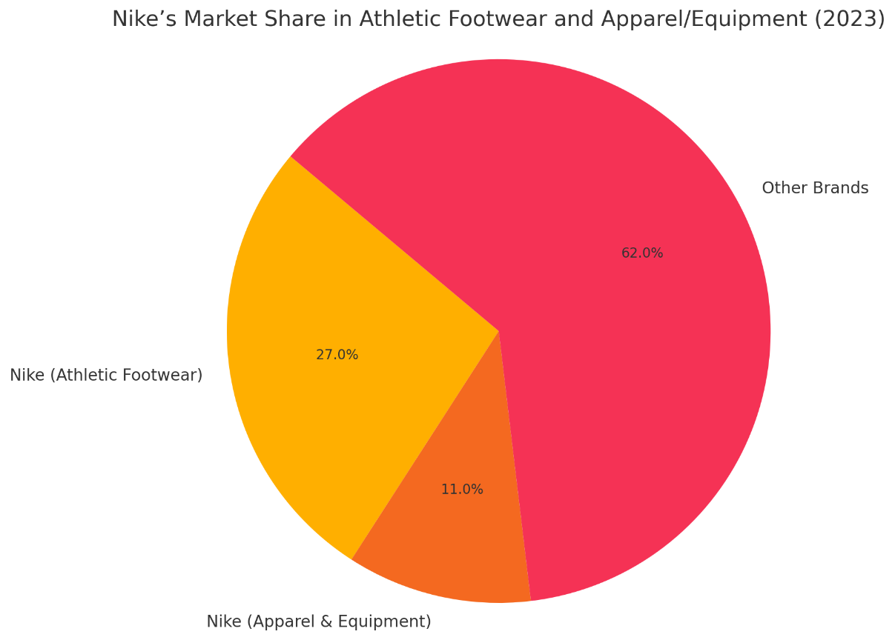

Nike Fund Revenue Investment
Focus Area | Investment detail | Purpose/ Impact
Digital Transformation | More than $1 billion was spent on data analytics, Nike.com, SNKRS, and the Nike App. | Improves individualized experience and direct-to-consumer (DTC) sales.
Sustainability | Investing in sustainable manufacturing, recycled materials, and "Move to Zero". | Serves to environmentally aware customers and supports Nike's carbon neutrality objective.
Product Innovation | R&D expenditures through the Nike Sport Research Lab and smart shoe technology. | Promote performance gear innovation and fortifies brand leadership
Marketing & Branding | Approximately $3.5 billion is spent on marketing each year (influencer partnerships, campaigns, and athletes). | Increases market share, cultural significance, and worldwide brand awareness.
Supply Chain | Funding for logistics optimization and regional supplier diversity. | Enhances delivery effectiveness and lowers the danger of worldwide disruptions.
1. Digital Transformation
Nike has made over $1 billion in investments in digital platforms such as the Nike App, SNKRS, and Nike.com. The goal is to expand its direct-to-consumer (DTC) business while giving customers a more seamless and customized experience. This action lessens Nike's need on outside merchants while fostering closer ties with its clientele.
2. Sustainability
Nike is investing heavily in recycled materials, sustainable production, and their "Move to Zero" initiative, which aspires to achieve zero waste and zero carbon emissions. Through these initiatives, Nike not only lessens its environmental effect but also draws in eco-aware customers, who represent a growing market share.
3. Product Innovation
By making significant investments in R&D through the Nike Sport Research Lab and cutting-edge technology like smart sneakers, Nike maintains its position as a leader in innovation. Nike's position as an innovator in the sports sector is upheld by these investments, which also keep the company at the forefront of performance apparel.
4. Marketing & Branding
Nike spends about $3.5 billion a year on marketing, which is still one of its best investments. Nike increases its global visibility, fortifies its cultural relevance, and grows its market share globally through influencer partnerships, high-profile campaigns, and athlete endorsements.
5. Supply Chain
Nike is likewise working to improve the speed and flexibility of their supply chain. Nike can more easily deliver goods and control the risks associated with worldwide disruptions by investing in logistics optimization and buying from a larger range of vendors. This guarantees that Nike maintains its competitiveness even in the face of unforeseen difficulties.

Market Summary
Nike operates within the global athletic footwear, apparel, and equipment industry. It is currently the largest sportswear brand in the world by revenue. Nike’s market spans a diverse range of customer demographics and regions. Its key market segments include athletes, fitness enthusiasts, casual wear consumers, and fashion-driven buyers. Nike maintains a global footprint, with its strongest markets in North America, Europe, and China. Emerging regions like Southeast Asia and Latin America are also seeing rapid growth, presenting expansion opportunities.
In recent years, Nike has increasingly focused on its Direct-to-Consumer (DTC) strategy, which includes owned retail stores and digital platforms like the Nike App and SNKRS app. This transition allows Nike to better control customer experience and increase profit margins by reducing reliance on wholesale distribution. According to their Fiscal Year 2023 report, Nike’s DTC revenue accounted for over 43% of total sales. ¹
The market has seen several ongoing trends that impact Nike’s strategy:
- Athleisure boom: Consumers are increasingly choosing athletic-inspired clothing for everyday wear.
- Sustainability: Demand for environmentally responsible brands is influencing consumer choices.
- Customization: Shoppers are looking for unique, personalized products.
- Digital transformation: E-commerce and data-driven consumer engagement are crucial to brand loyalty.
Nike is addressing these shifts by implementing AI and machine learning in product recommendations, introducing sustainable product lines (like Nike’s "Move to Zero"), and offering customizable sneaker models through Nike By You.
SWOT Analysis
Strengths | Weakness
- Nike is one of the most valuable and recognized brands in the world, with a brand value of over $50 billion.  - It has a strong distribution channel.  - Collaborations with world-class athletes like Lebron James and Cristiano Ronaldo strengthen brand credibility.  - It has Innovative shoe design which enables customer design their own shoe online.  - Has a strong Marketing Campaign and endorses different products. | - Over 90% of Nike products are made by independent contractors primarily in Asia.  - Its sales highly depend on the footwear sector.  - It has high prices compared to its competitors.eg Adidas  - It has violations in history, and they provide minimal wages to its workers.

Strengths
Nike is undoubtedly one of the strongest brands in the world, valued at over $50 billion. Its brand power is backed by a global distribution network that ensures Nike products are available almost everywhere. Collaborations with iconic athletes like LeBron James and Cristiano Ronaldo have further reinforced its credibility and status. Nike also leads the way in innovation, offering customers the ability to design and customize their own shoes online, which creates a more personalized shopping experience. On top of all that, Nike's marketing campaigns are bold, creative, and highly effective, helping the company stay culturally relevant across generations.
Weaknesses
Despite its strengths, Nike isn’t without challenges. A major concern is that more than 90% of Nike’s manufacturing is outsourced to independent contractors, mostly located in Asia, exposing it to reputational and operational risks. Another weakness is Nike’s heavy reliance on its footwear sales — if demand for athletic shoes ever declines, it could hit the company hard. Pricing is also a concern; Nike’s products are generally more expensive than competitors like Adidas, which could turn away price-sensitive customers. Lastly, Nike’s reputation has been tainted in the past by labor violations and criticism over low wages provided to factory workers, which remains a point of sensitivity.

Some of the briefly described strengths of nike are:
- With a brand value of $31.3 billion, Nike maintained its top spot as the most valuable clothing brand in the world in 2023, as per Brand Finance's "Apparel 50 2023" study. Even though this valuation was 6% lower than the year before, Nike was still ahead of its rivals in the clothing industry.
- According to unpauzed.com, partnerships with elite players like LeBron James and Cristiano Ronaldo enhance company credibility. Over $1 billion has been made by LeBron's association with Nike, which includes a lifetime contract, greatly enhancing the company's reputation and market power.
- Nike provides cutting-edge shoe design with its "Nike by You" platform, which lets users create and customize their own shoes online.
Wikipedia claims that the business offers a distinctive and customized experience by enabling clients to alter different parts of their shoes.
- Nike's brand recognition and credibility have been greatly increased by its marketing initiatives and product endorsements.
Forbes claims that the impact of the company's strategic marketing initiatives was demonstrated by the over $43 million in media exposure that the Colin Kaepernick campaign produced in only one day.

Some of the briefly explained Nike Weakness are:
- According to YaleGlobal, independent contractors manufacture more than 90% of Nike's products, mostly in Asia. According to Nike's 2005 corporate reports, the business employed hundreds of thousands of contract workers at its network of independent facilities spread around Asia, including 124 in China, 73 in Thailand, and dozens more in nations including South Korea and Vietnam.
- The footwear industry, which generated 68% of Nike's revenue in fiscal year 2024, is a major contributor to the company’s sales.
This substantial reliance on footwear highlights the line's significance to Nike's broader business plan, according to Investopedia.
- Nike has been under fire for their labor policies, which include paying workers less than the minimum wage in certain plants.
Concerns over Nike's labor standards have been raised by reports that show instances of manufacturing workers receiving less than the legally required minimum wage, according to Stanford University.

Opportunity | Threats
- It can develop products such as sport’s wear, sunglasses and jewelry.  - Further innovation in recycled materials and low-carbon manufacturing can attract environmentally conscious consumers.  - Women’s apparel and footwear are growing faster than men's, offering a profitable growth area.  - It can support different market events globally as (the Olympics, FIFA).  - Wearables, AR/VR fitting tools, and data-driven design can enhance user experience and brand stickiness. | - Fake Nike items dilute brand value and reduce consumer trust.  - Sensitivity to Price.  - An economic recession and fluctuations in the currency can lead Nike to losses.  - Higher competition as competitors are becoming more aggressive and creating high quality products.

Opportunities
There are numerous chances for Nike to keep expanding. Nike may be able to create new revenue streams by expanding into new product categories including jewelry, eyewear, and sporting accessories. Innovation is still a significant advantage; creating more environmentally friendly items with recycled materials and low-carbon manufacturing could appeal to consumers who care about the environment. The rapidly rising women's market presents another significant opportunity for Nike, as women's clothing and footwear are growing at a faster rate than men's. Nike's global profile could be increased by collaborating with major international events like the Olympics or FIFA World Cup. Additionally, Nike can develop even more engaging and memorable brand experiences by utilizing cutting-edge technologies like wearable technology, augmented reality (AR) fitting tools, and data-driven personalization.

Threats
There are some serious dangers to Nike that can halt its growth. Nike's brand image is harmed by the global counterfeit industry, which also confuses consumers and undermines their trust. Another problem is price sensitivity; if Nike's goods remain expensive while rivals offer comparable quality at lower prices, consumers may begin to switch brands. Although they are beyond Nike's control, economic downturns and volatile currency fluctuations could have a major negative impact on sales in many locations. Last but not least, the rivalry is getting fiercer every year as companies like Adidas and Puma, as well as upstarts, are growing more assertive and improving the quality of their products.
Competition
Nike's primary competitors in the sportswear and athletic footwear industry include Adidas, Under Armor, Puma, New Balance, and Reebok. Each of these brands competes with Nike across different segments such as performance apparel, casual/lifestyle wear, footwear technology, and sustainability. Most of these companies, like Nike, are also developing sustainability initiatives in response to environmental concerns and consumer demand.
Nike has set ambitious goals to reduce its environmental impact. As stated in its 2023 Impact Report, Nike aims to achieve zero carbon and zero waste to help protect the future of sport. Nike is working to reduce its carbon footprint by transitioning to 100% renewable energy in owned and operated facilities by 2025 and by increasing the use of sustainable materials like recycled polyester and organic cotton. They report that approximately 73% of all Nike footwear and apparel now contain recycled materials. However, Nike has faced criticism in the past regarding labor practices in supply chains, and despite efforts to improve transparency, some believe there is room for growth in terms of reporting and ethical sourcing. ¹²
Among Nike’s most direct competitors is Adidas, which has taken major steps in sustainability and innovation. Both brands have extensive global reach and are market leaders in athletic footwear and apparel. While Nike is known for its aggressive marketing, cutting-edge tech like Nike Air and Fly knit, and athlete endorsements (e.g., LeBron James, Serena Williams), Adidas positions itself strongly through its collaborations (e.g., Yeezy, Ivy Park) and its eco-innovation. Adidas introduced shoes made with ocean plastic through its partnership with Parley for the Oceans and aims to make nine out of ten articles sustainable by 2025.³ Compared to Nike, Adidas has a more visible commitment to sustainable materials, though Nike has a broader dominance in sports endorsements and product technology.
Another key competitor is Under Armor, a U.S.-based brand known for performance wear and innovations like sweat-wicking fabric (Heat Gear). While Nike appeals to both the athletic and lifestyle markets, Under Armor remains focused on high-performance training and fitness. Under Armor has struggled to scale its appeal beyond North America and has a smaller footprint in footwear compared to Nike. On sustainability, Under Armor launched its 2023 Sustainability & Impact Report outlining goals like reducing water and energy usage, but it has been less aggressive than Nike or Adidas in implementing large-scale material shifts or global campaigns. ⁴
Puma, a German brand, is considered a mid-tier competitor. It combines affordability with stylish performance wear, often collaborating with fashion icons like Rihanna and Neymar Jr. Puma is appealing to younger consumers who seek fashionable yet functional activewear. Puma’s Forever Better sustainability platform targets carbon neutrality by 2050 and emphasizes transparency in production processes. However, in terms of R&D and innovation, Puma lags behind Nike’s tech-driven product development. ⁵ Puma focuses more on fashion-forward streetwear compared to Nike’s dominance in performance and lifestyle crossover products.
New Balance is another U.S.-based brand, often considered a legacy competitor. While Nike relies heavily on overseas manufacturing, New Balance stands out for its domestic production, with several of its shoes made in the USA. Known for comfort and quality, especially in running and walking shoes, New Balance appeals to consumers who value durability and craftsmanship. New Balance also highlights its use of sustainable materials such as ethically sourced leather and environmentally friendly foam insoles. Its sustainability reporting is not as comprehensive as Nike’s, but its emphasis on local manufacturing reduces shipping emissions. ⁶
Reebok, now owned by Authentic Brands Group after being sold by Adidas, has shifted focus toward fitness, training, and casual wear. Reebok has adopted some sustainability practices, such as plant-based shoes and recycled materials, but has not made the same impact or investment as Nike. Its brand relevance has declined in the performance of the sports market, though it maintains a loyal following in fitness communities.
In summary, Nike’s competition varies widely. Adidas poses the biggest threat due to its equal brand stature and strong sustainability positioning. Under Armor and New Balance offer niche competition in performance and comfort-focused segments. Puma and Reebok target fashion and affordability but do not challenge Nike’s dominance in high-tech innovation or athlete endorsements. Nike remains a leader, but its competitors are gaining ground, particularly in eco-consciousness and niche brand loyalty.

Reebok | Adidas | Puma | Under armor | New balance
12.10% | 31% | 17.20% | 20.70% | 19%

Considering the competitive environment, Adidas has a significant 31% market share, placing it ahead of Nike's nearest competitors. With a strong 17.2%, Puma is next in line, followed by New Balance and Under Armour, which both have 20.7% and 19%, respectively. At 12.1%, Reebok has the least market share among these well-known companies.
According to the data, Adidas is undoubtedly very well-known throughout the world, but companies like Under Armour and New Balance are not far behind. Actually, the close proximity of Puma, Under Armour, and New Balance indicates that the market for sports footwear and clothing is highly competitive. Despite being smaller, Reebok is still a significant competitor and, with the correct tactics, may be able to recapture more market share. Overall, the market remains very competitive, with no brand (aside from Adidas) massively dominating the others, which leaves Nike facing a broad and capable field of challengers.

Impact of Messi's Partnership on Adidas Revenue
Adidas has seen significant revenue gains since Messi's affiliation with the company:​
Market Capitalization Growth: Messi's widespread appeal helped Adidas' market value rise from about $10 billion in 2006 to about $40 billion in recent years.
Sales of Inter Miami Jerseys: After Messi joined Inter Miami in 2023, Adidas was hit with a huge demand for the team's uniforms, receiving roughly 500,000 orders right away. According to estimates, almost $300 million was made from the sale of about 2 million Messi jerseys, with an average price of $150.
The Competitive Environment between Adidas and Nike
Both Adidas and Nike continue to use well-known athlete endorsements to further their fierce rivalry:​
Football Kit Sponsorships: For the 2025–2026 season, Adidas will sponsor 11 of the top 20 most profitable football teams, including Real Madrid, Bayern Munich, Manchester United, and Liverpool. Conversely, Nike supports five of the top 20 teams, with Barcelona being their most well-known sponsor.
Market Share Dynamics: Nike continues to have a larger market presence, even if Adidas has improved its standing in football. Adidas recorded €21.9 billion in revenue in 2023, while Nike reported €46.4 billion. The latest news from BILD.de
In conclusion, Messi's partnership with Adidas has increased the company's visibility in football and generated substantial financial advantages, thereby escalating its rivalry with Nike.

3.4 Marketing Strategy and Positioning
Nike’s marketing strategy is centered around a strong emotional connection with its audience, cutting-edge product innovation, digital engagement, and bold brand storytelling. As the world’s leading athletic brand, Nike doesn’t just sell shoes or apparel—it sells a lifestyle of motivation, ambition, and excellence. Its iconic slogan, “Just Do It,” remains one of the most recognized and enduring brand messages in advertising history. Nike’s marketing efforts are multi-channel, highly targeted, and deeply rooted in inclusivity, performance, and inspiration.
Objectives
- To Increase marketing communication tactics.
- To make sustainable development of products worldwide (increasing the market share in middle east).
- To produce quality and low-cost products.
- To apply continuous marketing strategies to broaden its product range (increasing aerobic products).

Target Market
Nike targets a broad range of consumer segments across demographics, psychographics, and behaviors:
- Athletes and sports professionals are looking for high-performance gear.
- Youth and young adults (ages 15–35) driven by fashion, identity, and pop culture.
- Fitness enthusiasts who value functionality and comfort.
- Casual consumers are drawn to athleisure and streetwear styles.
- Increasingly, eco-conscious consumers who prioritize sustainable brands.
Nike segments its audience by sport, region, gender, and activity type, enabling it to tailor marketing and product offerings to niche communities like runners, skaters, basketball players, or yoga practitioners.

Positioning Statement
Nike positions itself as the global leader in athletic innovation, empowering every individual to reach their potential through sport—regardless of age, ability, or background.
Its brand promise combines elite performance with emotional motivation, making consumers feel that greatness is accessible. This unique blend of technical excellence, aspirational storytelling, and inclusive branding positions Nike at the intersection of sport and culture.

Core Elements of the Marketing Strategy
1. Emotional Branding & Storytelling
Nike builds strong narratives around athletes, challenges, and social movements. Campaigns like “You Can’t Stop Us,” “Dream Crazier,” and “Equality” go beyond products to touch on values like perseverance, justice, and empowerment. These emotionally resonant stories help build loyalty and cultural relevance.
2. Athlete and Influencer Endorsements
Nike’s endorsement strategy is central to its marketing. Collaborations with top athletes such as Michael Jordan, Naomi Osaka, and Cristiano Ronaldo elevate the brand’s credibility. The Jordan Brand remains one of Nike’s most valuable sub-brands, blending exclusivity with cultural cachet.
3. Digital Ecosystem and DTC Focus
Nike invests heavily in digital experiences through its Nike App, SNKRS App, and Nike Run Club. These platforms not only drive DTC sales but also collect consumer data to personalize marketing. In 2023, Nike’s DTC strategy contributed significantly to its global growth, increasing margins and building deeper customer relationships.
4. Innovation-Driven Product Strategy
Nike's innovation in footwear and apparel (e.g., Nike Air Zoom, Fly Ease, Space Hippie) supports its premium positioning. These products offer comfort, performance, and sustainability, addressing both functional and emotional needs.

5. Sustainability as Brand Value
Through its “Move to Zero” initiative, Nike integrates environmental responsibility into its brand. Marketing campaigns now regularly highlight recycled materials, reduced emissions, and circular design. This shift is also reflected in product lines like the Nike Air Max Terras cape and Space Hippie, designed with eco-conscious consumers in mind.
6. Inclusive & Diverse Messaging
Nike’s campaigns consistently reflect diverse voices, body types, and communities. Marketing targeting women, the LGBTQ+ community, and adaptive athletes (e.g., Nike GO Fly Ease for hands-free access) has increased Nike’s reach and resonance.

References

Adidas Group. (2023). Adidas Sustainability Progress Report 2023. Retrieved from https://www.adidas-group.com
AS.com. (2023, July 21). Inter Miami and Adidas strike gold with Messi shirt sales. AS USA. https://en.as.com/soccer/inter-miami-and-adidas-strike-gold-with-messi-shirt-sales-n/
Authentic Brands Group. (2023). Reebok Brand Strategy Overview. Retrieved from https://www.authentic.com/brands/reebok
Bild. (2024, February 26). Deshalb hat Nike oft die Nase vorn. https://www.bild.de/geld/wirtschaft/wirtschaft/aktie-umsatz-strategie-deshalb-hat-nike-oft-die-nase-vorn-87613156.bildMobile.html
Bloomberg. (2023). Adidas vs Nike: Who Leads the Race in Innovation? Retrieved from https://www.bloomberg.com
Brand Finance. (2023). Apparel 50 2023 report: Nike retains top spot as most valuable apparel brand. Brand Finance. https://brandfinance.com
Business of Fashion. (2023). Nike's Digital Shift: How It’s Reinventing Retail. Retrieved from https://www.businessoffashion.com
CNBC. (2023). Nike's Marketing Spend Tops $3.5 Billion As Brand Stays Culturally Relevant. Retrieved from https://www.cnbc.com
Deloitte. (2023). Consumer Trends 2023: The Rise of Eco-Conscious Shoppers. Retrieved from https://www2.deloitte.com
Euromonitor International. (2023). Global Footwear and Apparel Industry Trends. Retrieved from https://www.euromonitor.com
Footy Headlines. (2024, November 15). Adidas smashes Nike in top football kit sponsorships. https://www.footyheadlines.com/2024/11/adidas-smashes-nike-in-top-football-kit-sponsorships.html
Forbes. (2018, September 5). Nike’s controversial ad campaign with Colin Kaepernick generated over $43 million in media exposure. Forbes. https://www.forbes.com
Forbes. (2023). Nike’s Brand Value Soars Above $50 Billion. Retrieved from https://www.forbes.com
Haden, J. (2023, March 29). The $10 billion man: How Nike lost Lionel Messi to Adidas for a few hundred bucks of tracksuits. Inc. https://www.inc.com/jeff-haden/the-10-billion-man-how-nike-lost-lionel-messi-to-adidas-for-a-few-hundreds-bucks-of-tracksuits.html
Harvard Business Review. (2023). Nike’s Path to Sustainable Innovation. Retrieved from https://hbr.org
Investopedia. (2024, June 22). How Nike makes its money. Investopedia. https://www.investopedia.com/articles/markets/080415/how-nike-nke-makes-its-money.asp
MarketLine. (2023). Nike, Inc. Company Profile. Retrieved from https://advantage.marketline.com
McKinsey & Company. (2023). The State of Fashion 2023: Sustainability and Digital Dominate. Retrieved from https://www.mckinsey.com
New Balance. (2023). Corporate Responsibility & Sustainability. Retrieved from https://www.newbalance.com/responsibility
Nike, Inc. (2023). Annual Report 2023 (Form 10-K). U.S. Securities and Exchange Commission. Retrieved from https://investors.nike.com
Nike, Inc. (2023). FY23 Impact Report. Retrieved from https://purpose.nike.com/reports
Porter, M. (2008). The Five Competitive Forces That Shape Strategy. Harvard Business Review, 86(1), 78–93.
Puma SE. (2023). Forever Better Sustainability Platform. Retrieved from https://about.puma.com/en/sustainability
Reuters. (2023). Nike Focuses on DTC Strategy as Wholesale Revenue Declines. Retrieved from https://www.reuters.com/business/retail-consumer
Stanford University. (n.d.). Nike labor standards and controversies. Stanford University. https://web.stanford.edu/class/e297c/trade_environment/wheeling/hnike.html
Statista. (2023). Nike’s Direct to Consumer (DTC) Revenue as Percentage of Total Revenue. Retrieved from https://www.statista.com/statistics/241683/nikes-direct-to-consumer-revenue-worldwide-since-2009
Under Armour. (2023). Sustainability & Impact Report. Retrieved from https://about.underarmour.com/sustainability
Unpauzed. (n.d.). How athlete collaborations drive brand engagement: The Nike x LeBron James case study. Unpauzed. https://www.unpauzed.com
Wikipedia. (n.d.). Nike By You. Wikipedia. https://en.wikipedia.org/wiki/NikeID
World Bank. (2023). Global Inflation and Supply Chain Trends. Retrieved from https://www.worldbank.org
YaleGlobal. (2005, October 6). Nike lists abuses in Asian factories. YaleGlobal Online. https://archive-yaleglobal.yale.edu/content/nike-lists-abuses-asian-factories

