Workshop 8 Solutions

Veerasak Kritsanapraphan

We’ll begin by loading all the packages we might need.

library(MASS)  
library(plyr)  
library(reshape) # You may need to install this one first!

##   
## Attaching package: 'reshape'

## The following objects are masked from 'package:plyr':  
##   
## rename, round_any

library(ggplot2)

### Is the data normal?

**(a)** Construct histograms of MPG.highway, one plot for each Origin category.

qplot(x = MPG.highway, data = Cars93, facets = ~Origin, geom = "histogram", fill = Origin, binwidth = 2)

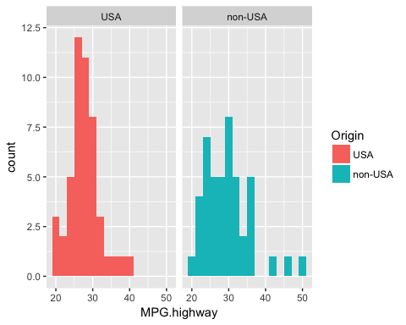

**(b)** Does the data look to be normally distributed?

The histograms don’t really look normally distributed, so we might be better off using the non-parametric test.

**(c)** Construct qqplots of MPG.highway, one plot for each Origin category. Overlay a line on each plot using with qqline() function.

par(mfrow = c(1,2))  
# USA cars  
with(Cars93, qqnorm(MPG.highway[Origin == "USA"]))  
with(Cars93, qqline(MPG.highway, col = "blue"))  
# Foreign cars  
with(Cars93, qqnorm(MPG.highway[Origin == "non-USA"]))  
with(Cars93, qqline(MPG.highway, col = "blue"))

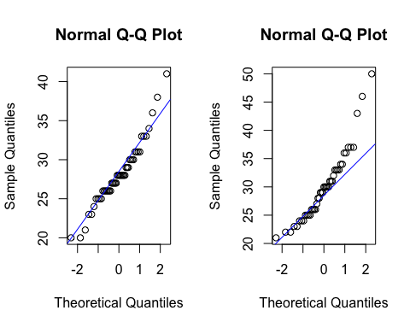

**(d)** Does the data look to be normally distributed?

The non-USA MPG.highway data looks very far from normally distributed.

### Check Shapiro-Wilk Normality test

shapiro.test(Cars93$MPG.highway[Cars93$Origin == "USA"])

##   
## Shapiro-Wilk normality test  
##   
## data: Cars93$MPG.highway[Cars93$Origin == "USA"]  
## W = 0.95361, p-value = 0.05575

shapiro.test(Cars93$MPG.highway[Cars93$Origin == "non-USA"])

##   
## Shapiro-Wilk normality test  
##   
## data: Cars93$MPG.highway[Cars93$Origin == "non-USA"]  
## W = 0.92056, p-value = 0.004417

### Testing means between two groups

**(a)** Using the Cars93 data and the t.test() function, run a t-test to see if average MPG.highway is different between US and non-US vehicles.

Try doing this both using the formula style input and the x, y style input.

# Formula version  
mpg.t.test <- t.test(MPG.highway ~ Origin, data = Cars93)  
mpg.t.test

##   
## Welch Two Sample t-test  
##   
## data: MPG.highway by Origin  
## t = -1.7545, df = 75.802, p-value = 0.08339  
## alternative hypothesis: true difference in means is not equal to 0  
## 95 percent confidence interval:  
## -4.1489029 0.2627918  
## sample estimates:  
## mean in group USA mean in group non-USA   
## 28.14583 30.08889

# x, y version

with(Cars93, t.test(x = MPG.highway[Origin == “USA”], y = MPG.highway[Origin == “non-USA”])) ```

**(b)** What is the confidence interval for the difference?

mpg.t.test$conf.int

## [1] -4.1489029 0.2627918  
## attr(,"conf.level")  
## [1] 0.95

## What about one tail?

### Mean of X less then Y

#### t.test(formula,alternative=“less”)

with(Cars93, t.test(x = MPG.highway[Origin == "USA"], y = MPG.highway[Origin =="non-USA"], alternative="less"))

##   
## Welch Two Sample t-test  
##   
## data: MPG.highway[Origin == "USA"] and MPG.highway[Origin == "non-USA"]  
## t = -1.7545, df = 75.802, p-value = 0.0417  
## alternative hypothesis: true difference in means is less than 0  
## 95 percent confidence interval:  
## -Inf -0.09886038  
## sample estimates:  
## mean of x mean of y   
## 28.14583 30.08889

### Mean of Y greater than X

#### t.test(formula,alternative=“greater”)

with(Cars93, t.test(x = MPG.highway[Origin == "USA"], y = MPG.highway[Origin =="non-USA"], alternative="greater"))

##   
## Welch Two Sample t-test  
##   
## data: MPG.highway[Origin == "USA"] and MPG.highway[Origin == "non-USA"]  
## t = -1.7545, df = 75.802, p-value = 0.9583  
## alternative hypothesis: true difference in means is greater than 0  
## 95 percent confidence interval:  
## -3.787251 Inf  
## sample estimates:  
## mean of x mean of y   
## 28.14583 30.08889