1. You can access to edit your database table, etc. here

<http://www.papademas.net/phpmyadmin/>

At the Welcome screen

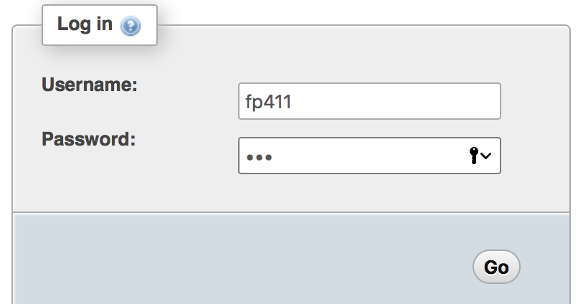

username = fp411

Password= 411

Your tables can be accessed by choosing the tickets database at the left hand side in the pull down menu labeled Database.

