**Website**

**Page 1**

Delete the third one investing my money.

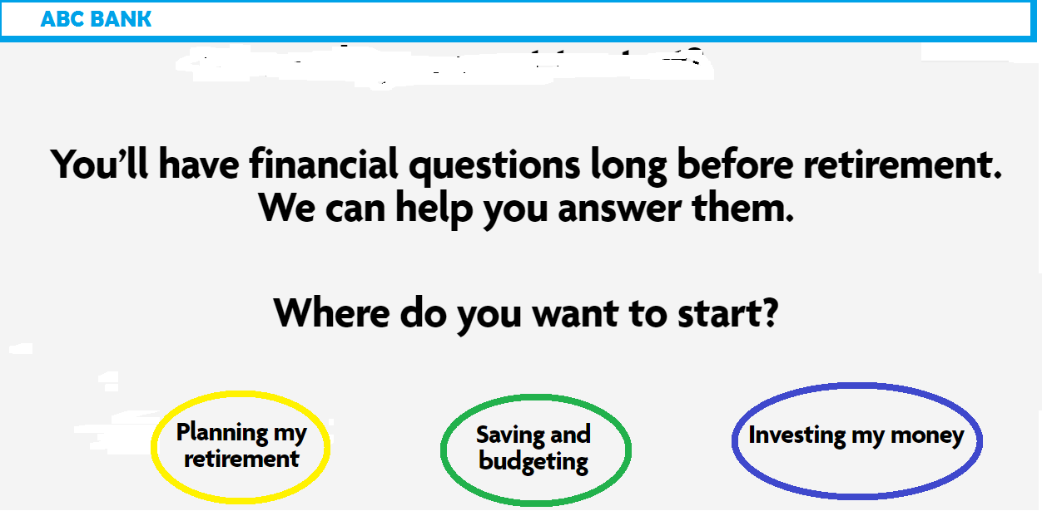

**Planning my retirement**

**Page 2**

The background photo is not necessary. Simple white background with Black color text is fine as you see from the page 1.



**Learn More Expand page**

### **Create a retirement vision—and potential budget.**

A more precise approach to estimating for *then* is to start with what you spend *now*. Make a list of your monthly expenses: rent or mortgage (including property taxes), utilities, groceries, health insurance and entertainment. Don’t forget miscellaneous expenses like your gym membership, haircuts and vet bills.

If you have a spouse or partner, it’s important to plan together for your retirement, including expenses.

Review questions like

* What health and medical considerations need to be considered into your decisions?
* Where do you want to live? Geographic location, proximity to family, climate and cost of living should all be considerations, as well as ideas about social life, friends, and community.

Revisit your “shared vision” once a year so it’s always in sync with your current situation.

**Saving and budgeting**

**Page 3**

No photo needed. White background and the black color text.



**Learn More Expand page**

### **50/30/20 rule**

Important budgeting technique is the 50/30/20 rule. It involves dividing your monthly income into three “buckets”:

* 50% (or less) goes to necessities such as housing, student loans and utilities. These are expenses you have to pay every month.
* 30% (or less) goes to nice-to-haves, such as entertainment, hobbies and travel.
* 20% (or more, if possible) goes toward savings and paying down debt.

The 50/30/20 rule can be adjusted based on your short- and long-term goals, but be careful about confusing “nice-to-haves” for “necessities.” Several dinners out each week and unlimited data plans may be nice to have, but they aren’t essential.