Introducing the SQLQueryStress Performance Testing Tool
(Updated for Version 0.9.4, October 20, 2006)
Many of the most commonly-discussed performance testing techniques focus on full-system testing using commercial tools. But sometimes it’s important to be able to run a quick performance test against a single query, in order to test ideas or validate changes.
SQLQueryStress is a simple, lightweight performance testing tool, designed to load test individual queries. It includes support for randomization of input parameters in order to test cache repeatability, and includes basic capabilities for reporting on consumed server resources.
In order to get comfortable with the tool, let’s take a quick tour of its capabilities. Figure 1 is a screen shot of the main screen.
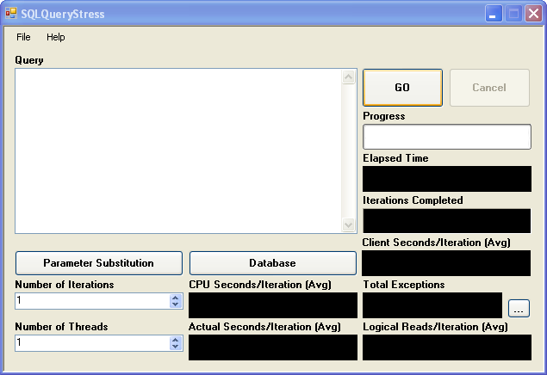
Figure 1. SQLQueryStress main screen
The main features here are as follows:
The Query area is where you can enter the query that you’d like to load test. This can be either a T-SQL query or a call to a stored procedure. You can also include variable names, which can be used for dynamic parameter substitution.
The Number of Iterations box is where you can define how many times the query should be executed by each virtual user as defined in the Number of Threads box. You can specify up to 200 threads, which will run the query simultaneously in order to simulate load.
The GO button starts the load test. During the test the Progress bar indicates the number of tests completed as compared to the number of tests to be run. The Iterations Completed box displays how many tests have actually been run, and the Total Exceptions box displays the number of exceptions that have occurred during the run. Clicking on the … button next to the Total Exceptions box pops up a window where you can view the details of the exceptions.
There are three types of time statistics collected and displayed by the tool. The Client Seconds/Iteration box displays the average runtime over all iterations, as recorded on the client. The CPU Seconds/Iteration and Actual Seconds/Iteration boxes both display time statistics reported by SQL Server. The former is the average reported CPU time, and the latter is the average reported total query time. Another statistic collected and shown by the tool is the number of logical reads (which is an amalgamation of buffer cache and disk reads), in the Logical Reads/Iteration box.
During a run, the load test can be stopped before it is complete using the Cancel button. Keep in mind that a lot of tear-down needs to take place in order to cleanly cancel a run. Especially if you’re running a lot of simultaneous threads, you may see cancellations take several seconds.
Before a load test can be run, a database connection must be set up. This is done by clicking the Database button, which launches a connection settings dialog.
The final button on the main screen is Parameter Substitution. This feature allows you to supply SQLQueryStress with a set of input values that will be dynamically applied to parameters of your query for each run, such that data caching does not incorrectly skew the results of the test.
For an example of where this might be used, consider the uspGetEmployeeManagers stored procedure in the SQL Server 2005 AdventureWorks sample database. This stored procedure has a single parameter, @EmployeeID. If this procedure were load tested in a loop and the same value were used for the parameter for every call, every run after the first would be faster thanks to data caching. This would defeat the accuracy of the test, because we would not know how the procedure would behave if uncached data was requested. To fix this problem, it’s important to pass in many different values during the course of the load test.
To set this up, the query should be entered into the Query textbox with a variable in the place of any parameters that need to be substituted, as shown in Figure 2.
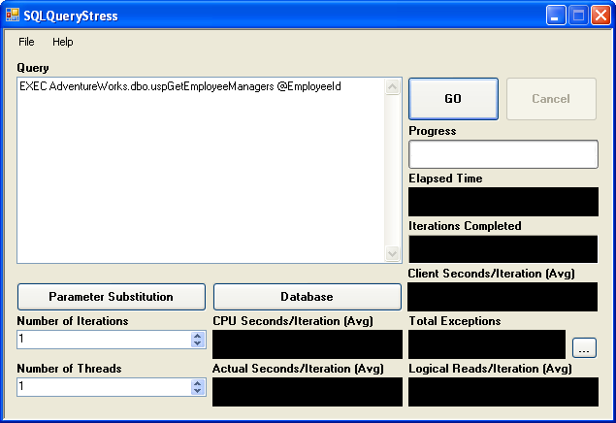
Figure 2. SQLQueryStress main screen with parameterized query
Once the query is entered in the text box, click the Parameter Substitution button, which brings up the screen shown in Figure 3.
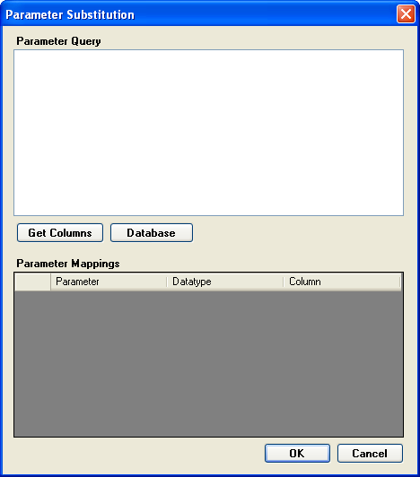
Figure 3. SQLQueryStress parameter substitution screen
The most important feature of this screen is the Parameter Query text box. This is where you define the query that pulls back the parameter values you’d like to dynamically substitute for the main query. In this case, we might want to pass in every employee ID in the AdventureWorks HumanResources.Employee table, so the following query might be used:
SELECT EmployeeId
FROM AdventureWorks.HumanResources.Employee
Once the parameter query is entered, the Get Columns button is used to set up the Parameter Mappings grid to allow the user to map the columns from the parameter query to the parameters defined in the main query. Each column in the parameter query can be mapped to one or more variables found in the main query. The completed mapping screen for this query is shown in Figure 4.
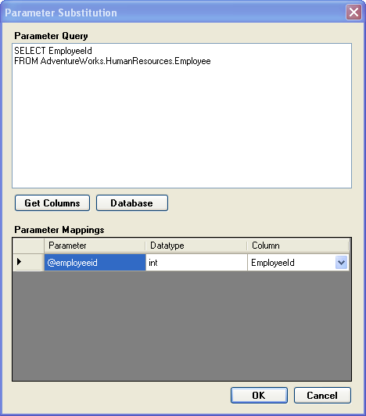
Figure 4. SQLQueryStress parameter substitution screen with mapping
After clicking OK, the load test can be run, and for each iteration a new value will be substituted in for the @EmployeeID parameter. If the tool runs out of values, it will loop around and reuse previous values the set, until it has completed the requested number of iterations.
From the File menu on the main screen, you can enter the Options dialog, shown in Figure 5. These options allow you to control some of the parameters for the test, in order to simulate various settings.
Changing the Connection Timeout option makes the tool wait longer before reporting an exception if the target server does not respond.
Connection Pooling can be disabled to show the affect of creating and destroying a new connection on each test iteration.
Modification of the Command Timeout option will make the tool report an exception if the query does not complete in time.
Changing the Collect I/O Statistics and Collect Time Statistics options will make the tool not collect the server time (CPU and Actual) and Reads statistics. This will make the run somewhat lighter-weight from a resource utilization point of view.
Finally, the Force Client Retrieval of Data option forces the tool to loop over all data returned by the query, thereby ensuring that it is sent over the network by SQL Server. By not setting this option, there is a chance—especially with larger queries—that the majority of the data may stay buffered in SQL Server, thereby not creating a realistic amount of network stress.
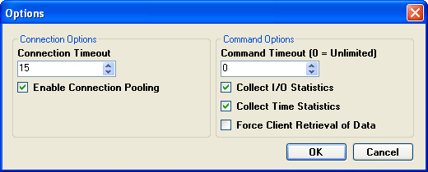
Figure 5. SQLQueryStress test options configuration
As a final note, it’s important to mention that inside of the File menu is an option to save the settings for a particular query, including database connection information and parameter settings. It can take a bit of time to set up a full SQLQueryStress test, and there is no reason to lose the work if you need to rerun the same test more than once.

