**C. Measures of default mode “resting” brain activity using MEG**

* Default mode resting state brain activity was measured using MEG during a passive visual fixation task.
* Neuromagnetic signals from MEG were mapped onto the cortical surface and portioned into approximately 450 regions of interest (ROI).
* The time variant power of rhythmic brain activity in ROIs was used to compute the data covariance amongst cortical regions under consideration.
* The computed ROI data covariance matrices were used to calculate Graph theoretical metrics to characterize the organization of different brain networks.

**Resting State Brain Activity**

Default mode “resting” brain activity refers to the ongoing intrinsic or spontaneous neural activity in the absence of overt task demands. Initially described using functional neuroimaging technologies, resting state activity has been linked to the large-scale functional organization of the brain. Resting state activity is characterized by sustained correlated spontaneous neural activity amongst groups of brain structures that show a reduction in ongoing activity levels during task-relevant behavior. This upregulated state of spontaneous neural activity is called default mode brain function, and is linked to a set of regions known as the brain’s default mode network (Raichle, 2001). The consistent spatial patterning of default mode activity amongst default mode network (DMN) structures allows researchers to map cortical connectivity, and also better understand disease states associated with brain disorders brain networks. The mapping of large-scale brain networks using default mode activity, or the study of resting-state functional connectivity, relies on characterizing the regional covariance amongst brain areas by mapping the pairwise temporal correlations in spontaneous neural activity between ROIs (Raichle, 2015).

**Magnetoencephalography**

Magnetoencephalography (MEG) characterizes electrophysiological brain activity by measuring extracranial magnetic fields associated with underlying neural activity. Analogous to radio frequencies, the neuromagnetic signal from a given brain region is dominated by periodic ongoing changes in electrical neural activity characterized by its frequency range. It is thought that these neural oscillations represent the spontaneous brain activity constituting default mode brain function. The fine temporal resolution of MEG offers many ways to characterize functional connectivity amongst brain regions based on the recorded oscillatory signals from the underlying neurons. Here we use one of the most robust methods, known as amplitude envelope correlation (AEC), which describes the temporal relationship between the amplitude neural oscillations in a particular frequency range arising from spatially distinct regions. Previous work has shown that AEC supports many of the observable resting state networks (RSNs) demonstrated by functional neuroimaging technology (Hipp, 2012).

**Graph theoretical connectivity metrics**

Graph theory originated with the mathematical solution by Euler to a navigational problem posed in the early 18th century. As such, the methods employed in this solution formed the basis for graph theory and a branch of science known as network science. Network science is a rigorous approach to studying the relationships between connected objects. By convention, a network is defined by a set of relational objects, or nodes, and connecting lines or edges as representation of relationships amongst nodes, see figure 1. In the context of functional brain connectivity, a node represents a cortical region of interest (ROI) and edges can represent one of many Graph theoretical metrics used to describe the structural organization of a given network. Thus, Graph theoretical metrics are used to understand systems not just in terms of connections between different parts, but also in terms of how connectivity is scaled-up throughout.

**Figure 1**

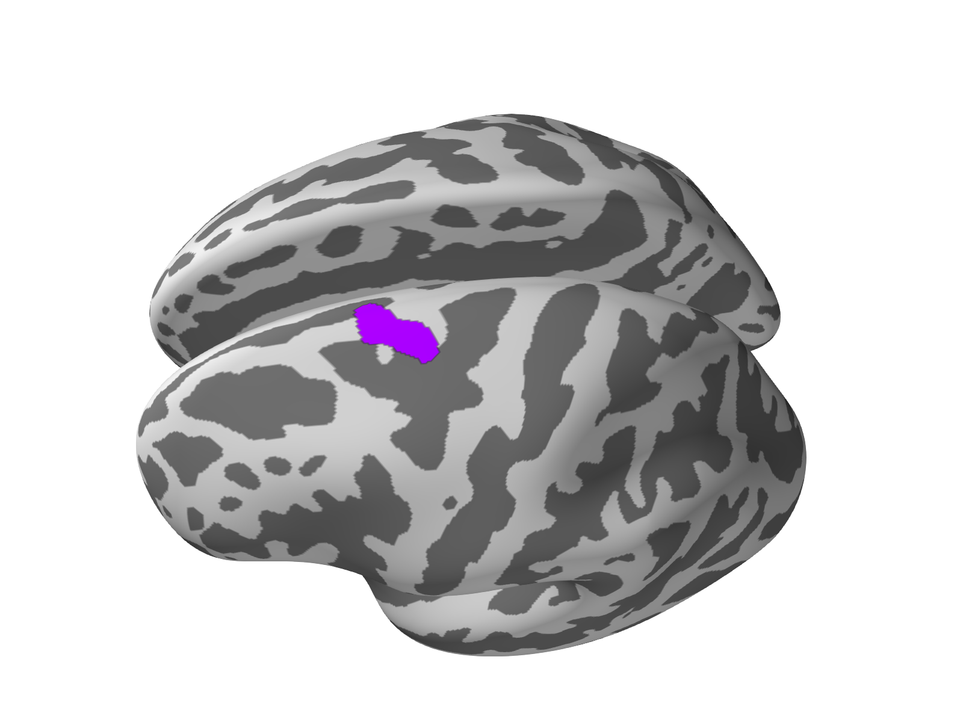

C

B

E

A

D

Networks are visualized by representing each node as a dot or circle and a connecting line or edge between nodes that share a relationship, e.g. on the left, a network with 5 nodes and arbitrary configuration of edges or connections is represented. The right panel illustrates the location of a cortical ROI exhibiting strong age dependent node clustering metric (c.f. Figure 3) across the 5 years of adolescent age range under consideration. This dorsal frontal region shows a reduction in local clustering with age, meaning that there is an overall attenuation of edges or connections amongst its neighboring regions that are connected to it.

In combination with MEG recordings of default mode “resting” brain activity we use Graph theoretical metrics to describe the organization of brain networks and characterize changes in network connectivity throughout adolescent development.

**Methods**

Briefly, 5 minutes of continuous “resting” state brain activity was recorded using a whole-head array MEG system. Participants were instructed to fixate on a visual cross-hair on a monitor and to remain still and day dream. The recorded neuromagnetic signals from the brain were low-pass filtered using a 333 Hz filter and sampled at 1000 Hz. The resulting data were processed offline using spatial filter denoising to remove contaminating environmental and instrument artifact signals and compensated for subjects’ head movements during the recording. Also, dimensionality reduction techniques were used to remove physiological artifacts like heartbeats, eye blinks and movements. To compute narrowband AEC for each participant the processed MEG data was bandpass filtered and Hilbert transformed to yield the time course of the signal amplitude for a given discrete frequency range. Next, using the subjects specific brain anatomy derived from the accompanying structural MRI data the spatiotemporal distribution of neural signal power underlying AEC measurements was mapped to the cortical surface using regularized minimum norm estimation technique.

**Preliminary Findings**

On the basis of AEC data covariance several Graph theoretical metrics were computed to characterize the network properties in the adolescent brain. For example, figure 2 shows the spatial distribution of the varying degree of connectivity between cortical ROIs amongst 9- and 17-years old participants for brain activity in the 30-50Hz (gamma) frequency range. The degree is a measure of a nodes centrality in a given network and is simply defined as the number of neighbors it has.

**Figure 2**

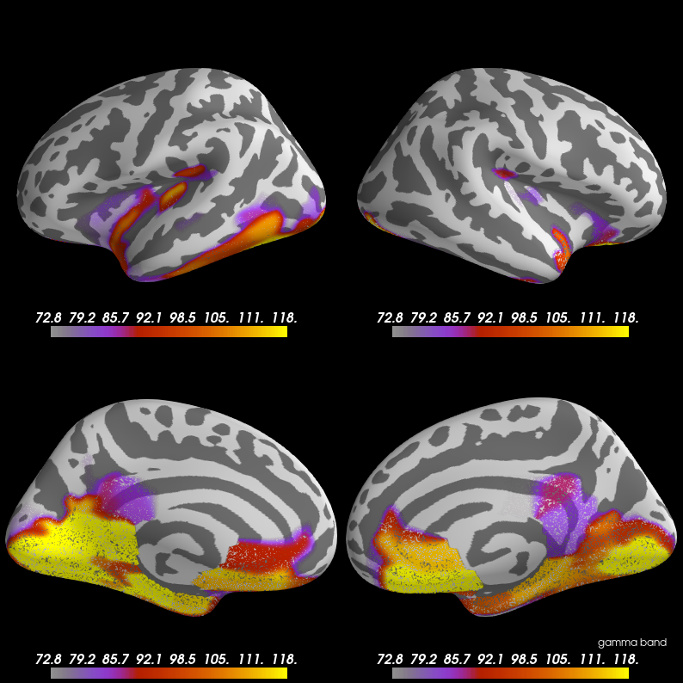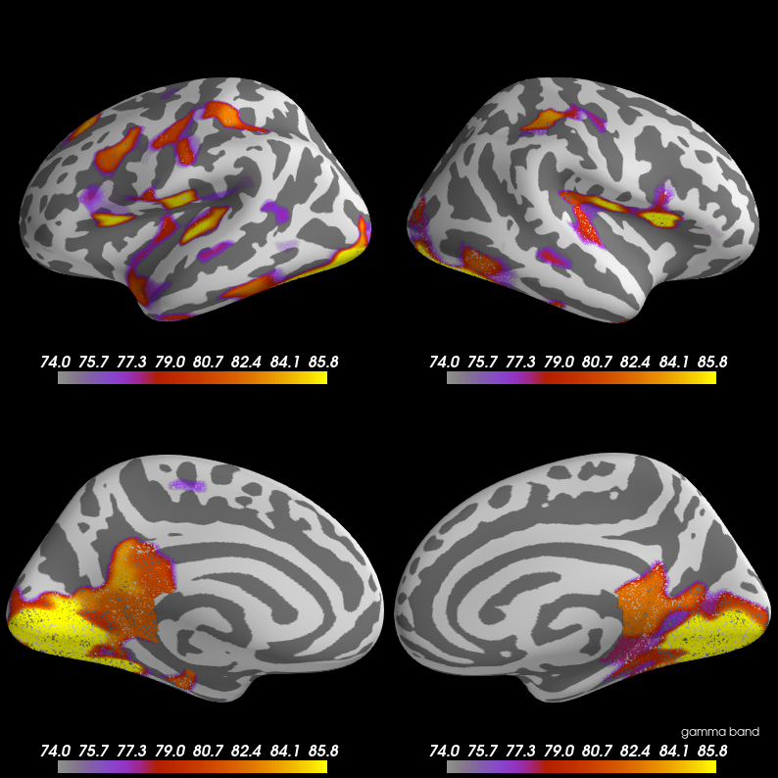

**Distributions of node centrality degree Graph theoretical metric computed for “resting” brain activity power in gamma (30-50Hz) frequency range.** Lateral and medial views of both hemispheres of the brain are shown. The density or degree of connectivity metric is mapped along the cortical surface, averaged across participants at 9- (left panel) and 17-years of age. Note the remarkable difference between degree value maxima across the two ages, as well as the absence of nodes in frontal and parietal cortices at 9 years.

A complementary measure of a node’s centrality is ﻿local clustering, which quantifies the interconnectedness amongst its neighboring nodes. Figure 3 shows a robust and strong (Spearman’s rank-rho -0.43) negative relationship between age and local clustering for an ROI in dorsal prefrontal frontal cortex in the left hemisphere (c.f. figure 1) for activity in the gamma range. Node centrality measures like degree and local clustering can be used to describe the local, or small-scale structural organization within a network. This is useful information for the identification of ﻿influential nodes, bottlenecks in information trafficking, and convenient regions for assembling information or resources in a given network. Taken together, the data for degree of connectivity and observation of prefrontal node clustering indicate that for a given range of signal power (30-50Hz) localized changes in functional organization are taking place between 9- and 17-years of age. Of note, the superior frontal gyrus extending the dorsal medial surface of the frontal lobe is known to be a functional hub, as well as a constituent part of the dorsal medial subsystem of the DMN (Andrews-Hanna, 2014). Amongst other behaviors the dorsal prefrontal cortex is involved in self-regulatory behavior and social cognition.

**Figure 3**

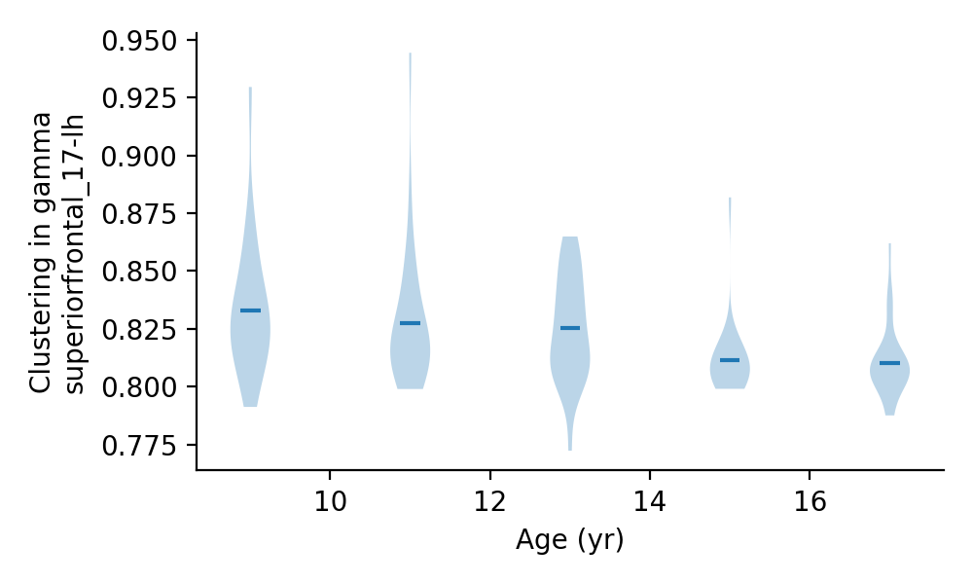

**Correlation between the local clustering coefficient for prefrontal node and age.** Of the 500 cortical ROIs under consideration the most robust correlational finding occurred in a dorsal frontal lobe structure in the left hemisphere for “resting” activity in the gamma (30-50Hz) frequency range.