Abstract

Over the past decade, a host of longitudinal neuroimaging studies in children with autism spectrum disorders (ASD) have been carried out by a national network of biomedical research institutions under NIH coordination. These efforts have yielded valuable diagnostic tools or biomarkers for underlying pathology commonly associated with ASD in the clinic. Neuronal biomarkers for developmental psychiatric disorders offer an invaluable tool for early detection, leading to better symptom management and better behavioral outcomes in almost every individual case. Here we describe results from a follow-up multimodal neuroimaging study in adolescents with an early childhood ASD diagnosis. Combining magnetoencephalography (MEG) recordings of auditory lexical processing with single-voxel magnetic resonance spectroscopic imaging (MRSI), we show a disassociation in lexical discrimination between ASD and age-gender matched typically developing (TD) peers. First, as expected, magnetic source imaging data revealed word-enhanced, left-lateralized cortical activity in distributed temporal-frontal language networks.

In contrast to their TD peers, young adults with ASD presented markedly longer evoked response peak-latency times following word stimuli in the left superior temporal gyrus (STG). ASD participants showed faster and stronger cortical activity following unintelligible noise stimuli in homolog right-hemispheric STG networks. This asymmetry in lexical decision electrophysiology in ASD was accompanied by more significant excitatory-inhibitory neurotransmitter concentrations in the right Perisylvian STG. The findings corroborate the theoretical model of cortical excitatory-inhibitory (E/I) imbalance in ASD.

Highlights

* Cortical excitatory-inhibitory (E/I) neurotransmission homeostasis is associated with auditory lexical processing.
* Slower eloquent cortex evoked response timing in ASD following lexical stimuli.
* An enhanced right-hemispheric E/I ratio linked to asymmetric cortical excitability during lexical decision in ASD.

Introduction

According to the most recent CDC figures, autism spectrum disorders (ASD) is an increasing neurodevelopmental disorder with neuropathology and associated behavioral presenting in early infancy[1]. Specifically, language impairments (LI) associated with ASD present with high variability and involve receptive and expressive language functions (Rapin and Dunn 2003). Language abilities in ASD are highly variable, with difﬁculties ranging from mild to severe impairments in pragmatics and social communication (Tager-Flusberg and Joseph 2003). A subset of ASD individuals has language problems characteristic of those observed in developmental language impairment (LI) disorders. Higher-order LI disorders in language processing are thought to affect processing at or above the level of lexical-word representations, either through severe word-finding or comprehension deficits. MEG evidence suggests that deﬁcits in discriminating rapid changes in sound at the cortical level are associated with impaired speech processing in children suffering from developmental language disorders, including ASD (3–10). Prior studies have identified many evoked-response components that correspond to different components in speech comprehension, including phonemic processing [1, 2], prelexical facilitation of access [3,4], and semantic cognition [5–7] of the speech comprehension processing. Given that lexical decision recruits broadly distributed neural systems in temporal-parietal and temporal-frontal networks along the Sylvian fissures, we expected to see delayed or more prolonged Here, we combine auditory lexical decision with magnetoencephalography (MEG) to describe the spatiotemporal patterning of neural activity in the brain for adult populations, including individuals with an early childhood diagnosis of ASD that have been highly characterized by behavioral and longitudinal MRI/MRSI studies (Webb et al. 2009; Sparks et al. 2002; Munson et al. 2008; 2006; Kleinhans et al. 2012; Kim et al. 2010; Estes et al. 2011; S. R. Dager et al. 2007; Corrigan et al. 2012; 2013; Brown et al. 2013a; Boger-Megiddo et al. 2006).

Theoretical models and experimental data support the idea that an imbalance in excitatory-inhibitory (E/I) homeostasis disrupts the functional organization in the cortex and results in aberrant excitability or unstable responsiveness to input with reduced modulatory output (Yizhar et al. 2011; Rubenstein and Merzenich 2003; Uhlhaas and Singer 2012; 2006; Casanova, Buxhoeveden, and Gomez 2003; DiCicco-Bloom et al. 2006; Polleux and Lauder 2004). In their ‘noisy’ autistic brain model, Rubenstein and Merzenich (2003) posit that behavioral deficits in autism may be caused by an imbalance between excitatory and inhibitory neurotransmission due to increased glutamatergic (excitatory) signaling or to a reduction in inhibition due to diminished GABAergic signaling (Rubenstein and Merzenich 2003). Several lines of evidence support the excitation-inhibition imbalance hypothesis; autism has been associated with pathology in GABA receptors (Fatemi, Folsom, et al. 2009; Fatemi, Reutiman, et al. 2009), mutations in genes encoding for GABA-A receptors (DiCicco-Bloom et al. 2006), reduced spontaneous GABAergic neurotransmission in a mouse model of idiopathic autism (Polleux and Lauder 2004), and regional reductions in glutamate (Han et al. 2014) and GABA (Brown et al. 2013a) concentrations in the auditory cortex. MRSI Spectral editing methods allow researchers to interrogate regional concentrations of chemical compounds, including neurotransmitters such as glutamine/glutamate (Glx) or γ-Aminobutyric acid (GABA) (Stephen R. Dager et al. n.d.; Posse et al. 2013). Tissue localization of these compounds has revealed that glutamate and GABA are densely concentrated in the synaptic vesicles of pyramidal and different types of interneurons, e.g., Martinotii and Basket cells (Prescot et al. 2012; Puts and Edden 2012) in the cortex. A growing number of MRS studies have linked ASD with altered concentrations of Glx and GABA. For example, clinical studies have shown that in comparison to peers with developmental delays (DD) and typical development (TD), three-year-old children with ASD (ASD + PDD – NOS) show differences in regional concentrations of chemicals, including glutamate-complex (Glx) in cortical as well as grey-white matter differences (Friedman et al. 2006). In children with ASD, auditory and motor regions showed diminished GABA concentrations (Brown et al. 2013b). Together these findings suggest that critical elements in the cortical architecture for regulating cortical excitability are involved in the pathophysiology of autism. Therefore, studies relating electrophysiological measurement of cortical activity to excitatory or inhibitory neurotransmitters may elucidate disease processes in autism and provide implications for treatment and strategies for early identification.

Results

A total of 37 adolescents participated in the study. Seventeen participants were diagnosed with autism spectrum disorder (ASD) at an early age. ASD subjects are considered high functioning by full-scale IQ scores (>80 WASII-FSIQ4); on average, participants were 22.2 years old, and the cohort consisted of three females. ASD subjects were sex- and age-matched by peers typically developing (TD). All participants underwent an auditory lexical decision task electrophysiological MEG measurement of brain activity. All participants also underwent magnetic resonance imaging to evaluate concentrations of excitatory glutamate and inhibitory GABA neurotransmitter physiology in the bilateral perisylvian cortex using single-voxel magnetic spectroscopic imaging (MRSI).

MRSI measurements of neurotransmitter concentrations revealed a modest significant difference between the ratio of glutamate to GABA between TD (8.4±1.2; M±SD) and ASD (9.7± 2.3) subjects in the right hemisphere (*p* < .05). E/I ratio between Glu: GABA single voxel concentrations were significantly more prominent in the right (9.7± 2.3) as compared to the left (8.1±1.2) hemisphere in the ASD cohort (*p* < .05). Amongst TD subjects, the E/I did not differ significantly between the hemispheres.

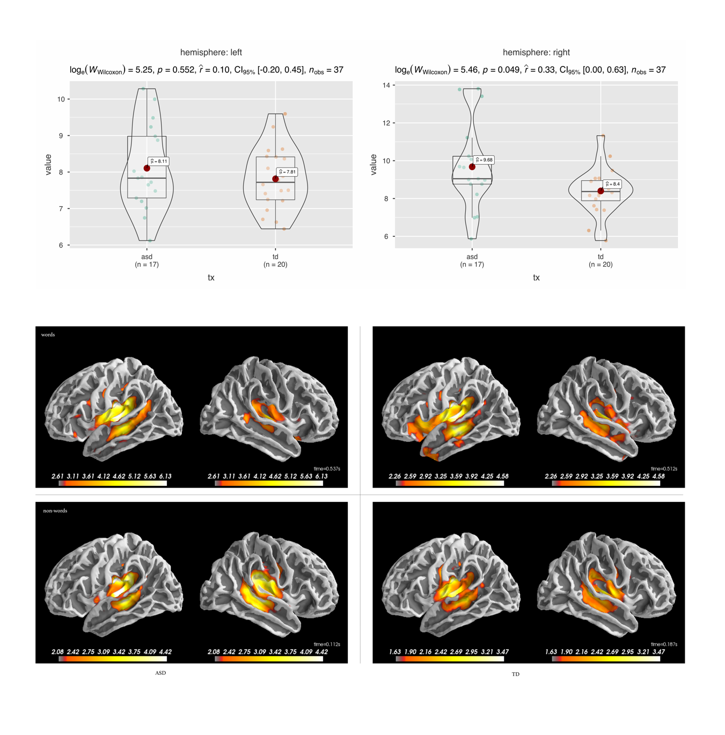Materials & methods

**Figure X. Multimodal neuroimaging of lexical decision task in high-functioning adolescents with ASD and matched typically developing peers: (a)** Single voxel MRS was used to measure glutamate (PRESS pulse sequence with TE=30) and GABA (MEGA-PRESS pulse sequence with TE=80 and macromolecule suppression) bilaterally in voxels containing superior temporal gyrus and insular cortex bilaterally along the perisylvian fissures. Chemical measurements were referenced to water and corrected for partial volume effects.

**(b)** Spatiotemporal patterning of peak auditory evoked cortical activity during lexical decision task revealed by source imaging data from electrophysiological magnetoencephalography (MEG) recordings. As expected, MEG revealed left-lateralized word enhanced neural activity in eloquent cortical regions in superior temporal gyrus (STG) and dorsolateral prefrontal cortex in TD and to a lesser extent ASD individuals. Notably, the peak latency times for auditory evoked responses (ER) to words stimuli were markedly delayed, or slower, in ASD (537ms) as compared to TD (512ms) participants. Furthermore, in contrast to TD peers, adolescents with ASD presented with significantly stronger ER following non-word, or psycho-acoustic foil, stimuli. Thus, electrophysiological MEG revealed a dissociation between lexical discrimination and treatment group, such that slower neural responses to words was accompanied by enhanced evoked auditory brain activity in response to non-word/nonsense signals.

Lexical Decision

Spoken word tokens were edited from digitized (44.1 kHz) recordings of a native English female speaker. The resulting sound wave files averaged 504 ± 56 ms (M±SD), including a 50 ms Gaussian fade-out ramp. Audio files were low-pass filtered (12 kHz) and normalized for peak root mean square amplitude to ensure equal loudness across stimulus tokens. Each word stimulus was temporally vocoded [REF] by 1 kHz band-passed white noise to control complex acoustic confounds. Control stimuli were distinctly word-like in prosody but unintelligible. Word and non-word stimuli were randomly arranged for each participant and presented binaurally using a 2.1 ± 0.2 s inter-stimulus interval.

MEG

MRSI

Discussion

The data for single-voxel MRSI in ASD revealed a significant increase in excitatory-inhibitory cortical imbalance lateralized to right-hemisphere in classical Wernicke’s or temporal-parietal cortex, including multimodal angular-gyrus and auditory structures along the superior temporal gyrus (STG) just shy of the temporal poles (c.f.). As expected, source imaging results from concomitant electrophysiological MEG recordings during an auditory lexical decision task revealed a significant delay in peak activity to lexical or word stimuli in left STG in ASD participants. The observed delay in peak cortical excitability following lexical items in ASD was on average 1.5 longer than the previously reported duration for temporal integration in the auditory cortex in TD adults (Roberts). Furthermore, the 75ms delay in peak activity to words corroborates previous MEG results of delayed rapid-temporal auditory processing in ASD linked to downstream higher-order or semantic level linguistic processing (Roberts).

Lateralization as a corollary for neural resilience

It is now well understood that early detection before the appearance of clinical symptoms is crucial to effective clinical outcomes and symptom management from targeted therapy in ASD. Convergent neuroimaging results from longitudinal MRI studies have identified robust biomarkers helpful in the early detection of ASD. MRI technology used in infants as young as 6-months to 5-years of age has revealed cortical surface area and volumetric overgrowth (Hazlett, 2017); increased cerebral, amygdala (Nordahl, 2012) and cerebellum (Pote, 2019) volumes; and increased cortical gray and white matter (Schumann 2010). ASD has also been characterized as a disconnection syndrome using diffusion-weighted MRI to describe aberrant white matter connectivity during early childhood development. Conti et al. (2017) used white matter tractography to describe the pattern of over-connectivity in networks involving the frontotemporal nodes and basal ganglia.

1. [CDC Report States That Prevalence Rate Increase, with 1 in 54 Children Diagnosed with Autism Spectrum Disorder.](https://www.autism-society.org/releases/cdc-releases-new-prevalence-rates-of-people-with-autism-spectrum-disorder/)