How to add, remove, and change the system settings
Manage General Settings Snapshot
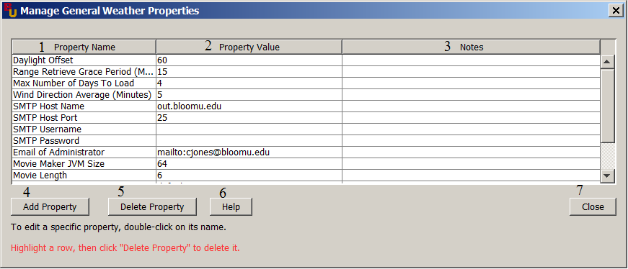
1 → Property Name: This displays the name of the property
2 → Property Value: This displays the value of the property
3 → Notes: This will display the notes, if any, of the property. You will be able to set and delete notes.
4 → Add Property: This button allows you to create a new property to properties you are currently under. In this instance we are under the General Weather properties.
5 → Delete Property: This button will delete any property that is selected.
6 → Help: This button will bring up the help file document.
7 → Close: This button will close the current window.

Adding a new property.
Add Property Window Snapshot
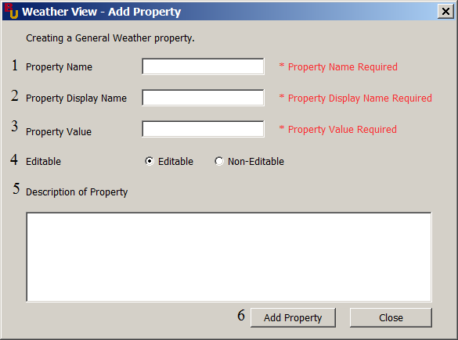
1 → Property Name: The name of the property you are creating. Example: daylightOffset
2 → Property Display Name: The display name that you will see in the manager window after creating the property. Example: Daylight Offset
3 → Property Value: The value of the property you are creating.
4 → Editable: If the value is editable than an administrator will be able to double click on a value in the manage window screen and update the value if needed. If it is not editable, when an administrator wants to edit it than the administrator will need to type in there username and password again when they try to edit.
5 →Description of Property: This is used to add any description or notes about the property if needed.
6 → Add Property: This button will add the new property to the database.

Editing an existing property
Edit Property Window Snapshot
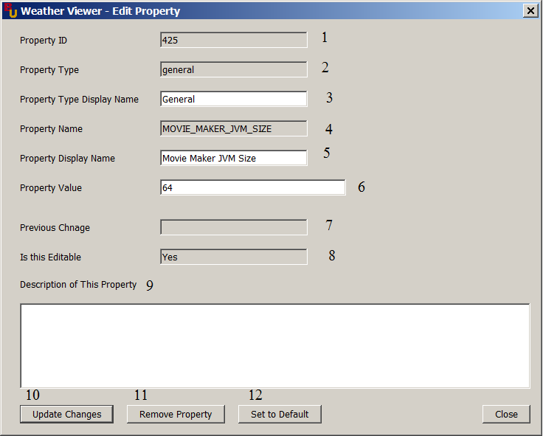
1 → Property ID: This is the ID of the property you are currently editing.
2 → Property Type: This is the type of property you are currently editing. This will change depending on the manager window you are currently on.
3 → Property Type Display Name: The display name for the property type.
4 → Property Name: The name of the property you are currently editing.
5 → Property Display Name: The display name of the current property you are editing.
6 → Property Value: The value of the property you are currently editing.
7 → Previous Change: This value will be filled in if you ever changed the value of the current property. The previous change will be the last value the property had.
8 → Is This Editable: If it is editable than you will be able to edit the property fields. If it isn’t you will have to type in your username and password to authenticate you are an administrator to be able to edit the properties.
9 → Description of Property: This is used to add any description or notes about the property if needed.
10 → Update Changes: This will update the property with any changes you have made.
11 → Remove Property: This will remove the current property you are editing.
12 → Set to Default: This will set all the values of the property back to the default values.

