Open the drawing provided

Do the following:

1. Copy component A and place it at B.
2. Delete component C.
3. Move component D to E.
4. Add wire between F and G.
5. Trim the wire between F and H.
6. Scoot component J to the right.
7. Align Relay NO A, B, and K
8. Add a rung to the end of the ladder
9. Create the following symbol for Horn/Strobe (see Figure 1). Use dimensions for scaling only.

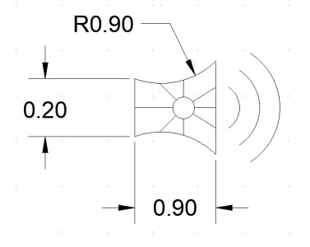Figure 1 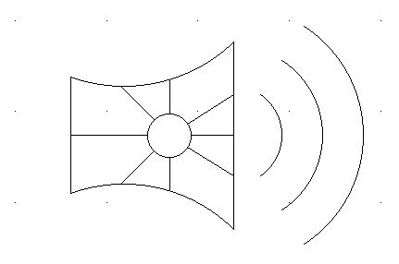

1. Add the following attributes (See Figure 2)

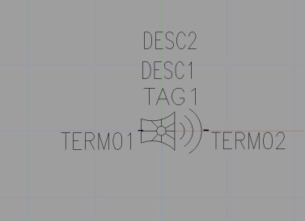 Figure 2

1. Insert the Horn at L
2. Insert the following attributes for

TAG 1 = H1

DESC1 = HORN

1. Save the drawing and upload to Brightspace.

EXTRA CREDIT:

Create the following 3D object

Create a new drawing named: Last name, first name Extra Credit.