**Display Data**

1. This type of error happens when the sql driver is missing or wrongly spelled.

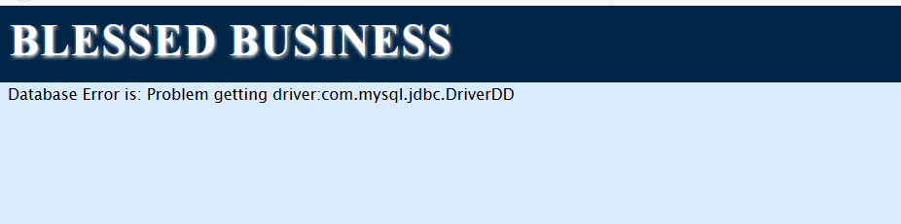

1. This type of error happens when using wrong database. It should fix by using the require database with correct spelling.

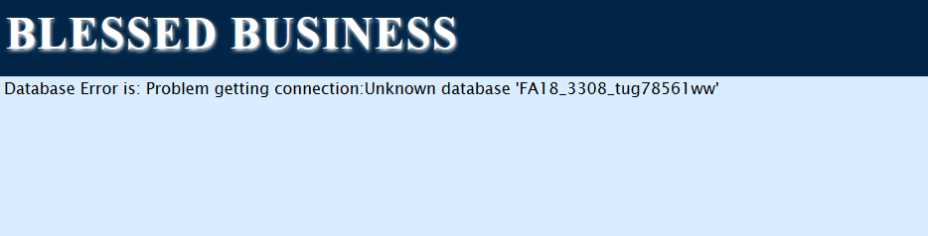

1. Database Error is: Problem getting connection:Access denied for user 'tug785612'@'cis-linux2-priv.temple.edu' (using password: YES)
2. Syntax error should be fixed by writing correct sql query.

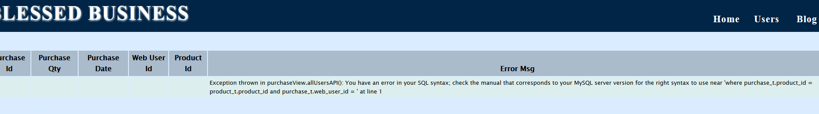

1. The error should be fixed by checking and writing correctly the column name

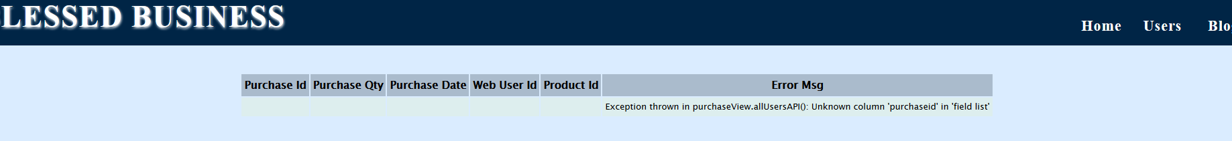

1. The error should be fixed by applying the correct data format in StringData.java class

