**Homework 2**

1. Kouassi Tchokoto
2. Functionality

In my website, user will be able to register, logon and logoff, edit, delete records.

1. **Marketing Material**

The application is dedicated to show case traditional African clothing and others traditional items. Are you curious to know about Africa and it culture? This website is specially design for you. Feel free to go through our products with their descriptions. Each product describes a tribe or even a country. The application promotes those traditional items exposing the beauty of African culture. Welcome to the mother land.

1. **Data Model**

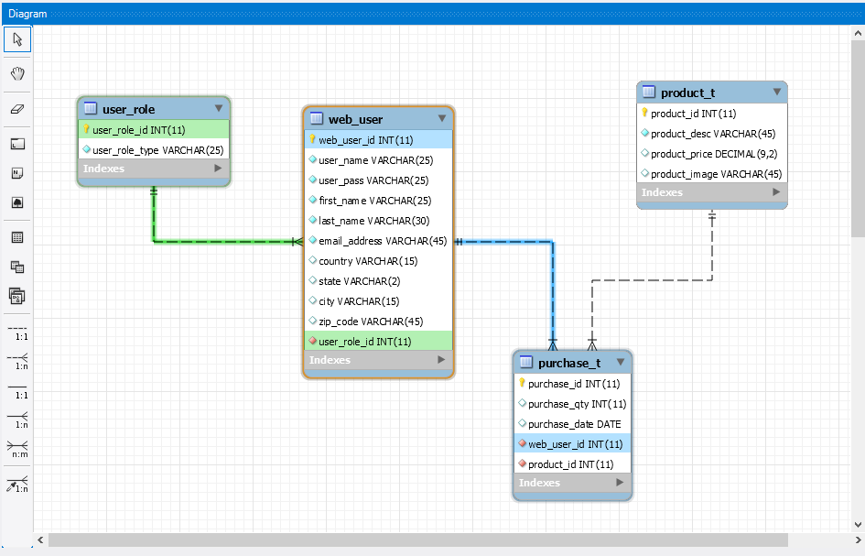

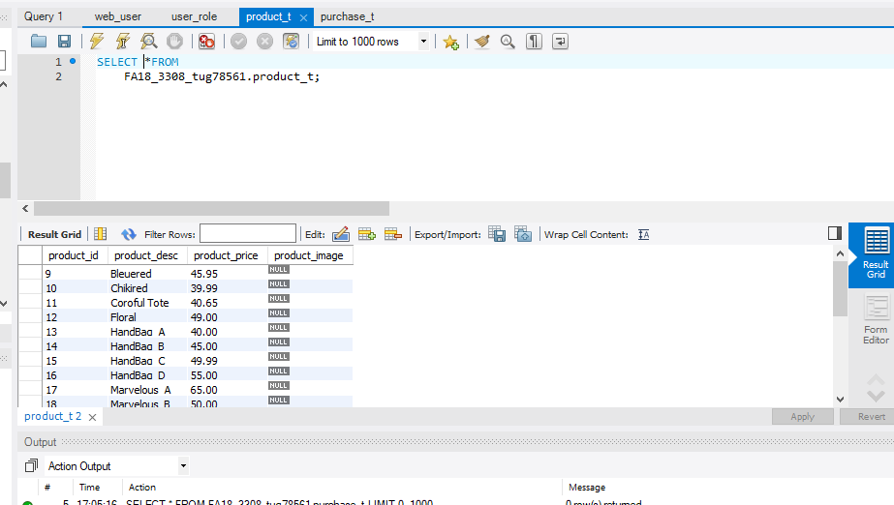

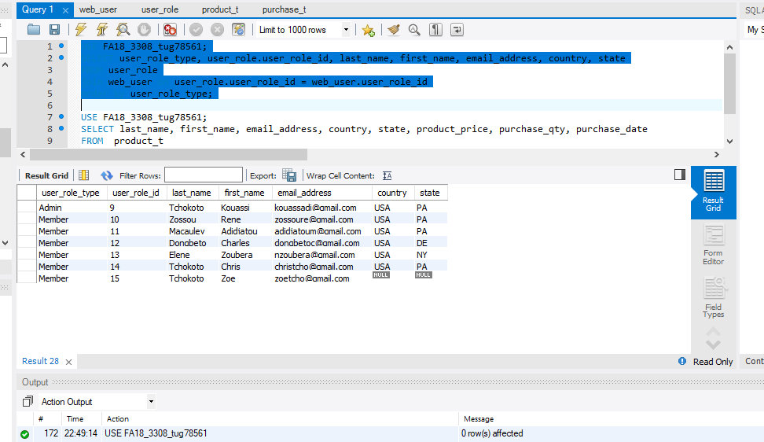

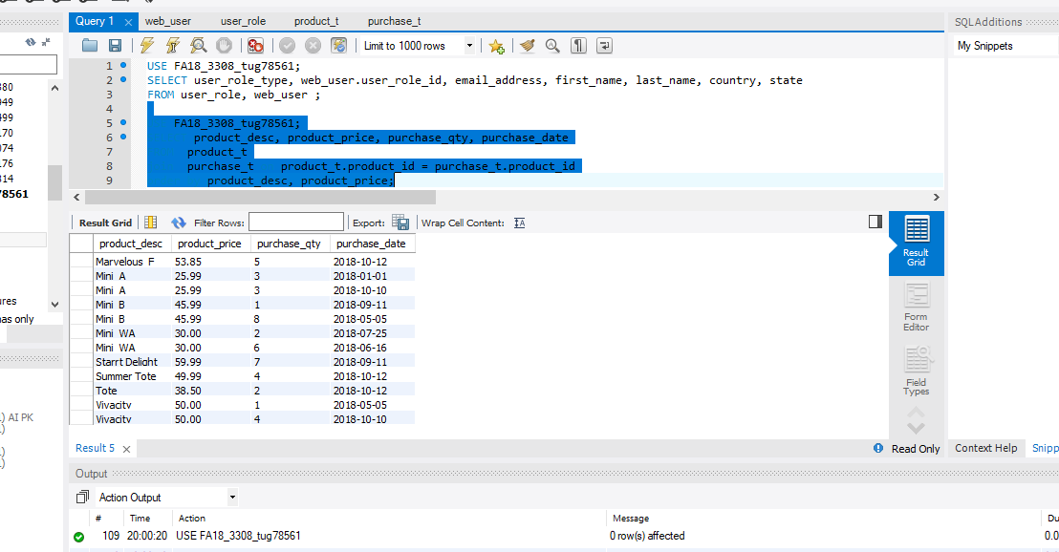

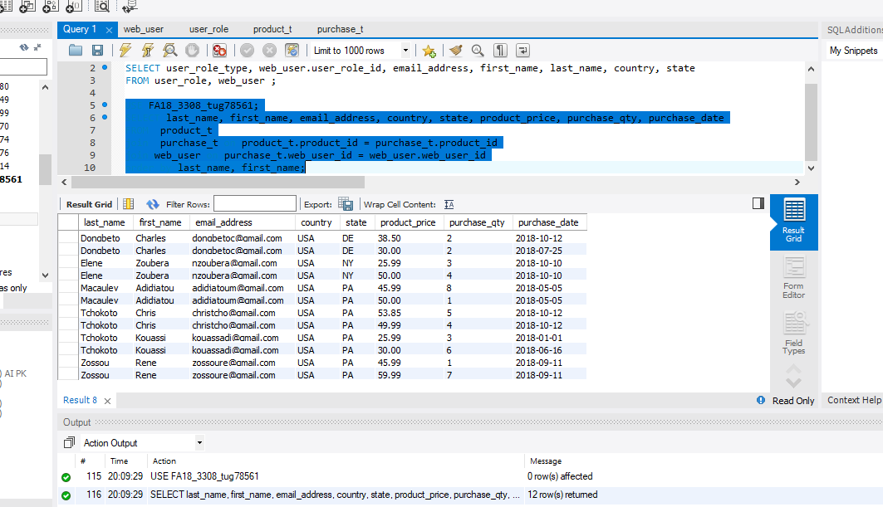

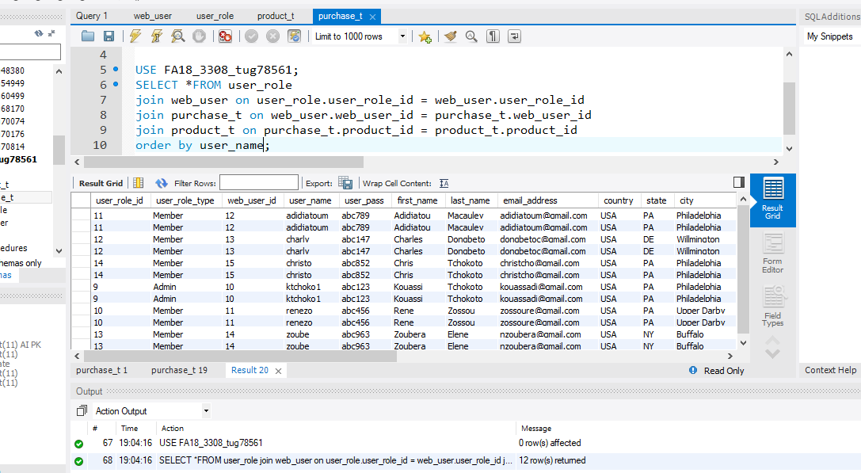

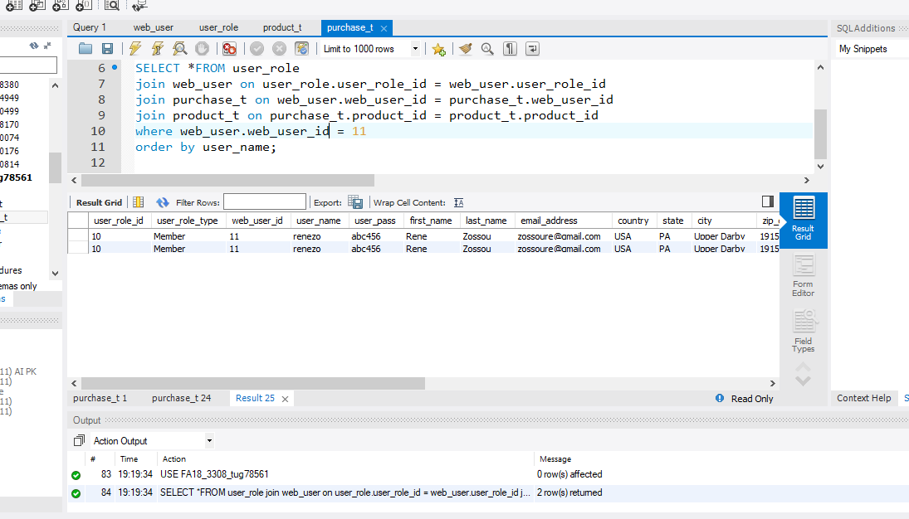

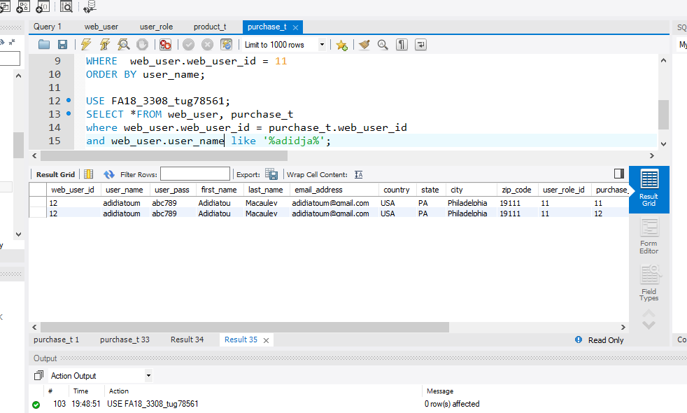

1. **Table Design**

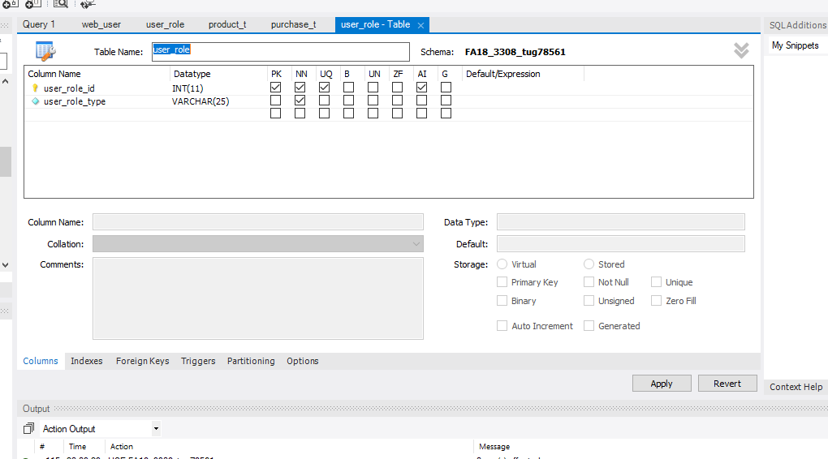

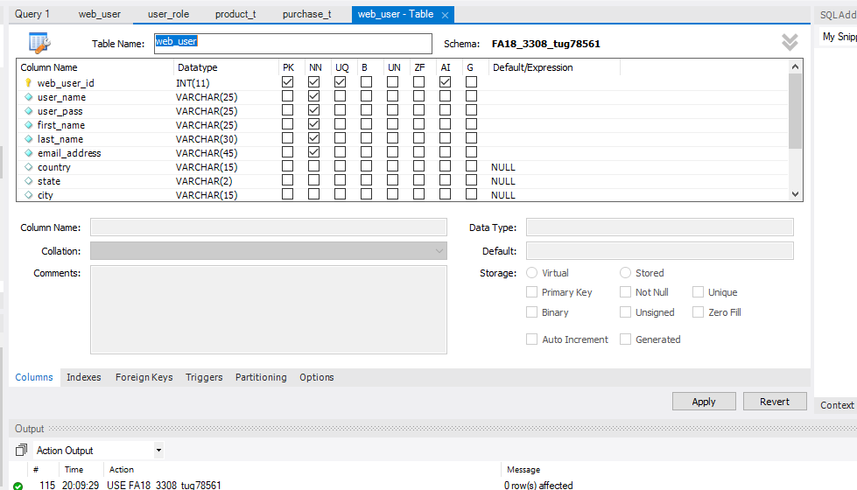

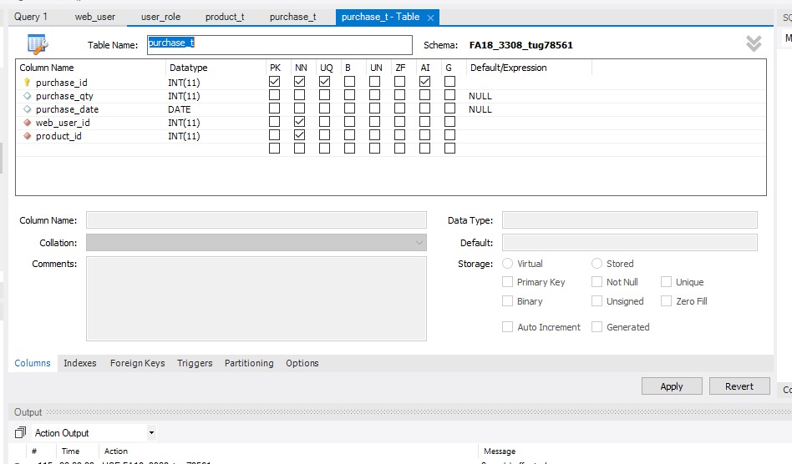

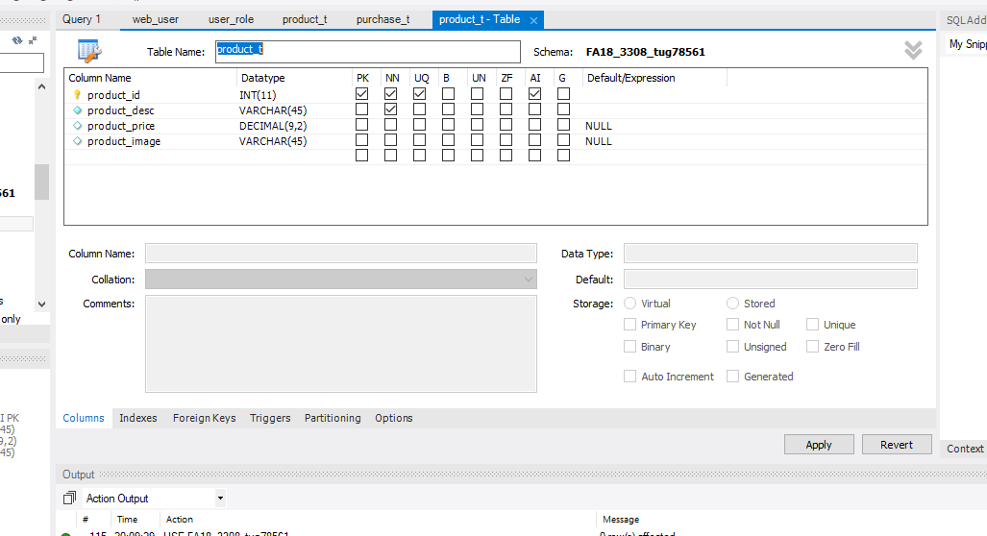

1. **Feedback from Classmates**

Daniel Dubovoy’s Review:

Overall, this is an excellent proposal with all the requirements met. The PKs, FKs, Not Null and Nullable checklist is satisfied, and there are no SQL keywords that will interfere with the data model presented. The presented relationships are unique to Kouassi’s project and are different and exciting, and I am looking forward to seeing Kouassi develop this into a working web application. All the data model requirements are met, and I approve of his data model.

Hazrat Rafiqzadah

I think your data model is excellent, from looking at the association and relationship diagram, I can tell that the “Other” table would be table “product_t” and the association table would be “purchase_t.” Much like my data flow, which you confirmed, your data flow seems to be correct. As for the naming of the elements of my tables, I will be changing that before the start of class Thursday and I would appreciate your help in this matter, thank you for offering.

1. **My Feedback**

Daniel Dubovoy:

Based on the data model, I think the will not be any conflict between the tables. “other” table stores information about the food and the users (vendor) so describing one to many relationships. All the relationships between the four tables are well define.

Hazrat Rafiqzadah I have revised your data model and I thing you should follow the guide, specially keeping the same name for the  user_role and the web_user table. I am going to revised that with you tomorrow before class starting. Your primary and foreign keys seem confusing, but your data flow is correct. Thanks, I add my data model for your feedback.

1. **Select Statement**
2. SELECT *FROM product_t

order by product_id;

1. SELECT user_role_type, user_role.user_role_id, last_name, first_name, email_address, country, stateFROM user_role

join web_user on user_role.user_role_id = web_user.user_role_id

order by user_role_type;

1. SELECT product_desc, product_price, purchase_qty

FROM product_t, purchase_t

where product_t.product_id = purchase_t.product_id

order by product_desc, product_price;

1. SELECT last_name, first_name, email_address, country, state, product_price, purchase_qty, purchase_date

FROM product_t join purchase_t on product_t.product_id = purchase_t.product_id

join web_user on purchase_t.web_user_id = web_user.web_user_id

order by last_name, first_name;

1. SELECT * FROM user_role

JOIN web_user ON user_role.user_role_id = web_user.user_role_id

JOIN purchase_t ON web_user.web_user_id = purchase_t.web_user_id

JOIN product_t ON purchase_t.product_id = product_t.product_id

1. SELECT * FROM user_role

JOIN web_user ON user_role.user_role_id = web_user.user_role_id

JOIN purchase_t ON web_user.web_user_id = purchase_t.web_user_id

JOIN product_t ON purchase_t.product_id = product_t.product_id

WHERE web_user.web_user_id = 11

1. SELECT *FROM web_user, purchase_t

where web_user.web_user_id = purchase_t.web_user_id

and web_user.user_name like '%adidja%';