Risk Model for ILP algo

There are 2 sets of securities :
• outright set (size M) e.g. 7 near/far futures M=14
• tradable set (size N≥M) which include outright set e.g. 7 near/far futures 7 spread M=21

Part 1. Functor FCovar
The risk model of ILP also starts with finding the covariance matrix of daily return among 14 outrights, which include 7 EGB near futures plus 7 EGB far futures, hence M=14, for example :

• FGBSU6 and FGBSZ6
• FGBMU6 and FGBMZ6
• FGBLU6 and FGBLZ6
• FGBXU6 and FGBXZ6
• FBTSU6 and FBTSZ6
• FBTPU6 and FBTPZ6
• FOATU6 and FOATZ6

There is a daily python job in qfilib to calculate the 14 by 14 covariance matrix from market data on each day retrospectively, which then performs PCA and extracts the 3 principal eigen vectors, corresponding eigen values and 14 residuals on diagonal of covariance. The qfilib job then saves the PCA result in KDB, which will be read by another unity process called egb_refdata, and published to stew folder. ILP algo then subscribes the stew folder for the PCA result from stew folder. Here is what it looks like in HPD. For simplicity, it shows 7 near outrights only, yet in production there are 14 outrights. The yellow box matrix is not about PCA, it is about liquidity adjusted VaR, please refer to next doc.

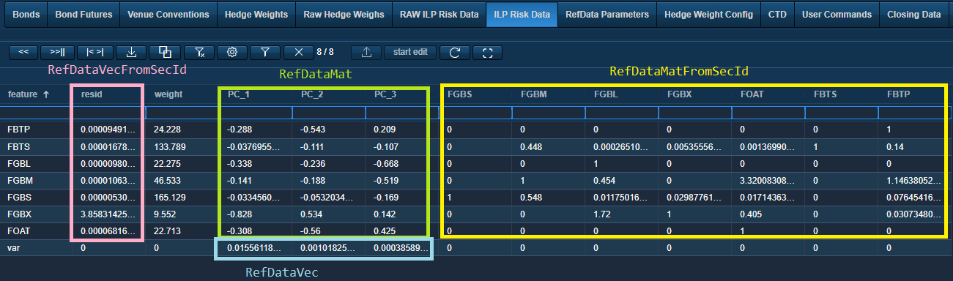

Dimension reduction with rank3-PCA is a noise-removal process by retaining major yield curve risk :

• PC1 = yield curve level shift
• PC2 = yield curve tilt
• PC3 = yield curve curvature

Residual ensures the covariance values on the diagonal are lossless after dimension reduction. ILP algo recontructs covariance matrix by functor FCovar using equation :

$Cov$ = $QΛQ^{T}+R$

where $Q$ = 14 × 3 matrix for eigen vector (green box)
$Λ$ = 3 × 3 diagonal matrix for eigen value (blue box)
$R$ = 14 × 14 diagonal matrix for residuals (red box)

ILP algo does not consider tradable set in FCovar. Offline retrospective covariance analysis is done with outright set only. Thus algos with different tradable sets, but same outright set can share the same FCovar without recalibrating its own FCovar. Numbers in yellow box are for risk adjusted VaR (see next doc).
Part 2. Functor FRisk
Risk model of ILP algo takes the following input :
• covariance of outright set (rank3-PCA approximation)
• position of outright set (all tradables are decomposed into outrights)

then calculates the following risk items :
• portfolio risk (variance)
• implied position of tradable set
• gradient of portfolio risk in outright space called bias / shading
• delta position for outright-wise risk minimization called maxRiskRed

2a. Position in tradable domain / outright domain
Let adopt the following notation :

$X_{trd}$ position of tradable set, size N
$X_{out}$ position of tradable set, decomposed into outrights, size M
$P_{trd}=\{p_{0},p_{1},…,p_{N-1}\}$ price of tradable set, size N
$P_{out}=\{p_{0}',p_{1}',…,p_{M-1}'\}$ price of outright set, size M
where $\{p_{0}',…,p_{M-1}'\}⊆\{p_{0},…,p_{N-1}\}$

We consider $X_{out}$ instead of $X_{trd}$ for risk model, because covariance matrix is calibrated overnight using outrights only, avoid including strategies like spreads or butterflies which can be different for different algos. First of all, portfolio of tradable set should have the same value as portfolio of outright set, if the outright set perfectly replicates tradable set :

$X_{trd}^{T}P_{trd}$ = $X_{out}^{T}P_{out}$

Given replication matrix S which is N by M (S is transpose of that in code), by no arbitrage pricing :

$P_{trd}$ = $SP_{out}$ no arbitrage pricing
$S_{n}$ = $[…,+1,-1,…]$ suppose nth row of S is a spread
$S_{n}$ = $[…,-1,+2,-1,…]$ suppose nth row of S is a butterfly
$S_{n}$ = $[…,+1,+1,+1,+1…]$ suppose nth row of S is a pack

from which, we can derive the relation between $X_{trd}$ and $X_{out}$ :

$X_{trd}^{T}P_{trd}$ = $X_{out}^{T}P_{out}$
→ $X_{trd}^{T}SP_{out}$ = $X_{out}^{T}P_{out}$ applied no arbitrage pricing
→ $X_{trd}^{T}S$ = $X_{out}^{T}$
→ $X_{out}$ = $S^{T}X_{trd}$

To summarise (please note that S matrix in code may be transpose of convention in here) :

$X_{trd}^{T}P_{trd}$ = $X_{out}^{T}P_{out}$ (eq1) portfolio replication
$P_{trd}$ = $SP_{out}$ (eq2) no arbitrage pricing
$X_{out}$ = $S^{T}X_{trd}$ (eq3) decompose tradable set into outright set

2b. Covariance matrix and portfolio risk

$C_{trd}$ = $Cov[P_{trd}]$
= $Cov\left[SP_{out}\right]$ since $P_{trd}=\left(SP_{out}\right)=SP_{out}$
= $SCov\left[P_{out}\right]S^{T}$
= $SC_{out}S^{T}$ (eq4) implemented in FRisk::updateCovar

$risk$ = $X_{trd}^{T}C_{trd}X_{trd}$
= $X_{trd}^{T}SC_{out}S^{T}X_{trd}$ apply eq4
= ${(S^{T}X_{trd})}^{T}C_{out}S^{T}X_{trd}$
= $X_{out}^{T}C_{out}X_{out}$ apply eq3 implemented in FRisk::updateRisk

Portfolio risk can be expressed in tradable domain or in outrights domain, both are equivalent. Eq6 is used instead of eq5, because only $C_{out}$ (not $C_{trd}$) is available in overnight calibration process. That makes calibration easier as it involves outright set only. In short, no $C_{trd}$ in KDB.

$risk$ = $X_{trd}^{T}C_{trd}X_{trd}$ (eq5)
= $X_{out}^{T}C_{out}X_{out}$ (eq6)

2c. Objective function (i.e. functor FRisk value) and derivative
The objective function is portfolio risk plus liquidity cost of all tradable securities. Liquidity cost can be different for different securities, proportional to position size regardless of sign of position, i.e. the same liquidity cost for long or short position of the same amount. It is transaction cost plus spread the desk needs to pay to offset a position.

$f(X_{trd})$ = $risk+2\sum_{n}{{lq}_{n}\left|x_{trd,n}\right|}$
= $X_{trd}^{T}C_{trd}X_{trd}+2\sum_{n}{{lq}_{n}\left|x_{trd,n}\right|}$
= $X_{trd}^{T}C_{trd}X_{trd}+2{lq}^{T}\left|X_{trd}\right|$ where lq is column vector with size N
= $X_{out}^{T}C_{out}X_{out}+2{lq}^{T}\left|X_{trd}\right|$ where || is elementwise absolute

Functor FRisk also calculates gradient of $J(X_{trd})$, we take derivatives with respect to $X_{trd}$, instead of $X_{out}$, because we are going to hedge with tradable sets, not with trading outrights.

$\frac{1}{2} \frac{df(X_{trd})}{dX_{trd}}$ = $\frac{1}{2}\frac{d}{dX_{trd}}(X_{out}^{T}C_{out}X_{out})+\frac{d}{dX_{trd}}{lq}^{T}\left|X_{trd}\right|$
= $\frac{1}{2}\frac{d}{dX_{trd}}(X_{trd}^{T}SC_{out}S^{T}X_{trd})+\frac{d}{dX_{trd}}{lq}^{T}\left|X_{trd}\right|$ apply eq3
= $SC_{out}S^{T}X_{trd}+\sum_{n}{{lq}_{n}μ_{n}}$
= $SC_{out}X_{out}+\sum_{n}{{lq}_{n}μ_{n}}$ apply eq3 again

where $μ_{n}$ = $\left[\begin{matrix}+1 & if & x_{n}>0 \\ -1 & if & x_{n}<0 \\ 0 & if & x_{n}=0\end{matrix}\right.$

In ffwk code, we define :

FRisk::value() = $f(X_{trd})$ = $X_{out}^{T}C_{out}X_{out}+2{lq}^{T}\left|X_{trd}\right|$
FRisk::m_bias = $\frac{1}{2} \frac{df(X_{trd})}{dX_{trd}}$ = $SC_{out}X_{out}+\sum_{n}{{lq}_{n}μ_{n}}$

2d. Marginal risk reduction (per security risk reduction)
If we hedge by ${∆X}_{trd}$, objective function becomes $J(X_{trd}+∆X_{trd})$, the minimum is trivial, perfect hedge can give minimum with zero objective function (also zero liquidation cost) :

$\min_{∆X_{trd}}{f(X_{trd}+∆X_{trd})}$ = $f(0)$ when $∆X_{trd}=-X_{trd}$
= $0$

Yet, a perfect hedge for all tradables simultaneously is impossible in practice. We cannot synchronize the hedges for all securities, as it assumes infinity market liquidity and zero trading latency. In practice, we have to do marginal variance reduction iteratively by trading security one at each time. Consider the case with 2 correlated securities having position $X_{trd}=[-2,-1]$, the ideal hedge will be buy 2 and buy 1 shares respectively, which is not achievable, hence we need to do it iteratively. In each step, we do not completely offset the position of a security, because a smaller portfolio varaince can be achieved with non zero position due to the correlation between the tradables.

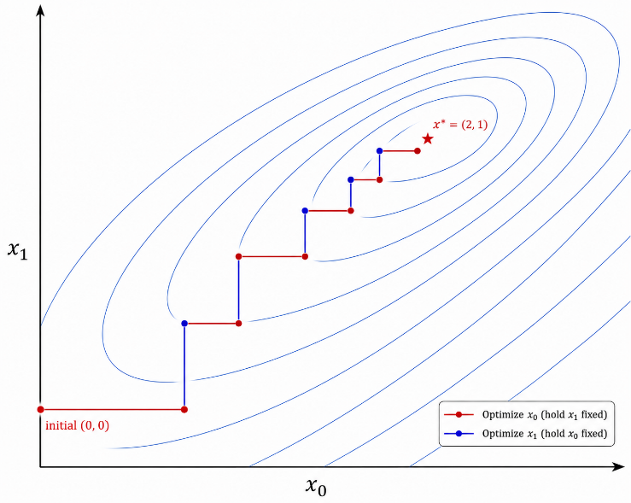

Now consider minimizing objective $f(X_{trd})$ by trading only with tradable k, that is, by changing :

$x_{trd,m}$ → $x_{trd,m}$ for m ≠ k
$x_{trd,k}$ → $x_{trd,k}+∆x$ for m = k (use symbol $∆x$ instead of $∆x_{trd,k}$ for simplicity)
hence $X_{trd}$ → $X_{trd}+∆xδ_{k}$
where $δ_{k}$ = 1 at k-th position, 0 otherwise (column vector of size N)

Recall objective $f(X_{trd})$ as follows, and we denote $f(X_{trd}+∆x)$ as 1D quadratic $f(∆x)$ for simplicity :

$f(X_{trd})$ = $X_{out}^{T}C_{out}X_{out}+2{lq}^{T}\left|X_{trd}\right|$
= $X_{trd}^{T}SC_{out}S^{T}X_{trd}+2{lq}^{T}\left|X_{trd}\right|$

$f(∆x)$ = ${(X_{trd}+∆xδ_{k})}^{T}SC_{out}S^{T}(X_{trd}+∆xδ_{k})+2\sum_{m≠k}{{lq}_{m}\left|x_{trd,m}\right|}+2{lq}_{k}\left|x_{trd,k}+∆x\right|$
= ${\left(∆x\right)}^{2}\left(δ_{k}^{T}SC_{out}S^{T}δ_{k}\right)+2∆x\left(δ_{k}^{T}SC_{out}S^{T}X_{trd}\right)+$
$\underset{const}{\underbrace{X_{trd}^{T}SC_{out}S^{T}X_{trd}+2\sum_{m≠k}{{lq}_{m}\left|x_{trd,m}\right|}}}+2{lq}_{k}\left|x_{trd,k}+∆x\right|$

= ${\left(∆x\right)}^{2}\left(δ_{k}^{T}C_{trd}δ_{k}\right)+2∆x\left(δ_{k}^{T}SC_{out}X_{out}\right)+2{lq}_{k}\left|x_{trd,k}+∆x\right|+const$
= ${\left(∆x\right)}^{2}C_{trd,k,k}+2∆x\left(S_{k}C_{out}X_{out}\right)+2{lq}_{k}\left|x_{trd,k}+∆x\right|+const$
$f'\left(∆x\right)$ = $2∆xC_{trd,k,k}+2\left(S_{k}C_{out}X_{out}\right)+2{μ_{k}lq}_{k}$
$f'\left({∆x}_{opt}\right)$ = $2{∆x}_{opt}C_{trd,k,k}+2\left(S_{k}C_{out}X_{out}\right)+2{μ_{k}lq}_{k}$ = 0
${∆x}_{opt}$ = $- \frac{S_{k}C_{out}X_{out}+{μ_{k}lq}_{k}}{C_{trd,k,k}}$
where $S_{k}$ = $δ_{k}^{T}S$ = k-th row of S (row vector of size M)
$C_{trd,k,k}$ = $δ_{k}^{T}C_{trd}δ_{k}$ = (k,k) element of tradable covariance
$μ_{k}$ = $\left[\begin{matrix}+1 & if & x_{trd,k}+{∆x}_{opt}>0 \\ -1 & if & x_{trd,k}+{∆x}_{opt}<0 \\ [-1,+1] & if & x_{trd,k}+{∆x}_{opt}=0\end{matrix}\right.$ = slope of $\left|x_{trd,k}+{∆x}_{opt}\right|$

Applying LASSO soft threshold operator :

${∆x}_{opt}$ = $\left[\begin{matrix}- \frac{S_{k}C_{out}X_{out}+{lq}_{k}}{C_{trd,k,k}} & if & {∆x}_{opt}>-x_{trd,k} \\ - \frac{S_{k}C_{out}X_{out}-{lq}_{k}}{C_{trd,k,k}} & if & {∆x}_{opt}<-x_{trd,k} \\ -x_{trd,k} & if & otherwise\end{matrix}\right.$

which means :

${∆x}_{opt}$ = $\left[\begin{matrix}{∆x}_{opt}^{+} & if & -x_{trd,k}<{∆x}_{opt}^{+}<{∆x}_{opt}^{-} & where & {∆x}_{opt}^{+}=- \frac{S_{k}C_{out}X_{out}+{lq}_{k}}{C_{trd,k,k}} \\ {∆x}_{opt}^{-} & if & {{∆x}_{opt}^{+}<∆x}_{opt}^{-}<-x_{trd,k} & where & {∆x}_{opt}^{-}=- \frac{S_{k}C_{out}X_{out}-{lq}_{k}}{C_{trd,k,k}} \\ -x_{trd,k} & if & {∆x}_{opt}^{+}<-x_{trd,k}<{∆x}_{opt}^{-} & & \end{matrix}\right.$

since liquidation cost ${lq}_{k}$ is always positive :

${∆x}_{opt}^{+}$ < ${∆x}_{opt}^{-}$

In other words, if 100% hedge of tradable k (i.e. $-x_{trd,k}$) lies within the band ${[∆x}_{opt}^{+},{∆x}_{opt}^{-}]$, then optimal is 100% hedge, otherwise if $-x_{trd,k}$ lies outside the band, we just clamp it to the nearest boundary. The 100% hedge means the benefit of marginal risk reduction (i.e. per security risk reducetion) is less than the liquidation cost of that security, then we would rather 100% offset it.

In ffwk code, we define :

FRisk::m_targetVar[n] = $C_{trd,n,n}$ $∀n∈[1,N]$
FRisk::m_maxRiskRed[n] = ${∆x}_{opt}$ for tradable n $∀n∈[1,N]$

2e. Implied tradable position (from outright position)
In part 2a, we know how to decompose tradable position into outright position, yet there is no way to imply $X_{trd}∈R^{N}$ from $X_{out}∈R^{M}$, where $N≥M$ (since tradables contains outrights). There are multiple possible tradable positions, that can be decomposed into the same outright position. Therefore a proper design is that the functor FRisk takes tradable position as input, and convert it to outright position inside the functor, it will then have accurate position for both domains. However for some reasons, FRisk takes outright position as input instead, hence it needs to imply tradable position.

Approach 1 – Imply tradable position using least square
Assuming that :
1. tradables do not contain outright and
2. number of tradables is less than number of outrights (i.e. $M≥N$), then

$S^{T}X_{trd}$ ~ $X_{out}$ LS model
$\hat{X_{trd}}$ = $\underset{X}{argmin}{{(S^{T}X-X_{out})}^{T}(S^{T}X-X_{out})}$ LS error
= ${({SS}^{T})}^{-1}(SX_{out})$ unfortunately FRisk is not doing this
Approach 2 – Projection of outright position on n-th row of S
The current implementation inside FRisk is :

$X_{trd,n}$ = $\frac{S_{n}X_{out}}{{\left|S_{n}\right|}^{2}}$ = projection of $X_{out}$ on $S_{n}$
where $S_{n}$ = $δ_{n}^{T}S$ = n-th row of S (row vector of size M)

The physical meaning of projection is that, if the entire book (i.e. all outright positions) are held as n-th tradable only, how many shares of tradable m would there be. However that does not make much sense. Consider 1 unit spread M6-U6, 1 unit spread U6-Z6, plus 0 unit spread M6-Z6, hence $X_{out}={[1,0,-1]}^{T}$, implied position for the 3 spread contracts are :

$X_{trd,0}$ = $\frac{[1,-1,0]X_{out}}{{\left|1,-1,0\right|}^{2}}$ = $\frac{1}{2}$
$X_{trd,1}$ = $\frac{[0,1,-1]X_{out}}{{\left|0,1,-1\right|}^{2}}$ = $\frac{1}{2}$
$X_{trd,2}$ = $\frac{[1,0,-1]X_{out}}{{\left|1,0,-1\right|}^{2}}$ = $1$

In ffwk code, we define :

FRisk::m_impliedPos[n] = $\frac{S_{n}X_{out}}{{\left|S_{n}\right|}^{2}}$ $∀n∈[1,N]$

2f. Benchmark
Functor FRisk also calculates a few benchmark items. Added them in the following summary.

FRisk::value() = $f(X_{trd})$ = $X_{out}^{T}C_{out}X_{out}+2{lq}^{T}\left|X_{trd}\right|$
FRisk::m_bias = $\frac{1}{2} \frac{df(X_{trd})}{dX_{trd}}$ = $SC_{out}X_{out}+\sum_{n}{{lq}_{n}μ_{n}}$

FRisk::m_maxRiskRed[n] = $\left[\begin{matrix}- \frac{S_{n}C_{out}X_{out}+{lq}_{n}}{C_{trd,n,n}} & if & {∆x}_{opt}>-x_{trd,k} \\ - \frac{S_{n}C_{out}X_{out}-{lq}_{n}}{C_{trd,n,n}} & if & {∆x}_{opt}<-x_{trd,k} \\ -x_{trd,n} & if & otherwise\end{matrix}\right.$ $∀n∈[1,N]$

FRisk::m_impliedPos[n] = $\frac{S_{n}X_{out}}{{\left|S_{n}\right|}^{2}}$ $∀n∈\left[1,N\right]$
FRisk::m_targetVar[n] = $C_{trd,n,n}$ $∀n∈[1,N]$
FRisk::m_targetVol[n] = $\sqrt{C_{trd,n,n}}$ $∀n∈\left[1,N\right]$

FRisk::m_benchRisk = ${A_{bench}^{2}C}_{trd,bench,bench}$
FRisk::m_benchQty[n] = $A_{bench}\sqrt{\frac{C_{trd,bench,bench}}{C_{trd,n,n}}}$ $∀n∈[1,N]$
FRisk::m_targetRange[n] = $\sqrt{\frac{R_{bench}{A_{bench}^{2}C}_{trd,bench,bench}}{C_{trd,n,n}}}$ $∀n∈[1,N]$

Appendix : Least Absolute Shrinking and Selection Operator (LASSO)
LASSO is a common techique when we add L1 penalty to least square regression problem. Lets review.
For a typical least square problem, L1 and L2 penalty are (A is N×M, B is N×1 and X is M×1) :

$\min_{X}{({\left(AX-B\right)}^{T}\left(AX-B\right)+λ\sum_{m}{\left|x_{m}\right|})}$ least square with L1 penalty, a.k.a. LASSO
$\min_{X}{({\left(AX-B\right)}^{T}\left(AX-B\right)+λX^{T}X)}$ least square with L2 penalty, a.k.a. ridge regression

Both above objective functions have 2 parts, the first part for minimising sum of error square, the second part for forcing each parameter close to zero. The contours for L2 penalty are concentric circles (spheres) with origin as the centre, while the contours for L1 penalty are diamonds in 2D, octahedrons in 3D with minimum at the centre.
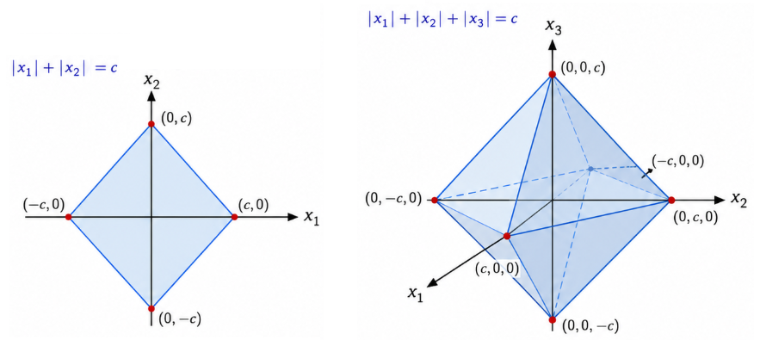

L2 penalty is differentiable, hence its solution is obvious :

$f\left(X\right)$ = ${\left(AX-B\right)}^{T}\left(AX-B\right)+λX^{T}X$
$∇f\left(X\right)$ = ${2A}^{T}\left(AX-B\right)+2λX$
$∇f\left(X_{opt}\right)$ = ${2(A}^{T}AX_{opt}-A^{T}B)+2λX_{opt}$ = $0$
$X_{opt}$ = ${{(A}^{T}A+λI)}^{-1}A^{T}B$

L1 penalty is not differentiable, need to consider different cases. For each dimension, there are 3 cases :

$\left[\begin{matrix}x_{m}>0 \\ x_{m}<0 \\ x_{m}=0\end{matrix}\right.$ $∀m∈[1,M]$

Therefore there will be $3^{M}$ cases. Consider one out of the $3^{M}$ cases, with $μ={{[μ}_{0},μ_{1},…,μ_{M-1}]}^{T}$ so that

$\left[\begin{matrix}μ_{m}=+1 & if & x_{m}>0 \\ μ_{m}=-1 & if & x_{m}<0 \\ μ_{m}=0 & if & x_{m}=0\end{matrix}\right.$

$f\left(X\right)$ = ${\left(AX-B\right)}^{T}\left(AX-B\right)+λ\sum_{m}{\left|x_{m}\right|}$
= ${\left(AX-B\right)}^{T}\left(AX-B\right)+λμ^{T}X$
$∇f\left(X\right)$ = ${2A}^{T}\left(AX-B\right)+λμ$
$∇f\left(X_{opt}\right)$ = ${2(A}^{T}AX_{opt}-A^{T}B)+λμ$ = $0$
$X_{opt}$ = ${{(A}^{T}A)}^{-1}(A^{T}B-\frac{1}{2}λμ)$

After solving $X_{opt}$, we need to verify if it is consistent with assumption in $μ$, if yes, take this as a solution, if not, abandone it, go for next combination $μ$, however this approach needs to retry $3^{M}$ cases, which is infeasible. Instead it can be implemented iteratively by fixing all except one dimensions of parameter unchanged, optimize by solve for that dimension $x_{k}$, then move on to next, repeat until convergence.
Iteration is done as following. Given current estimate $X$, we update dimension k from $x_{k}$ to $x_{k}+{∆x}_{k}δ_{k}$, while keeping all other dimensions unchanged. Find the value of scalar ${∆x}_{k}$ that minimises L1 cost.

$x_{m}$ → $x_{m}$ for m ≠ k
$x_{k}$ → $x_{k}+∆x_{k}$ for m = k
hence $X$ → $X+{∆x}_{k}δ_{k}$
where $δ_{k}$ = 1 at k-th position, 0 otherwise (column vector of size M)

Objective function $f\left(X+{∆x}_{k}δ_{k}\right)$ becomes a 1D quadratic function $f({∆x}_{k})$ :

$f\left({∆x}_{k}\right)$ = ${\left(A(X+{∆x}_{k}δ_{k})-B\right)}^{T}\left(A(X+{∆x}_{k}δ_{k})-B\right)+λ\sum_{m≠k}{\left|x_{m}\right|}+λ\left|x_{k}+{∆x}_{k}\right|$
= ${\left({∆x}_{k}{Aδ}_{k}+(AX-B)\right)}^{T}\left({∆x}_{k}{Aδ}_{k}+(AX-B)\right)+λ\sum_{m≠k}{\left|x_{m}\right|}+λ\left|x_{k}+{∆x}_{k}\right|$
= ${\left({∆x}_{k}\right)}^{2}{\left({Aδ}_{k}\right)}^{T}\left({Aδ}_{k}\right)+{2∆x}_{k}{\left({Aδ}_{k}\right)}^{T}\left(AX-B\right)+$
$\underset{const}{\underbrace{{\left(AX+B\right)}^{T}\left(AX-B\right)+λ\sum_{m≠k}{\left|x_{m}\right|}}}+λ\left|x_{k}+{∆x}_{k}\right|$

= ${\left({∆x}_{k}\right)}^{2}{\left({Aδ}_{k}\right)}^{T}\left({Aδ}_{k}\right)+{2∆x}_{k}{\left({Aδ}_{k}\right)}^{T}\left(AX-B\right)+λ\left|x_{k}+{∆x}_{k}\right|+const$
= ${\left({∆x}_{k}\right)}^{2}(δ_{k}^{T}{(A}^{T}{A)δ}_{k})+{2∆x}_{k}{\left({Aδ}_{k}\right)}^{T}\left(AX-B\right)+λ\left|x_{k}+{∆x}_{k}\right|+const$
= ${\left({∆x}_{k}\right)}^{2}C_{k,k}+{2∆x}_{k}A_{k}^{T}R+λ\left|x_{k}+{∆x}_{k}\right|+const$
$f'\left({∆x}_{k}\right)$ = 2${∆x}_{k}C_{k,k}+2A_{k}^{T}R+μ_{k}λ$

At optimum :

$f'\left({∆x}_{k,opt}\right)$ = 2${∆x}_{k,opt}C_{k,k}+2A_{k}^{T}R+μ_{k}λ$ = 0
${∆x}_{k,opt}$ = - $\frac{A_{k}^{T}R}{C_{k,k}}-\frac{μ_{k}λ}{{2C}_{k,k}}$

where $A_{k}$ = ${Aδ}_{k}$ = k-th column of $A$ (column vector of size N)
$C_{k,k}$ = $δ_{k}^{T}{(A}^{T}{A)δ}_{k}$ = (k,k) element of $C$ i.e. $A^{T}A$
R = $AX-B$
$μ_{k}$ = $\left[\begin{matrix}+1 & if & x_{k}+{∆x}_{k}>0 \\ -1 & if & x_{k}+{∆x}_{k}<0 \\ [-1,+1] & if & x_{k}+{∆x}_{k}=0\end{matrix}\right.$ = slope of $\left|x_{k}+{∆x}_{k}\right|$

case 1 : $x_{k}+{∆x}_{k,opt}>0$, $μ_{k}=+1$ then optimal ${∆x}_{k,opt}$=- $\frac{A_{k}^{T}R}{C_{k,k}}-\frac{λ}{{2C}_{k,k}}$ must fulfill condition :

${x_{k}+∆x}_{k,opt}$ = $x_{k}-\frac{A_{k}^{T}R}{C_{k,k}}-\frac{λ}{2C_{k,k}}$ > 0
$x_{k}-\frac{A_{k}^{T}R}{C_{k,k}}$ > +$\frac{λ}{2C_{k,k}}$

case 2 : $x_{k}+{∆x}_{k,opt}<0$,$μ_{k}=-1$ then optimial ${∆x}_{k,opt}$=- $\frac{A_{k}^{T}R}{C_{k,k}}+\frac{λ}{{2C}_{k,k}}$ must fulfill condition :

${x_{k}+∆x}_{k,opt}$ = $x_{k}-\frac{A_{k}^{T}R}{C_{k,k}}+\frac{λ}{2C_{k,k}}$ < 0
$x_{k}-\frac{A_{k}^{T}R}{C_{k,k}}$ < $-\frac{λ}{2C_{k,k}}$

case 3 : $x_{k}+{∆x}_{k,opt}=0$, $μ_{k}∈[-1,+1]$ then optimial ${∆x}_{k,opt}$=-$x_{k}$ must fulfill condition :

${x_{k}+∆x}_{k,opt}$ = $x_{k}-\frac{A_{k}^{T}R}{C_{k,k}}-\frac{μ_{k}λ}{2C_{k,k}}$ = 0
$x_{k}-\frac{A_{k}^{T}R}{C_{k,k}}$ = $-\frac{μ_{k}λ}{2C_{k,k}}$ ∈ $±\frac{λ}{2C_{k,k}}$ (the kink)
Given a positive semidefinite covariance $C=A^{T}A$, quadratic optimization must have one global optimum. For manually chosen penalty weight $λ$, X is intermediate solution for previous iteration, and ${∆x}_{k,opt}$ is the optimal change in one dimension for next iteration :

• if X and $x_{k}$ satisfy $x_{k}-\frac{A_{k}^{T}R}{C_{k,k}}>+\frac{λ}{2C_{k,k}}$
we can safely assume $x_{k}+{∆x}_{k,opt}>0$ and get solution ${∆x}_{k,opt}=-\frac{A_{k}^{T}R}{C_{k,k}}-\frac{λ}{2C_{k,k}}$
i.e. taking simple least square solution of dimension k, suppressed by $\frac{λ}{2C_{k,k}}$

• if X and $x_{k}$ satisfy $x_{k}-\frac{A_{k}^{T}R}{C_{k,k}}<-\frac{λ}{2C_{k,k}}$
we can safetly assume $x_{k}+{∆x}_{k,opt}<0$ and get solution ${∆x}_{k,opt}=-\frac{A_{k}^{T}R}{C_{k,k}}+\frac{λ}{2C_{k,k}}$
i.e. taking simple least square solution of dimension k, enhanced by $\frac{λ}{2C_{k,k}}$

• if X and $x_{k}$ lies in dead zone $-\frac{λ}{2C_{k,k}}<x_{k}-\frac{A_{k}^{T}R}{C_{k,k}}<+\frac{λ}{2C_{k,k}}$

both assumptions $x_{k}+{∆x}_{k,opt}>0$ and $x_{k}+{∆x}_{k,opt}<0$ will be wrong
as this is a convex optimization with positive semidefinite C, the only possible optimal is ${∆x}_{k,opt}=-x_{k}$

In conclusion, optimum move can be found by soft-threshold operator :

if $x_{k}-\frac{A_{k}^{T}R}{C_{k,k}}>+\frac{λ}{2C_{k,k}}$ then ${∆x}_{k,opt}=-\frac{A_{k}^{T}R}{C_{k,k}}-\frac{λ}{2C_{k,k}}$
if $x_{k}-\frac{A_{k}^{T}R}{C_{k,k}}<-\frac{λ}{2C_{k,k}}$ then ${∆x}_{k,opt}=-\frac{A_{k}^{T}R}{C_{k,k}}+\frac{λ}{2C_{k,k}}$
if $x_{k}-\frac{A_{k}^{T}R}{C_{k,k}}∈±\frac{λ}{2C_{k,k}}$ then ${∆x}_{k,opt}=-x_{k}$ (dead zone, making $x_{k}$ zero)

Please note that :
1. dead zone is a region where previous value X and $x_{k}$ lie, not where ${∆x}_{k,opt}$ lies
2. dead zone makes the value of k-th parameter zero, that is ${x'}_{k}=x_{k}+{∆x}_{k,opt}=x_{k}-x_{k}=0$
3. dimension k may lie in dead zone, while other dimensions may not
4. dimension with ${x'}_{k}=0$ implies feature is suppressed, LASSO is effectively a feature selection

Comparison to SVM
• LASSO is a feature selection algorithm, resulting in a sparse set of features.
• SVM is a data selection algorithm, resulting in sparse set of data points.

