Kim Dang

April 14, 2017

Professor Yong Jae Lee

ECS 174

Problem Set 0

* 1. A row vector of 500 random permutations of integers is generated, such that the maximum element in the vector is 500.
  2. The matrix a contains a 3-by-3 matrix such that the elements increment from 1 in the upper left corner to 9 in the bottom right corner. The vector b is the third row of a.
  3. The vector b is now a column vector containing all the elements of matrix a from part (b) strung along in column major format.
  4. A column vector f of size 10 is generated containing a random assortment of normally distributed numbers. The second command creates a column vector g containing any positive elements from the vector f.
  5. The first command generates a row vector x that is 5 zeros scaled by 0.5 such that all the elements in x are 0.5, The second command generates a row vector y that is the length of vector x, in which this case is 5, and filled with 0.5. The third statement, however, issues an error saying that the matrix dimensions of the operation must agree.
  6. Vector a is a row vector of elements incrementing from the integer 1 to 50. Vector b is a row vector of elements decrementing from the integer 50 to 1.
  7. round(5.*rand(1) + 1)
  8. y = [1 2 3 4 5 6]’;

Z = reshape(y, 2, 3);

* 1. x = max(max(Z);

[row, col] = find(Z==x);

r = Z(row, :);

c = Z(:, col);

* 1. v = [1 8 8 2 1 3 1 8];

x = 0;

for k=1:length(v),

if (v(k)==8),

x = x + 1;

end

end

* 1. The following plot is a plot of all intensities in the matrix A.

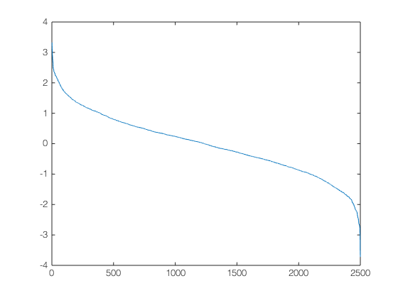

* 1. The following plot is a histogram of intensities of matrix A.

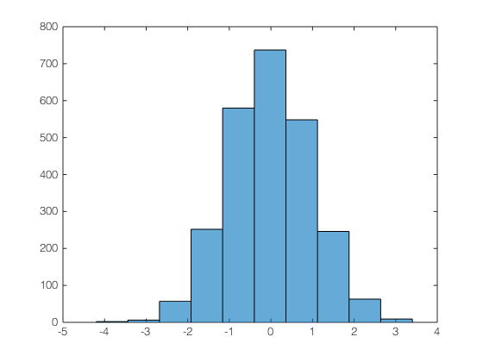

* 1. The following figure is an image of matrix Z.

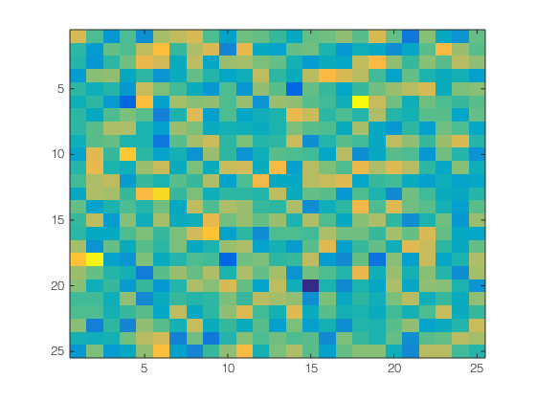

* 1. The following image is of image W.

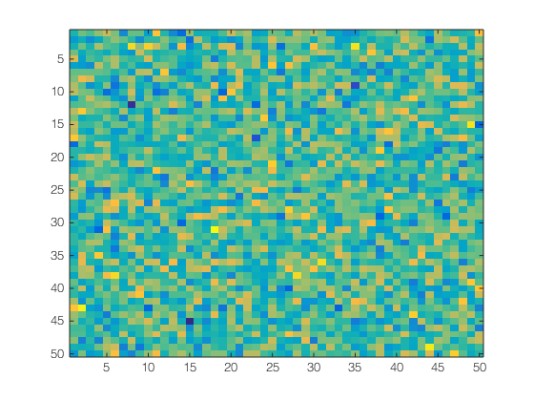

* 1. The following plot is of the matrix Y.



II. The following picture is the original image to be manipulated in the short programming example:



The following image is the subplot generated by the script in file PS0_Q2.m:

