Kim Dang

May 22, 2017

Professor Yong Jae Lee

ECS 174

Problem Set 2

**I. Short Answer Problems**

1. The given filter bank will be invariant to orientation because of the filters have been recorded at every single rotation possible. This means that rapid changes in intensity can be detected in any direction.
2. If we run k-means, the points of the two concentric circles will be split cleanly in half. K-means doesn’t do well with clusters within clusters. K-means attempts to guess the center of clusters and tries to minimize the sum of squared differences among all the points near the supposed cluster centers. Therefore, k-means doesn’t make a distinction between concentric shapes such as the ones given.
3. The mean-shift algorithm would be the most favorable grouping algorithm to find the model parameter hypotheses from a continuous vote space. A k-means algorithm requires evaluation of the distance of the hypothesized center to all bins, which will be impossible to do with a continuous vote space. Graph-cuts may work best when the space has been discretized into single units like pixels in an image, which is not the case here. The mean shift algorithm only needs one parameter of a window size and not have to perform calculations for all votes placed in the vote space.

**II. Programming Problem**

1. The following images are provided by <http://www.photofit4panorama.com/gallery.html>. On the first row are the hand sampled points of interest using the cpselect tool. The bottom row is the result of applying the homographic matrix calculated from computeH.mat. The red dots are the chosen or predicted points calculated. Even without normalization, the points line up very well. A test file labeled text.m to show and map these points is attached in the file.

|  |  |
| --- | --- |
| C:\Users\gadau\AppData\Local\Microsoft\Windows\INetCache\Content.Word\b1_hand.png | C:\Users\gadau\AppData\Local\Microsoft\Windows\INetCache\Content.Word\b2_hand.png |
| C:\Users\gadau\AppData\Local\Microsoft\Windows\INetCache\Content.Word\b1_predict.png | C:\Users\gadau\AppData\Local\Microsoft\Windows\INetCache\Content.Word\b2_predict.png |

1. The following figure is an attempted warped image of crop1.jpg onto crop2.jpg. The bounding box was not very well calculated and so the warped image is cropped.

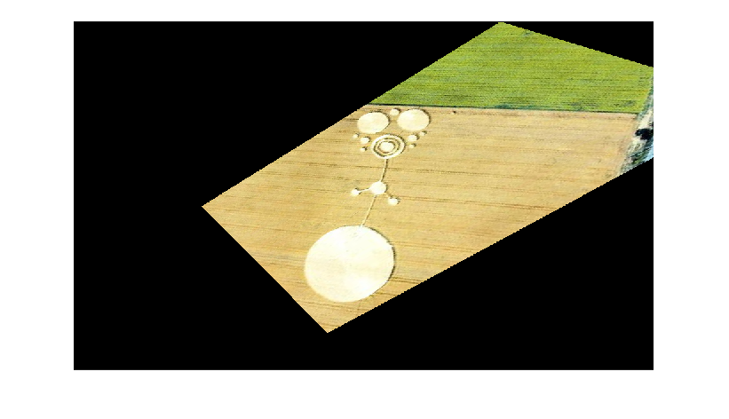

1. The following figure is an attempted inverse warp of the image GJ1.jpg. onto GJ2.jpg.

