Karl Diedrich
BMI6300 Medical Decision Making

Diagnosis of Complex Regional Pain Syndrome 1 (CRPS 1):
CRPS 1 is a chronic pain syndrome and nerve disorder usually occurring in the arms or legs after another initial injury.

Setting
Automatic computerized diagnosis of CRPS 1 would ideally occur in a system monitoring an Electronic Medical Record (EMR) for signs and symptoms, findings, of CRPS 1 and alert the medical staff when the probability of CRPS 1 passes a threshold. CRPS 1 is a rare disease occurring in 0.02% of the population (Quisel et al. 2005). Diagnosis is difficult because the pain of CRPS 1 is thought to stem from the original initiating injury. Clinicians will not normally think to use an independent diagnostic tool. I developed an independent diagnostic tool for CRPS 1 as a demonstration of the diagnostic method that can be used by physician, a patient or a most likely a researcher investigating the diagnosis of CRPS 1. The source code for my CRPS 1 diagnostic tool is modular enough to reuse the diagnostic engine in a Java based EMR to run in a time-driven fashion to find potential cases of CRPS 1.

Decision description
The tool assigns a probability a patient has CRPS 1 based on signs from a physical examination or symptoms reported by a patient. Computerized tools for diagnosing CRPS 1 are important because it takes an average of 30 months to diagnose CRPS 1 (Wasner et al. 2003) due to the rarity and confounding injuries described above. There is a lack of awareness among clinicians of CRPS 1 so computerized system to catch CRPS 1 in EMR would be very helpful.

CRPS 1 is diagnosed by observing a wide range of findings that also occur in other diseases and injuries. A positive CRPS 1 diagnosis comes from observing multiple findings and ruling out pain from the initial injury. Computerized systems can assimilate this wide-ranging information more easily than an unaided clinician. The following table shows the signs and symptoms and their probabilities of association with CRPS 1.

Variable | P[sign | CRPS 1] | P[symptom | CRPS 1]
Allodynia | 0.74 | -
Decreased range of motion | 0.70 | 0.80
Color changes | 0.66 | 0.87
Hyperalgesia | 0.63 | -
Temperature Asymmetry | 0.56 | 0.79
Edema | 0.56 | 0.80
Weakness | 0.56 | 0.75
Sweating changes | 0.24 | 0.53
Dystonia | 0.14 | 0.20
Nail changes | 0.09 | 0.21
Hair changes | 0.09 | 0.24
Tremor | 0.09 | 0.24
Hyperesthesia | - | 0.65
Burning pain | - | 0.81
Female | 0.80 | -
Table 1. Column 1: the condition, Column 2: The probability a patient with CRPS 1 shows this sign on examination by a clinician, Column 3: The probability a patient with CRPS 1 reports this symptom to the clinician in an interview. (Quisel et al. 2005)

Data collected and decision
To diagnose CRPS 1 using the diagnostic tool the clinician needs to enter the presence or absence of the signs from table 1. The diagnostic tool also supports self-diagnosis by the patient based on symptoms. A clinician could also use the symptoms mode of the diagnostic tool to diagnose CRPS 1 using patient reported symptoms. Using the inputs the diagnostic tool calculates the probability that the patient has CRPS 1.

The treatment for CRPS 1 is non-invasive intense physical therapy for two to three weeks, five to six hours per day (Sherry 2003). The therapy focuses on strengthening, stress loading and stretching the affected extremity and on whole body cardiovascular exercise to break the pain cycle. As long as the patient has no contraindications for doing the therapy, such as a physical disability, the therapy is worth trying if CRPS 1 is likely. CRPS 1 is only conclusively diagnosed by the success of the treatment; if the treatment succeeds the diagnosis was CRPS 1. Before and during treatment the patient has to be reassured that a neural syndrome is causing the pain and the therapy is not causing physical damage to the affected extremity. The patient and her physician will have to decide at what probability of disease the therapy is worth undertaking, this may be dependant on how willing the patient is to undertake the intensive physical therapy and on the absence of therapy contraindications.

Knowledge acquisition
The probabilities of findings, given the patient has the CRPS 1 disease, were collected from literature reviews. The paper by Quisel et al. (2005) summarized the probabilities making the data easy to collect. The literature was the only source of information on the probabilities of findings in CRPS 1 patients. Data on the probabilities of findings occurring in patients without CRPS 1 was not available. This was a serious drawback because I used Bayes theorem to calculate a probability of the disease given findings. Bayes Theorem uses both probability of a finding given CRPS 1 and the probability of a finding given no CRPS 1 to determine the probability of CRPS 1 given the findings. To get around this problem the diagnostic tool allows the user to change any probability of a finding given no disease. For convenience the diagnostic tool lets the user set the probability of all findings given no disease as a fraction of the probability of the sign or symptom given the disease. The flexibility of the diagnostic tool allows the user to change values to get a feel for the probability of CRPS 1 given any assumption the user wants to make. The CRPS 1 Diagnostic Tools is most useful to a researcher developing a CRPS 1 diagnostic protocol.

Knowledge used to create system
The diagnostic tool uses the probabilities of findings given that the patient has CRPS 1 using multi-membership Bayes’ Theorem as described in a lecture by Dr. Peter Haug of the University of Utah (2007). The basic Bayes’ Theorem starts with the probabilities of findings given the disease, which is not directly useful for diagnosing disease, and calculates the probability of the disease given the finding, which can be used to diagnose disease. The diagnosis of CRPS 1 depends on the presence of many findings, so multi-membership Bayes’ Theorem that handles multiple findings was used. Multi-membership Bayes’ Theorem is seeded with the baseline population probability of CRPS 1 as the prior probability which is 0.02% (Quisel et al. 2005). Then uses the probability of the finding given the disease and given no disease to calculate the probability of the disease given the finding. The calculated probability using the first finding is used as the prior probability for the second finding and the process is repeated for each sign or symptom. The figure below demonstrates the steps of multi-membership Bayes’ Theorem.

P[CRPS 1| Sign 1] =
P[CRPS 1]*P[ Sign 1|CRPS 1]
P[CRPS 1]*P[ Sign 1|CRPS 1] + P[ no CRPS 1] * P[ Sign 1|no CRPS 1]
P[CRPS 1| Sign 2] =
P[CRPS 1|Sign 1]*P[ Sign 2|CRPS 1]
P[CRPS 1]*P[ Sign 2|CRPS 1] + P[ no CRPS 1] * P[ Sign 2|no CRPS 1]
P[CRPS 1] = 0.0002
Repeat for each sign
With CRPS 1 and sign
With sign
Prior probability of disease
Knowledge representation method
The diagnostic tool uses the probabilistic Bayes’ Theorem to model the question and diagnose the probability of the CRPS 1. Another CRPS 1 diagnostic system uses Boolean logic. The Boolean diagnosis looks for disproportionate continuing pain after an initial injury and one symptom in each of four categories and one sign in two or more of four categories and determines the diagnosis as a simple Boolean yes or no instead of a probability. The diagnosis is described below.

1) Continuing pain, which is disproportionate to any inciting event.
2) 1 symptom in each of 4 categories:
a. Sensory: hyperesthesia
b. Vasomotor: temperature asymmetry and/or skin color changes and/or skin color asymmetry
c. Sudomotor/Edema: Edema and/or sweating changes and/or sweating asymmetry
d. Motor/Trophic: Decreased range of motion and/or motor dysfunction (weakness, tremor, dystonia) and/or trophic changes (hair, nail, skin)
3) 1 sign in 2 or more of 4 categories:
a. Sensory: Evidence of hyperalgesia (to pinprick) and/or allodynia (to light touch)
b. Vasomotor: Temperature asymmetry and/or skin color changes and/or asymmetry
c. Sudomotor/Edema: Evidence of edema and/or sweating changes and/or sweating asymmetry
d. Motor/Trophic: Evidence of decreased range of motion and/or motor dysfunction (weakness, tremor, dystonia, neglect) and/or trophic changes (hair, nail, skin) (Harden & Bruehl 2006)

The probabilistic Bayesian diagnostic highlights the subtlety of the diagnosis. CRPS 1 is diagnosed based on many findings and one patient’s diagnosis based on more signs or symptoms than another patient’s diagnosis is a more confidant diagnosis. Some findings are more diagnostic of CRPS 1 than others. For example the sign, allodynia, occurs in 74% of CRPS 1 patients, hair changes occur in only 9%. Therefore allodynia could be a stronger indicator of CRPS 1 than hair changes, given similar background probabilities of those signs. The probabilistic Bayes’ method takes the relative strength of the diagnostic finding into account. Under the Boolean system these findings have equal weight.

Interface method
The diagnostic tool provides a sign based diagnosis for clinicians or a symptom based diagnosis for use by the clinician or self-diagnosis by a patient. After self-diagnosis the patient should tell her doctor about the possibility of CRPS 1. In reality this in unlikely to happen since few patients would think to use a stand-alone CRPS 1 diagnostic tool, an EMR integrated diagnostic tool is the ideal system.

As an example of the stand-alone CRPS 1 Diagnostic Tool, the physician examined a patient who previously had a broken left ankle that appears to have healed but has continuing burning pain. Upon physical examination the physician finds signs of allodynia, decreased range of motion in the ankle, hyperalgesia, weakness in the left ankle when compared to the right, the left ankle appears slightly bluish and the patient is female. The physician clicks the yes check boxes for those signs in the “Diagnose by signs for clinicians” tab and then clicks the “Diagnose disease probability button”. The disease probability was calculated at 0.90 or 90%. At this level of probability the patient should begin therapy to treat CRPS 1. The treating physician and physical therapists should monitor the ankle during treatment to make sure they are not causing any physical damage to the ankle during CRPS 1 therapy.

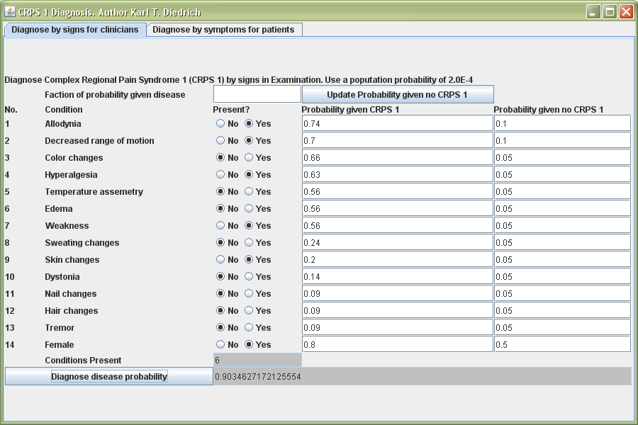
Figure 1. A clinician calculated the probability of CRPS 1 after finding signs of
allodynia, decreased range of motion, hyperalgesia, weakness and skin color changes in a female patient.

Implementation Feasibility
As mentioned before the CRPS 1 diagnostic tool is a research system to later develop an EMR connected diagnostic system. Information from EMR’s can be entered into the current interface to test the concept of identifying CRPS 1 from EMR’s. The multi-membership diagnostic engine in the current implementation is programmed as a reusable component for any Java based EMR system.

System Evaluation
The performance of the system needs to be evaluated. Since this system is ultimately suited for integration into an EMR the best test would be, taking the EMR’s for a group of patients that includes some patients diagnosed with CRPS 1 by an expert and a random sample of patients with other diseases. The actual diagnosis for CRPS 1 would be removed from copies of the EMR for the trial to make it a blind trial. A non-expert would fill in the CRPS 1 diagnosis tool based on the EMR data and calculate the probabilities of the CRPS 1. The probabilities of the patients without CRPS 1 would be compared to the probabilities of the patients with CRPS 1. If the system is working the average probability of the portion of patients with CRPS 1 should be higher than the probability of the portion without CRPS 1. After this is done, select the probability above which the patient is positive for a CRPS 1 to get most True Positives above the cut-off and most True Negatives below the cut-off. The cut-off probability will depend on the desired sensitivity and specificity.

Once the system is tuned to have a useful sensitivity and specificity the Bayesian diagnostic engine was coded in a modular subunit that could be added to any EMR system support Java. More work is needed to read the findings in from the EMR into the Bayesian diagnostic engine and to send the alert of a possible CRPS 1 diagnosis to clinicians.

References
- Harden, Norman R. & Stephen P. Bruehl. “Diagnosis of Complex Regional Pain Syndrome.” Clinical Journal of Pain 22, no. 5 (2006): 415-419.
- Quisel, A., et al. “Complex regional pain syndrome underdiagnosed.” The Journal of Family Practice 54, no. 6 (2005), http://www.jfponline.com/Pages.asp?AID=1947
- Sherry, David. “Amplified Musculoskeletal Pain or Reflex Neurovascular Dystrophy (RND) A guide for parents of children with RND ” (2003), http://www.childhoodrnd.org/index.html
- Wasner G. et al. “Complex regional pain syndrome – diagnostic, mechanisms, CNS involvement and therapy.” Spinal Cord 41 (2003): 61-75.

