12/6/2007
Karl Diedrich
BMI6300 Medical Decision Making

Computer aided diagnosis of Complex Regional Pain Syndrome 1 (CRPS 1)

Introduction

CRPS 1 is a chronic pain syndrome and nerve disorder usually occurring in the arms or legs after another initial injury. CRPS 1 is a rare disease occurring in 0.02% of the population (Quisel et al. 2005).
The treatment for CRPS 1 is non-invasive intense physical therapy for two to three weeks, five to six hours per day (Sherry 2003). The therapy focuses on strengthening, stress loading and stretching the affected extremity and on whole body cardiovascular exercise to break the pain cycle.
CRPS 1 is only conclusively diagnosed by the success of the treatment; if the treatment succeeds the diagnosis was CRPS 1. Before and during treatment the patient has to be reassured that a neural syndrome is causing the pain and the therapy is not causing physical damage to the affected extremity. CRPS 1 can only be diagnosed with a certain level of probability. The patient and her physician will have to decide at what probability of disease the therapy is worth undertaking, this may be dependant on how willing the patient is to undertake the intensive physical therapy and on the absence of therapy contraindications. The therapy is non-invasive so if the patient has no contraindications for doing the therapy, such as a physical disability, the therapy is worth trying if CRPS 1 is at all likely.

Diagnosis of CRPS 1 is difficult because the pain of CRPS 1 is thought to stem from the original initiating injury. Therefore, misdiagnoses often occur. To help clinicians to overcome this problem I developed an independent diagnostic computer program for CRPS1.
This program is a standalone tool for diagnosing CRPS 1. By simply answering the questions, an automatic computerized diagnosis of CRPS 1 would ideally occur using this program and alert the medical staff when the probability of CRPS 1 passes a threshold. Physicians, patients as well as researchers investigating the diagnosis of CRPS 1 can use this program easily.
In the future, this program can be integrated into an Electronic Medical Record (EMR). Then a systematic monitoring of an Electronic Medical Record (EMR) for signs and symptoms of CRPS 1 can be used in addition to the individual answers for an accurate diagnosis. EMR monitoring is especially important because clinicians rarely think to look for CRPS 1 so the monitoring needs to happen automatically.

Clinical Diagnosis of CRPS 1

CRPS 1 is diagnosed by observing a wide range of findings that also occur in other diseases and injuries. A positive CRPS 1 diagnosis comes from observing multiple findings and ruling out pain from the initial injury. The following Table 1 shows the signs and symptoms (both referred to as findings) and their probabilities of association with CRPS 1. It takes an average of 30 months to diagnose CRPS 1 (Wasner et al. 2003) due to the rarity and confounding injuries.

Variable | P[sign | CRPS 1] | P[symptom | CRPS 1]
Allodynia | 0.74 | -
Decreased range of motion | 0.70 | 0.80
Color changes | 0.66 | 0.87
Hyperalgesia | 0.63 | -
Temperature Asymmetry | 0.56 | 0.79
Edema | 0.56 | 0.80
Weakness | 0.56 | 0.75
Sweating changes | 0.24 | 0.53
Dystonia | 0.14 | 0.20
Nail changes | 0.09 | 0.21
Hair changes | 0.09 | 0.24
Tremor | 0.09 | 0.24
Hyperesthesia | - | 0.65
Burning pain | - | 0.81
Female | 0.80 | -

Table 1. Column 1: the condition, Column 2: The probability a patient with CRPS 1 shows this sign on examination by a clinician, Column 3: The probability a patient with CRPS 1 reports this symptom to the clinician in an interview. (Quisel et al. 2005)

Computer aided Diagnosis of CRPS 1

Computerized tools for diagnosing CRPS 1 are important because there is a lack of awareness among clinicians of CRPS 1. In addition, computerized tools can assimilate this wide-ranging information more easily than an unaided clinician. However, currently there is no program is available for diagnosis of CRPS 1.
To diagnose CRPS 1 using the program suggested in this paper, the clinician needs to enter the presence or absence of the signs from table 1. The diagnostic tool also supports self-diagnosis by the patient based on symptoms. A clinician could also use the symptoms mode of the program to diagnose CRPS 1 using patient reported symptoms. Using the inputs the program calculates the probability that the patient has CRPS 1. Details of the program are described following sections.

Boolean method

Harden and Bruehl suggested a Boolean method for diagnosis of CRPS 1 in 2006. The Boolean diagnosis looks for disproportionate continuing pain after an initial injury and one symptom in each of four categories and one sign in two or more of four categories and determines the diagnosis as a simple Boolean yes or no instead of a probability. The diagnosis is described below.

1) Continuing pain, which is disproportionate to any inciting event.
2) 1 symptom in each of 4 categories:
a. Sensory: hyperesthesia
b. Vasomotor: temperature asymmetry and/or skin color changes and/or skin color asymmetry
c. Sudomotor/Edema: Edema and/or sweating changes and/or sweating asymmetry
d. Motor/Trophic: Decreased range of motion and/or motor dysfunction (weakness, tremor, dystonia) and/or trophic changes (hair, nail, skin)
3) 1 sign in 2 or more of 4 categories:
a. Sensory: Evidence of hyperalgesia (to pinprick) and/or allodynia (to light touch)
b. Vasomotor: Temperature asymmetry and/or skin color changes and/or asymmetry
c. Sudomotor/Edema: Evidence of edema and/or sweating changes and/or sweating asymmetry
d. Motor/Trophic: Evidence of decreased range of motion and/or motor dysfunction (weakness, tremor, dystonia, neglect) and/or trophic changes (hair, nail, skin) (Harden & Bruehl 2006)

Multi-membership Bayes’ theorem
Bayes' theorem relates the conditional and marginal probability distributions of random variables. In some interpretations of probability, Bayes' theorem tells how to update or revise beliefs in light of new evidence a posteriori. The probability of an event A conditional on another event B is generally different from the probability of B conditional on A. However, there is a definite relationship between the two, and Bayes' theorem is the statement of that relationship. In this program, multi-membership Bayes’ theorem was used to compute the probability of CRPS 1. In multi-membership Bayes’ theorem, it is assumed that patients have any group of disease and each disease is evaluated independently.
Bayesian approach is very useful for CRPS 1 because it can give inferential explanation for previously undetermined findings as well as new findings upon discovery. For example, in the case of determining the likelihood of CRPS 1, any symptoms related to CRPS 1 can be input into the computer and the computer can determine the resultant probability. Assuming the independence among these findings (represented as f1, f2, f3 and f4), the probability of CRPS 1 can be calculated as joint probability of each finding.
P(CRPS 1) = P(f1, f2, f3, f4)

= P(f1|f2,f3,f4)*P(f2|f3,f4)*P(f3|f4)*P(f4)

The probabilities of findings, given the patient has the CRPS 1 disease, were collected from literature reviews. The paper by Quisel et al. (2005) summarized the probabilities making the data easy to collect. The literature was the only source of information on the probabilities of findings in CRPS 1 patients. Data on the probabilities of findings occurring in patients without CRPS 1 was not available so these probabilities were assumed and are easily changeable in the program. Bayes’ theorem uses both probability of a finding given CRPS 1 and the probability of a finding given no CRPS 1 to determine the probability of CRPS 1 given the findings. For convenience the program lets the user set the probability of all findings given no disease as a fraction of the probability of the sign or symptom given the disease. The flexibility of the program allows the user to change values to get a feel for the probability of CRPS 1 given any assumption the user wants to make.

The probabilistic Bayesian diagnostic highlights the subtlety of the diagnosis. CRPS 1 is diagnosed based on many findings and one patient’s diagnosis based on more signs or symptoms than another patient’s diagnosis is a more confidant diagnosis. Some findings are more diagnostic of CRPS 1 than others. For example the sign, allodynia, occurs in 74% of CRPS 1 patients, hair changes occur in only 9%. Therefore allodynia could be a stronger indicator of CRPS 1 than hair changes, given similar background probabilities of those signs. The probabilistic Bayes’ method takes the relative strength of the diagnostic finding into account.
The Boolean diagnosis by Harden and Bruehl (2006) and the Bayes’ diagnosis described here use the same findings. The Bayes’ method takes into account the relative strengths of the findings as indicators of CRPS 1 but the Boolean method treats all findings equally.

Design of computer program for CRPS 1 diagnosis

This computer program provides a tool for clinicians to diagnose CRPS 1 based on findings. As an example of how the program works for diagnosing CRPS l, the physician examined a patient who previously had a broken left ankle that appears to have healed but has continuing burning pain. Upon physical examination the physician finds signs of allodynia, decreased range of motion in the ankle, hyperalgesia, weakness in the left ankle when compared to the right, the left ankle appears slightly bluish and the patient is female. The physician clicks the yes check boxes for those signs in the “Diagnose by signs for clinicians” tab and then clicks the “Diagnose disease probability button”. The disease probability was calculated at 0.90 or 90%.
The interface for the program is illustrated in Figure 1.

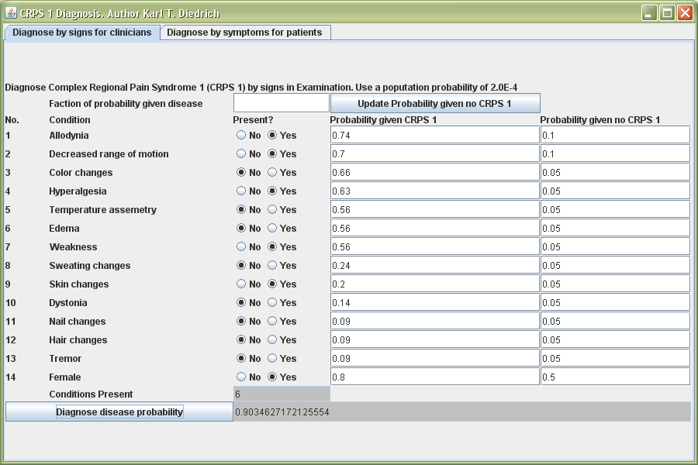

Figure 1. A clinician calculated the probability of CRPS 1 after finding signs of
allodynia, decreased range of motion, hyperalgesia, weakness and skin color changes in a female patient

Program Evaluation

The performance of the system needs to be evaluated. Since this system is ultimately suited for integration into an EMR the best test would be, taking the EMR’s for a group of patients that includes some patients diagnosed with CRPS 1 by an expert and a random sample of patients with other diseases. The actual diagnosis for CRPS 1 would be removed from copies of the EMR for the trial to make it a blind trial. A non-expert would fill in the CRPS 1 diagnosis tool based on the EMR data and calculate the probabilities of the CRPS 1. The probabilities of the patients without CRPS 1 would be compared to the probabilities of the patients with CRPS 1. If the system is working the average probability of the portion of patients with CRPS 1 should be higher than the probability of the portion without CRPS 1. After this is done, select the probability above which the patient is positive for a CRPS 1 to get most True Positives above the cut-off and most True Negatives below the cut-off. The cut-off probability will depend on the desired sensitivity and specificity.

This program provides a sign based diagnosis for clinicians or a symptom based diagnosis for use by the clinician or self-diagnosis by a patient. After self-diagnosis the patient can tell her doctor about the possibility of CRPS 1. This program is an easy to use standalone program but it is planned to integrate into EMR system in the future. This program can be easily integrated into any Java based EMR system.

Reference

- Harden, Norman R. & Stephen P. Bruehl. “Diagnosis of Complex Regional Pain Syndrome.” Clinical Journal of Pain 22, no. 5 (2006): 415-419.
- Quisel, A., et al. “Complex regional pain syndrome underdiagnosed.” The Journal of Family Practice 54, no. 6 (2005), http://www.jfponline.com/Pages.asp?AID=1947
- Sherry, David. “Amplified Musculoskeletal Pain or Reflex Neurovascular Dystrophy (RND) A guide for parents of children with RND ” (2003), http://www.childhoodrnd.org/index.html
- Wasner G. et al. “Complex regional pain syndrome – diagnostic, mechanisms, CNS involvement and therapy.” Spinal Cord 41 (2003): 61-75.

