ECE 425 VLSI Circuit Design Lab 4 prelab

Lab partners: YI HAN, Kemal Dilsiz.
Time: Feb, 28, 2017

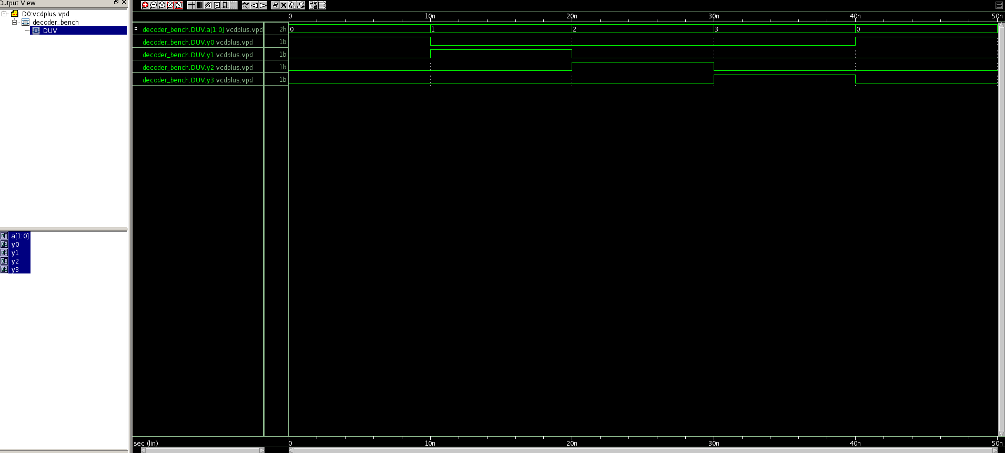
Vcdpulus.vpd simulation waveform

dc_shell schematic image

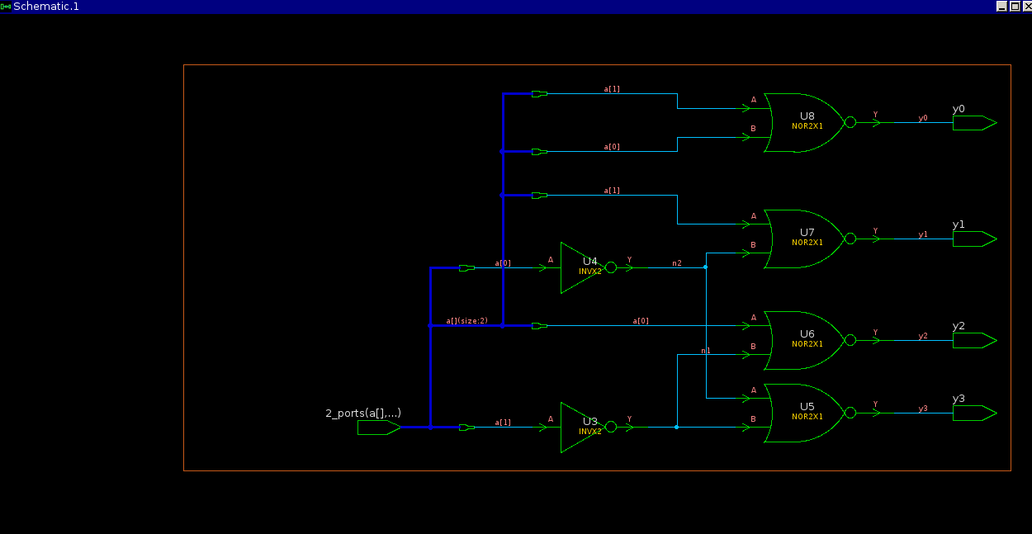

original decoder screenshot

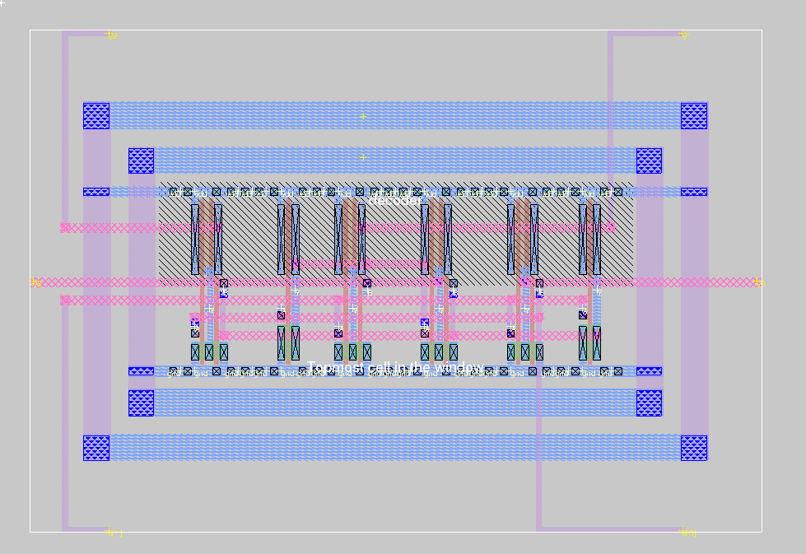
original decoder analyzer

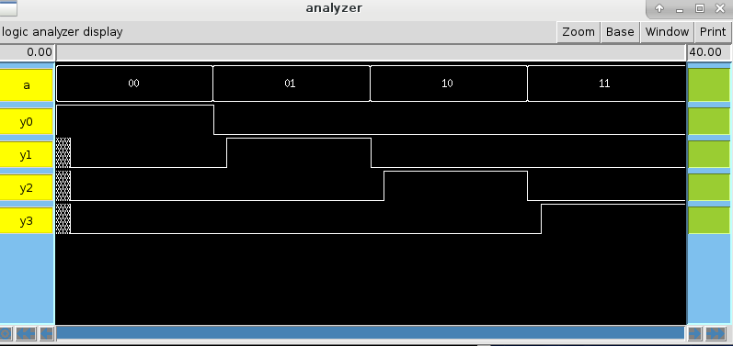
new synthesis_comb.tcl schematic image

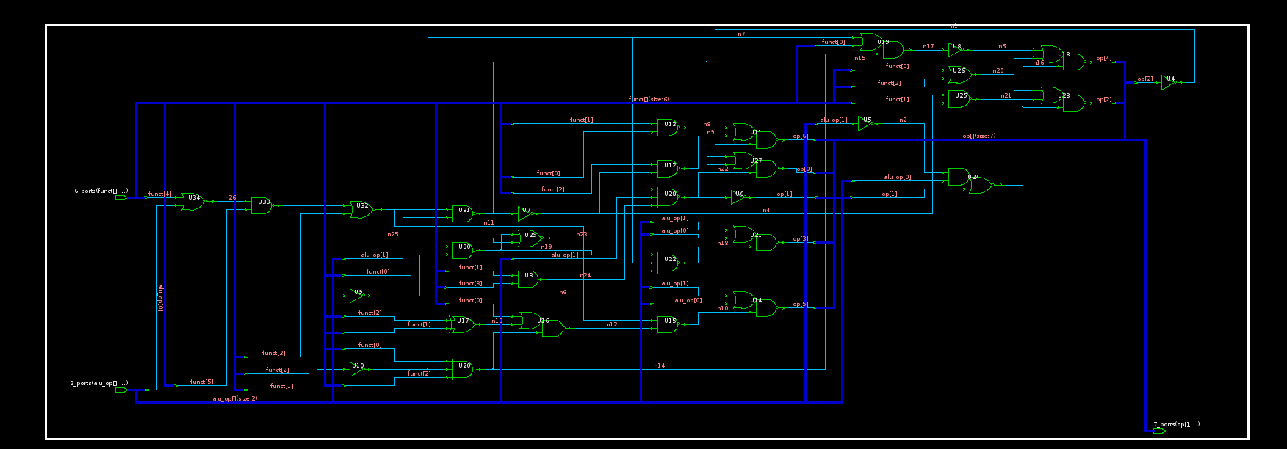

new decoder layout

