ECE 425 VLSI Circuit Design Lab 4 prelab

Lab partners: YI HAN, Kemal Dilsiz.
Time: Mar, 7, 2017

wv inv.tr0 waveform

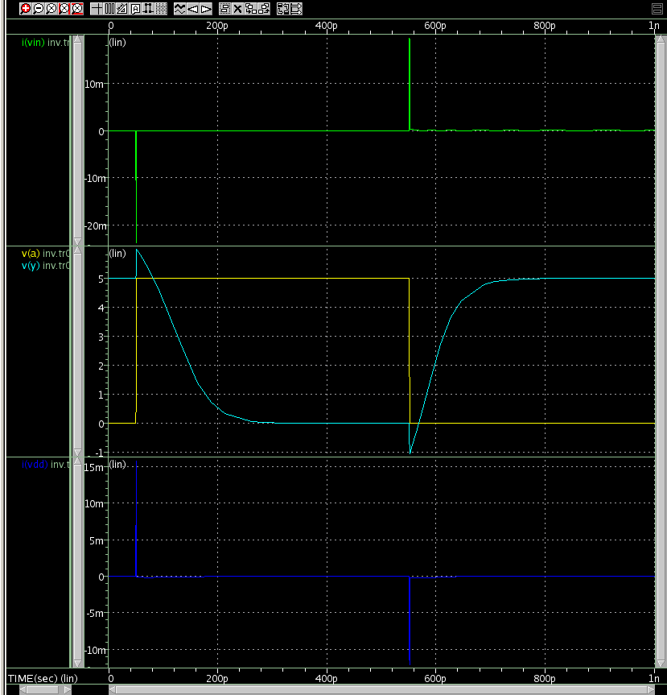

wv Fo4.tr0 waveform

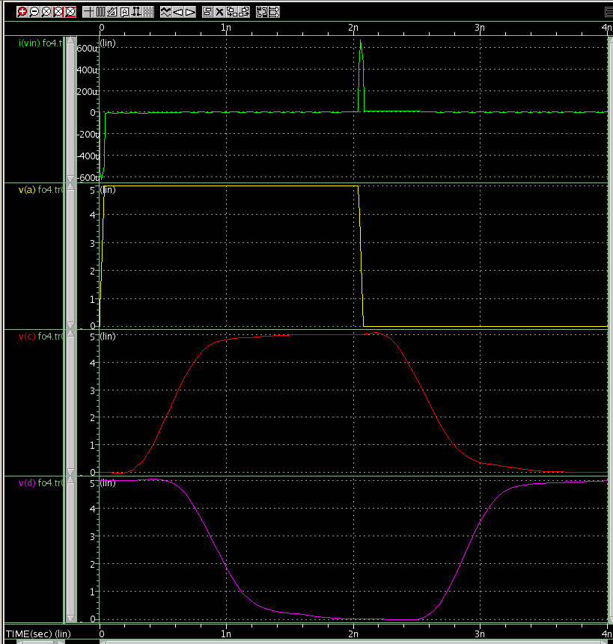

The time measurement of Fo4

****** transient analysis tnom= 25.000 temp= 70.000 ******
tpdr= 291.3731p targ= 2.8921n trig= 2.6007n
tpdf= 355.7412p targ= 927.3073p trig= 571.5661p
tpd= 323.5572p
trise= 323.1150p targ= 3.0624n trig= 2.7393n
tfall= 369.0093p targ= 1.1214n trig= 752.3502p

wv nor_lx_bench.tr0 waveform
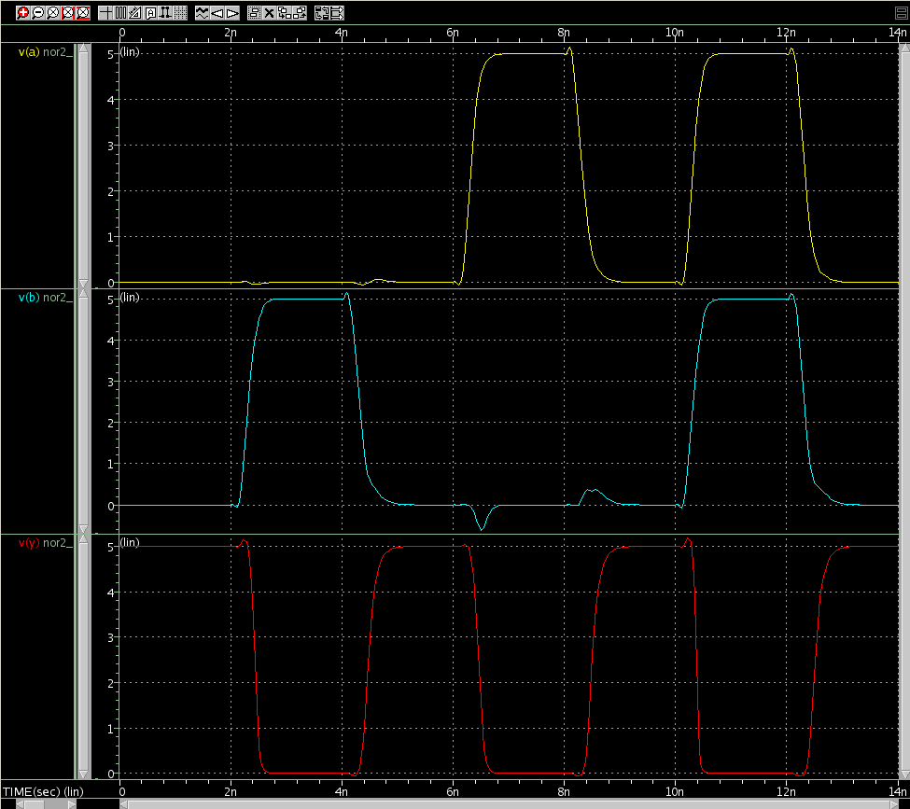

Time measurement of nor2_1x_bench

****** transient analysis tnom= 25.000 temp= 70.000 ******
tpdr_a= -3.8448n targ= 4.4787n trig= 8.3235n
tpdf_a= -3.8819n targ= 2.4390n trig= 6.3209n
tpd_a= -3.8633n
tpdr_b= 162.9026p targ= 4.4787n trig= 4.3158n
tpdf_b= 116.1930p targ= 2.4390n trig= 2.3228n
tpd_b= 139.5478p
trise= 176.7381p targ= 4.5781n trig= 4.4014n
tfall= 103.8105p targ= 2.4889n trig= 2.3851n

The best and worst case of Zero detect circuit waveform
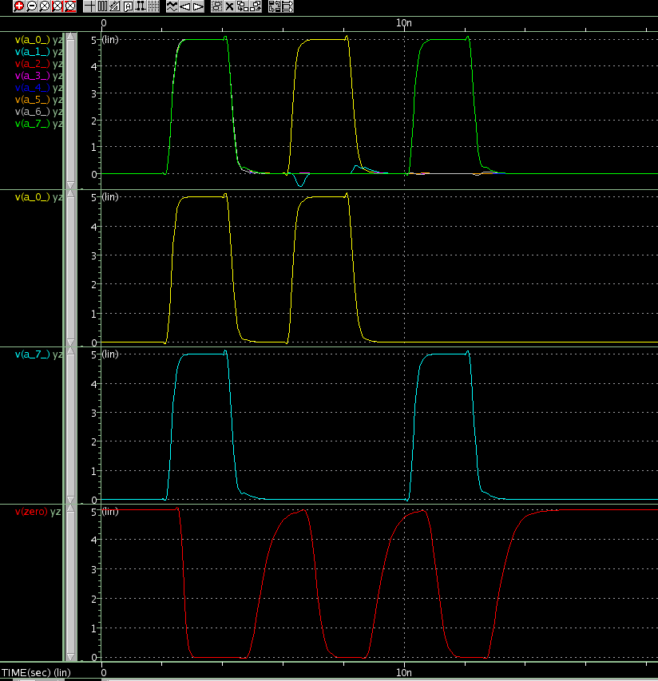

We have observed through the wavelength simulations that the High to Low change in the single input makes the worst delay in the output. For example, for the nor gate, when ‘a’ input is 1 and ‘b’ input is 0, if the ‘a’ input goes down to 0 as well, this will create the worst delay in the output. There was no significant difference between which input node changes. The best case scenario was when both inputs are turned on and turned off. This is because the resistance goes down with the parallel structure of the mos gates.

Observing this situation from the NOR gate. We have concluded that the best case for Yzerodetect would be the situation where all inputs are turned on. This can be seen as the first change in the simulation picture that we have attached. Then for the worst case scenario, only a_0_ or a_7_ should be changed because this would create the highest possible resistance similar to the NOR gate situation. We have simulated both of these situations in out data: first turning on and off a_0_ and then turning on and off a_7_. Again, this is observable in our picture from the simulation.

****** transient analysis tnom= 25.000 temp= 70.000 ******
tpdr_a_0= 977.6504p targ= 5.2986n trig= 4.3209n
tpdf_a_0= 397.0092p targ= 2.7184n trig= 2.3214n
tpd_a_0= 687.3298p
tpdr_a_7= 987.5224p targ= 5.2986n trig= 4.3111n
tpdf_a_7= 395.5124p targ= 2.7184n trig= 2.3229n
tpd_a_7= 691.5174p
trise= 594.5535p targ= 5.6515n trig= 5.0570n
tfall= 167.5948p targ= 2.8075n trig= 2.6399n

