ECE 425 VLSI Circuit Design Lab 8 prelab

Lab partners: YI HAN, Kemal Dilsiz.
Time: Mar, 28, 2017

Simulation of counter testbench
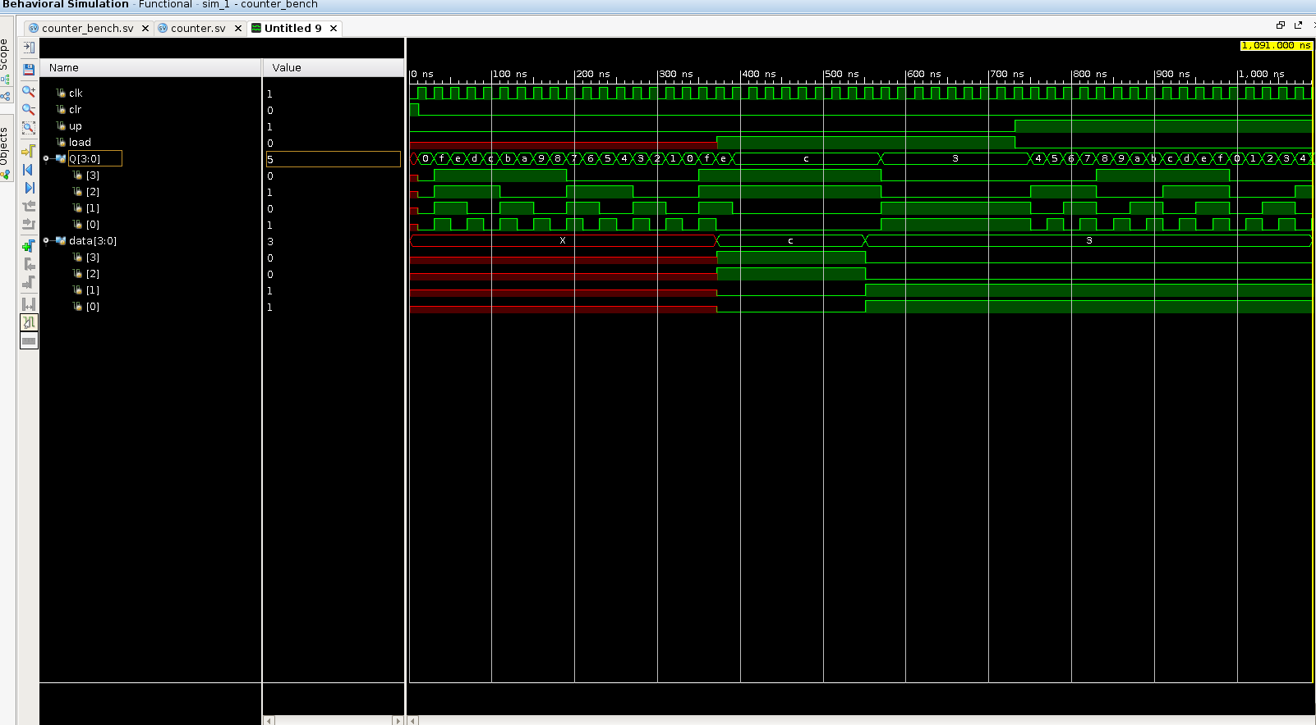

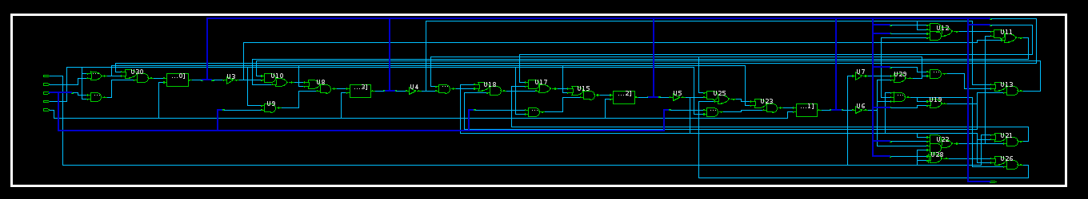

Schematic of counter

Counter simulatuon waveform

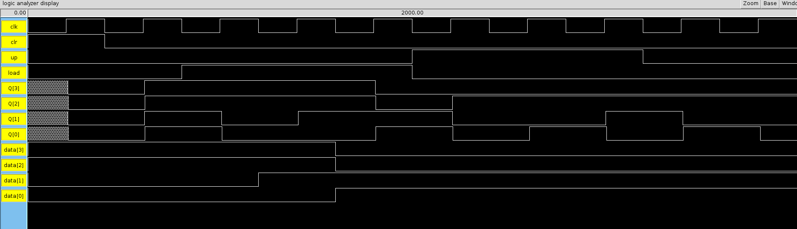

Counter layout

MIPS_FSM layout

MIPS_FSM size

Root cell box:
width x height ( llx, lly ), ( urx, ury ) area (units^2)

microns: 321.60 x 174.00 ( 0.00, 0.00 ), ( 321.60, 174.00) 55958.40
lambda: 1072 x 580 ( 0, 0 ), ( 1072, 580 ) 621760

