ECE 425 VLSI Circuit Design Lab 1
Lab partners: YI HAN, Kemal Dilsiz.
Time: Jan,31,2017

3-inputs NAND gate sticky diagram

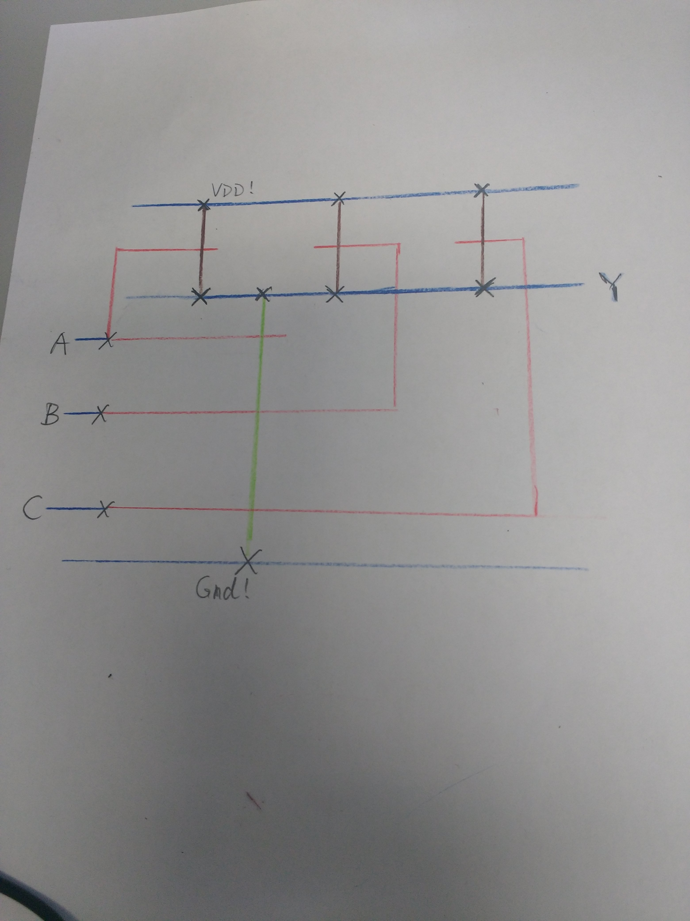

3-inputs NAND gate diagram

3-inputs NAND gate results

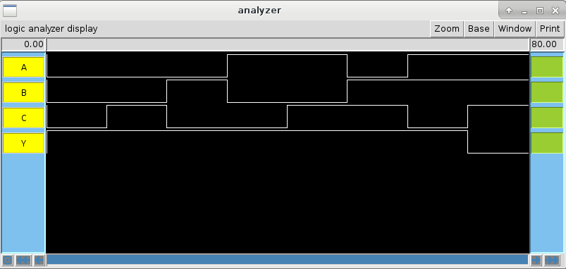

The cell sizes and are of 3-inputs NAND gate:

Root cell box:
width x height ( llx, lly ), ( urx, ury ) area (units^2)

microns: 38.10 x 16.80 (-24.30, -6.60 ), ( 13.80, 10.20) 640.08
lambda: 127 x 56 ( -81, -22 ), ( 46, 34 ) 7112

AiO21 gate sticky diagram

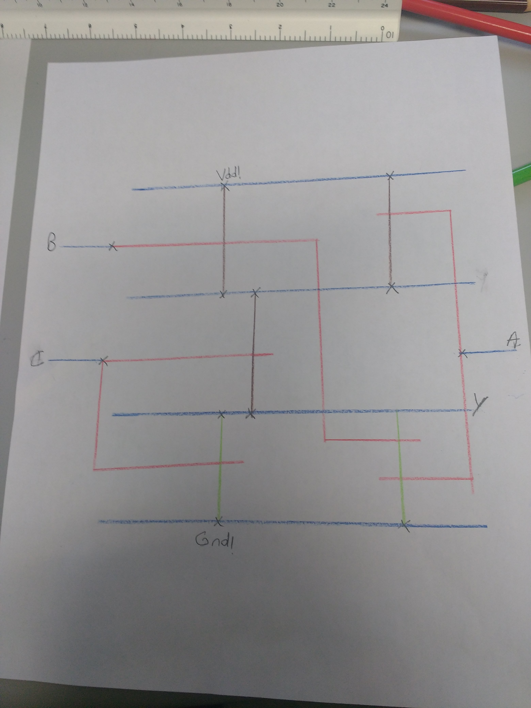

AiO21 gate diagram

AOI21 gate results

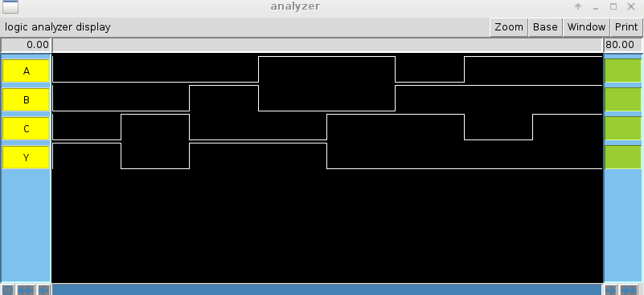

The cell sizes and are of AOI21 gate:

Root cell box:
width x height ( llx, lly ), ( urx, ury ) area (units^2)

microns: 31.80 x 17.40 (-19.50, -6.60 ), ( 12.30, 10.80) 553.32
lambda: 106 x 58 ( -65, -22 ), ( 41, 36 ) 6148

Time uses for the: 3.5 hours

