ECE 425 VLSI Circuit Design Lab 3
Lab partners: YI HAN, Kemal Dilsiz.
Time: Feb, 7 ,2017

The size of the NAND3 gate
Root cell box:
width x height ( llx, lly ), ( urx, ury ) area (units^2)

microns: 12.00 x 30.00 ( -1.80, -1.20 ), ( 10.20, 28.80) 360.00
lambda: 40 x 100 ( -6, -4 ), ( 34, 96 ) 4000

The diagram of the NAND3 gate

The result analyzer of the NAND3

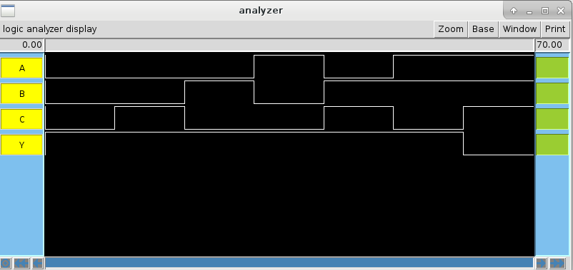

The size of the AND3 gate
Root cell box:
width x height ( llx, lly ), ( urx, ury ) area (units^2)

microns: 16.80 x 30.00 ( 0.00, 0.00 ), ( 16.80, 30.00) 504.00
lambda: 56 x 100 ( 0, 0 ), ( 56, 100 ) 5600

The diagram of the AND3 gate

The result analyzer of the AND3 gate

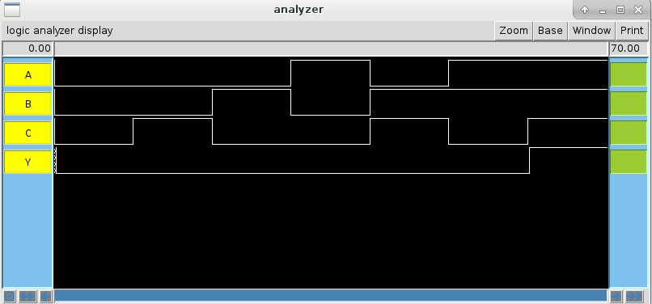

spacing between or2gates
Root cell box:
width x height ( llx, lly ), ( urx, ury ) area (units^2)

microns: 12.00 x 3.00 ( -1.80, 94.80), ( 10.20, 97.80) 36.00
lambda: 40 x 10 ( -6, 316 ), ( 34, 326 ) 400

The signals going through the bitslice
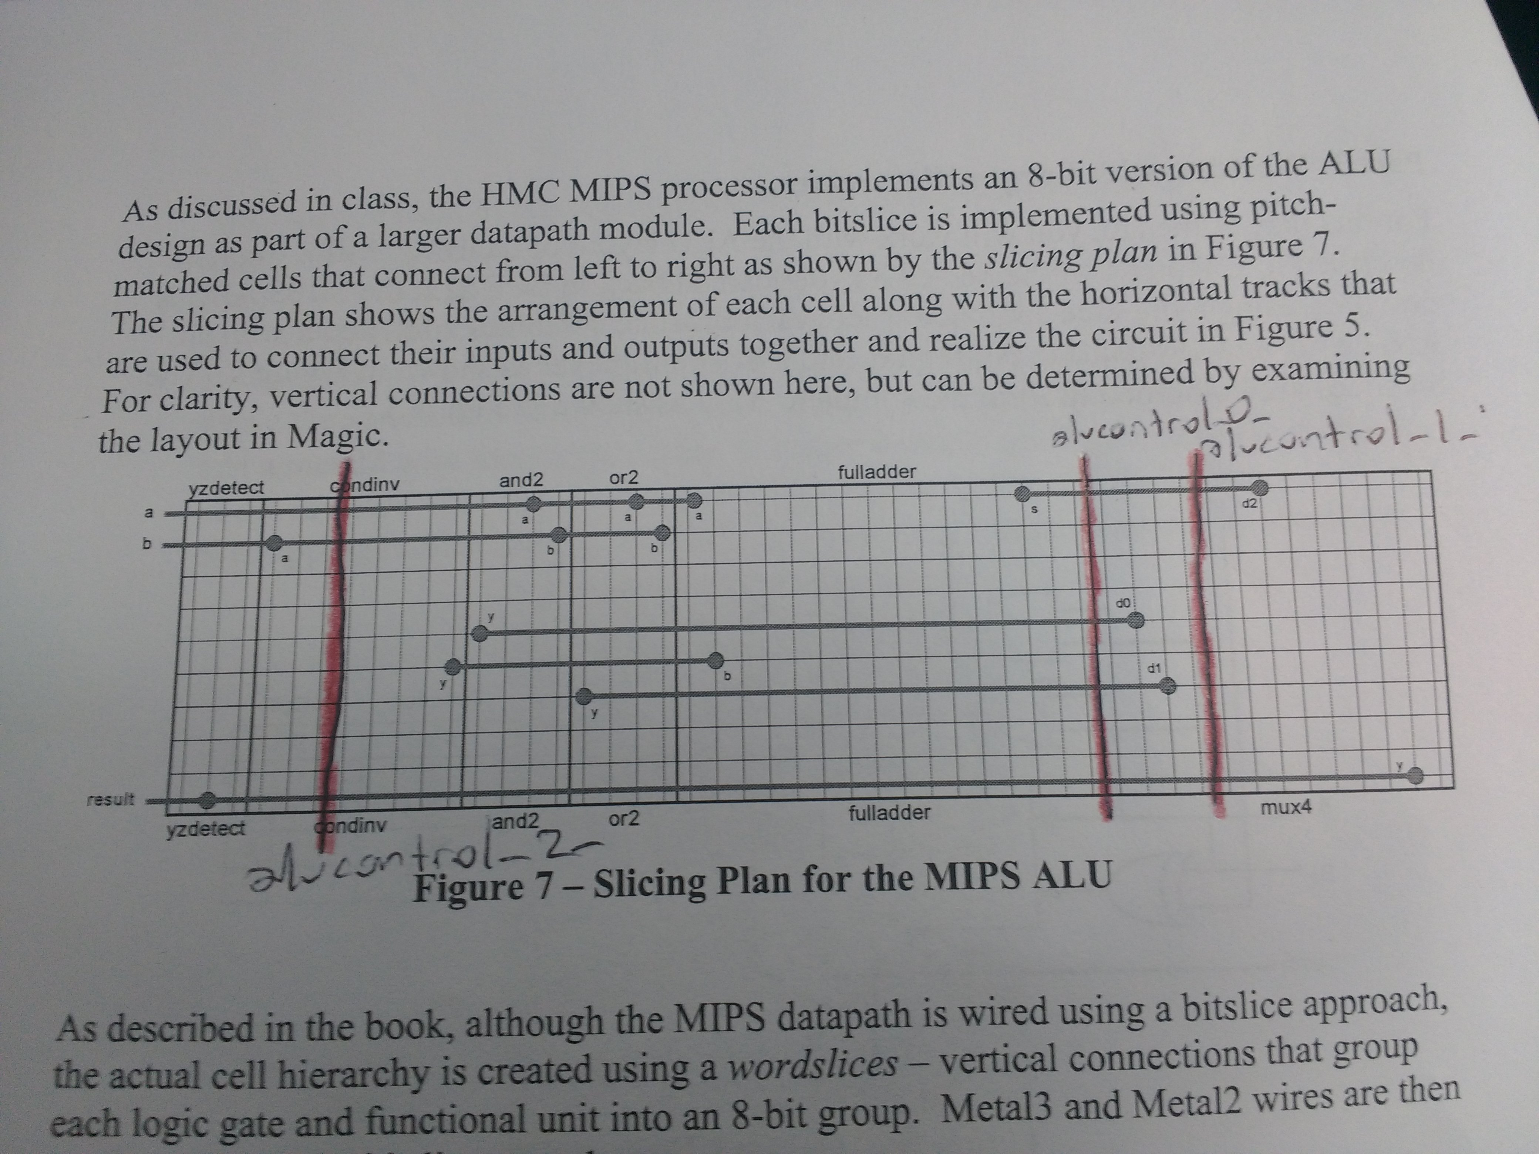

The diagram of the and2_1x_8

The diagram of the ALU

The result analyzer of the ALU

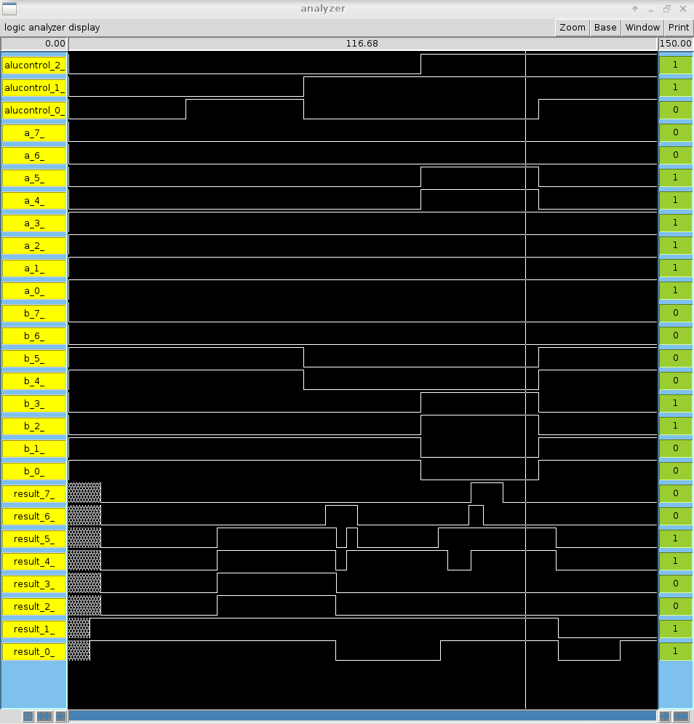

The size of the ALU

Root cell box:
width x height ( llx, lly ), ( urx, ury ) area (units^2)

microns: 123.30 x 294.00 ( -5.10, -1.20 ), ( 118.20, 292.80) 36250.20
lambda: 411 x 980 ( -17, -4 ), ( 394, 976 ) 402780

The problems :
The problems we have is how to plot large amount of inputs and outputs in clear way

Time use:
3:30 hours

