ECE 425 VLSI Circuit Design Lab 4 prelab
Lab partners: YI HAN, Kemal Dilsiz.
Time: Feb, 14 ,2017

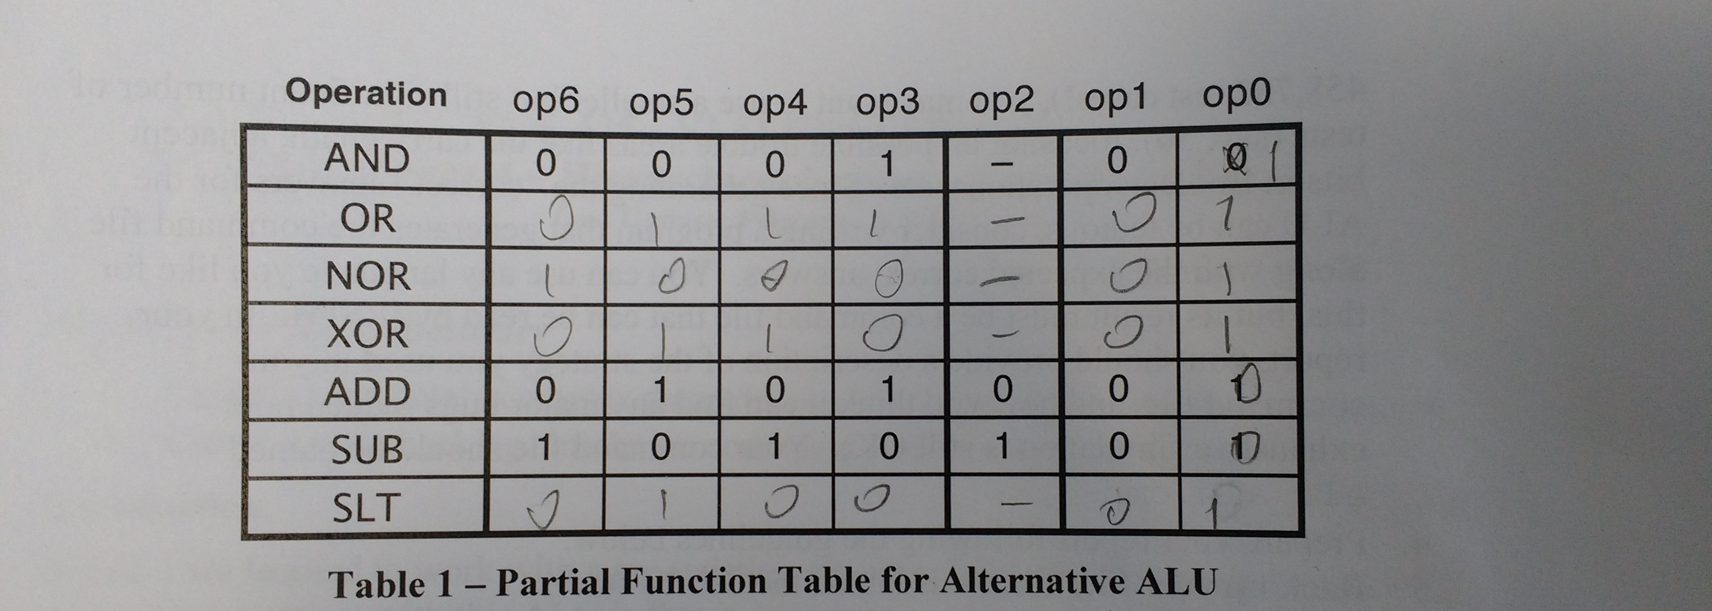
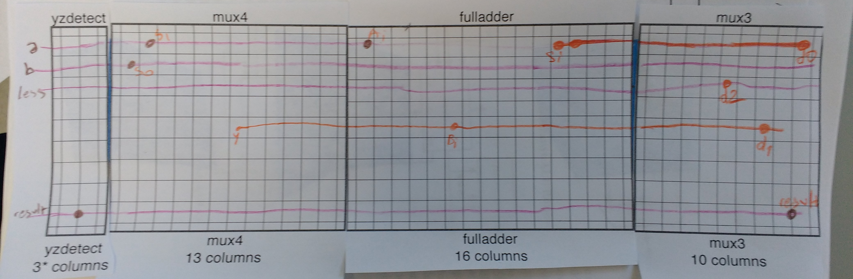
Truth table

Slicing plan

