ECE 425 VLSI Circuit Design Lab 7
Lab partners: YI HAN, Kemal Dilsiz.
Time: Mar, 21, 2017

yzdetect_fast:

****** transient analysis tnom= 25.000 temp= 70.000 ******
tpdr_a_0= 777.9435p targ= 5.0946n trig= 4.3167n
tpdf_a_0= 324.7327p targ= 2.6461n trig= 2.3214n
tpd_a_0= 551.3381p
tpdr_a_7= 787.4422p targ= 5.0946n trig= 4.3072n
tpdf_a_7= 323.4744p targ= 2.6461n trig= 2.3227n
tpd_a_7= 555.4583p
trise= 243.5465p targ= 5.2349n trig= 4.9914n
tfall= 78.8103p targ= 2.6878n trig= 2.6090n

old yzdetect:

****** transient analysis tnom= 25.000 temp= 70.000 ******
tpdr_a_0= 977.6504p targ= 5.2986n trig= 4.3209n
tpdf_a_0= 397.0092p targ= 2.7184n trig= 2.3214n
tpd_a_0= 687.3298p
tpdr_a_7= 987.5224p targ= 5.2986n trig= 4.3111n
tpdf_a_7= 395.5124p targ= 2.7184n trig= 2.3229n
tpd_a_7= 691.5174p
trise= 594.5535p targ= 5.6515n trig= 5.0570n
tfall= 167.5948p targ= 2.8075n trig= 2.6399n

Here you can clearly see the difference in between the delay values in between the two circuits. Yzdetect fast is clearly superior in every situation. Especially with trise and tfall values.

This shows our delay time comparison and we had problems with the power values and couldn’t keep up with the schedule of the labs so we have decided to submit this lab without completing the last step, Step 2.5 in lab 07 in the moodle page. We have completed all the other steps as you can also observe from our magic tarball.

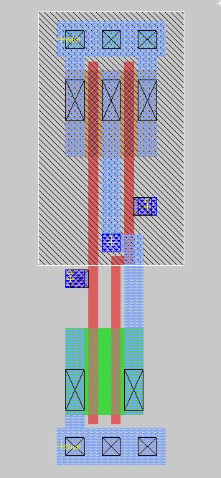
New Nand 2
New Nor 2

