Kenneth Dandrow 2/23/25

Prof. Sean Morris CS-340

**Module 7: Project Two README**

**Overview**

This project is a web-based MongoDB Dashboard built using Dash, Plotly, and Flask, designed for the company Grazioso Salvare. The dashboard allows users to filter and visualize shelter dog data from the Austin Animal Center Outcomes dataset.

**Features**

* Interactive Data Table: Displays shelter dog records with sorting and filtering options.
* Filtering by Rescue Type: Users can select from:
* Water Rescue
* Mountain/Wilderness Rescue
* Disaster/Individual Tracking
* Pie Chart Visualization: Shows breed distribution for selected rescue type.
* Geolocation Map: Displays locations of filtered dogs based on latitude/longitude.
* Grazioso Salvare Branding: Custom logo and UI elements included.

**Installation & Setup**

**Prerequisites**

Ensure you have the following installed:

* Python 3
* Jupyter Notebook
* MongoDB (running locally or via Apporto)
* Required Python Libraries: dash, dash-leaflet, plotly, pandas, pymongo

**Steps to run**

1. Run Jupyter Notebook
2. Open ProjectTwoDashboard.ipynb and execute all cells.
3. Click on the Dash URL in the output (http://127.0.0.1/) to open the dashboard in your browser.

**Screenshots**

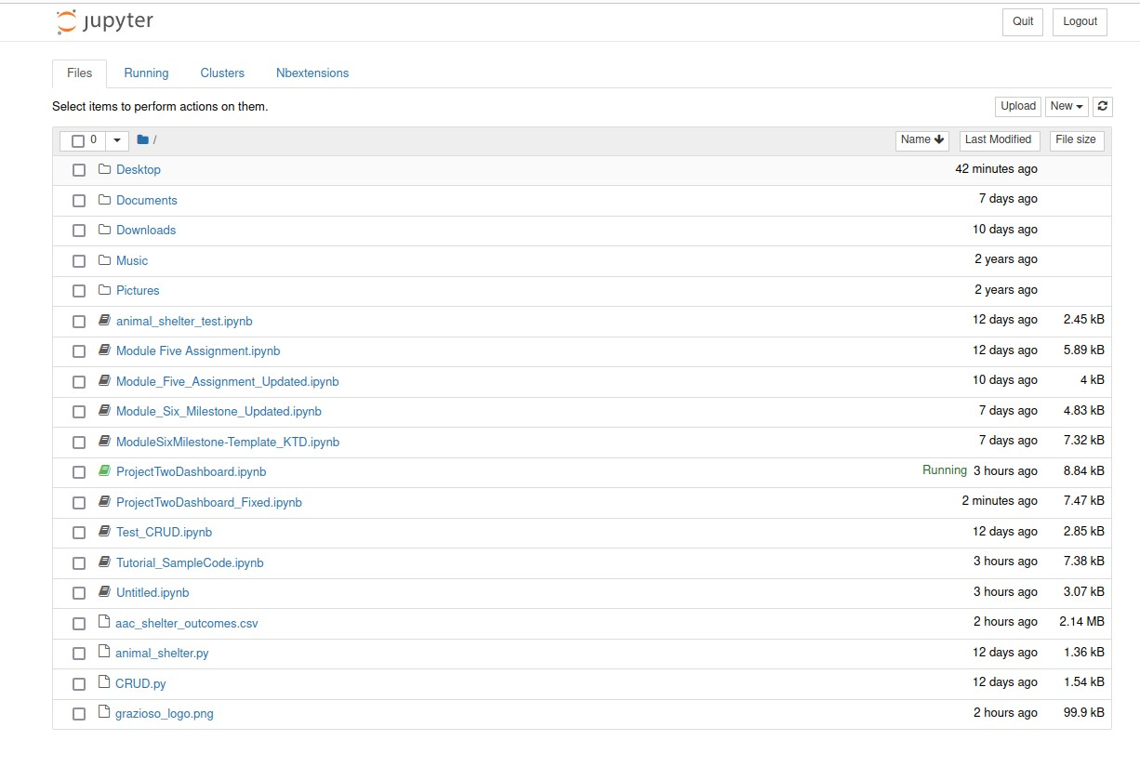

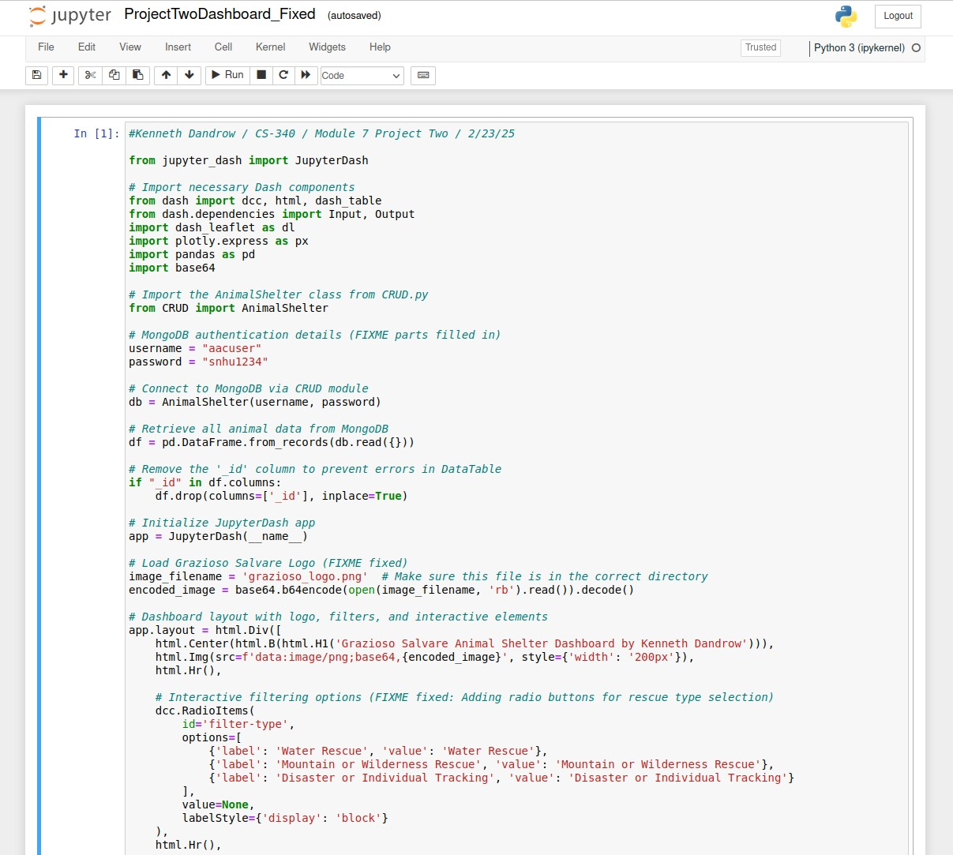

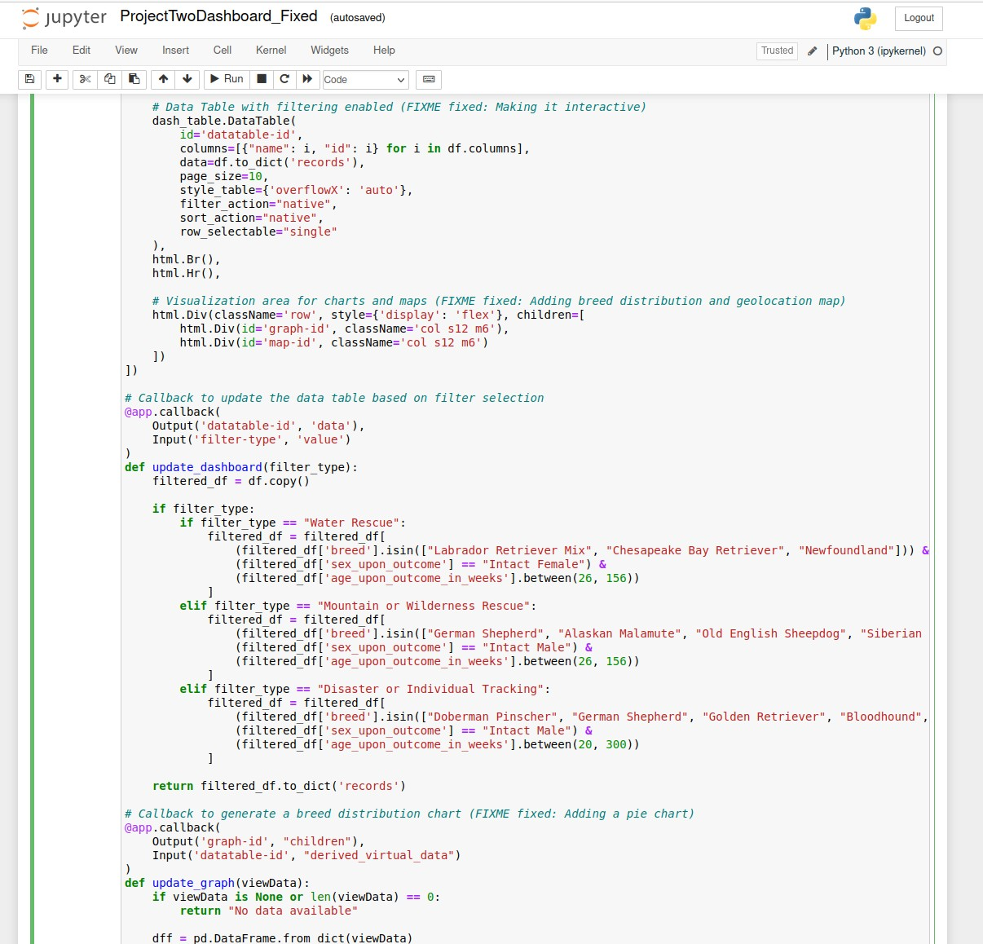

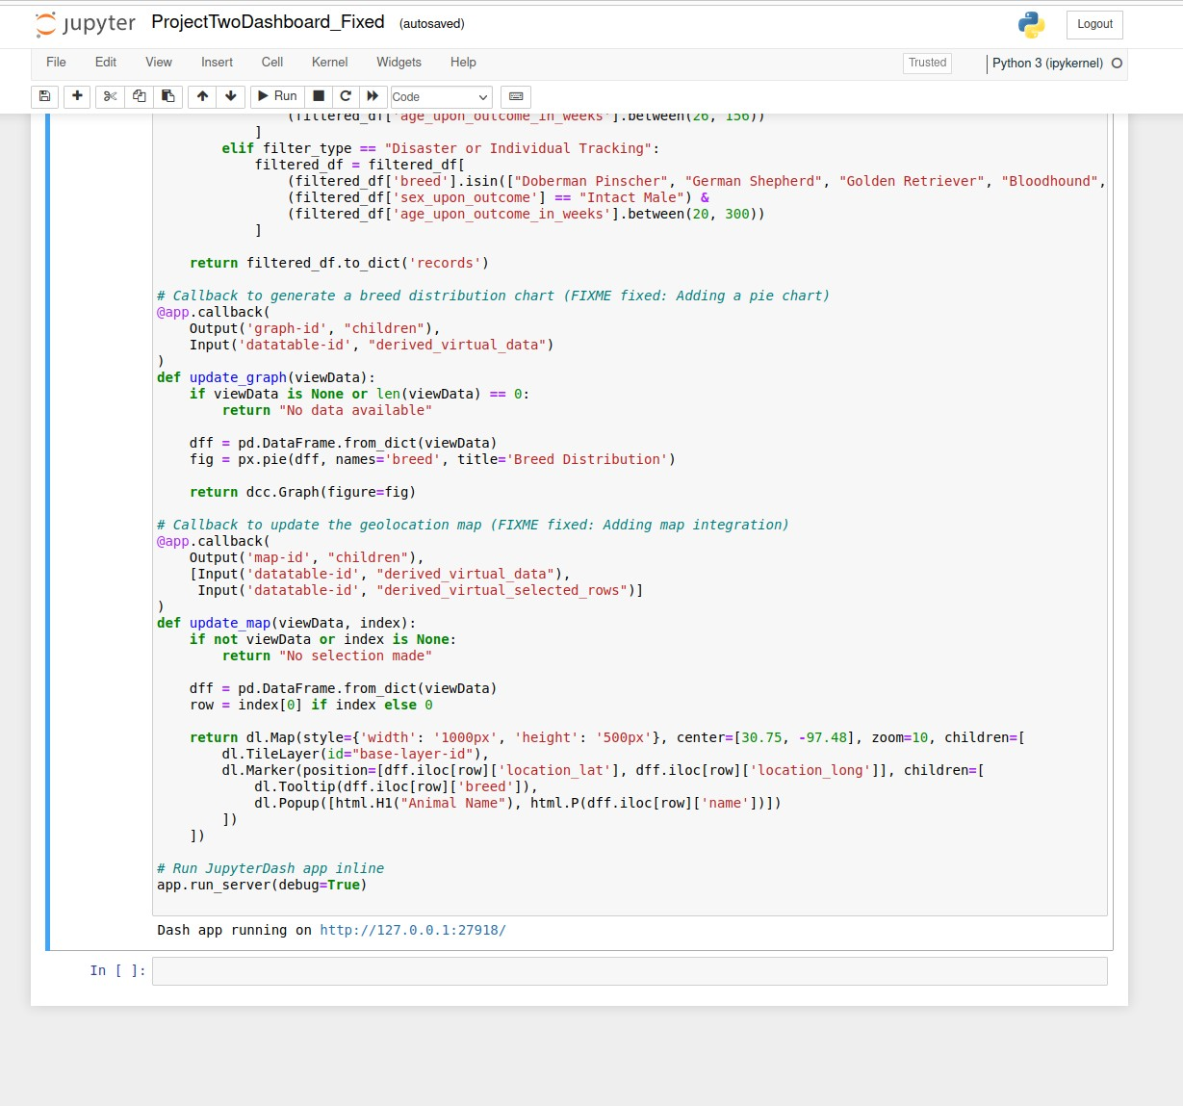

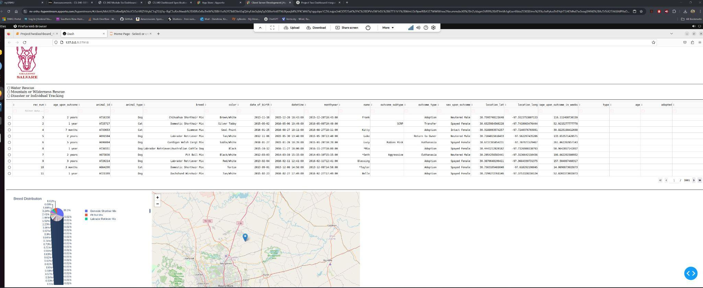

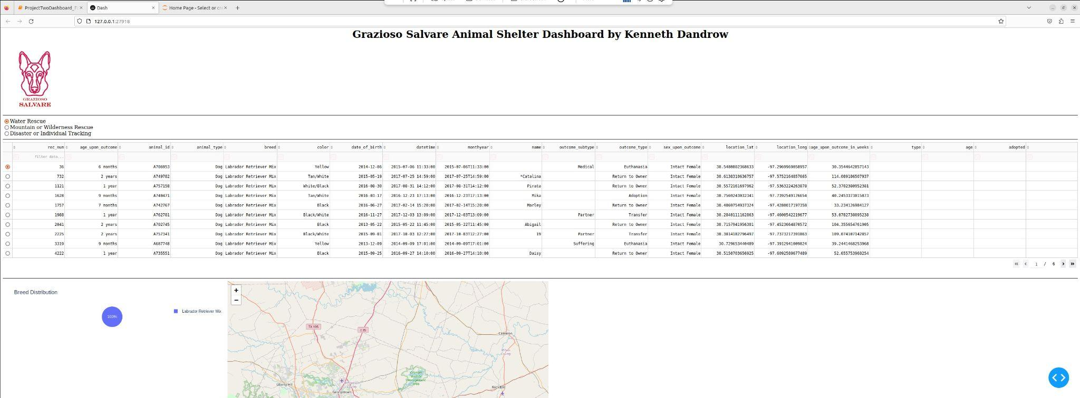

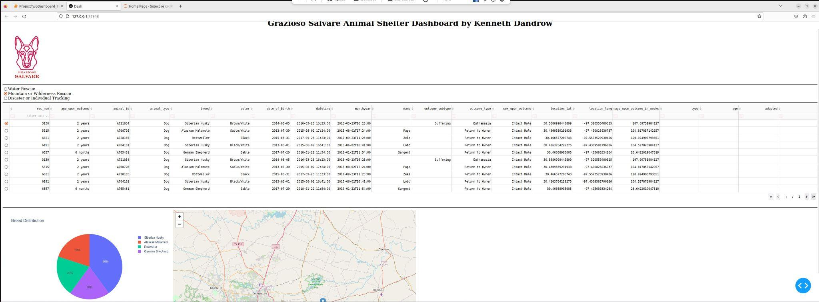

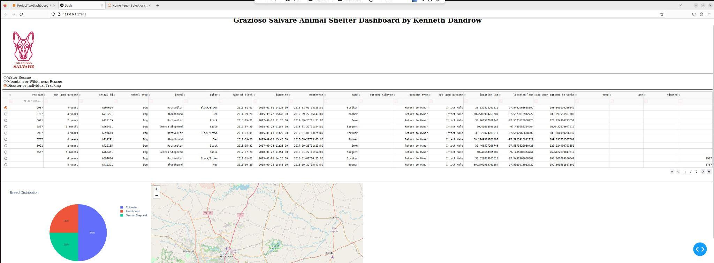

**Challenges and Lessons Learned**

* MongoDB Connection Issues: Had to ensure correct username/password and database authentication.
* Filtering Logic: The dataset lacked a rescue_type field, so we dynamically filtered data based on breed, age, and sex.
* Visualization Adjustments: The breed distribution pie chart initially showed too many labels, requiring filtering to only relevant breeds.
* Geolocation Errors: Some data had missing lat/long values, requiring handling for missing entries to prevent map crashes.
* Code Debugging & Refinements: It took quite a bit of time to get all the lines of code working correctly in ProjectTwoDashboard.ipynb. Toward the end, I had to do a lot of tweaking to ensure the columns and data displayed properly.
* Overall Learning Experience: I learned an incredible amount in this class and through this project. Working with MongoDB, Dash, and data visualization tools provided hands-on experience that significantly improved my understanding of client-server development.

**Conclusion**

This project successfully demonstrates a client-facing dashboard using MongoDB, Dash, and Plotly. It provides an interactive and visual representation of available rescue dogs, aiding Grazioso Salvare in their training selection process.

**Developer:** Kenneth Dandrow  
**Course:** CS-340 - Client/Server Development  
**Date:** February 23, 2025