KtechLab documentation

Legend:
green text: comments, notes
red text: problem description
yellow text: notes for further development

  - Features – overview (features in „rough lines”)

- creating, editing, saving projects
  - adding, removing files to/from project
- creating, editing, saving documents
- document types:
  - circuit
    - can be simulated
  - flowcode
    - set up pic to upload to
    - can be converted to microbe, hex, assemby
    - uploaded to pic
  - text
    - hex
    - assembly
    - microbe
    - C
    - can be converted to some other formats and uploaded to the pic
- help can be read
  - for each item there should be help

- Features – detailed (every feature should be listed here, useful for testing)

- creating, editing, saving projects
  - adding, removing files to/from projekt
  - creating subprojects
- creating, editing, saving documents
  - zoom in/out
  - cut/copy/paste
  - undo/redo
  - print
- document types:
  - circuit
    - can be simulated
  - flowcode
    - set up pic to upload to
    - can be converted to microbe, hex, assemby
    - uploaded to pic
  - flowcode & circuit
    - can be exportedas an image
    - items can be :
      - placed on the document by drag and drop
      - deleted
      - selected
      - their properties can be edited
      - can be rotated
    - items can be connected
  - text
    - hex
    - assembly
    - microbe
    - C
    - can be converted to some other formats and uploaded to the pic
      - can be exported as html

( here should come quite a few features / use cases )

- Class diagrams

3.1: ktechlab, document, documentifaces, views, viewifaces
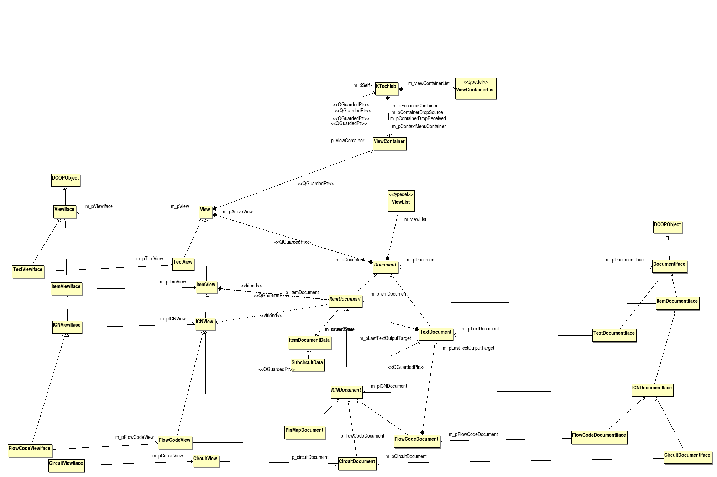
Here are 4 class categories:
- Document
- DocumentIface
- View
- ViewIface
hierarchies. (what are these good for?) they seem to be related to kde & dcop

From each category there are 4 levels of abstraction:
- Document
  - TextDocument
  - ItemDocument
    - ICNDocument
      - FlowCodeDocument
      - CircuitDocument

( has ICN* any meaning as an abstraction? Is it needed? )
( the ItemDocumentData class is flawed; there should be a class hierarhy – there are are lots of dynamic_cast -s in its implementation; also the objects should know to convert themselves to XML, to make the structure extensible )

3.2 Circuit: circuitdocument, *node, connector,*item, component, element

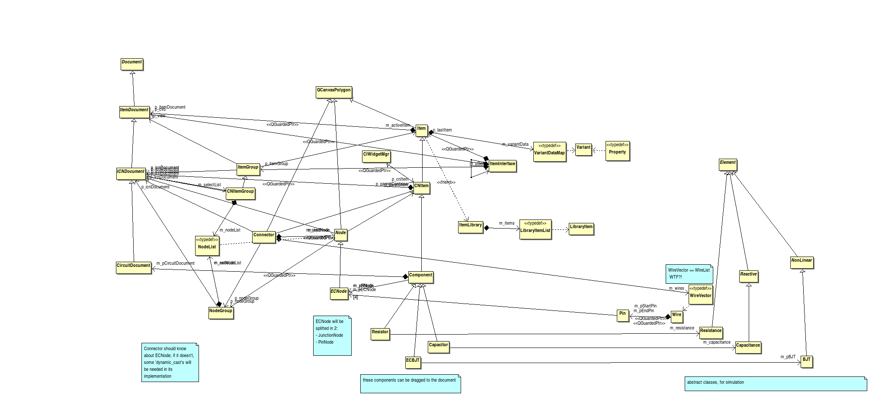

Relations:
- an Item knows about ItemDocument
- CNItem about ICNDocument
- Component about CircuitDocument

A Connector connects two Nodes. There should be separate connectors for circuits and for flow documents.
ECNode will be split into JunctionNode and PinNode.
The creation of Components is messy and not extensible; the Component class has methods for creating Pins, Wires, …
There is an ugly tyedef for Variant == Property; WireVector == WireList

General problem: there are multiple typedefs for ConnectorList, ItemList, NodeList, …

There are no clearly defined abstraction levels: the left side of the diagram looks like a spider’s net

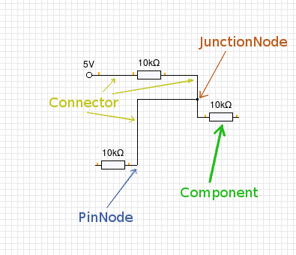

3.3 Flowdocument: FlowPart, FPNode, FlowCodeDocument, FlowCode

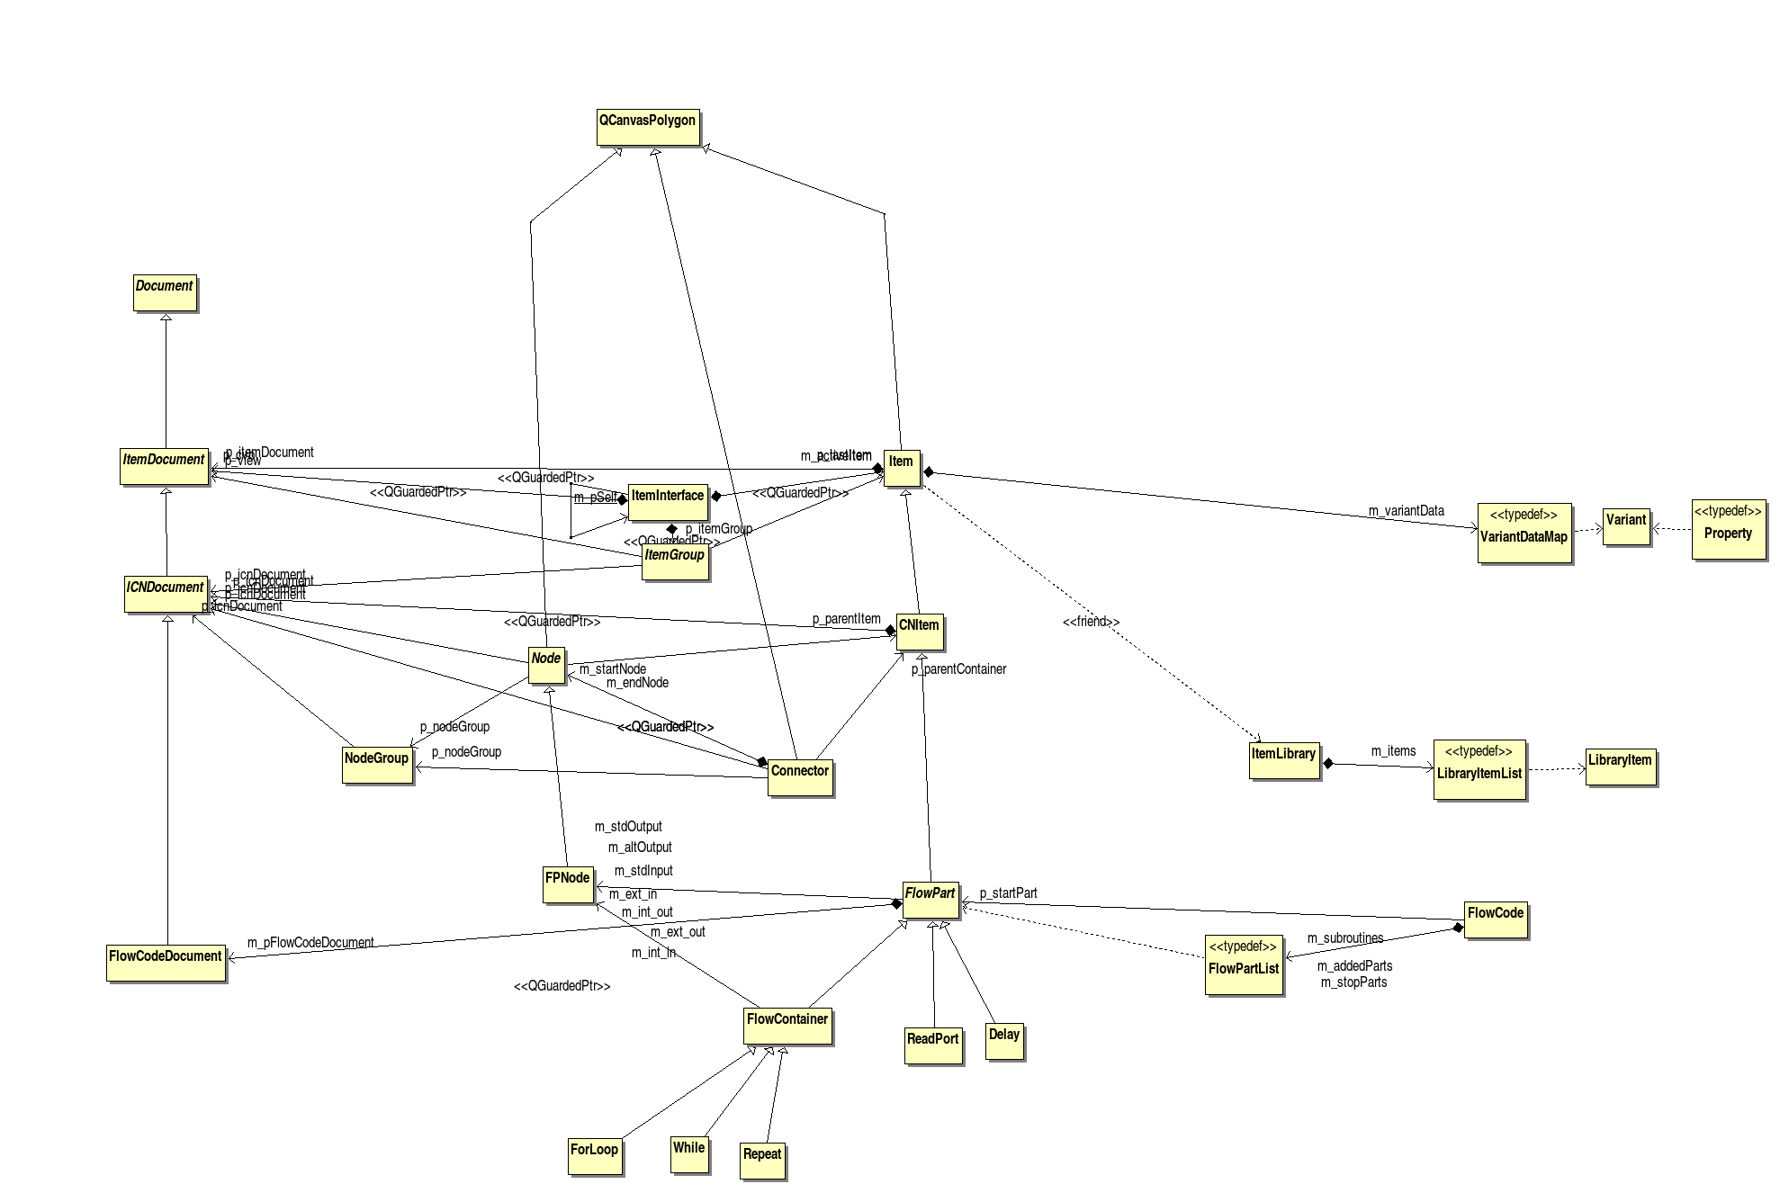
This diagram is similar to the circuitdocument; the separation of abstraction levels is better. The product of this class structure is the FlowCode; the FlowPart class has a generateMicrobe virtual member.

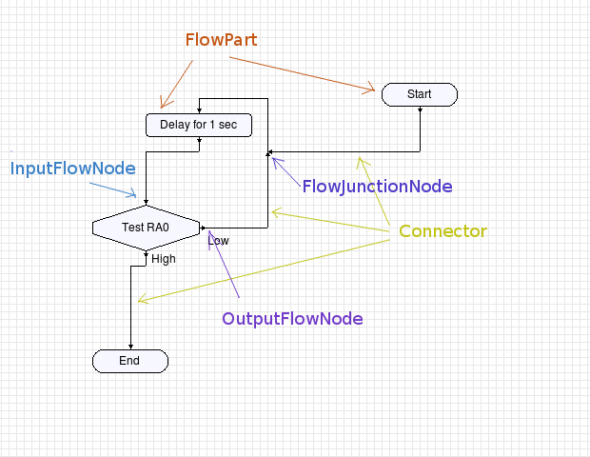

3.4 Language, LanguageManager

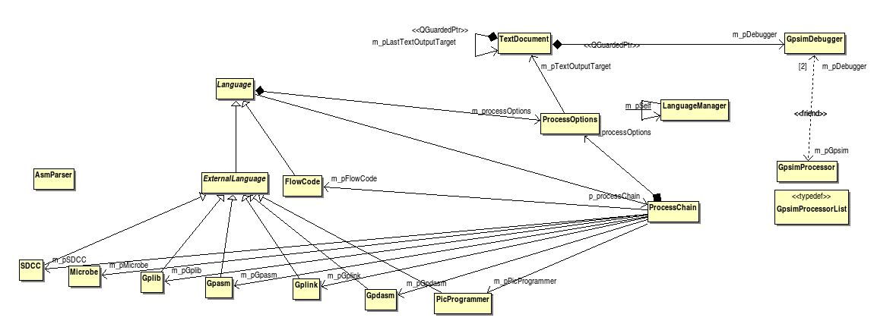
The descendents of ExternalLanguage call the external programs to do the effective work. The programs act on temporary files. The needed conversions are described by the ProcessOptions class, which is passed from the textDocument to the LanguageManager and finally to the specific ExternalLanguage.

See the collaborations part for more description.

(here should come other diagrams, covering each class at least once)
(diagrams are created by the Bouml UML modeler, which can reverse the entire ktechlab code, without becoming unusably slow)

- Collaboration Diagrams

(here should come quite a few collaborations; each feature/task from the detailed feature list should have one)

4.1 Creating components / flowparts

At applications startup:
ItemLibrary::ItemLibrary() -> ItemLibrary::addComponents(); -> add{Components|FlowParts|Mechanics|DrawParts} -> ItemLibrary::addLibraryItem( [CLASSNAME]::libraryItem() )

Creating:
CVBEditor::event() -> CircuitView::dragEnterEvent() -> ItemView::createDragItem() -> ItemLibrary::createItem() -> [CLASSNAME]::consturct()-> [CLASSNAME]::[CLASSNAME] (consturctor..)

Note: [CLASSNAME] is the name of the class inherited from Component or FlowPart

4.2 Compiling something

User clicks the convert to menu:
slot: TextDocument::slotConvertTo() -> TextDocument::convertToHex() -> LanguageManager::compile() -> new ProcessChain -> QTimer::singleShot( compile() ) [ new thread ]; ProcessChain::compile() -> [SDCC, GPASM, flowCode,... [language] ]-> processInput() ;

When more than one processing needed, the currecnt processer (SDCC, GPASM, flowCode,...) sets which should be the next operation/processer. That is a design problem.

Finishing:
slot got signal: ExternalLanguage::processExited() -> Language::finish() -> [SDCC, GPASM, flowCode, ...]::outputPath() : defines the next thing to do.

5. Emitted Singals & Slots receiving

This is an important feature in QT and it’s heavily used in ktechlab. This makes also the program flow harder to follow.
(The bad part of this is in debugging, as one can see meaningful stack only from qt_invoke, because the rest of the program runs in parralel, in separate thread. So quess where was that signal emitted...)

