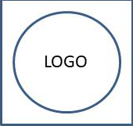

**Abcde Fghij Klmno Pqrs**

Immunization Report from 2022-02-27 to 2022-03-12

Investigator: **First Name Last**

|  |  |  |  |  |
| --- | --- | --- | --- | --- |
| Immunogen | Adjuvant | Sample | Sample Batch | Supplied By |
| DHEY-22 | DH-261 | Full herd was immunized with sample supplied. The total volume is in buffer looked slightly particulate in nature. No processing done. | AWXD-123 | Sjfwe fwer |