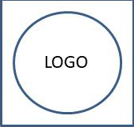

**Abcde Fghij Klmno Pqrs**

Immunization Report from 2022-03-01 to 2022-08-08

Investigator: **First Name Last**

|  |  |  |  |  |
| --- | --- | --- | --- | --- |
| Immunogen | Adjuvant | Sample | Sample Batch | Supplied By |
| IGGfc | FCA | First Primary injection | ART01 | ART |
| IGGfc | FCA | Second Primary injection | ART01 | ART |