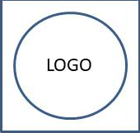

**Abcde Fghij Klmno Pqrs**

Serum Collection Report from 2022-02-01 to 2022-03-10

Investigator: **Abcd Efgh**

|  |  |  |  |  |
| --- | --- | --- | --- | --- |
| Herd | Total | Volume | Date | Batch Code |
| 1 | 30 | 621 | 2022-03-02 | RTGqdCHf |