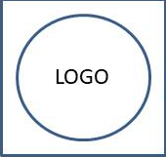

**${title}**

Notebook from ${frDate} to ${toDate}

Investigator: **${piName}**

${table}