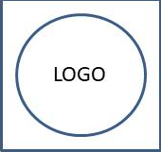

**${title}**

Usage from ${frDate} to ${toDate}

Investigator: **${piName}**

Project: ${projecTitle}

${table}