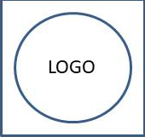

**Abcde Fghij Klmno Pqrs**

Usage from 2019-01-01 to 2022-01-24

Investigator: **Demo PISG**

Project: This is Abcd of Xyz of test

|  |  |  |  |
| --- | --- | --- | --- |
| Dt.Usage | Name | Number | Details |
| 25-09-2020 | fagr | 25 | Mice/Balb/c-Nz/Male/6-Months |
| 25-09-2020 | fagr | 20 | Mice/C57BL/6/Any/4-Weeks |
| 25-09-2020 | fagr | 30 | Mice/SCID-1/Female/4-Weeks |
| 25-09-2020 | fagr | 10 | Mice/SCID-1-KOL/Male/5-Weeks |
| 25-09-2020 | fagr | 10 | Mice/SCID-1-KOL/Female/8-Days |