The following box plots were generated from three different datasets.

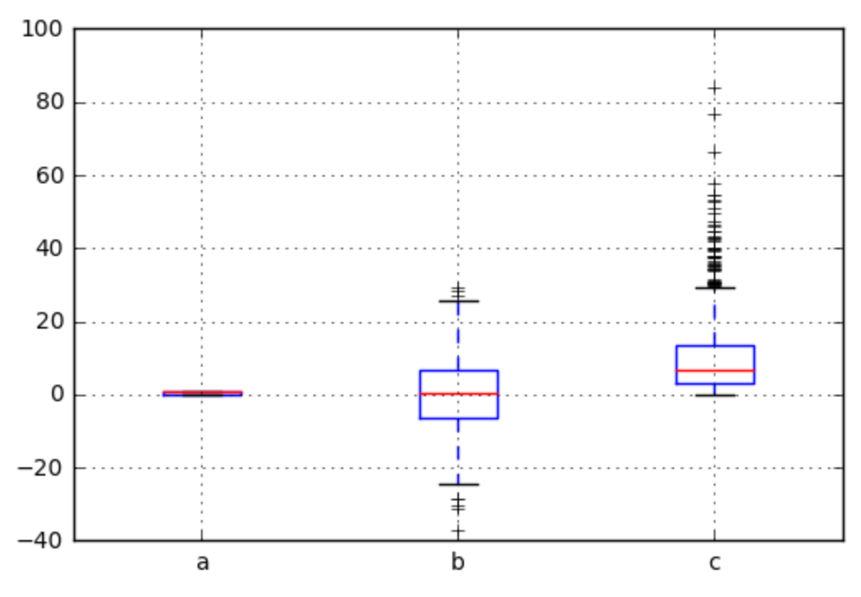

Can you match the density plots below to their corresponding box plots? (Hint: one of them is a density plot for a dataset that was not used in the box plot figure)

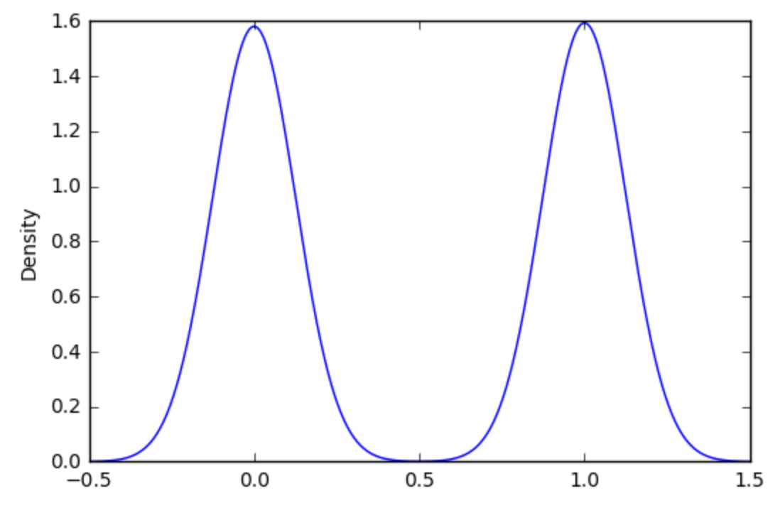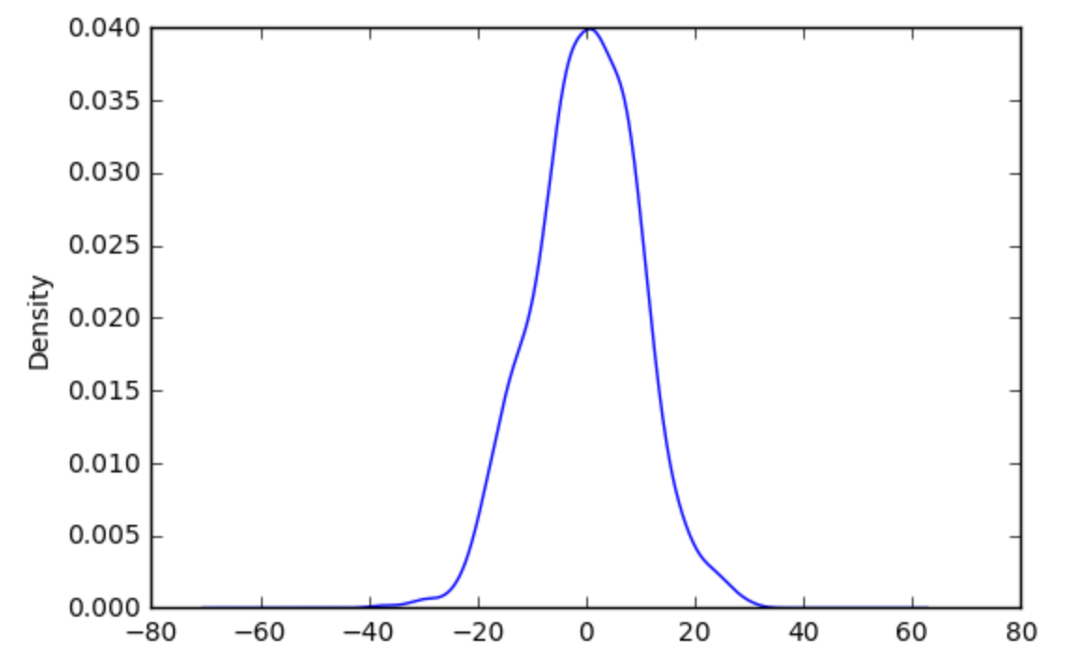

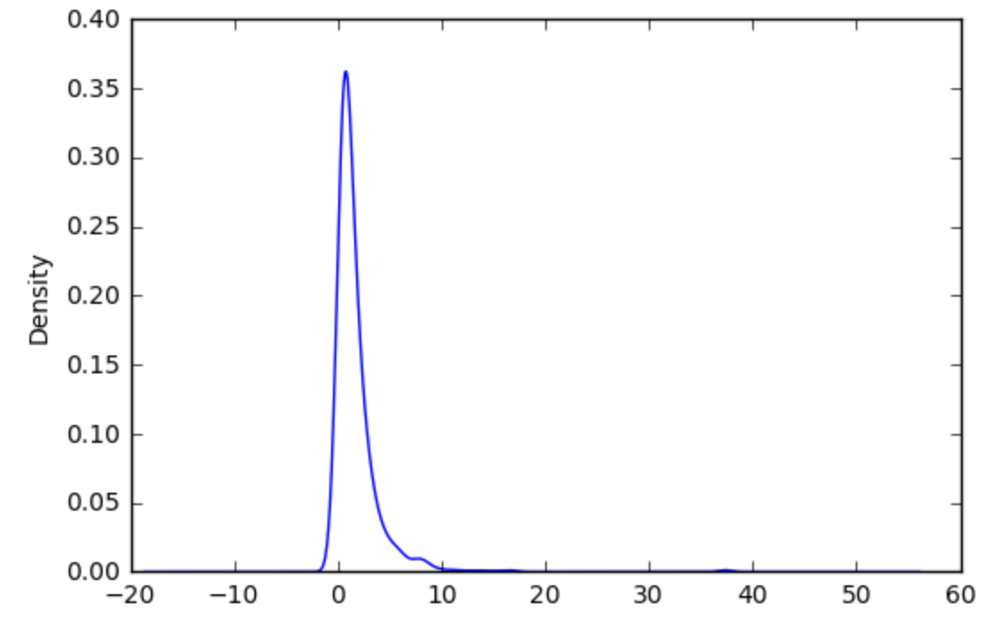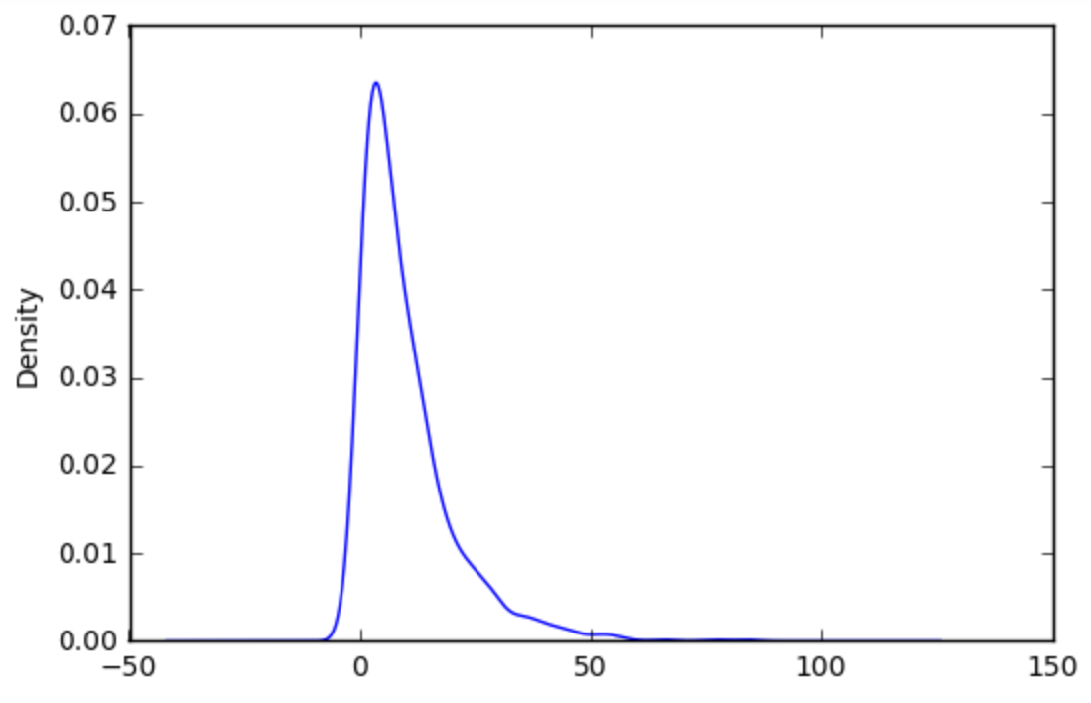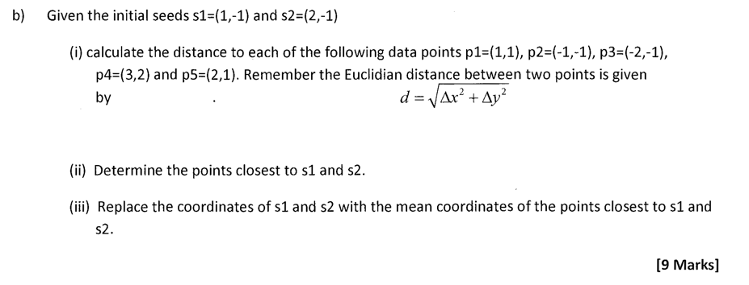

From: https://stats.stackexchange.com/questions/149816/k-means-clustering-exam-question