Jian et al. 2025
Response_category | Metrics
Growth | Abundance  Biomass  Body length  Body volume  Ciliate biomass  Growth rate  Length  Offspring body size  Prosome length
Metabolism | Respiration rate  Ingestion rate  Fatty acids — Total  Fatty acids — MUFA  Fatty acids — PUFA  Average calcium content
Reproduction | Hatching success / hatch rate  Egg production rate  Fertilization rate  Nauplii production  Development time (repro stage)
Survival | Percent survival  Survival rate  Hatching success  Mortality  Calcification rate

Alter et al. 2024: Invertebrates [LARVAE AND POSTLARVA]
Response_category | Metrics | Recoded
Behaviour | Number of algal cells cleared/12 hr — mL⁻¹  Activity — s min⁻¹  Number of artemia eaten — ind h⁻¹  Number of lines crossed — s min⁻¹ | Behaviour  Behaviour  Behaviour  Behaviour
Calcification | Carapace [Ca²⁺] — mmol mg⁻¹  Net calcification rate — µmol mg_shell⁻¹ d⁻¹  Shell damage — % area  Calcium content — mg L⁻¹ mg FW⁻¹ | Physiology  Physiology  Physiology  Physiology
Development | Abnormalities — %  Arm asymmetry — µm, mm  Asymmetry — µm  Calcified larvae — %  Developmental period zoea 2 — days  Gastrulation — %  Larval duration — days  Larval stage — %  Malformation — %  Mean larval emergence — NA  Metamorphosis — %  Molt stage duration Z5 — days  Normal — %  Normal larvae — %  Settlement — %, % total planulae  Settlement success — %  Time to first hatch — days  Veliger stage — %  Yolk-sac volume — mm³ | Development  Development  Development  Physiology  Development  Development  Development  Development  Development  Development  Development  Development  Development  Development  Development  Development  Development  Development  Growth
Growth | Arm length — µm  Biomass — µg·polyp⁻¹  Body length — µm  Dorsal mantle length — mm  Dry weight M14 — µg ind⁻¹  Growth at PII — µm  Growth rate — mm; µm; µm·d⁻¹·10³  Larval area — mm²  Larval length — µm  Larval size — mm²; %/d  Length — mm; µm  Length (change after 1 day) — mm  Length:width ratio — NA  Mean daily growth rate — µm·d⁻¹  Shell length — µm  Skeletal mass — µg·polyp⁻¹  Test diameter — µm | Growth  Growth  Growth  Growth  Growth  Growth  Growth  Growth  Growth  Growth  Growth  Growth  Growth  Growth  Growth  Growth  Growth
Physiology | RNA:DNA ratio — ratio (often treated as unitless; some rows NA)  Host HSP70 expression — NA  CS activity (Day 11) — µmol larva⁻¹ min⁻¹  C:N ratio — NA (unitless)  Total protein (change after 1 day) — µg larva⁻¹  Symbiont density (change after 1 day) — 10³ cells larva⁻¹  Lipid index — NA  Symbiodinium density — 10³ cells larva⁻¹  Total protein — µg larva⁻¹  LT100 (critical thermal maximum) — °C  Heat shock protein levels (HSP70) — ng mg⁻¹ wet mass  Malondialdehyde (oxidative stress marker) — nmol mg⁻¹ (P) (as in your sheet; typically per mg protein) | Physiology  Physiology  Physiology  Physiology  Physiology  Physiology  Physiology  Physiology  Physiology  Physiology  Physiology  Physiology  Physiology  Physiology
Routine Respiration | Respiration — pmol O₂ larva⁻¹ h⁻¹; nmol O₂ larva⁻¹ min⁻¹  O₂ consumption (Day 11) — nmol larva⁻¹ min⁻¹ (same rate, O₂ implied)  Oxygen consumption — nmol O₂ h⁻¹ mg DW⁻¹ | Physiology  Physiology  Physiology
Survival | Survival — %  Mortality — %; % total planulae  Density — larvae mL⁻¹  Hatching success — % | Survival  Survival  Survival  Reproduction

Alter et al. 2024: Fish [LARVAE AND EMBRYO]
Response_category | Metrics | Recoded
Aerobic scope respiration | aerobic scope — mg kg⁻¹ hr⁻¹ | Physiology
Behaviour | Time Active — %  Ucrit — BL/sec | Behaviour  Behaviour
Calcification | otolith area — mm²  Saggitae diameter at hatch — µm/cm | Growth  Development
Development | Eye diameter (42 days) — µm  Abnormal larvae — %  Total abnormalities — %  Yolk area at 1 dph — mm²  Yolk area — mm²  Yolk sac area — mm²  Deformities / Normal (reported as “% hatched larvae”) — % hatched larvae  Developmental time — days  Hatching time — days  Hatch duration — h  Time to hatch — days | Growth  Development  Development  Growth  Growth  Growth  Development  Development  Development  Development  Development
Growth | Instantaneous growth rate — none  Standard length at 21 dph — mm  Length — mm  Growth rate — % d⁻¹; mm d⁻¹  Mass — g  Total length at 11 dph — cm  Length at hatch — mm  hatching length - mm2  length at hatch - mm  egg volume - mm3  growth rate - % day-1  ipc-cover - % of yolk sac area  mass - mm2 | Growth  Growth  Growth  Growth  Growth  Growth  Development  Development  Development  Growth  Growth  Growth  Growth
Physiology | Enzyme activity — µmol ATP mg⁻¹ protein h⁻¹  Heart rates — beats min⁻¹  Routine heart rates — beats min⁻¹  Citrate synthase activity — U mg protein⁻¹  Critical thermal maximum (postlarva) — °C  C:N ratios (42 days) — NA  Critical thermal maximum (hatchling) — °C  Osmolarity — mosmol kg⁻¹  Heart rates — %  ETS mitochondrial capacity — nmol O₂ (eggs·h)⁻¹ | Physiology  Physiology  Physiology  Physiology  Physiology  Physiology  Physiology  Physiology  Physiology  Physiology
Reproduction | Fertilization success - % | Reproduction
Routine Respiration | Resting metabolic rate — mg kg⁻¹ hr⁻¹  Oxygen consumption rate — µmol O₂ g⁻¹ h⁻¹; µmol O₂ h⁻¹ mg WW⁻¹  oxygen consumption rates (hatchling) — µmol O₂ g⁻¹ h⁻¹ (wet weight)  routine metabolic rate (pre-hatching embryo) — mmol O₂ embryo⁻¹ h⁻¹  Ln O₂ consumption rates — nmol ind⁻¹ h⁻¹  MO₂ — nmol O₂ (eggs·h)⁻¹ | Physiology  Physiology  Physiology  Physiology  Physiology  Physiology
Survival | Daily mortality rate — n d⁻¹  Flexion — %  Survival — %  Survival from 1 to 25 dph — %  Larval survival — %  Survival — %  Survival — Percent hatch  Survival at 1 dph — %  Hatching success — %  Hatching success — % fertilized eggs  Eggs that survived to hatching — %  Total embryo mortality — % | Survival  Development  Survival  Survival  Survival  Survival  Reproduction  Survival  Reproduction  Reproduction  Reproduction  Survival

Final Categories | Working definition
Growth  Development | Change in body size or mass over time. (e.g., length, biomass, growth rate)  Progress through life-history stages or time to milestones. (e.g., time to hatch/flexion, % at flexion, stage duration)
Behaviour | Observable actions/performance affecting feeding, movement, or risk. (e.g., time active %, Ucrit, swimming speed, foraging/escape responses)
Physiology | Internal functional state and processes maintaining homeostasis. (e.g., respiration/ṀO₂, CO₂ production, acid–base/pH/HCO₃⁻, calcification, ion balance, cardiac/ventilation rate, thermal tolerance, antioxidant/immune markers)
Reproduction | Gamete production and success from fertilisation to early offspring. (e.g., fecundity, egg/nauplii production, fertilisation %, hatching success)
Survival | Probability of remaining alive over a period. (e.g., % survival, mortality rate n·d⁻¹)

META-ANALYSIS REFERENCES:
Methodologies:

- Alter et al. 2024: Invertebrates Dataset
- Filter all columns > Go to LifeStage > and only enable EMBRYO, LARVA, AND POSTLARVA (924)
- Since there are other invertebrates that may be HOLOPANKTONIC, extract the unique species values for ADULT, JUVENILE, JUVENILE/ADULT, and use AI (ChatGPT) to identify which ones are holoplanktonic =>
  - Check this whether it already exists with Jian’s dataset => All already exists (0)

Alter et al. 2024: Fish Dataset
- Filter all columns > Go to LifeStage > and enable EMBRYO AND LARVA
- In the column Group, only enable Fish as elasmobranch are not planktonic at all in all of its life stages (260)

- Jian et al. 2022

For zooplankton:
- Filter columns > Ecosystem_category == Marine > Biota_Group == Zooplankton (retrieved 350)
- One entry under Towle, Erica K. et al., 2016 was categorised under Zooplankton but was transferred to Meroplankton (349)

For fish and invertebrae:
- Filter columns > Ecosystem_category == Marine > Biota_Group == Fish & Invertebrae (retrieved 259)
- For these remaining studies, look at first whether they already exist in Alter or not. If not:
- Check whether the reference studied meroplankton stage or not (look up the study itself). If they did not look at meroplanktonic stage, on the link column, note this down.
- Moreover, exclude juveniles (i.e., Kikkawa et al. 2003)
- Using this schematic, only 127 retrieved.
- Since Hoshijama U et al. 2017 look at pteropods, this was transferred to holoplankton, thus the remaining retrieved entries is just (123)

- Hoppit et al. 2022
- Filter columns > In the column taxonomy, disable the following: Seagrass, Algae, calcifying algae => 514 studies
- Under organism, look up which species are holoplanktonic and enable them only, and this include the following (29) 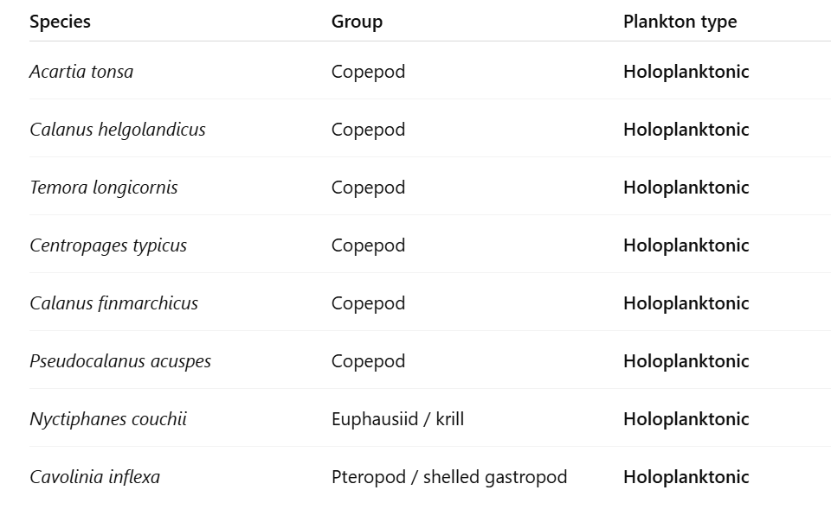
- Then check whether each of these already exists in the current database => all are new (29)
- Now, under organism, disable all the holoplanktonic species, and then under the column dev_stage, disable the adults and juvenile and na (technically leave egg/larva) => 85
- Then check whether these studies are new
- The new ones => 55
- Thus, the total for Hoppit et al. combined is 84.

- Hu et al. 2024
- Filter columns > Go to LifeStage and enable embryo, egg, fertilization and larvae => 150 records
- Go to species column and identify which species don’t undergo planktonic stage and disable them => strict no include Sepia officinalis and Macrocystis spp. => 141 records remain
- Manually check whether such studies already exist in the database or not. If they already exist drop them => 51 records remain
- Now, clear all filters, and then go to species section, identify which species are holoplanktonic => Limacina spp., Neogloboquadrina, and marginopora => 12 records
- Identify whether they are new records or not => 12 records remained
- In total, 51 + 12 => 63 records retrieved

- Kindinger et al. 2022
- Filter columns > Go to Cons_taxa spec and then enable only those holoplanktonic species, which include these:

Copepod
Krill
Ciliate
dinoflagellate

- This results to 28 retrieved entries. Then identify what’s new => 24
- Then remove filter, and then got to Cons_taxa spec again, and then try to enable everything except for the holoplanktonic taxon groups and then under cons_lstage category, select larv => 32 entries, then check whether new => 20
- In total, 24 + 20 => 44 entries

- Kruft-Welton et al. 2024
- Filter columns > Go to developmental_stage == Egg/larva => 45 entries
- Check if new => 42 entries

- Lang et al. 2023
- Filter columns > Lifestage > select embryonic, larval, and gametes => 295 entries
- manually check if study already exists in the database (in reference to Alter et al.) => 242 entries

- Ross et al. 2024
- Standard protocol: Go to Life_stage > enable larval only > and then manually check if data already exists
- There are four spreadsheets
  - OA_Data_Size => 60 entries
  - OA_Mortality => 45 entries
  - T_Data_Size => 19 entries
  - T_Mortality => 37 entries

- Rynkowski et al.
- Filter columns > Life stage = larvae, embryo, gametes => 26 entries

- Hamraj et al. 2021
- There are several sheets in this database
- All the acidification related sheets are already reflected in Jian et al. 2025 => double checked and apparently not all the entries are reflected in Jian
  - Egg production => 79 records => 53 records after filtering out existing records
  - Survival => 22 entries => 3 entries
  - Respiration => 56 entries => 65 entries
  - Feeding => 26 entries => 17 entries
  - Egg hatching => 152 entries => 110 entries
- All the temperature related entries are new => 312 entries
  - Egg production => 121 entries
  - Egg hatching => 70 entries
  - Survival => 52 entries
  - Respiration => 46 entries
  - Feeding => 23 entries

- Leung et al. 2022
- Provided by the author himself

