

Strategic Analysis, Planning Brief & Recommendation Memo
Prepared for: Shane & Josh
ABN 14 885 784 590 | Perth, Western Australia

Data Methodology Note
⚠ METHODOLOGY NOTE: The DQ Status Tally is a CUMULATIVE daily snapshot. Each row records the pipeline state for a consultant on that date — it is NOT a log of new events. Summing across rows double-counts leads. All figures in this document are derived from snapshot comparisons (first vs. last date), day-over-day changes from Josh’s analyst notes, and within-snapshot ratios (e.g., rejection rates). An earlier version (V2) incorrectly summed cumulative rows, reporting inflated totals such as ‘3,594 leads.’ Those figures have been corrected throughout this document.

PART 1: DATA ANALYSIS — Evidence & Significance

1. Key Numbers
A. DQ Status Tally — Field Operations Pipeline (Feb 20 – Apr 2, 2026)
The DQ Status Tally contains 170 rows of daily cumulative snapshots across 4 consultants, tracking the full lead lifecycle from door-knock to sale. This is the most significant dataset in the source material. The correct way to read it is to compare pipeline states across dates, not to sum rows.

Pipeline Snapshot Comparison (First vs. Last Date):
Consultant | Feb 20 Pipeline | Apr 2 Pipeline | Change | Growth % | Status
Josh | 65 leads | 58 leads | -7 | -11% | Mature — pipeline cycling (leads closing or rejecting)
DJ | 0 leads | 58 leads | +58 | New | Surging — matched Josh’s pipeline in 5 weeks
Lea | 26 leads | 28 leads | +2 | +8% | Frozen — static at 28–29 for 15 days; departing
Shane | 1 lead | 13 leads | +12 | +1200% | Small but growing; highest conversion efficiency
TOTAL | ~107 leads | ~157 leads | +50 | +47% | Growing overall; driven by DJ onboarding

Pipeline Composition (Apr 2, 2026 Snapshot):
Consultant | Total Leads | Warm Leads | Discovery+ | Sale Stage | Rejection %
Josh | 58 | 20 | Multiple | Sale-stage (data entry) | ~36%
DJ | 58 | 20 | 2 (FA stage Apr 2) | None | ~32%
Lea | 28 | 8 | Some | None | ~40%
Shane | 13 | 3 | Some | Closes deals (off-system) | ~42%
TOTAL | ~157 | ~51 | — | Shane closes; Josh records | ~37%

Rejection Rate Trend Over Time (within-snapshot ratios — valid):
Period | Rejection Rate | Trend
Late February (Feb 20–23) | ~15–16% | Baseline — stable, healthy
Early March (Feb 24 – Mar 10) | ~30%+ | Sharp increase — lead quality or categorization shift
Late March (Mar 20–31) | ~44–45% | Peak rejection — warm leads cooling across board
Early April (Apr 1–2) | ~39% | Slight improvement — but still 2.5x baseline

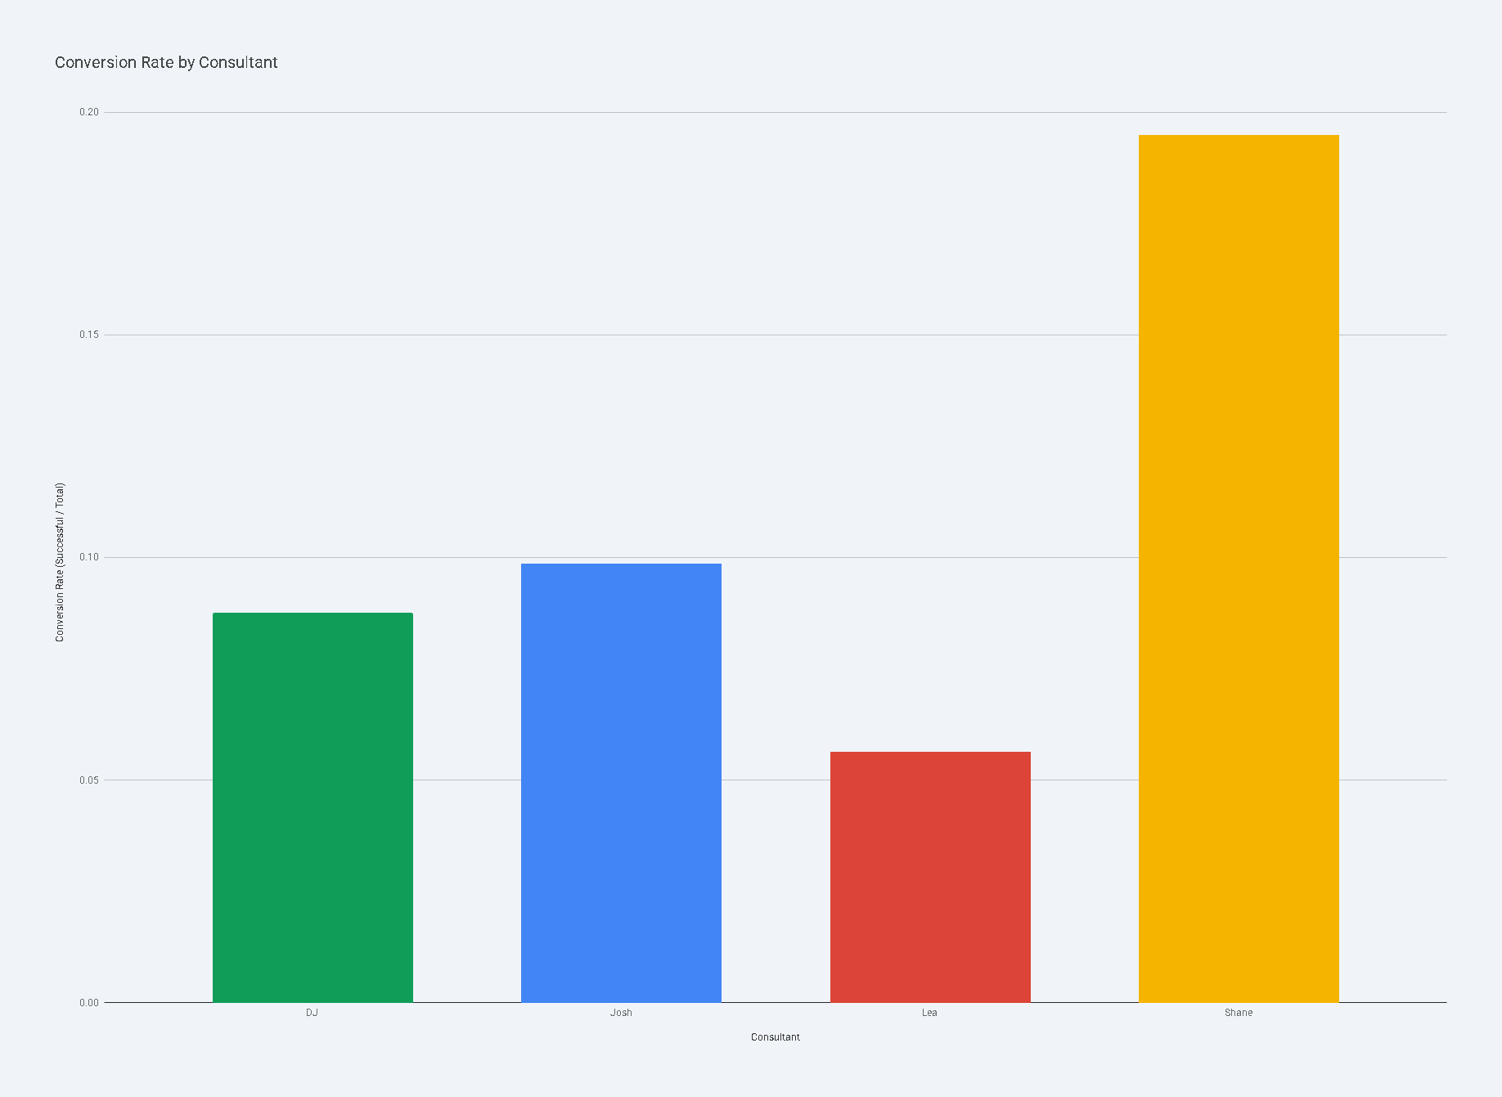

Personnel Dynamics:
Team Roles (actual operations vs. CRM data):

Shane Hewson (CFO):
The closer. Shane is the stronger salesman and handles deal conversion. However, he barely uses Notion, so his sales activity is underrepresented in the CRM. The DQ data showing Josh with Sale-stage leads reflects data entry, not who closes.

Josh (COO):
Trainer, coach, and system operator. Josh trains DJ and Lea on door-knock technique, writes daily analytical notes on all consultants, and is the primary Notion user. His pipeline shrank from 65 to 58, consistent with leads progressing to Shane for closing.

DJ & Lea: Doorknockers (lead generation). Both university students work part-time. They generate the top-of-funnel pipeline through suburb canvassing. Josh trains them.
Lea is preparing to leave. Her pipeline has been static at 28–29 leads for 15 consecutive days. No systematic lead reallocation has occurred. These leads are decaying daily.
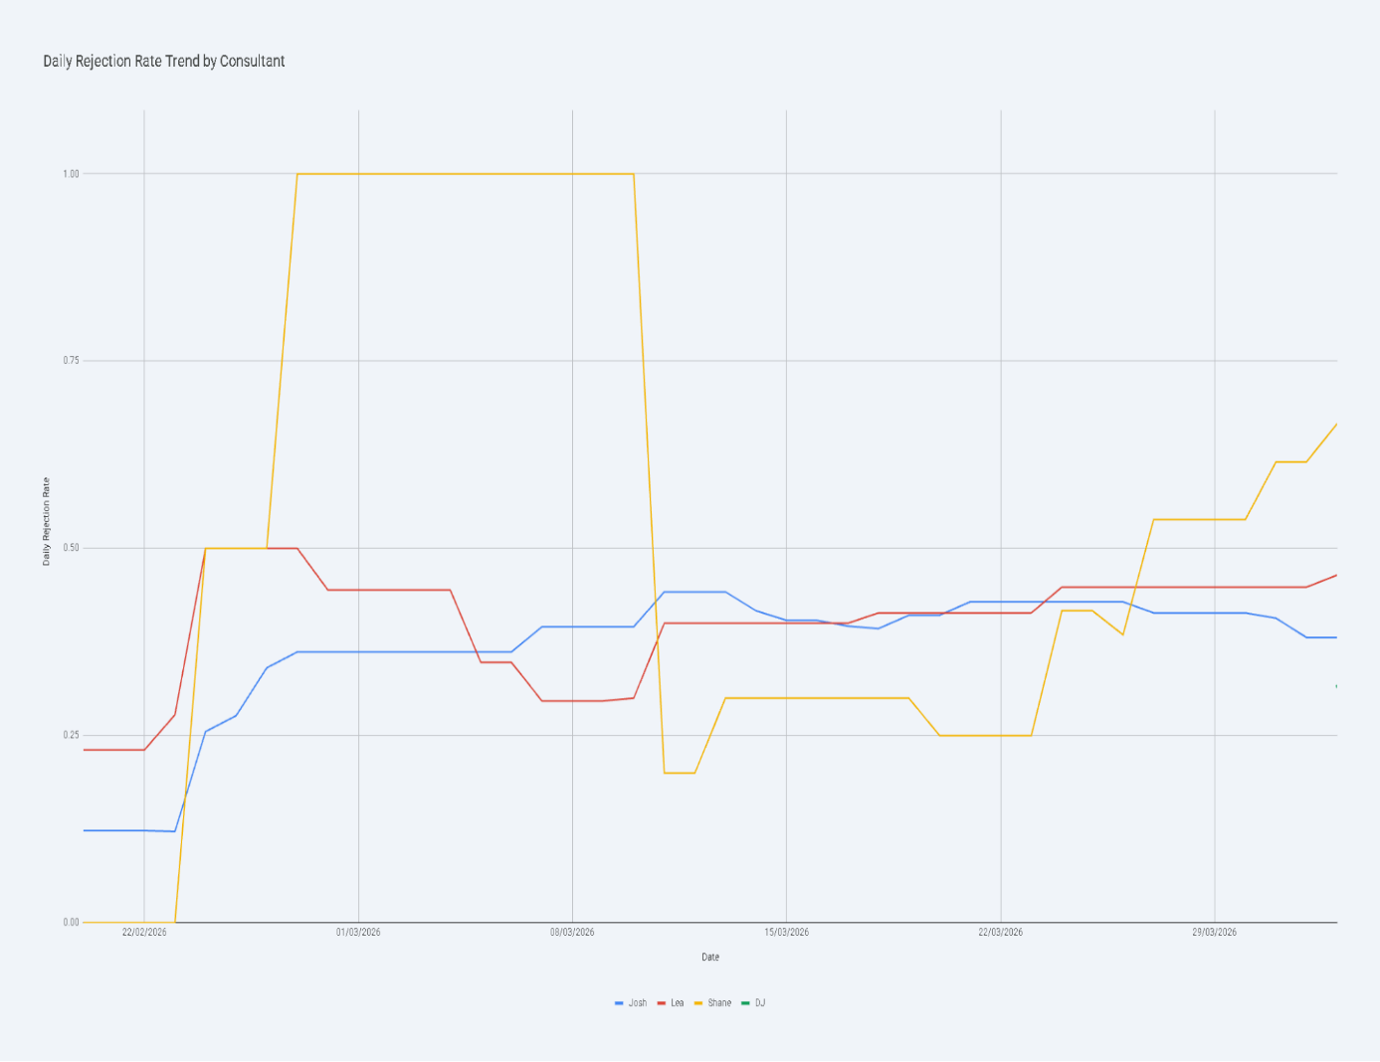

All four CSV financial templates (Balance Sheet, P&L, Cash Flow, Break-Even) remain unpopulated with $0 across every field. Sign-up date shows June 1, 2020. No actual revenue, cost, or cash position data is available in these templates.

2. Most Meaningful Comparisons
Pipeline Growth: DJ’s Ramp vs. Josh’s Handoff Pattern
DJ went from 0 to 58 leads in 5 weeks, matching Josh’s current pipeline size. Meanwhile, Josh’s pipeline shrank from 65 to 58 — consistent with his role as trainer/qualifier whose hands warmed leads to Shane for closing. DJ and Lea accumulate leads through door-knocking; Josh qualifies and warms them; Shane closes. The critical question is whether DJ can progress leads to the point where Shane can close them efficiently — his Apr 2 FA conversions suggest he’s beginning to.
Rejection Trend: Feb vs. Apr
Rejection rate nearly tripled from ~16% to ~45% in 6 weeks. This is the most concerning operational trend. Possible causes:
- lead territory exhaustion (same suburbs being re-canvassed),
- seasonal effects, categorization drift, or
- declining door-knock quality.
- Josh’s notes confirm ‘warm leads cooling across the board’ by late March.
IMPORTANT: This trend is measured from within-snapshot ratios and is valid regardless of the cumulative data structure.
Shane’s CRM Blind Spot
Shane is the actual closer but operates with the smallest visible pipeline in Notion (13 leads). His real sales activity is happening off system. The Gemini analysis showed him with the highest conversion efficiency, but this likely reflects partial data entry, not true efficiency metrics. The critical question isn’t whether Shane can close — he can — it’s whether the business can measure and optimize his close rate without his activity being in the CRM.
Lea’s Frozen Pipeline
28 leads have been static for 15 days. These leads are decaying daily. If Lea leaves without reallocation, the pipeline investment in those leads is lost. At the team’s estimated $30 per lead (derived from consulting hours / pipeline size), that’s roughly $840 of sunk pipeline cost at risk. More importantly, warm leads cool quickly — a 2-week-old warm lead is qualitatively different from a fresh one.

Investment vs. Operational Reality
The system cost ($8,194 Year 1) is generating real operational output: a pipeline of ~157 active leads tracked daily across 4 consultants, with Josh progressing leads to the Sale stage. However, the financial templates are empty — none of this field activity has been translated into revenue accounting. The disconnect between operational data (rich) and financial data (zero) is the core issue.
Consultant | Total Leads | Warm Leads | Discovery+ | Sale Stage | Rejection %
Josh (Coach) | 58 | 20 | Multiple | Data entry only | 36.0%
DJ (Door-knocker) | 58 | 20 | 2 (FA on Apr 2) | None yet | 32.0%
Lea (Door-knocker) | 28 | 8 | Some | None | 40.0%
Shane (Closer) | 13 | 3 | Some | Closes off-Notion | 42.0%
TOTAL | 157 | 51 | — | Shane closes; Josh records | 37.5%
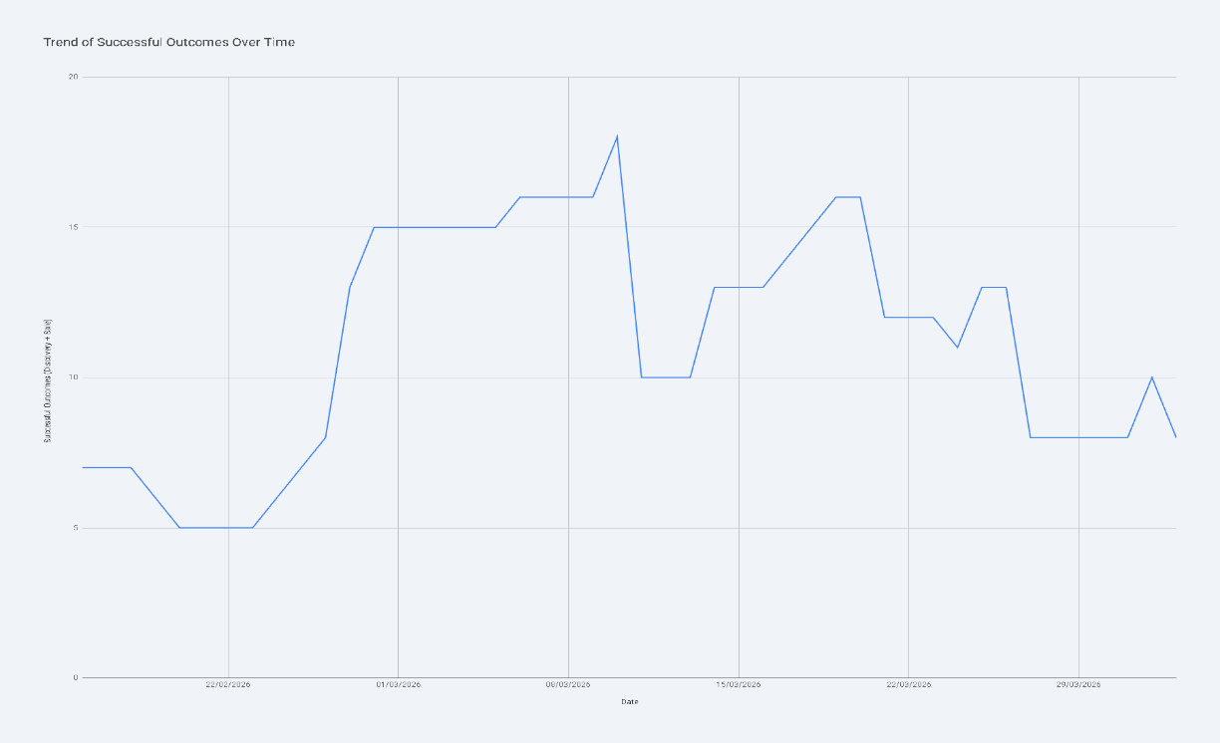

3. Why These Numbers Matter

~157 active pipeline leads (growing from ~107):
This proves the CRM system is operational and generating real data. The DQ Status Tally is not a demo — it’s 6 weeks of actual field operations with daily consultant-level tracking. The pipeline grew 47% in this period, driven almost entirely by DJ’s onboarding. The system works.

Rejection rate 16% → 45% → 39%: Nearly half of all leads in late March snapshot were rejected (Fake Number + Not Interested + Prospects). This erosion, if not reversed, makes the door-knock model unsustainable.
The voice agent and website bot offer an alternative acquisition channel with potentially lower rejection rates. The slight drop to 39% in early April may indicate a floor, or it may be noise.

Shane = sole closer, off system: Shane (co-founder) closes the deals but barely uses Notion. Josh enters the CRM data, so the DQ tally attributes Sale-stage leads to Josh. The real concentration risk is that Shane’s capacity, pipeline, and close rate are unmeasured. If Shane is at capacity, the business can’t see it. If he’s underperforming, the business can’t diagnose it. Getting Shane’s activity into the CRM is the single highest-leverage data action.

DJ: 0 → 58 leads in 5 weeks: DJ’s growth trajectory is the strongest positive signal in the data. He matched Josh’s pipeline size in 5 weeks, and his Apr 2 FA conversions show he’s learning to progress leads, not just collect them. If DJ can qualify leads to the point where Shane can close them efficiently, he becomes a direct revenue multiplier.

28 leads frozen (Lea): A pending departure with no lead transition plan. This is an immediate operational risk that doesn’t appear on any dashboard or alert. The ‘Ghost Detector’ escalation engine (Phase 3) would catch this — but Phase 3 hasn’t started.

$0 financial data: Every financial template is blank. The operational story is compelling (growing pipeline, active coaching, daily tracking), but without revenue data, no ROI claim can be verified, no grant application can be substantiated, and no investor conversation can be credible.

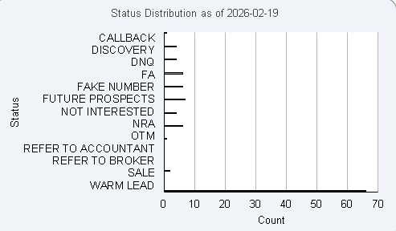

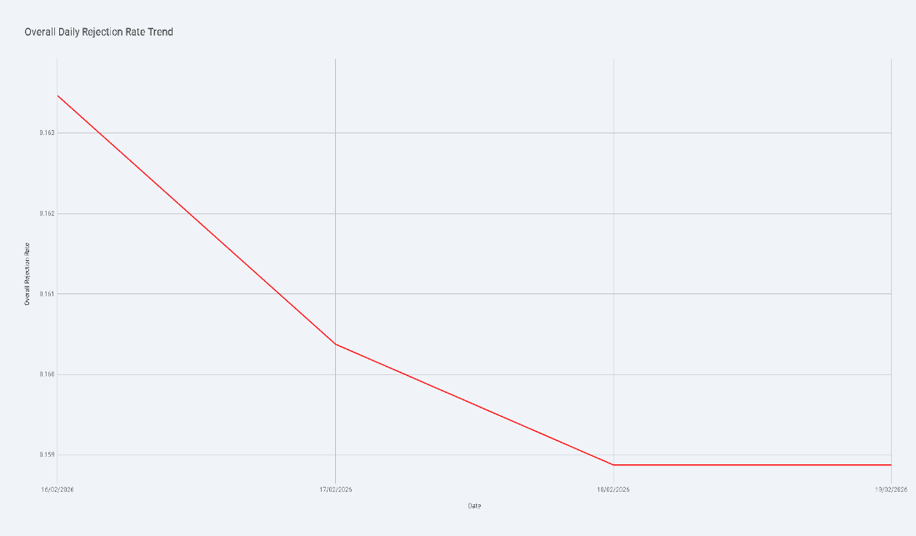

4. Link Between Data and Claims
Claim | Supporting Evidence | Challenge / Gap
3.3x ROI in Year 1 | Low cost ($8,194/yr); real operational output (~157 leads tracked) | Zero financial data; P&L blank; ROI projected not measured
Voice agent: $30k/mo qualified leads | System live; call routing built | 40% qual rate unverified; no pre/post comparison
6x website lead volume increase | Bot deployed on WordPress; 24/7 operation confirmed | No pre/post traffic data available
60% onboarding time reduction | Tier 2 knowledge bot live; team access confirmed | No time-tracking baseline
$12k–$35k resale margin | Pricing tiers defined; partners named | No signed agreements; unvalidated
70% discount vs market | $8,194 vs $27,380 self-assessed | Market value not independently benchmarked
Door-knock model works | Pipeline growing (107→157); Shane closing (off-system); DJ ramping fast | SUPPORTED — but rejection rate trending up sharply; Shane’s activity unmeasured
CRM system operational | 170 daily snapshots; 11 n8n workflows in production | SUPPORTED — verified from multiple sources
Compliance enforced | AFSL guardrails; Privacy Act handling documented | SUPPORTED — data handling doc references legislation
Team scaling | DJ 0→58 in 5 weeks; FA conversion on Apr 2 | PARTIALLY — DJ ramping well but untested at handoff-to-close; Lea exit risk

Summary: Infrastructure claims are well-supported. Revenue projections remain ungrounded. The DQ data provides the first real evidence of operational performance but has not yet been translated into financial metrics.

Click on the graph to go to the excel sheet. ~

B. Investment & Financial Structure
Metric | Value | Source
Phase I Setup (Foundation) | $3,900 | Invoice GAI-KIS-2025-FINAL
Phase II Setup (Voice Agent) | $799 | Invoice GAI-KIS-2025-FINAL
Total Setup (inc GST) | $5,169 | Delivery Summary
Monthly Recurring (inc GST) | $275/month | Delivery Summary
Year 1 Total Investment | $8,194 | Delivery Summary
Market Value Equivalent | $27,380 | Invoice Value Comparison
Savings vs Market | $19,186 (70%) | Invoice Value Comparison
Breakeven Period | ~1.5 months | Delivery Summary
Projected ROI | 3.3x / 230% profit | Delivery Summary
Consulting Hours | 51 hours | Delivery Summary

C. Resale Opportunity
Segment | Setup Fee | Monthly Fee | Annual Margin
Stuart (SMSF admin) | $1,500 | $150 | $1,332/yr
Property Developers (3x) | $3,500 ea | $200 ea | $3,996/yr combined
5 Mortgage Brokers | $1,500 ea | $150 ea | $6,660/yr combined
Year 1 Conservative (5–10 resales) | — | — | $12k–$35k gross

D. Grant Landscape (WA)
Program | Amount | Co-contribution | Status
LCF Digital Transformation | Up to $50,000 | 50% match | Round 2 TBD (annual)
SBDC Growth Grants | Up to $20,000 | None stated | CLOSED (Oct 2025)
R&D Tax Incentive | 43.5% offset | Spend first | Ongoing (ATO)
AI Adopt Program | Up to $20,000 | Unknown | Announced, not open

E. Financial Templates

Figure 1 CLICK ON ME TO MOVE TO EXCEL

PART 2: STRATEGIC PLANNING BRIEF

1. Strategic Issue
Kismet Finance Group has deployed an AI-powered business operating system that is generating real operational data — a pipeline of ~157 active leads tracked daily across 4 team members, growing 47% over 6 weeks. However, the business faces three converging pressures:
(1) rejection rates have nearly tripled from ~16% to ~45%, threatening the door-knock model’s sustainability;
(2) the sole closer (Shane, co-founder) operates almost entirely off-system, making sales performance unmeasurable; and
(3) Phase 3 (the field operations automation layer) remains at 0% completion while a door-knocker (Lea) is departing. The strategic question is:
Where should Kismet concentrate its next 90 days of effort to convert real operational traction into sustainable, measurable revenue?

2. Evidence and Constraints
Evidence
- CRM system is live and generating daily data (snapshots, n8n workflows, 6 Notion databases).
- Pipeline grew from ~107 to ~157 active leads over 6 weeks (+47%), driven primarily by DJ’s onboarding.
- Shane (co-founder) closes deals but barely uses Notion — his sales activity is unmeasured in the CRM. DJ is growing rapidly (0→58 in 5 weeks) and beginning to qualify leads (FA stage Apr 2). Josh (co-founder) trains the team and operates the system.
- Total investment to date: $5,169 setup + $275/month = defensible cost base.
- LCF grant opportunity: up to $50k at 50% co-contribution (next round TBD).
- Service catalogue and grant-ready documentation prepared (Layer 3 Synthesis).
Constraints
- Financial templates completely empty — operational data not translated to revenue accounting.
- Lea departing — 28 leads frozen for 15+ days, no reallocation plan.
- Phase 3 at 0% — 50+ tasks including territory management, DocuSign, Vertex AI, mobile field forms.
- Phase 1 end date (Jan 2026) passed with AI Foundation tasks still open (GCP, Vertex AI).
- Rejection rate at ~39% (down from peak of ~45%, but still 2.5x the Feb baseline of ~16%). If door-knock yields continue declining, acquisition cost per lead rises unsustainably.
- Single-closer blind spot — Shane closes but is off-system. Cannot measure close rate, capacity, or bottlenecks.

3. Strategic Options
Option A: Close the Revenue Gap
Focus the next 90 days on three actions:
(1) Get Shane’s closing activity into Notion so sales performance becomes measurable;
(2) Redistribute Lea’s 28 leads to DJ before they decay further;
(3) Populate financial templates with actual revenue data from Shane’s closed deals to build a real P&L. Parallel: coach DJ to qualify leads to handoff-ready stage faster. This is the highest emergency option because it addresses the immediate data blind spot and revenue gap.
Option B: Fix the Funnel
Attack the rising rejection rate. Analyze the DQ snapshot data to identify which suburbs, days, and lead sources produce the highest rejection. Deploy the voice agent and website bot as alternative top-of-funnel channels. Prioritize Phase 3 tasks that directly reduce rejection: territory management system, mobile field forms, Ghost Detector logic. Timeline: 6–8 weeks. This addresses the structural sustainability risk.
Option C: Grant-Funded Acceleration
Use the real DQ data as baseline KPIs for a LCF grant application ($25k–$50k at 50% match). The ~157 active leads, rejection rate trend, and $275/month operating cost create a compelling before-state. Phase 3 becomes the funded after-state. Timeline: 8–10 weeks prep + 12–18 month delivery. Risk: grant timing uncertain.
Option D: Resale-First Revenue
Shift focus to selling voice agent capabilities to named partners (Stuart, property developers, brokers) while internal operations continue. Generate external revenue from proven technology. Timeline: outreach starts immediately; first resale 4–8 weeks. Risk: support burden on a system not yet fully stress-tested internally.

4. Recommended Path
Option A + B (hybrid): Close the Revenue Gap AND Diagnose the Funnel simultaneously.

5. Rationale
The DQ data reveals that Kismet has real traction (pipeline growing, daily tracking operational, DJ ramping fast) but faces two urgent threats: the sole closer (Shane) operating off-system making revenue unmeasurable, and accelerating rejection (16% to 45% in 6 weeks). Both must be addressed in the next 90 days before they become crises. Getting Shane’s sales activity into Notion (Option A) is the single highest-leverage data action — without it, you cannot measure close rates, identify bottlenecks, or substantiate revenue for grants.
DJ’s Apr 2 FA conversions show he’s learning to qualify leads for Shane, which increases closing throughput. Redistributing Lea’s leads is a 1-day administrative task with immediate value preservation. Populating financial templates converts existing operational data into the business case needed for grant applications (Option C) and investor conversations. Meanwhile, analyzing the rejection trend data (Option B) to identify territory exhaustion and deploying the voice agent as an alternative channel addresses the structural risk to the door-knock model. These are not competing priorities — they reinforce each other, and all can be executed within the existing $275/month cost base.

PART 3: RECOMMENDATION MEMO

TO: Shane Hewson, Kismet Finance Group
FROM: Kevin PL Tan, Good AI Australia
DATE: April 7, 2026
RE: Critical Actions for the Next 90 Days

1. Issue
Kismet’s CRM system tracks a pipeline of ~157 active leads daily across 4 team members, growing 47% over 6 weeks — proving the technology works. However, three risks require immediate action: Shane (the sole closer) operates almost entirely off Notion, making sales performance unmeasurable; rejection rates have risen from ~16% to ~39% (peaking at ~45%); and Lea’s departure will leave 28 leads unmanaged. A decision is needed on how to allocate the team’s effort over the next 90 days to convert operational traction into measurable, sustainable revenue.

2. Key Evidence
Factor | Finding
Pipeline Size | ~157 active leads (up from ~107 on Feb 20 — 47% growth in 6 weeks)
Pipeline Driver | DJ: 0 to 58 leads in 5 weeks; matched Josh’s pipeline size
Closing Gap | Shane closes deals off-system; Josh enters Sale-stage data in Notion. Sales activity is unmeasured in CRM
Rejection Trend | Rose from ~16% to ~45% peak; currently ~39% — still 2.5x baseline
DJ Trajectory | 58 leads, 20 warm; Discovery-to-FA conversion on Apr 2; learning to qualify leads for Shane
Lea Exit Risk | 28 leads frozen 15+ days; no reallocation plan in place
System Status | 11 n8n workflows active; 6 Notion databases; voice agent live; daily tracking operational
Financial Data | All CSV templates blank ($0); no P&L, cash flow, or revenue accounting exists
Phase 3 Progress | 0% of 50+ tasks (field ops, AI deployment, territory management)
Cost Structure | $275/month recurring — sustainable operational floor
Grant Opportunity | LCF: up to $50k at 50% match; DQ data provides baseline KPIs

3. Recommendation
Execute a 90-day Revenue & Resilience sprint across four parallel tracks:
- WEEK 1 (Immediate): Redistribute Lea’s 28 leads to DJ based on territory proximity. Get Shane to log his current open deals and recent closes into Notion — even a one-time data dump gives us a baseline. Begin populating financial templates with actual revenue data from Shane’s closed deals.
- WEEKS 2–4 (Revenue): Establish a lightweight daily CRM habit for Shane (even 5 min/day updating deal stages). Josh continues coaching DJ on lead qualification to handoff-ready stage. DJ has the pipeline (58 leads, 20 warm) and his Apr 2 FA conversions show readiness. Target: DJ consistently qualifying leads to the point Shane can close with minimal friction.
- WEEKS 3–6 (Funnel): Analyse the DQ rejection snapshots to identify territory exhaustion patterns — which suburbs, which days show highest rejection? Begin 3 highest-impact Phase 3 tasks: territory management system, mobile field forms, Ghost Detector logic. These directly address the 39% rejection rate and help DJ/future door-knockers avoid burnt territory.
- WEEKS 6–12 (Scale): With 2–3 months of financial data populated, begin LCF grant application. Use the DQ baseline (~16% rejection in Feb, ~39% in Apr, ~157 pipeline leads) as the before-state. Phase 3 completion becomes the funded after-state. Parallel track: approach Stuart for a pilot voice agent resale.

4. Implementation Implications
This plan requires no additional capital. Kevin’s time shifts from new feature development to data instrumentation (financial templates, Looker Studio dashboards) and selective Phase 3 delivery. The hardest behavioural change is Shane adopting a minimal daily Notion habit — this is the single biggest blocker to measurable revenue. Josh continues as trainer/analyst. The grant application (8–10 weeks prep) produces a structured project plan that doubles as the Phase 3 execution roadmap. The most critical resource is Shane’s willingness to use the system he co-founded. Josh’s bandwidth as coach + analyst is the secondary constraint.

5. Risks and Cautions
- Shane’s CRM adoption is the linchpin: If Shane doesn’t adopt even a minimal Notion habit, sales remain unmeasurable. Consider Kevin building a simplified mobile-first data entry flow (e.g., a Fillout form that pushes to Notion) to reduce friction.
- Rejection trend may be structural: If territory exhaustion is the root cause, no amount of coaching fixes it. The voice agent and website bot become the critical alternative acquisition channel.
- Grant timing uncertain: LCF Round 2 may not open until H2 2026. Phase 3 execution should not be gated on grant approval — start the highest-impact tasks regardless.
- Financial data discipline required: If the team doesn’t consistently populate revenue and cost data, the grant application will be weak and the business case will remain unverifiable.
- Lea transition is time-sensitive: Every day her 28 leads sit unmanaged, they cool further. This is a Day 1 action item, not a Week 2 task.
- Data interpretation matters: Future DQ analysis must account for the cumulative snapshot structure. Reporting ‘total leads processed’ by summing rows will produce inflated, misleading numbers. Use snapshot comparisons and day-over-day deltas instead.

This analysis is grounded in 21 source documents including the DQ Status Tally (170 cumulative daily snapshots, Feb 20 – Apr 2, 2026), 6 Gemini Export files, the Delivery Summary, Invoice, Phase 1–3 documentation, SYSTEMS overview, Kismet knowledge base files, Layer 3 Synthesis, and financial templates. All quantitative claims are derived from snapshot comparisons and within-snapshot ratios. Market value estimates ($27,380) are self-assessed and not independently benchmarked. V3 corrects cumulative-sum errors present in V2.

