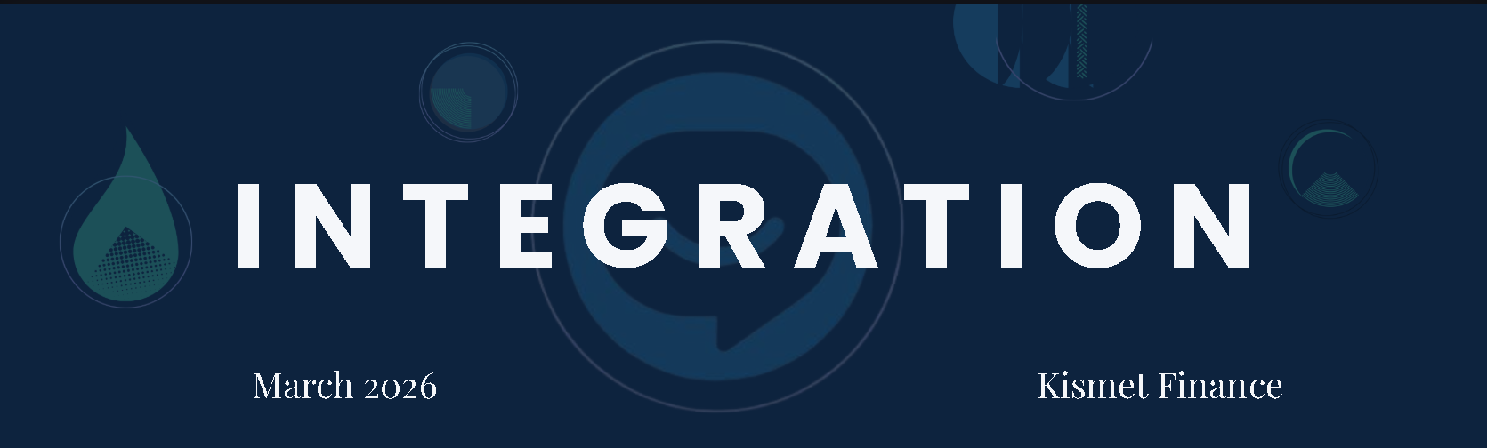

Kismet Finance Tech Stack Overview:

Door Knocking & Area Movement Workflow

The Big Picture (Phase 3 Goals)
- What we're building: A system to manage the "Door Knocking and Area Movement" workflow, tracking field representative activity and customer engagement.
- The Tech Stack: A cohesive blend of n8n (Orchestrator), Notion (Database/UI), Google Workspace (Data Entry), Slack (Alerts), and JustCall (Telephony/AI Analysis).
- The Big Problem: Strict compliance with Australian finance regulations (APRA CPS 230, WA PRIS Act, AUSTRAC Tranche 2), all effective in 2026.

Field Operations Vibe: "Phone-First"
- Reps' Tools: Field reps exclusively use their phones and the native Google Maps app. No complex custom applications.
- Data Capture: Reps "click house to survey," copy the Google Maps address, and paste it into a Google Form (or branded equivalent).
- Survey Limit: Max five simple questions for rapid in-field data capture.
- Post-Submission Magic (n8n's Role): n8n cleans the messy address data, instantly creates linked "Household" and "People" records in Notion, generates follow-up tasks, and automatically updates the Suburb-Level Report Dashboard.

The Tech Stack Superpowers (2026 Updates)
Platform | Role | Cool 2026 Features
n8n | The Brain/Core Orchestrator | v2.0 Updates: Separate Save/Publish functions (prevents breaking live workflows), better handling for huge data spikes, and built-in AI assistance for building and debugging. Critical for parsing messy Google Maps addresses.
Notion | The Database/Cockpit | Better native database automations. Compliance: SOC2/ISO certified, integrates with security tools (SIEM/DLP). The Catch: Data still sits offshore (US/EU), posing a significant Australian compliance headache.
Slack | The Alert/AI Hub | Model Context Protocol (MCP): Allows AI agents (like Claude) to securely query Slack data in plain English for management insights (e.g., "Why were people not interested in Suburb X?"). New Block Kit tools show the AI's "thinking" process.
JustCall | The Telephony/AI Layer | Number Health: Proactively monitors phone numbers' reputation (Healthy, At Risk) to prevent "Scam Likely" flagging. Sends AI-generated Call Scores, Transcriptions, and Summaries directly into Notion pages.

Key Workflows (How the System Actually Runs)
- Lead Capture (Workflow 1): Google Form submission -> n8n grabs raw data -> n8n uses a JavaScript node to clean and parse the address -> n8n creates a "Household" and a linked "Person" record in Notion -> n8n calculates metrics and sends a Block Kit alert to the #area-movement Slack channel.
- "No Ghost" Protocol (Workflow 2): (Compliance-focused) Daily n8n cron job polls Notion at 2:00 AM, searching for incomplete records (data 'ghosts'). If found, n8n flags them, aggregates them into a report, and sends a single, comprehensive Slack report to managers, tagging responsible reps.
- Call Sync (Workflow 3): JustCall fires a webhook after a call -> n8n's Crypto node verifies the SHA256 signature (security first) -> n8n deduplicates the payload -> n8n matches the phone number in Notion -> n8n waits for the final summary webhook and posts the AI Call Summary/Transcription to the person's page.

The Compliance Pressure Cooker (Deadlines)
Regulation | When it Hits | What It Means for the Tech Stack
APRA CPS 230 (non-SFIs) | July 1, 2026 | Requires proof the system won't crash. Must use n8n's error triggers and Slack's Retry APIs for Business Continuity Planning (BCP). Audit all vendor contracts (Notion, n8n) for APRA's audit rights.
Federal Privacy Act Reforms | Dec 10, 2026 | Mandatory AI Disclosure. Google Forms disclaimers MUST clearly state that data is processed by automated systems and phone calls are transcribed by AI.
WA PRIS Act | July 1, 2026 | Applies if working with WA government programs. The "No Ghost" protocol aids in catching data leaks fast for mandatory breach reporting.
AUSTRAC Tranche 2 | July 1, 2026 | Broader AML/CTF rules. The system must show a perfect, immutable lineage for every lead: who, where, and when they were captured (supports KYC/CDD).
Data Residency (Notion) | Ongoing | Notion data is offshore (US/EU). Mitigation: Legal ring-fence contracts, use SIEM tools to monitor Notion access 24/7, and self-host n8n in an Aussie data centre to keep all API keys and transient data payloads securely onshore.

