EQUATOR Component Infrastructure Design Notes
2003-01-09
Chris Greenhalgh, Ian Taylor, James Mathrick, Tom Rodden
V. 1.0 2003-01-12-cmg

Background
Initially considering a possible infrastructure for the Curious Home project, based on EQUIP (although approach, types, etc. could be mapped to other technologies).
Various design choices could be relaxed/refined/expanded, but the intention is to specify an implementable, testable and useful starting point.

Hardware and Networking Design
The home is assumed to have a single ADSL/Cable modem for always-on Internet connectivity. This is assumed to incorporate firewall, router, DHCP server and WaveLAN Access Point.
The WaveLAN network name (and hence BSSID) is assumed to be unique for this particular house; primary authentication is by possession of network name and hence fact of access to local (domestic) wireless network.
One or more “infrastructure servers” (i.e. dedicated PCs, probably without normal I/O devices, such as those use in the Audio Chairs) are “bought”, either pre-configured or locally configured on delivery with the WaveLAN network name. These host the main software components and are the main connection point(s) for other devices, sensors and actuators.
General configuration and maintenance is assumed to be performed by an “expert” using a dedicated device with its own wireless networking capability, e.g. a tablet PC.
I/O devices are attached to the various infrastructure servers, and may include mics, speakers, video cameras, screen and projectors, mice, keyboards, joysticks as well as more unusual I/O devices connected via serial (e.g. SmartITs, BASICStamp) or USB (e.g. Phidgets). In some cases (e.g. SmartITs) there may be a gateway device connected to the infrastructure server which allows downstream connection of various sensors and/or communication (e.g. RF) with other small devices.
In the first version we will not address (re)programming of devices other than the infrastucture server(s).

Software Component Design

Host Manager
Each infrastructure server will run a single bootstrap application, the Host Manager. This will support discovery of the host/infrastructure server, local and remote determination of host capabilities, and access to software component hosting environments (containers) on that host.
In the default EQUIP implementation discovery is supported by each Host Manager having an EQUIP discovery server, advertising as type “equip.infrastructure.host/1.0”, and a group which is specific to the particular installation (e.g. the same as the WaveLAN network name). The value will be the full URL of a per-host EQUIP dataspace which is maintained by the Host Manager.
The Host Manager will maintain Data Items in the Host Dataspace to represent the capabilities of that Host, i.e. what ports and APIs it supports, how much memory, what CPU, what storage, etc. The Data Item types to be used the formalism to use for their values is yet to be determined. Related existing types are equip.service.ServiceAvailable and equip.mope.ReportDeviceData (a.k.a. equip.bystander.ReportDeviceData) and equip.mope.ReportPowerData (a.k.a. equip.bystander.ReportPowerData). A first version is likely to use simple opaque strings to identify capabilities; a later version might use RDF.
The Host Manager also exposes discovery and life-cycle management facilities for software component hosting environments within that host, i.e. component containers.
In the default EQUIP implementation this is performed via the Host Dataspace. The Host Manager maintains Data Items in the Host Dataspace to identify the types of container that it is capable of creating on this Host.
Each running container maintains a corresponding Data Item in the data space indicating its existence, type and any additional information required to use/access it (e.g. any additional Dataspace URLs). Inspection of these Data Items allows existing containers to be discovered.
The Host Manager is requested to create/maintain a container by the presence of a suitable container request Data Item in the Host Dataspace; see the analogous equip.service.ServiceRequest Data Item type. To support restart/recovery these request Data Items may need to be persistent within the Host Dataspace.
The Host Manager is also responsible to advertising/describing the devices/sensors attached to that Host by means of descriptive Data Items in the Host Dataspace. In some cases this may be possible automatically through OS API inspection facilities; in other cases third party observer processes may need to insert/maintain these Data Items in the Host Dataspace on the Host Manager’s behalf.

Container Manager
One Component type and consequently one Component Container is defined in version 1: Java Beans. The container is consequently a JVM which support the Container Manager functionality.
At least in version 1, the Container Manager will make use of the Host Dataspace.
The Container Manager advertises the types of Components that it can create/host using suitable Data Items in the Host Dataspace.
Component instantiation is requested using request Data Items, again in the Host Dataspace.
Running components are identified (e.g. for discovery) by Data Items in the Host Dataspace. This is comparable to the Bean Data Item in the ACCORD system.

Component
In version 1 a single kind of software component is supported, based on (but not identical to) Java Beans. The intention is to allow other kinds of software component to be discovered, managed and used in the same way, so some abstraction from Java-specific details are required. Some clarifications drawn from other component models (e.g. CORBA components) are also made explicit.
As noted above, the Container Manager exposes the existence of each Component by a Data Item in the Host Dataspace.
In is expected that additional Component description information will be required (compare Java BeanInfo class), and that this will be exposed by a Component or Component Class-specific Data Item in the Host Dataspace.
A component has zero or more properties. Each property may be read-only or read/write. In Java Beans one can distinguish simple, observable and vetoable properties, and single-valued and array-valued properties. In the first version we will assume by default that all properties are observable but not vetoable, and single-valued. We will also consider separately properties whose values are references to other components.
Each property will be represented by a corresponding Data Item in the Host Dataspace. The type will allow mapping to the corresponding Component Data Item. Changes to observable properties will be reflected by updates to the corresponding DataItem.
In general, components should use IDL-defined (rather than native, e.g. Java Serializable) types for properties, events, etc.; these should receive better cross-container support. Native types may be boxed in IDL-defined types, e.g. equip.data.SerializedObjectImpl.
By default, in version 1, read/write properties will be updated when another process updates their property Data Item (no additional update will be triggered). This is as per ACCORD’s Bean implementation. Note that EQUIP concurrency control is current undefined/unimplemented, and so remote updates to Data Items should be performed with caution, and typically require significant knowledge of application-specific semantics (and/or careful Component design) to avoid race conditions.
A component may generate one or more classes of event. In JavaBeans these can support single or multiple observers. All components will support at least the PropertyChange event type. In addition, components may expose other event classes using – in the first version – the Java SWING event/listener idiom. All events should support multiple observers and should catch exceptions by default. It is assumed that Component events will – at least in version 1 – be mapped to events in the Host Dataspace. Consequently notification should be assumed to be asynchronous, and source ordered.
A component may implement one or more interfaces, i.e. “provide” a certain unit of functionality. In version 1 at least, this will only be accessible to other Components within the same Container, since it will need to be implemented in terms of the native Component technology (EQUIP IDL does not at present support interfaces). In the case of Java Beans this involves (a) implementing a particular Java interface or capability and (b) declaring this fact within the Component (class) description. Note that this Java model is less expressive than some Component models (e.g. CCA) since it cannot distinguish between distinct interfaces of the same language type.
A component may make use of services/operations from an interface provided by another component (see above). This corresponds to the sub-set of Java Bean properties whose value is a reference to another Bean. This must be declared by the Component (class) description. In the first instance this is represented by a Data Item which identifies both the interface type and the GUID of the component providing that functionality. The Container Manager must collaborate with the Components concerned to pass a language-native reference to the provider component to the using component.

Component Inter-connection
Additional support is required from the Container Manager to support connections between components.
An event listener is realised similarly to an interface provider (at least in version 1), by the observer providing the appropriate listener interface. However, unlike the normal provides/uses relationship a single observer may observe many event sources. Consequently the Container Manager will support the existence of any number of Event Routing Request Data Items in the listener’s Host Dataspace, which will cause the identified EQUIP event(s) mapped from the corresponding source component and event type to be delivered to the provided event listener interface.
Links must also be supported between similarly typed properties on different components. Since it is more common to have a single fan-in to a property, and multiple fan-out, these links will be maintained by the receiving component’s Container Manager, according to Property Routing Request Data Items in the subscriber’s Host Dataspace.
Standard components may also be defined to allow different classes of Property value transformation during routing, as specified by extended/alternative Request Data Items (c.f. iRoom Patch Panel).

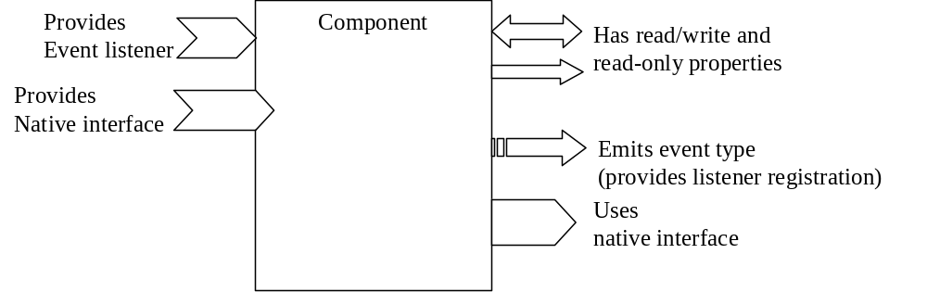
Abstract Component
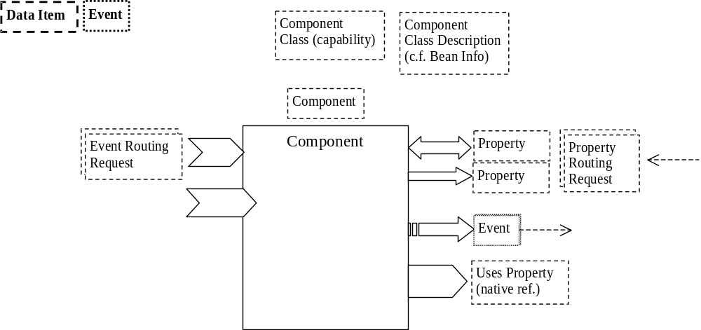
EQUIP mapping of component
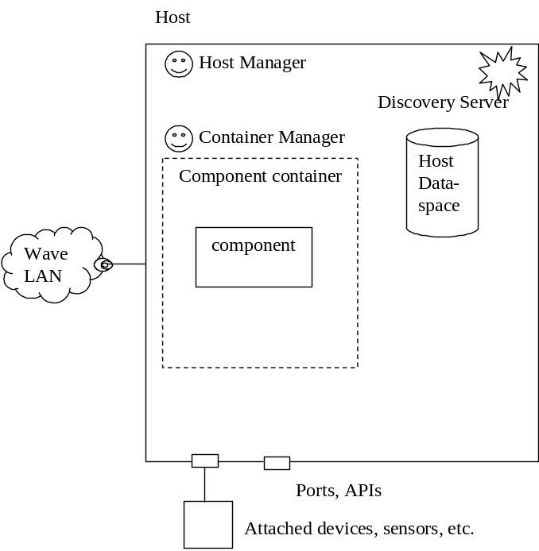
Overview

