EQUATOR Component Infrastructure: Implementation 1.0 Notes
2003-02-05
Chris Greenhalgh, James Mathrick, Tom Rodden, Ian Taylor
V. 1.0 2003-02-05-cmg

Overview
House AP
House Manager
Host Manager
Container Manager
Component
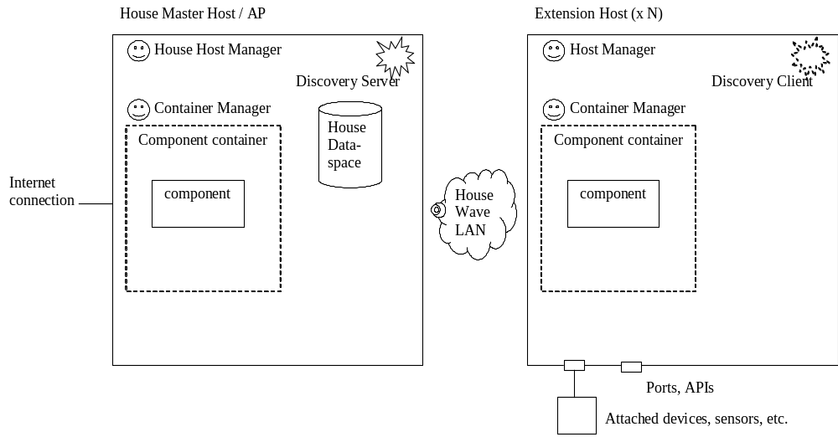Under coordination scheme 1:
- a single House Master device hosts the primary Dataspace server and a multicast discovery server to announce this on the House WaveLAN.
- Zero or more extensions Hosts are added to the House WaveLAN (requiring setting “in the factory” of Network name (i.e. BSSID) and encryption key (if any)), and thereby
  - Obtaining an IP address, DNS server and gateway router from the house firewall/router
  - Allowing the extension host’s host manager to discover the House dataspace (via local network scope multicast, optionally filtered by addition “factory configured” house “community” name)
How is a house identified?
WaveLAN network name, optional encryption key, house ID/community name
How is a host identified?
House identity
IP address BUT dynamically allocated hence may change under certain circumstances
MAC address (BUT may need custom helpers to get hold of this)
Other “fixed” per-host identifier, e.g. stored GUID
Local name? c.f. computer names in a domain? BUT requires local allocation and avoidance/management of clashes/duplication
On the other hand you could swap in a replacement on host failure, but given that you would have to replug all the devices etc. it might be just as easy to have a “repair/replace wizard”.
How is a container identified/characterised?
*Type of components supported (E.g. Java Bean, C# instance)
*Specific component classes supported (e.g. equip.foo.custom.Class)
Specific component instance supported?
Specific class of port or device present? (/host)
Specific device present? (host)
How is a class of component identified/characterised?
*Specific class name of implementation
Other description of capability e.g. implemented interface, supported device
How is a specific component identified/characterised?
*Unique instance instantiation ID
*Persistent instance ID
Singleton of class X
Properties/capability description
[mobility between containers/hosts??]

When do multiple ways of requesting/referring to a component get satisfied by the same component?
How does the satisfaction by a particular component get expressed?

Types
Host advert [created by running host manager; used for interactive configurator, for some version of ONE host deployment resolution, and for fault tolerance/failover (future extension)]:
- Host unique ID: GUID (not item ID)
- Host type: String (“host-type:house-manager”, “host-type:extension-node”)
- Host attributes: array of name:String, value:Object pairs?
Container advert [created by running container manager; used for interactive configurator, for some version of ONE host deployment resolution, and for fault tolerance/failover (future extension)]:
- Host unique ID: GUID (not item ID)
- Container unique ID: GUID
- Container attributes: array of name:String, value:Object pairs?
Component capability advert:
- Host unique ID: GUID
- Container unique ID: GUID, optional
- Required component attributes: array of name,value,qualifier (String,Object,String) pairs [see below]
- Required component properties: array of name,value,qualifier (String,Object,String) pairs
- Component attributes options (e.g. technology, specific class): array of name:String, (array of name:String,value:Object); where nested name,value pairs characterise the outer named attribute/property, e.g. supported value or value range expression, short description, long description, attribute or property.
Component request v.1 [typically created by configurator and persistent]:
- Unique request ID: GUID (item ID)
- Host unique ID [special values for ALL hosts, and for ANY host (or N hosts); ANY requires arbitration process or rule, e.g. House master only, lowest MAC address, arbitrary but deterministic replicated evaluation, dynamic voting process]: String (“host-filter:one”, “host-filter:any”, “host-filter:all”), optional host unique GUID
- Component attributes (to distinguish same/different instance, container type, implementation class name; defaults to singleton): array of name,value,qualifier (String,Object,String) triples [managed and understood by the container; fixed for the lifetime of this request; may also reflect source/justification of request]
  - Standard attribute names: “component-attribute:class-name”, “component-attribute:technology” (e.g. “component-attribute-technology:java-bean”, “component-attribute-technology:dotnet-object”)
  - Standard qualifiers: “attribute-qualifier:required”, “attribute-qualifier:suggested”
- Component properties (actually set on component): array of name,value,qualifier (String,Object) pairs [fixed for the lifetime of this request]
- Component unique ID (optional): GUID
Component request response [created by running container or host manager in response to current request]:
- (response ID: GUID = item ID)
- Unique request ID: GUID (not Item ID)
- Host unique ID (multiple hosts may respond): GUID
- Failure Message: String (null=OK)
- Container unique ID (ephemeral?): GUID (if successful)
- Component unique ID: GUID (if successful)
Component advert [Created only by running container on behalf of contained component]:
- Host unique ID: GUID (not item ID)
- Container unique ID (ephemeral?): GUID
- Component unique ID: GUID
- Component attributes: array of (name:String, value:Object)
Component property [Created only by running container on behalf of contained component, although may be persisted across container restarts for resilience] (or configuration constant [Created by configurator, persistent]):
- Component unique ID: GUID
- Property name (unique for this component): String
- Property type: readable - boxed Boolean, writeable – boxed boolean
- Property value: Object
Property link request [created by configurator, persistent]:
- Unique request ID: GUID (item ID)
- Source component request ID: GUID (or)
- Source component unique ID: GUID
- Source component property name: String
- Destination component request ID: GUID (or)
- Destination component unique ID: GUID
- Destination component property name: String
Property link response [created by Source component container – mainly for diagnostics; only with current property link request]:
- unique response ID: GUID (item ID)
- unique property link request ID: GUID
- source component property value unique ID: GUID
- destination component property value unique ID: GUID
- activation count: Boxed Int
Causes attempted update event on destination component property value item? Or another event specific to containers? NO
Causes destination component manager to monitor source component property and apply local updates to property accordingly (avoids race conditions and allows – kind of – access control).
Direct Event link – as above, but source event name, destination listener name
Causes source component container to (or it may in any case) emit event with…
- source component unique ID: GUID
- source component event (type)/listener name: String
- sequence number: boxed int
- local event: Object
Causes destination component to subscribe to those events and call the appropriate listener method/delegate with the communicated event object.
Channel Event Source request ? Channel Event Sink request?
Direct invocation link – as above but Source/Uses local (property) name, and Destination/Provides fully-qualified interface name.
Causes the source component’s manage to try to set the corresponding Interface reference-valued property on the source object from a direct destination component reference obtained within that container.
(Might cause the destination component’s manager to try to make the destination component available in that way)

Use

Software-only components
Configurator discovers house manager; joins house dataspace; shows view of hosts, containers, components, links, …
User requests instantiation of particular components on particular hosts, and establishment of links between particular components [consider request vs instance]
How does the configurator know what components can instantiated on what hosts?
- are they all pre-configured and advertised by the hosts?
- Is there an internet directory which provides lists of component classes compatible with the particular host and/or devices?

Hardware components – plug and play scenarios (i): Phidgets
An extension node comes supplied with Phidgets support, i.e. phidgets drivers.
In the factory it is configured with a persistent request for a host phidget manager. This is created automatically when the system (re)boots, and uses phidget introspection API to detect plug/unplug of phidgets.
This automatically creates Phidget interface components for all current phidgets. The component IDs should be persistent across restarts and same port/same device unplug/replug. If the component IDs are NOT persistent in this way then the component attributes (and/or read-only properties) must reflect the specific phidget that they represent in a way that does not change under (only?) this case.
The configurator can be used to link the phidget (sw) components either via the specific component IDs (if persistent) or request IDs for custom requests created to match the phidget in q uestion.

