PoorGuy

Game Design Document

Personal Project Spring2018

Jihoon Bae, Taehoon Kwon

Contents
Table of Contents
Summary 3
High Concept 3
Expanded Concept 3
Key Features 3
Expected Audience 3
Expected ESRB Rating 3
Game Mechanics 4
Player Movement 4
Story 5
Plot Overall 5
Environment 6
Resources 7
Character 7
NPC 7

Controls 10
Game Designs 11
Visual Designs 11

[2]

Summary

High Concept

A 3D isometric view RPG game which player can explore the world, find weapons, fight with monsters to survive.

Expanded Concept

PoorGuy is isometric view day-time based game that player should survive from many dangers including hunger. Overall atmosphere is like Beat Cop because of clearing quest and pixel arts, and also similar to Don’t Starve Together since the view of the game is isometric, game use 2D character and goal of the game is survival.
Main character has to find way to survive everyday by looking for place to sleep, finding weapons to defend himself.

Key Features

- Exploring and getting items.
- Nurturing character with experience and having better equipment.
- Fighting with gangsters & hunting monsters.
- Random generating character at the beginning of the game.
- Interaction with NPCs on the map

Expected Audience

- Mature aged over 17 because of gloomy story game.
- Hardcore masochist due to zero based game.

Expected ESRB Rating

“M” for Mature: Overall game is aggressively looking and atmosphere is gloomy.
There are many violence and crime scenes. Story is also heavy so the game is not easy to play for young player.

[3]

Game Mechanics

Player Movement

Player can move the main character by clicking mouse right button.
Player can use back step skills to move back quickly..

Item Inventory

Combat

Player can attack enemys by clicking left mouse.

Day System

~~~~~~.

Experience System

NPC Quest System

[4]

Story

Plot Overall

[5]

Environment

The main motive of the character
is based on the quest. ▼Game overall concept
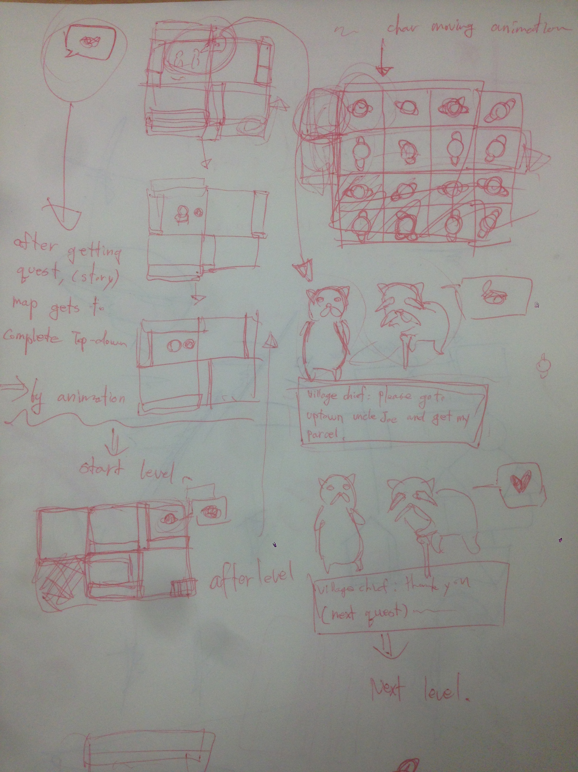
Quest will be given by the NPC
as seen in the picture.
Also some animations will be shown
while quest is given.

The game will take place starting from
a small village that main character lives in.
Character will move mainly from village
to forest, forest to city. Each spots have
3 levels inside and story
and level's story line will be
enter – wander – solve.

For Game back ground music,bright and peaceful music will be played
in village map since the concept of
village is vibrant and peaceful.
A bit dark and gloomy music will be played
for forest map and look of the map also
will be dark and slimy kind of impression.
And for city, speedy and bustle
music will fit.

There are basic collision with player and
walls in each tiles. If tile is rotated, collision
of wall also gets rotated.

[6]

Resources

Character
▶character in game

NPC

[7]

[8]

[9]

Controls

Keyboard and mouse is used to play the game

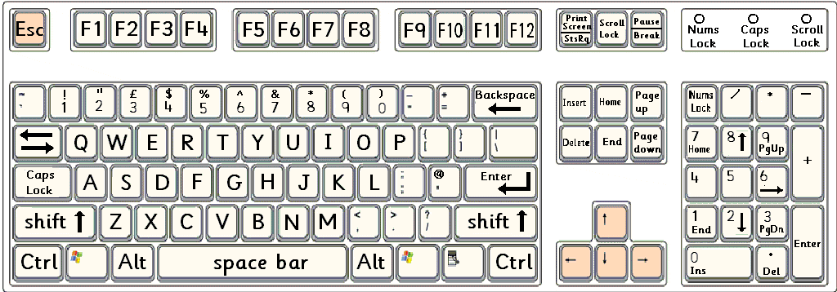

[10]

Game Designs

Visual Designs

[11]

[12]

