**System Overview:**

The SIMS system is primarily a web application designed for the department of Medical BioPhysics (MSc), which will be used to can track important dates from inception to completion of the program lifecycle and help manage information on an efficient basis. The system will provide effective reporting techniques including custom reminders, tracking and gathering input from the graduate students.

The application should implement user security with user authentication and authorization and the system users can be assigned rights and privileges. A system wide sign in page will be located at the URL, which upon authentication will redirect the browser to the appropriate page.

**System Requirements:**

***External Interface Requirements:***

Web Interface:

The web interface is a primary link for providing users with system functionality access. The web interface will require a specific web browser to be used in order to prevent any compatibility issues. An accessibility guide will be posted on the web site for accessing the system using other browsers.

**Graphical User Interface**

**System wide login page**

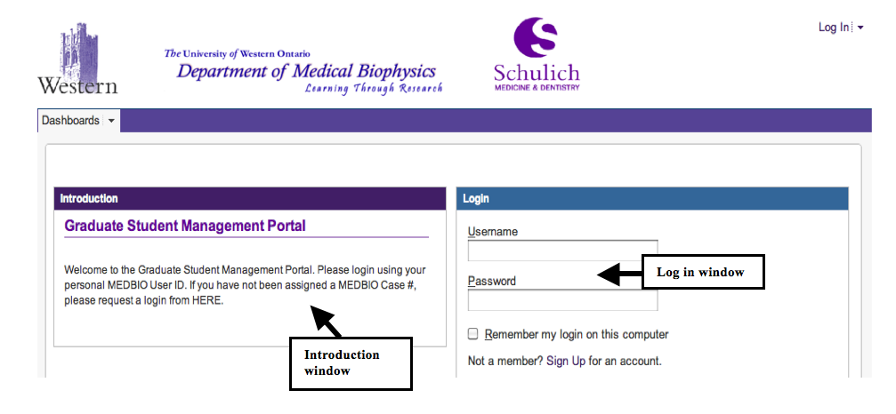

Figure 1 - System Login Interface

* *Purpose:* Provide a universal log-in page to provide access to the end users of the system
* *Response Sequence:* In order to access the login page, user will have to type the system URL in a supported browser and will be directed to this log in page.
* *Associated Functional Requirements:* 
  + Introduction widget: This widget will provide a short introduction to the purpose of the management system. It will also feature an Important Links section with a link to the website of Department of Medical BioPhysics. Furthermore, a link to a technical troubleshooting page will be created.
  + Login window: This is the actual login page where the user will enter their credentials to login. Users cannot sign up for the system individually. The Graduate Administrator facilitates the sign up process and a direct link to request the login credentials will be set up.

**System Dashboard:**

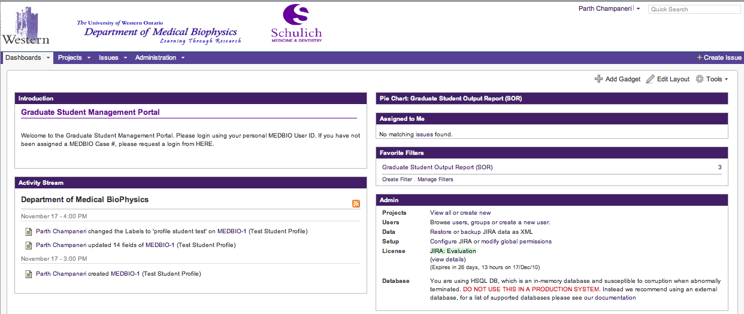

* *Purpose:* Provide a centralized location of all system functions while preserving ease of use and accessibility.
* *Response sequence:* The user will be directed to this page after login.
* *Associated Functional Requirements:*
  + Provide various plugins on the dashboard based on different user roles and access for access to student profiles and various system features. Plugins can be RSS feed or activity stream, various preset charts and reports.
  + Search: Be able to search a students profile from the dashboard.

**Student Profile**

* *Purpose:* Provide an intuitive dossier format interface for users to see the student profile in a centralized location. The key goal is to ensure that all the important system functionality in a centralized location. Note the attached sample HTML page.

# Parth Champaneri:Users:Pat:SIMS:HTMLTemplating:StudentProfileMain.tiff

Figure 2 - Sample Login interface

# *Response sequence:* In order to access the GUI, the user will be required to login and will be taken to a dashboard which will have options to generate reports and search a student by their assigned id. Once selected the user will be able to see a student profile and be able to perform various functions based on their authentication scope as defined in the access control list.

* *Associated Functional Requirements:*
  + Information Tab Section: The profile page will feature information tabs with centralized information about their Personal Information, Program Information, Supervisor Information and Advisory Committee Meeting Information.

**Supervisor Information:** This tab contains information regarding a students’ direct Supervisor Name and information about the supervisors minimum student contribution along with other logistical information. This information is created with the sample medical biophysics excel sheet provided by our end-user Wendy hough at the department of Medical BioPhysics. 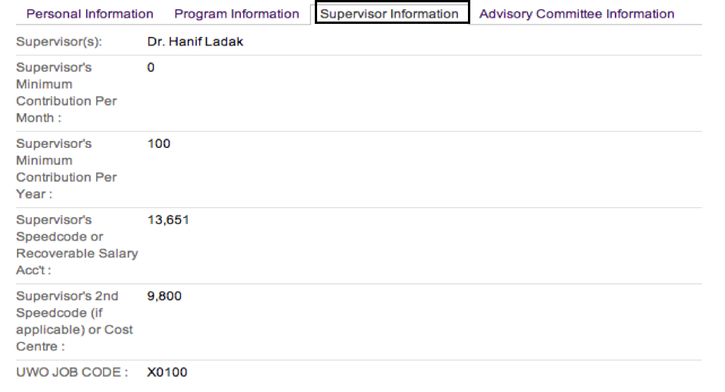

Figure 3 - Supervisor Information Tab

**Advisory Committee Information:** This is a centralized location for all advisory committee information which has taken place for a student. Under this tab, pertaining information such as the list of all advisory meetings, evaluation of a particular advisory meeting whether it was satisfactory or unsatisfactory and any supervisor/member reccomendations after the meeting. Advisory committee is a progression requirement which happens for each student atleast once a year. Scheduling is usually done by the student or by the graduate administrator. One of the key requirements is to track and remind students of their advisory meeting output and ensure that a post-meeting report is generated to satisfy their progression requirements.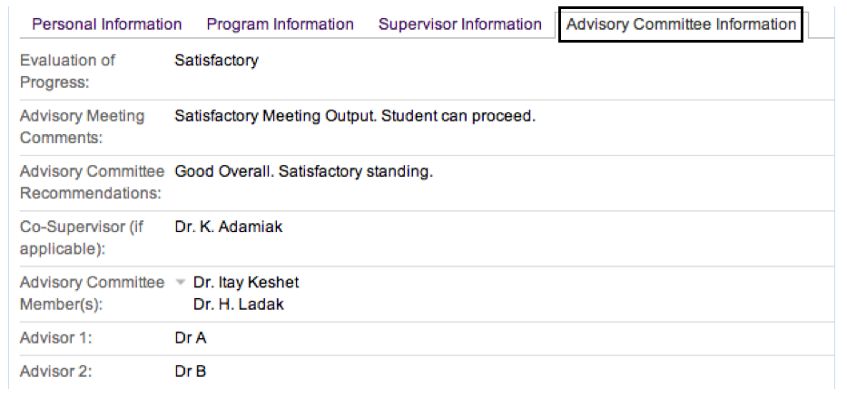

Figure 4 - Advisory Committee Information

* + Expansion: Each section can be clicked on to show summary of additional information
  + Link: Each information tab will link to another section pages (if applicable)
  + Grouping: Group dates and People in the same window area for better accessibility
  + Export Options: There should be an export option to ensure that a user can export their entire student profile in Word, PDF or in a Printable format
  + Attachment Options: The dossier should feature an attachment tab that includes all relevant attachments/forms for that student profile.

# Electrical Device Interface:

* *Purpose:* To provide an interface for recording advisory committee member signatures.
* *Response Sequence:* When the e-signature pad is connected to the device, it will automatically start the e-signature interface which records an individual signature.
* *Associated Functional Requirements:*
  + Clear: Ability to clear the signature if the signee does not accept the signature
  + Sign: Once the output on the screen is satisfactory, the user can “Sign” the document which will save the image in a document on the database.

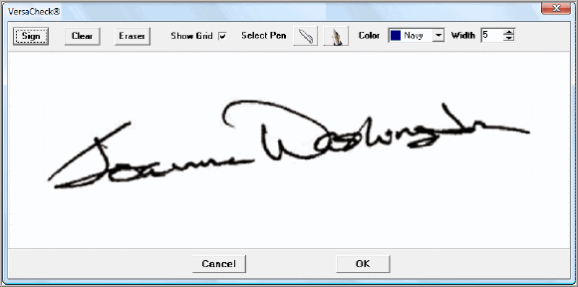

Figure 5 - E-signature interface

**System Features:**

**User Administration:**

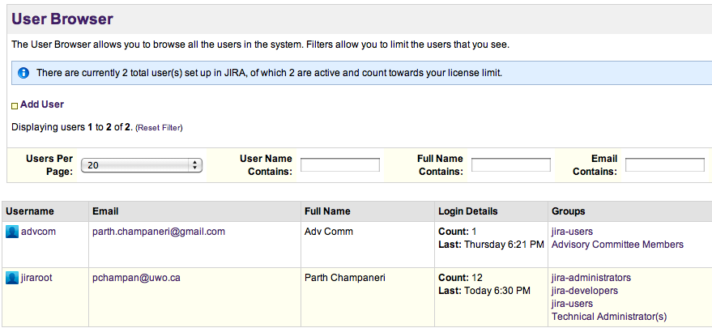

Figure 6 – Sample User browser

* *Purpose*: The user browser lists all the users in the system for technical administration.
* *Response Sequence*: Login and click on User Browser from the adminisFrom this page, the administrator can perform the following fucntions:
* *Associated Functional Requirements:*
  + Create new users: Adding a new user to the system can only be accomplished by the technical administrator after an approval from the Graduate Administrator.

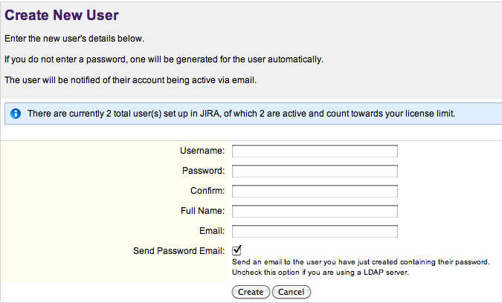

Figure 7 - Add a new user

* + Adding new user roles: User roles are primary stakeholder groups for the system. Currently, our primary stakeholders are Advisory Committee Members, Graduate Administrators, Graduate Executives, and Graduate Students.

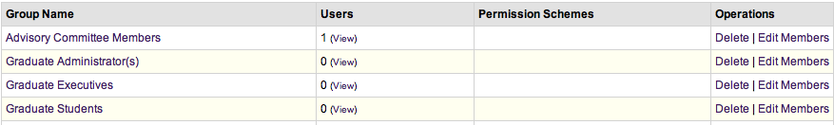

Figure 8 - Add new user roles

* + Adding Operation to roles: Permissions can be added to the user permission list by clicking on the Add New permission button under User Administration. This can be done by the technical administrator.

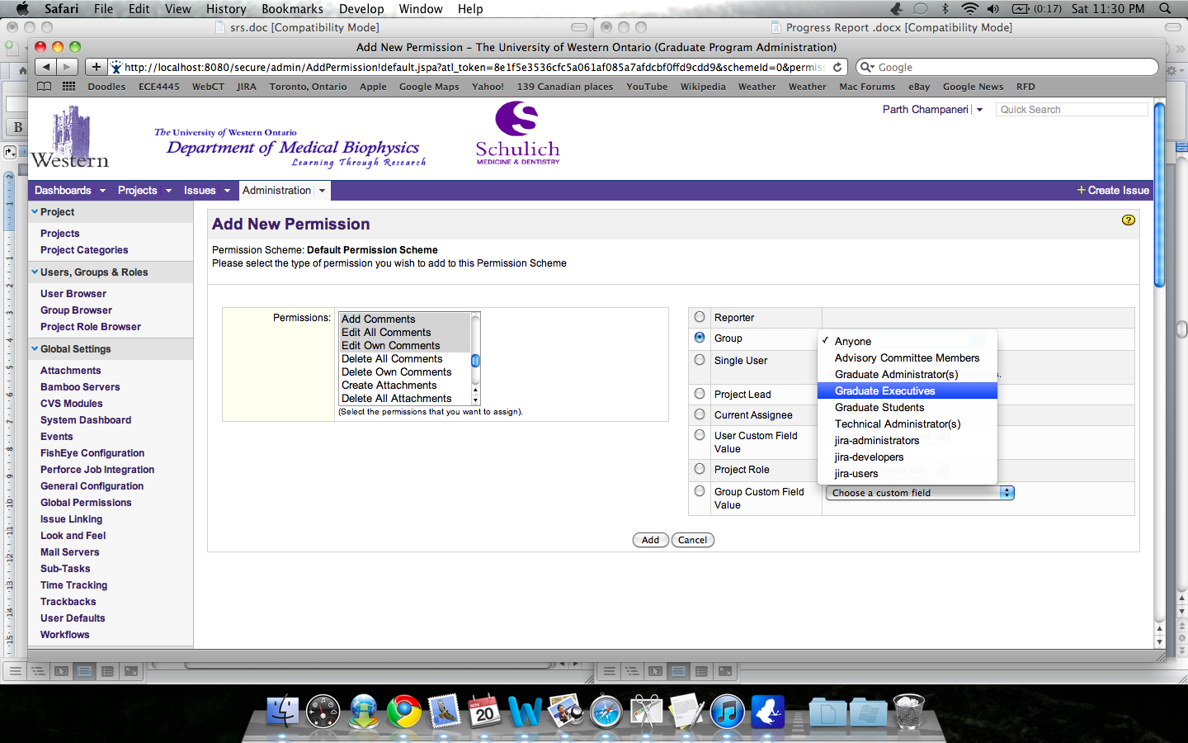

**Groups**

Figure 9 - Add permission

**Tracking:**

**Graduate Students’ Personal Information:**

Contains data regarding to the students contact information including their UWO e-mail address and their current location. This system feature is to document how personal information is stored and accessed via different user roles.

* + *Graduate Students:* Graduate Students can view their entire profile including their program information, supervisor information, advisory committee information and personal information. Data access is restricted only to their personal profile.
  + *Graduate Administrator:* Ability to edit all fields.
  + *Graduate Executives and Advisory Committee members:* Read Only access*.*
  + *Update Personal Information*

Visibility: Graduate students only

Restrictions: Only allowed to update contact information and address.

Critical Assumption: Graduate administrator is responsible for inputting student data.

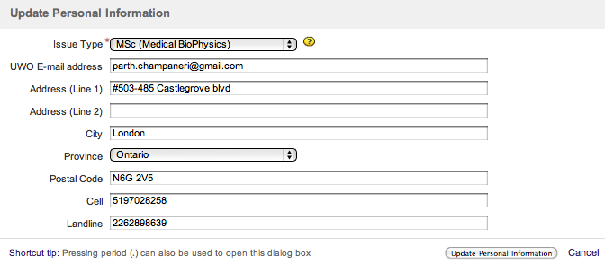

Figure 10 - Update Personal Information

**Graduate Students’ Program Information:**

Contains information related directly to the studuents program enrollment. Information includes Admission Term and Year, Thesis information, Publications (if any) and a custom field that records if the student has indicated MSc to PhD reclassification.

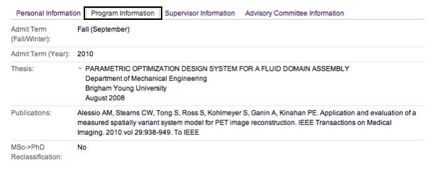

Figure 11 - Program Information Tab

* *Update Program Information*

Visibility: Graduate students only

Restrictions: Allowed to update Publications, Thesis (if applicable) and Low-Level exam date if known.

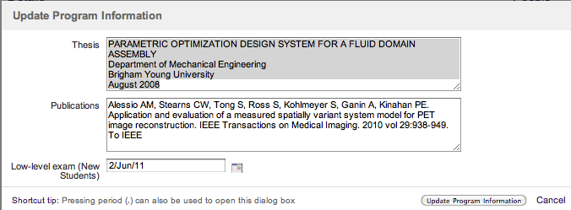

Figure 12 - Update Program Information

* + *Update Advisory Committee Information*

Visibility: Graduate students only

Restrictions: Allowed to update names of supervisor and advisors after a date for the meeting has been formed.

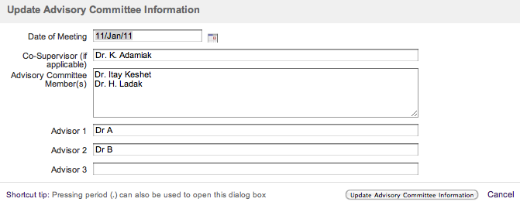

Figure 13 - Update Advisory Committe Information