Interactive Graduate Student Information Database

**Progress Report**

Parth Champaneri (250367669)

[pchampan@uwo.ca](mailto:pchampan@uwo.ca)

## ECE 4416 Electrical and Computer Engineering Project

Department of Electrical and Computer Engineering

The University of Western Ontario

London, Ontario, Canada

##### Date: November 22, 2010

Comments of the Faculty Advisor: Dr. H. Ladak

Mark of the Faculty Advisor: /20

Signature: ………………………………. Date: ……………………….

Course Coordinator: Dr. K. Adamiak

Mark of the Course Coordinator: /20

Signature: ……………………………… Date: …………………

______________________________________________________________________________

***Abstract* —** **The purpose of this report is to document the progress in eliciting the detailed business requirements for the Interactive Graduate Student Information System (SIMS). Additionally, the first project iteration report as indicated in the proposal is also documented. The report includes two system critical features: Permissions Schematic (Access control) and HTML templating (Page design). Furthermore, analysis of E-signature technology was performed.**

# PROJECT WORK COMPLETED

**System Overview:**

The SIMS system is primarily a web application designed for the department of Medical BioPhysics (MSc), which will be used to can track important dates from inception to completion of the program lifecycle and help manage information on an efficient basis. The system will provide effective reporting techniques including custom reminders, tracking and gathering input from the graduate students.

**System Requirements:**

Requirements gathering and analysis was performed after several meetings with the end user (Ms. Wendy Hough) and Dr. Ladak. A summary of the major requirements is provided here:

* Graphical User Interface (GUI): Provide an intuitive dossier format interface for users to see the student profile in a centralized location.
* External electrical hardware interface requirement includes an optional e-signature pad capable of recording signatures for graduate advisory meeting output and a primary web interface for providing users with access to the system functionality.
* Tracking: To be able to track, manage and generate reports on Grants and Publications, Advisory Committee members, Seminar dates, PhD. Reclassification
* Automatic Notification service: Calculate upcoming MSc. milestones (Date/time) and trigger automatic notification emails for reminders.
* Access control and real-time collaboration: Ensure ad-hoc access for multiple users to facilitate realtime collaboration and ensure up-to date information in the database.
* Security: Adhere to local and federal privacy laws (FIPPA) and UWO acceptable use policy.
* Data storage: Ensure integrity, improve error detection and stability of the system

**Graphical User Interface**

**Universal System Log In:**

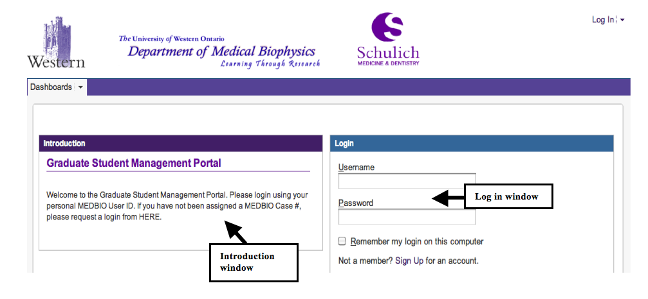

Figure 1 - System Login Interface

*Purpose:* Provide a universal login page to provide access to the end users of the system

*Response Sequence:* In order to access the login page, user will have to type the system URL in a supported browser and will be directed to this log in page.

*Associated Functional Requirements:*

* Introduction widget: This widget will provide a short introduction to the purpose of the management system. It will also feature an Important Links section with a link to the website of Department of Medical BioPhysics. Furthermore, a link to a technical troubleshooting page will be created.
* Login window: This is the actual login page where the user will enter their credentials to login. Users cannot sign up for the system individually. The Graduate Administrator facilitates the sign up process and a direct link to request the login credentials will be set.

**System Dashboard:**

*Purpose:* Provide a centralized location of all system functions while preserving ease of use and accessibility.

*Response sequence:* The user will be directed to this page after login.

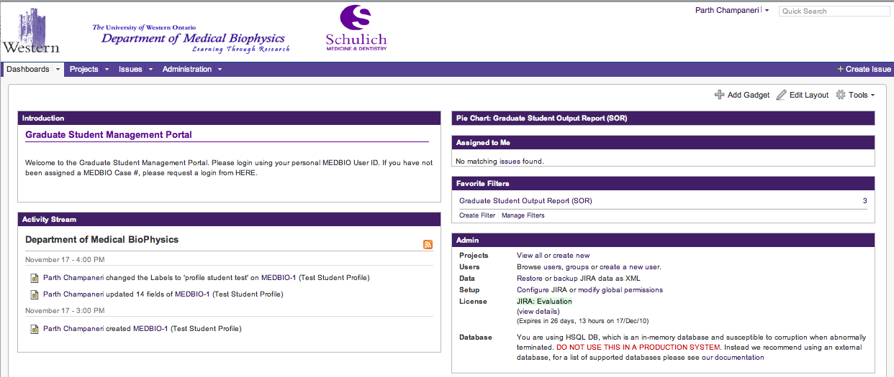

Figure 2 - System Dashboard

*Associated Functional Requirements:*

* Provide various plugins on the dashboard based on different user roles and access for access to student profiles and various system features. Plugins can be RSS feed or activity stream, various preset charts and reports.
* Search: Be able to search a students profile from the dashboard.

**Graduate Student Profile**

*Purpose:* Provide an intuitive dossier format interface for users to see the student profile in a centralized location. The key goal is to ensure that all the important system functionality in a centralized location.

*Response sequence:* In order to access the GUI, the user will be required to login and will be taken to a dashboard which will have options to generate reports and search a student by their assigned id. Once selected the user will be able to see a student profile and be able to perform various functions based on their authentication scope as defined in the access control list.

# Parth Champaneri:Users:Pat:SIMS:HTMLTemplating:StudentProfileMain.tiff

Figure 3 - Sample Login interface

*Associated Functional Requirements:*

* Information Tab Section: The profile page will feature information tabs with centralized information about their Personal Information, Program Information, Supervisor Information and Advisory Committee Meeting Information.
* Expansion: Each section can be clicked on to show summary of additional information
* Link: Each information tab will link to another section pages (if applicable)
* Grouping: Group dates and People in the same window area for better accessibility
* Export Options: There should be an export option to ensure that a user can export their entire student profile in Word, PDF or in a Printable format
* Attachment Options: The dossier should feature an attachment tab that includes all relevant attachments/forms for that student profile.

# Electrical Device Interface:

*Purpose:* To provide an interface for recording advisory committee member signatures.

*Response Sequence:* When the e-signature pad is connected to the device, it will automatically start the e-signature interface which records an individual signature.

*Associated Functional Requirements:*

* Clear: Ability to clear the signature if the signee does not accept the signature
* Sign: Once the output on the screen is satisfactory, the user can “Sign” the document which will save the image in a document on the database.

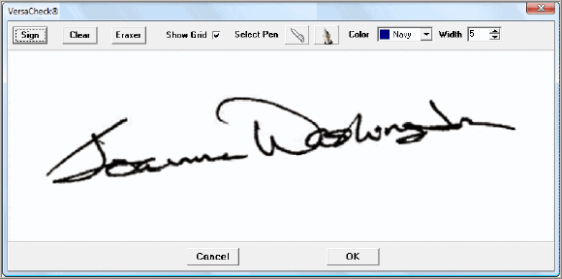

Figure 4 – Sample E-signature interface

**System Features:**

**User Administration:**

*Purpose*: The user browser lists all the users in the system for technical administration.

*Response Sequence*: Login and click on User Browser from the administration page.

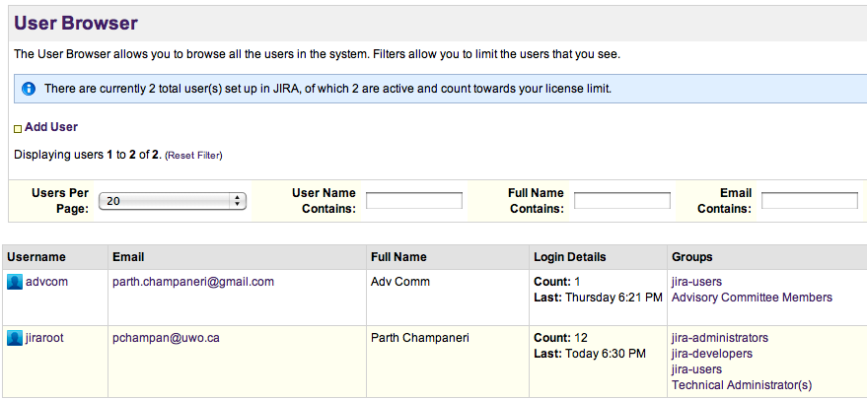

Figure 5 – Sample User browser

*Associated Functional Requirements:*

* + Create new users: Adding a new user to the system can only be accomplished by the technical administrator after an approval from the Graduate Administrator.

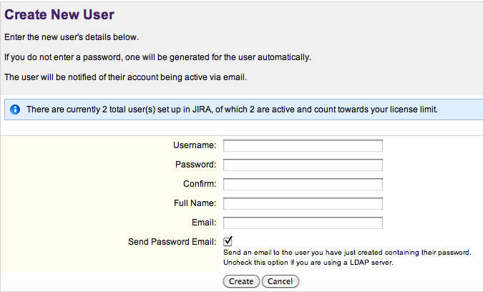

Figure 6 - Add a new user

* + Adding new user roles: User roles are primary stakeholder groups for the system. Currently, our primary stakeholders are Advisory Committee Members, Graduate Administrators, Graduate Executives, and Graduate Students.

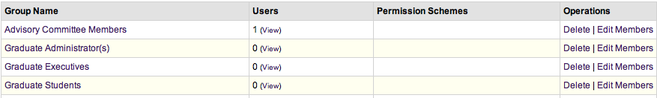

Figure 7 - Add new user roles

* + Adding Operation to roles: Permissions can be added to the user permission list by clicking on the Add New permission button under User Administration. This can be done by the technical administrator.

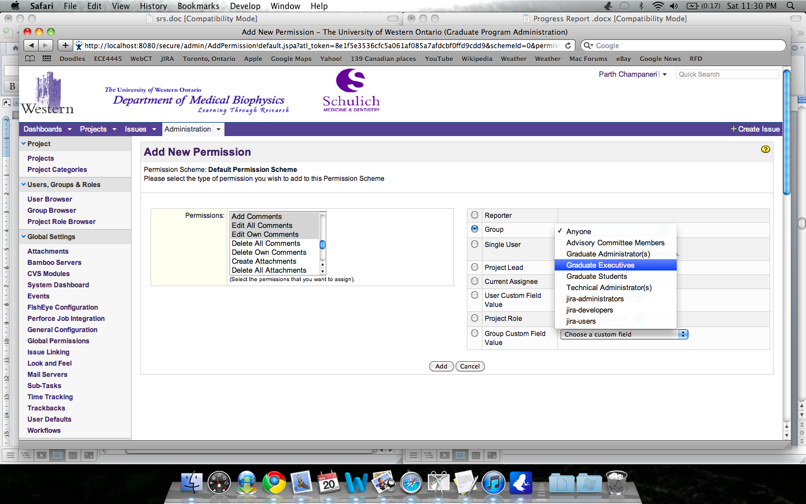

Figure 8 - Add permission

**Tracking:**

*Permissions Schematic (Access Control):*

Figure 9 - Permissions Schematic for Key Stakeholders of the system

**Graduate Students’ Personal Information:**

This tab in the student profile contains data regarding to the students contact information including their UWO e-mail address and their current location. This system feature is to document how personal information is stored and accessed via different user roles.

* + *Graduate Students:* Graduate Students can view their entire profile including their program information, supervisor information, advisory committee information and personal information. Data access is restricted only to their personal profile.

***Functions Available:***

*Update Personal Information:*

Restrictions: Only allowed to update contact information and address.

Critical Assumption: Graduate administrator is responsible for inputting student data.

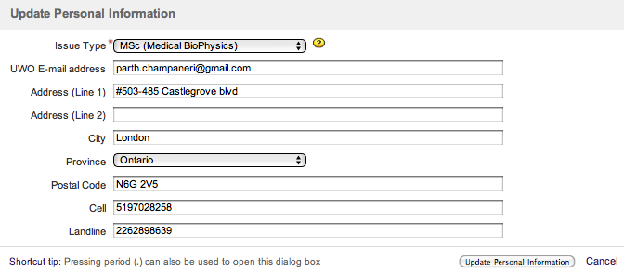

Figure 10 - Update Personal Information (For Students)

* + *Graduate Administrator:* Ability to edit all fields.
* *Graduate Executives and Advisory Committee members:* Read Only access*.*

**Graduate Students’ Program Information:**

Contains information related directly to the studuents program enrollment. Information includes Admission Term and Year, Thesis information, Publications (if any) and a custom field that records if the student has indicated MSc to PhD reclassification.

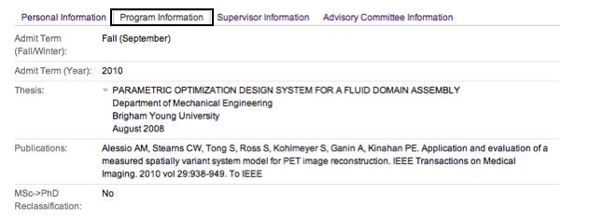

Figure 11 - Program Information Tab

***Function Available***

*Update Program Information*

Visibility: Graduate students only

Restrictions: Allowed to update Publications, Thesis (if applicable) and Low-Level exam date if known.

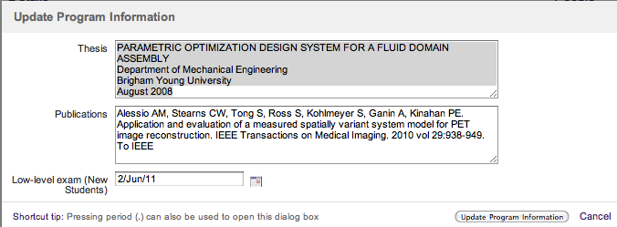

Figure 12 - Update Program Information

**Graduate Students’ Advisory Committee:**

Advisory Committee Information tabis a centralized location for all advisory committee information which has taken place for a student. Under this tab, pertaining information such as the list of all advisory meetings, evaluation of a particular advisory meeting whether it was satisfactory or unsatisfactory and any supervisor/member reccomendations after the meeting. Advisory committee is a progression requirement which happens for each student atleast once a year. Scheduling is usually done by the student or by the graduate administrator. One of the key requirements is to track and remind students of their advisory meeting output and ensure that a post-meeting report is generated to satisfy their progression requirements.

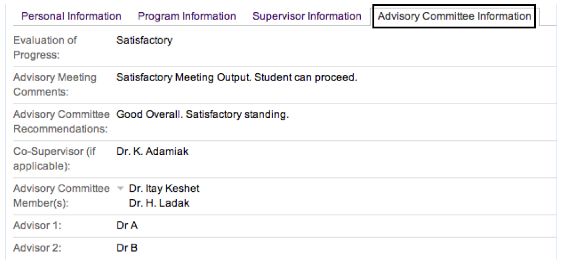

Figure 13 - Advisory Committee Information

***Functions Available:***

*Update Advisory Committee Information*

Visibility: Graduate students and Graduate Administrator

Restrictions: Allowed to update names of supervisor and advisors after a date for the meeting has been formed.

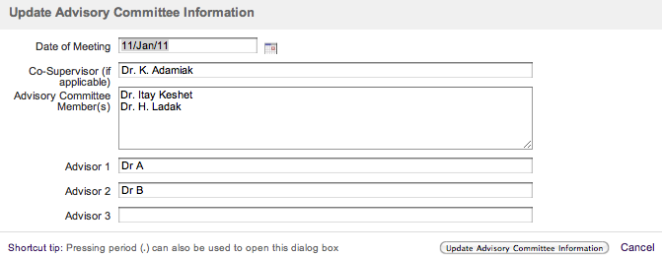

Figure 14 - Update Advisory Committe Information

*Comment on Advisory Committee Meeting****:***

Visibility: Advisory Committee Members

Restrictions: Cannot access any other data. Members can update progress and output of the meeting. Can also provide reccomendations and comments.

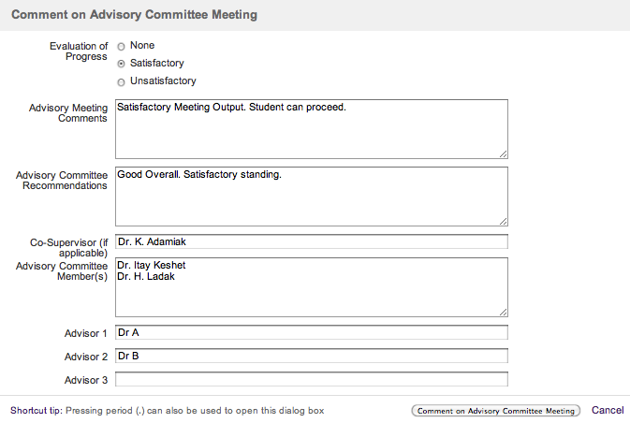

Figure 15 - Comment on Advisory Meeting

**Data Reporting:**

*Queries:* Reports can be generated by filtering via various fields or by entering customized queries in the reporting interface. Queries can be run by the administrator, advisory members and graduate executives.

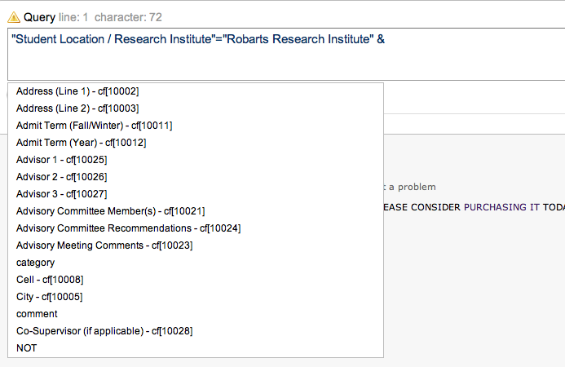

Figure 16 - Query interface

*Sample Student Profile Report (Word):* Users can export student profile in a Word document which contains all the information regarding the selected student. The scope of the document generated will be restricted to the roles and permission of the user.

|  |  |
| --- | --- |
| [MEDBIO-1] [Test Student Profile](http://localhost:8080/browse/MEDBIO-1) Created: 17/Nov/10  Updated: 17/Nov/10 | |
| **Status:** | Open |
| **Project:** | [Department of Medical BioPhysics](http://localhost:8080/secure/BrowseProject.jspa?id=10000) |

|  |  |  |  |
| --- | --- | --- | --- |
| **Type:** | MSc (Medical BioPhysics) | | |
|  |  |  |  |
| **Labels:** | profile, student, test | | |

|  |  |
| --- | --- |
| **Student Name (First Last):** | Parth Champaneri - Test |
| **UWO Student ID:** | 250,367,669 |
| **UWO E-mail address:** | [parth.champaneri@gmail.com](mailto:parth.champaneri@gmail.com) |
| **Address (Line 1):** | #503-485 Castlegrove blvd |
| **City:** | London |
| **Province:** | Ontario |
| **Postal Code:** | N6G 2V5 |
| **Cell:** | 5,197,028,258 |
| **Landline:** | 2,262,898,639 |
| **Student Location / Research Institute:** | Robarts Research Institute |
| **Admit Term (Fall/Winter):** | Fall (September) |
| **Admit Term (Year):** | 2010 |
| **Thesis:** | PARAMETRIC OPTIMIZATION DESIGN SYSTEM FOR A FLUID DOMAIN ASSEMBLY  Department of Mechanical Engineering  Brigham Young University  August 2008 |
| **Publications:** | Alessio AM, Stearns CW, Tong S, Ross S, Kohlmeyer S, Ganin A, Kinahan PE. Application and evaluation of a measured spatially variant system model for PET image reconstruction. IEEE Transactions on Medical Imaging. 2010 vol 29:938-949. To IEEE |
| **Low-level exam (New Students):** | 02/Jun/11 |
| **MSc->PhD Reclassification:** | No |
| **Supervisor(s):** | Dr. Hanif Ladak |
| **Supervisor's Minimum Contribution Per Month :** | 0 |
| **Supervisor's Minimum Contribution Per Year :** | 100 |
| **Supervisor's Speedcode or Recoverable Salary Acc't :** | 13,651 |
| **Supervisor's 2nd Speedcode (if applicable) or Cost Centre :** | 9,800 |
| **UWO JOB CODE :** | X0100 |
| **Date of Meeting:** | 11/Jan/11 |
| **Evaluation of Progress:** | Satisfactory |
| **Advisory Meeting Comments:** | Satisfactory Meeting Output. Student can proceed. |
| **Advisory Committee Recommendations:** | Good Overall. Satisfactory standing. |
| **Co-Supervisor (if applicable):** | Dr. K. Adamiak |
| **Advisory Committee Member(s):** | Dr. Itay Keshet  Dr. H. Ladak |
| **Advisor 1:** | Dr A |
| **Advisor 2:** | Dr B |

Generated at Thu Nov 18 00:00:16 EST 2010 by Parth Champaneri using JIRA 4.2#587.

*Sample Graduate Student Output Report (SOR) - Excel:* Users can export a SOR based on custom queries which are either preset or custom created.

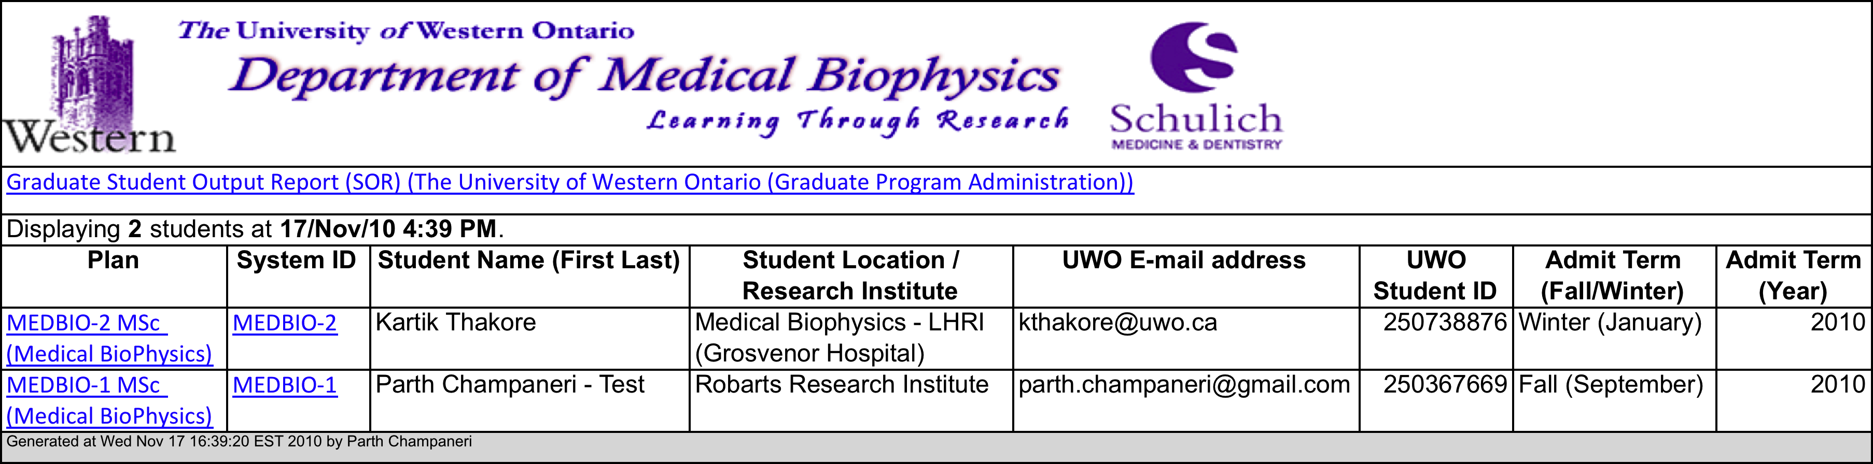

Figure 17 - Sample Student Output Report

*Custom Pie Charts:* Pie charts and trend charts can be generated based on the SOR or a custom query.

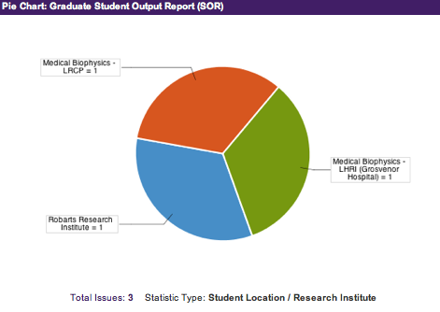

Figure 18 - SOR Pie Chart

**Automatic Notification Triggering:**

Notifications can be added only by Graduate Administrator and can range from reminders to the students based on upcoming dates or email a copy of filters output to the users on a weekly basis. Further the administrator can specify the time and date a notification can be sent out.

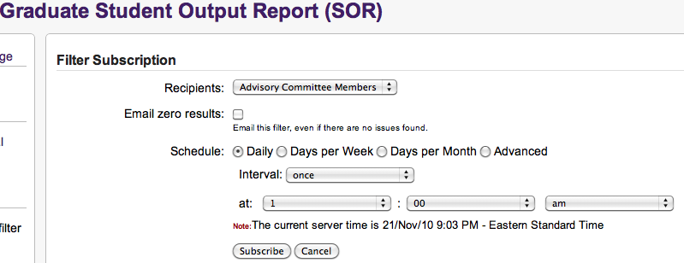

Figure 19 - Add Notification

**E-signature Integration:**

The E-signature pad will feature passive digitizing technology which captures user input by using electromagnetic induction. The tablet generates electromagnetic signal which is detected by the capacitive-inductive resonating circuit in the stylus. Upon detection of a stylus signal, the tablet activates the reception mode and reads the digitally encoded input signal from the stylus. Resistance detection is used to determine the amount of pressure needed to read the signal and is usually adjustable.

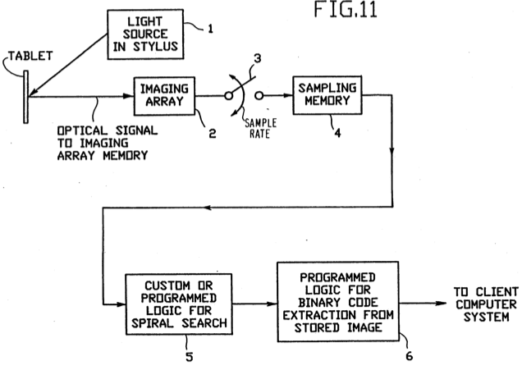

Figure 20 - High level process flow of the system[1]

Signature acquisition operates by capturing the X,Y position of the pen at a constant sampling rate which then uses inductive coupling from a coil in the pen to the coil array in the tablet to capture the stylus position. Various image algorithms can then be used to verify, and improve the picture quality before storage. We have worked on a a simple image capturing script which captures the signature image using a Wacom tablet, which is currently being used for rapid prototyping, and saves the image in .bmp format.

# FUTURE WORK

Our goal is to address all the critical documented requirements to ensure that our final product meets user expectations and is user friendly. Over the upcoming iterations we will be addressing and implementing system critical components such as network security, compliance with the federal and local regulations and customizing features as nessecary. The system requirements will be revamped several times during the course of the project to ensure meeting client expectations.

One of the key advantages of the agile project methodology is to obtain periodic user feedback and iterate the existing requirements to better suit clients’ need. Please refer to the Gantt chart for specific details regarding the implementation. Key things we will be focusing on are:

* Interface customization
  + Iterative customization
* Systematic milestone tracking and notifications
  + Advisory Committee Meeting
  + Low level exam dates
  + Scholarship and Term X calculations
* System security
* E-signature integration
  + Rapid Prototyping – Wacom Tablet
* RFID integration
* Smartphone accessibility
  + Mobile Website
  + Custom Application

# UPDATED GANTT CHART

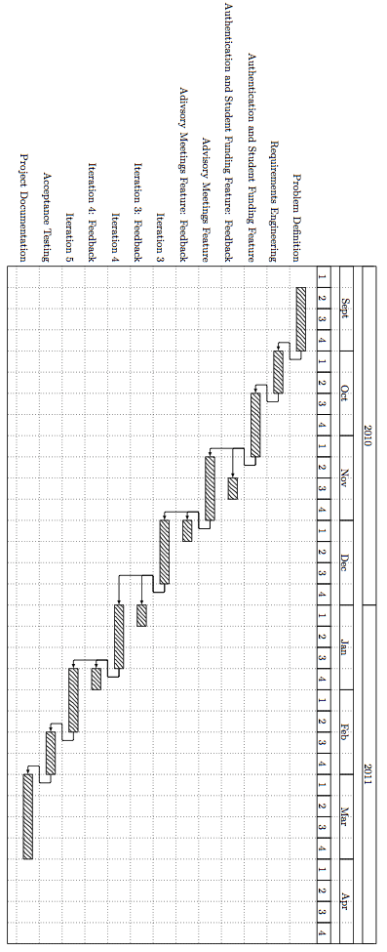

# REFERENCES

Joe Lin, Charley Ho, Wasim Sadiq, and Maria E. Orlowska, “On workflow enabled e-learning services”, Advanced Learning Technologies, IEEE International Conference on, vol. 0, pp. 0349, 2001.

Office of the Privacy Commissioner of Canada, “Canada’s personal information protection and electronic documents act”, http://www.priv.gc.ca/information/guide_e.cfm, 2003, This is an electronic doc- ument. Date of publication: November 20, 2003. Date retrieved: October 4, 2010. Date last modified: [Date unavailable].

T.G. Zimmerman, G.F. Russell, A. Heilper, B.A. Smith, J. Hu, D. Markman, J.E. Graham, C. Drews ["Retail Applications of Signature Verification",](https://docs.google.com/viewer?url=http%3A%2F%2Fwww.research.ibm.com%2Fpeople%2Fj%2Fjyhu%2FSnG.pdf), *SPIE Defense and Security Symposium, Biometric Technology for Human Identificatoin,* Orlando, Florida, April 2004.

Lidstrom, Mattias. "The Input Race: A comparative study between two input modalities." Luleå University of Technology. 28 May 2007. Department of Music and media. 10 Nov. 2010 <http://epubl.ltu.se/1402-1552/2007/110/LTU-DUPP-07110-SE.pdf>

Bennett, William E. (Mahopac, NY), Boies, Stephen J. (Mahopac, NY), Davies, Anthony R. (Romsey, GB2), Etzold, Karl-friedrich (Briarcliff Manor, NY), Rodgers, Todd K. (Chappaqua, NY) 1991 Optical stylus and passive digitizing tablet data input system United States International Business Machines Corporation (Armonk, NY) 5051736 <http://www.freepatentsonline.com/5051736.html>

“Council highlights”, http://www.cou.on.ca/News/News---Views/Newsletters/PDFs/ Council-Highlights-2005May.aspx, 2005, This is an electronic document. Date of publication: May 1, 2005. Date retrieved: Sept 29th, 2010.

I.P.W. Fung, “On monitoring study progress with time-based course planning”, Advanced Learning Technologies, 2001. Proceedings. IEEE International Conference on, pp. 361 –364, 2001.

1. United States Patent 5051736