**Steps to execute**

1. Clone the code from git hub
2. Use command `mvn clean install` to build the project**. Employee and Address Pojos are created through jsonschema2pojo and corresponding code**
3. Use command `mvn spring-boot:run` from `employeeservImplementation` folder to run the project.
4. Once after project is started. Use the below url on browser to access the h2 database.

<http://localhost:8080/h2>

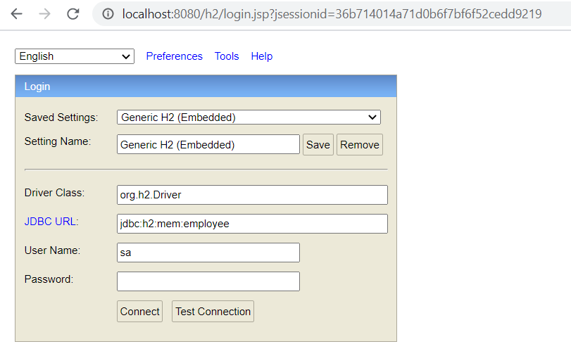

**Note : Make sure JDBC URL is given as above**.

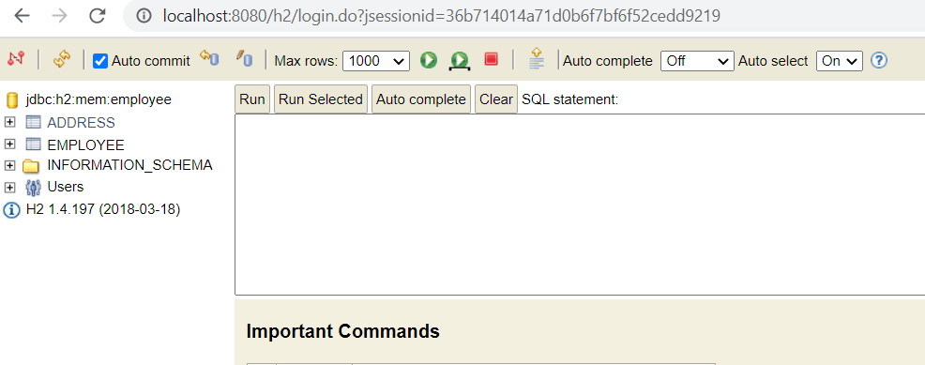

**Employee and Address tables are created.**

1. Open postman and execute the create employee api. Below are api details. Data will be inserted into Employee and Address tables

<http://localhost:8080/v1/bfs/createemployee>

{

"id":106,

"first_name":"pay",

"last_name":"pal",

"date_of_birth":"1980-06-30",

"address": {

"line1":"500 country brook",

"line2":"road 12",

"city":"san ramon",

"state":"california",

"country":"USA",

"zip_code":"30097"

}

}

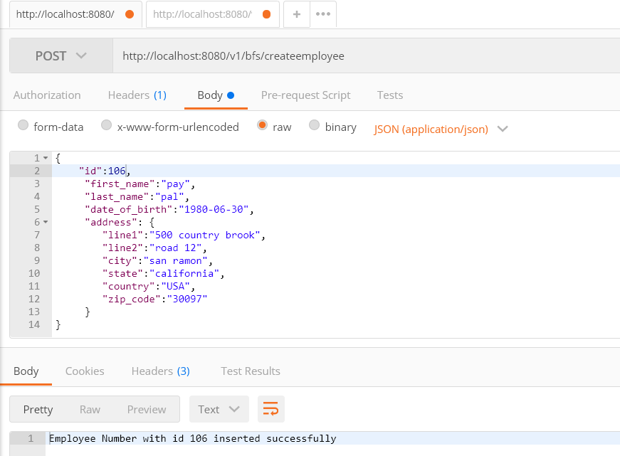

1. Retrieve the data using below API .

http://localhost:8080/v1/bfs/employees/106

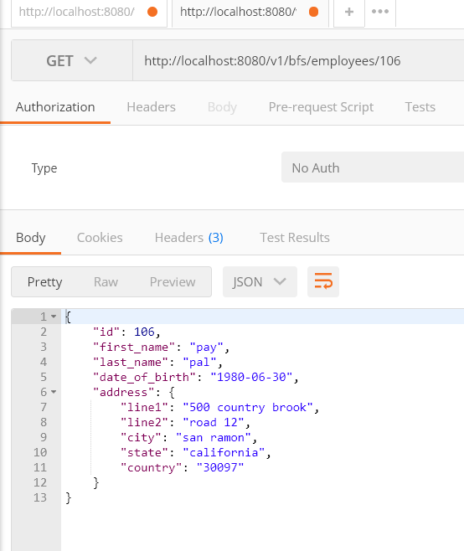

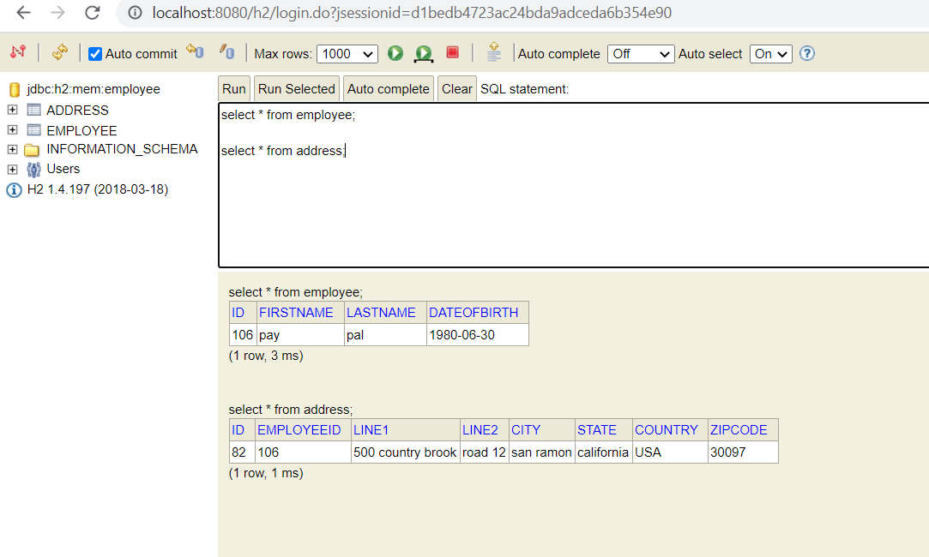

1. Validation : Idempotency logic to avoid duplicate resource creation

