Preliminary Online Hotel Review Analysis
For all code referenced please click here

In this report we are going to look through online reviews for hotels on the Las Vegas strip. The goal of this paper is to give insight into consumer behavior and to determine if we can predict or explain negative reviews. We will define a negative review as any score of two or below in a one to five point rating system. We will be looking at consumer rating behavior and then specific hotel performance.

I wanted to see if consumers who reviewed hotels frequently behaved differently then those who reviewed more casually. Looking at the distribution of reviews per user there is a very large gap between the volume of reviews for the frequent user and the casual user. One can also see that the majority of users behave similarly as demonstrated in the graph below.
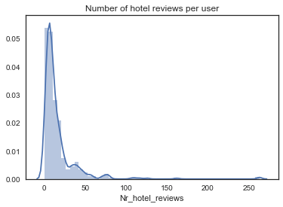
Before we dive into user behavior we will want to explore the scores themselves to better understand their distribution. After digging through the scores I was surprised to find that 91.9% of the scores were three stars or above and that the hotels had a mean rating of 4.12. I would be surprised if hotels in most tourist cities had reviews this high and it could be an interesting follow up experiment to compare across the country.

Now I want to see if the super users rating behavior differs from the population. I took a sample of the users whose review volume was above one standard deviation from the mean of the population’s reviews. The mean review volume was 16 and the standard deviation was 24 thus defining our sample as the reviewers with 40 or more reviews. A boxplot describing the distribution of scores between the two groups was very interesting:

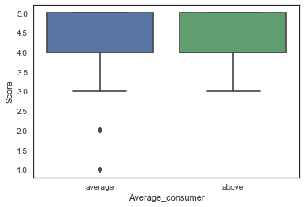
You can see that their scoring was basically identical except for a few outliers in the form of bad reviews submitted by the average reviewer. It is also intriguing that the seasoned reviewers have zero reviews with a score below three but more research would need to be done on this type of reviewer as their group is only represented by 40 individuals or 7.9% of the sample. Finding more data on high volume reviewers and determining if they tend to avoid low reviews more then the casual reviewer could also become an interesting followup report.

I also wanted to see if there would be many instances of negative reviews coming from those who review less then the average patron. This could be due to someone only reviewing when they’ve had a bad experience or because they are less familiar with the frustrations of travel. So I created a new sample group and compared the reviewers with less reviews then the mean and those above the mean. Again the similarities were very interesting:

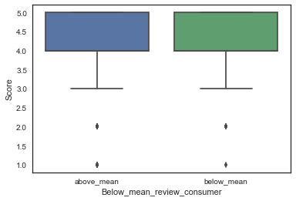

As you can see they are basically identical and we don’t have to worry as much about difference in sample sizes as we did with the previous comparison as the groups were 355 and 149 respectively. Their mean scores are also basically identical with the mean score for the group with more reviews being 4.14 and the mean score for the less frequent reviewers being 4.08

This tells us that we cannot predict the scores based on volume of reviews although it would be very interesting to collect data across different review site platforms and compare the group that reviews more frequently then one standard deviation above the mean to the rest of the population.

I am now interested in understanding whether hotels with lower average scores in general make up the majority of the negative reviews or if the negative reviews are distributed more at random. After separating the hotels based on the bottom 25% of their reviews the better performing group obviously had a higher mean, ceiling, and floor, but it is interesting to see that there are still a decent amount of negative reviews associated with this group:

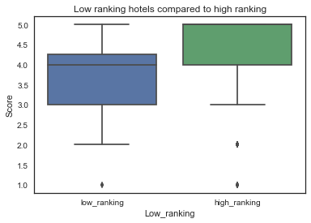
Digging a bit deeper we can see that 51.22% of the negative reviews come from hotels with their average scores above the mean so we cannot definitively say that overall customer satisfaction is a predictor of bad reviews. I would be interested in investigating whether hotels that perform poorer overall tend to get more scores of two as this score seems like it could be an example of habitual poor performance while scores of one seem more retaliatory or anomalous.

What does pop out when looking at the distribution of negative reviews is the fact that Monte Carlo and Excalibur have six apiece and the two combined account for 29.27% of the negative reviews while they only account for 09.52% of the reviewed hotels.

In summation we have factored out some demographic and performance based predictors however a few insights and follow up hypotheses have arisen. While the majority of customer satisfaction is aimed at two hotels the distribution of negative reviews seems more circumstantial then behavioral. I would like to look into “super users” review patterns to see if they tend to give better reviews then the population as they seemingly take their reviewing more seriously and want to maintain credibility. I would also like to explore the difference between scores of one and two and see if there are different motivations for the two low scores.

