Distributions of Fantasy Basketball Points by Position

All programming used in this analysis can be found here

Today we will be looking at fantasy basketball statistical trends. Specifically we will be looking at the distribution of points by position played. Before we dive into the numbers I will give you a quick breakdown of fantasy basketball.

Positions:
PG – Point Guard
SG – Shooting Guard
SF – Small Forward
PF – Power Forward
C – Center

Fantasy Basketball 101:

Fantasy basketball is a game where you build a team of players and score points based on their stats. There are many ways the game can be structured but today we are going to focus on the “daily fantasy sports” style or DFS. In daily fantasy you are allotted a “salary cap” to use to build your team and each player has a “salary” based on their perceived value.

Once you build your team and you stay below the salary cap you can enter into contests based on the games being played that day. Today we will be focusing on basketball and are going to see if we can use data analysis as a way to get a leg up on the competition.

Defense vs. Position:

To begin my research I went to Rotogrinders’ "Defense vs. Position" tool and put each team’s performance against each traditional position (listed above) in a data frame and began to dig through the data. Defense versus position is one of the first stats that a fantasy basketball player learns to use as it demonstrates how well a team performs against each position and you can use this information to see which players should perform better than they normally would based on their matchup.

There are five positions in basketball and some of the positions are similar in style of play so we are going to see if there is a correlation between the fantasy points given up by each team to similar positions and how we can use that to our advantage. We are going to look at four combinations of similar positions (listed below) and see if we can learn anything that we can apply to our team selection or “roster build”.

Similar positions:
PG-SG
SG-SF
SF-PF
PF-C

Do any positions correlate?

There are many different ways to build your team in DFS but one of the methods players will use is called “stacking”. It is a strategy where you pick multiple players from the same game hoping that the game has a collection of variables that lends to high scores for multiple players. This is one of the core concepts in fantasy basketball and if you are interested in learning more you can read about it here.

I began my analysis by creating histograms for each position as well as plotting the means and standard deviations for each position. The graphs were quite interesting.

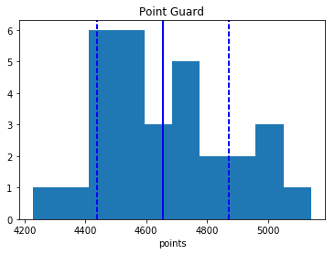
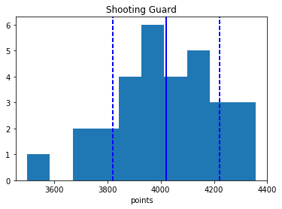
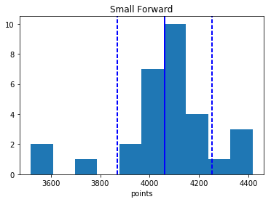
Avg. = 4655 Avg. = 4021 Avg. = 4060
Variance = 46987.4264368 Variance = 40503.0402299 Variance = 37025.8264368
Standard Deviation = 216.765833186 Standard Deviation = 201.253671345 Standard Deviation = 192.420961532
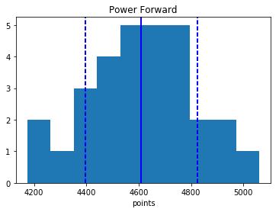
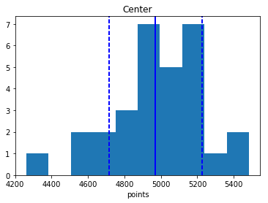

Avg. = 4610 Avg. = 4970
Variance = 45867.9816092 Variance = 65427.8402299
Standard Deviation = 214.168115295 Standard Deviation = 255.788663216

None resemble normal distribution or are similar to each other so as far as correlation there is not much we can gather from these graphs so I decided to plot a scatter graph of the similar positions hoping to find a linear correlation.

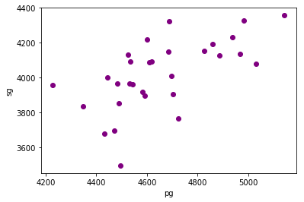
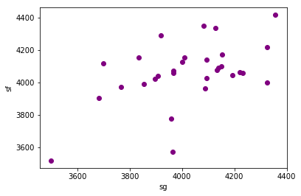

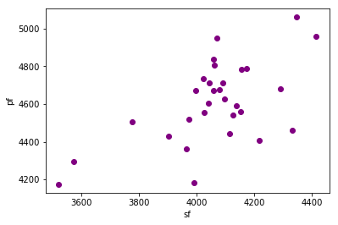
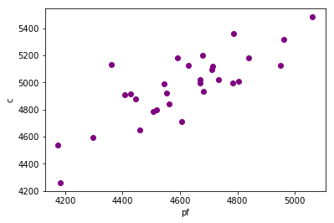

Now we’re getting somewhere! In the first three graphs it seems that once the outliers are removed there is some sort of linear pattern but the PF-C graph shows a strong linear correlation. This would make sense as blocks and rebounds are very valuable as far as fantasy points are concerned and centers and power forwards are the positions most likely to accumulate them. Now let’s try and see if we can gather a bit more data to give us confidence that there is a strong correlation between their performances.

Is there any further evidence that the defensive performance against power forwards and centers are correlated?

I wanted to see if there was any further data that would strengthen the hypothesis that there is a correlation between teams’ defense of power forwards and centers so I plotted a histogram of the average of the two positions performances. It slightly resembles the histogram of the center position so it seems to somewhat strengthen our case. This obviously could be due to the fact that we are averaging both the center and power forward positions to create this data so I plotted histograms of other similar positions and there was much less commonality between most except for both of the small forward comparisons (you can view them here).
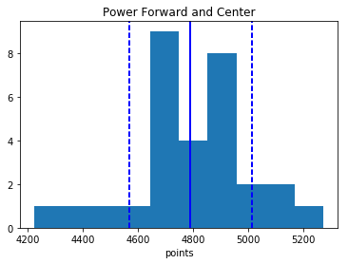
I would in no way say that this gives us conclusive data so I wrote a program that takes a list of all of the teams above the mean for power forward and center and returns the number of teams that are in both lists. Click here to see the code.

Teams above the mean:
Power Forward: 15
Center: 17
Both: 14

This seems to tell me that there is a pretty strong correlation as 93.33% of the power forward group and 82.35% of the center group end up on both lists. I also ran the program for teams above the mean plus the standard deviation and it came out to:

Teams above the STD:
Power Forward: 4
Center: 3
Both: 2

Based on the evidence we have accumulated I am relatively confident that there is at least a minor correlation between the two positions and I am ready to start shaping my roster around this assessment. So, where do we go from here?

Should I focus on the center or power forward position?

In DFS deciding where to focus our attention is a major part of the game. I have personally researched one game for two months to try and take down a $1,000,000 tournament and the amount of information you can use to make your decisions is nearly endless. Since we normally just have one day to research and have to get the lineups in by 4:00 PM PST I want to focus on one of the two positions. Since there is a correlation between the two positions the best play from both the PF and C groups may be the same but this won’t always be the case.

I decided to look at measures of central tendency as well as measures of variance to try and see if I can determine who the most important position of the two would be. I also researched their ceilings to understand which position has the most upside.

Pf C
Avg. = 4610 Avg. = 4970
Variance = 45867.9816092 Variance = 65427.8402299
Standard Deviation = 214.168115295 Standard Deviation = 255.788663216
Ceiling = 5061 Ceiling = 5484

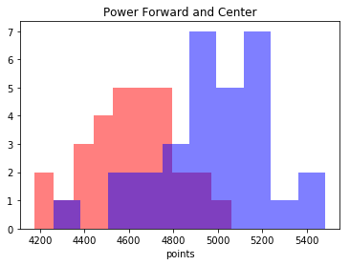
As you can see the mean and ceiling are higher for the center position but what I think is the most important to our analysis is the fact that the standard deviation is also higher. This tells me that I have more to gain or lose by picking the center and that I should focus my analysis for the day on that position.

I also plotted the histograms of each position in the same graph to give us a visual of the fantasy points distributions. It shows that not only is the ceiling higher but also that the position has a much larger range of outcomes.

What now?

Now that I am ready to begin to build my teams around the center and power forward position I have a few more questions I want to ask as far as performance is concerned on a game to game basis. I want to look at the performances of the two positions against the teams that allow the most points to see if both positions perform well against them from game to game or if success alternates between players on a daily basis. I would do this by charting the performances of the positions game by game and comparing their linear expressions as well as using the techniques displayed today. I would also like to look into predicting which type of player should have the most success against these teams by grouping players together based on similar stats and comparing their performances against each team. My project would be centered around the question:
“How do power forward and center positions perform on a nightly basis against the teams that give up the most fantasy points and can we predict which types of players will have the best performances.”

