DFF High Salary Cornerstone
Python code found here
SQL code found here

In this project we will be looking into lineup construction in daily fantasy football or “DFF”. One of the most highly debated concepts daily sports is when to “spend up” or when to choose a high priced or star player. In DFF the goal is to combine “value” (cost to performance ratio), “upside” (how many points a player could legitimately score above projections), and “safety” (how reliable a player is in scoring in a certain range). Juggling these three variables and how to apply them towards roster construction are major points of debate in the community and are critical to sustained success.

I am hoping to build a “lineup optimizer by goal” application for the daily fantasy site www.rotogrinders.com to simplify this process. They have already built an application that I suggested to them and I would love to get a position on their team building programs instead of just giving them the concept to build. In order to begin to build my application I need to create a structure for one of the lineup building strategies.

Some DFF players prefer a “fair and balanced” approach, which means picking players with similar salaries, but we are going to look at the “stars and scrubs” approach which means picking some high salary players and pairing them with lower priced players to balance the “salary cap” (salary limit that your roster may not exceed). In order to do this we want to find a position that yields a high rate of return but also has low variance in the value.

Possibly the most important concept to understand is the fact that these salaries are generated by an algorithm that takes DFF player behavior into account. Our goal is to find position where the top tier players have been more overlooked by the public then other positions. Doing this will hopefully give us a position to build our team around and create a clear picture for our line up construction goals.

I sourced player salary and performance information for week 17 in 2016 and went into SQL to split positions into multiple groups based on salary (“position status”). I then imported the data into Python and created a new column “ratio” that will give us the ratio between points and salary. After aggregating by position status I decided to graph all of the new position groupings I created to get an overview of the dataset.
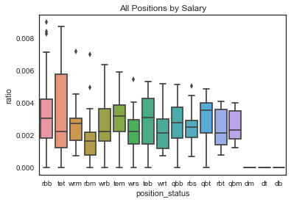
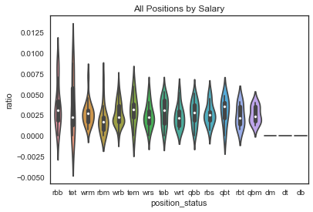

A few things to note when looking at these two similar representations. First is the strange issue with the “defense” (dm, dt, db) values. For some reason the ratio conversion for the defensive positions returned zero but fortunately we are only interested in offensive players so this can be discarded and looked into later. There was also a large discrepancy of the distribution of players at the top of the salary food chain and the bottom. This is an issue that is inherent in salary distributions and will be addressed when analyzing players in the lower price ranges but I am pretty happy with the top tier distributions.

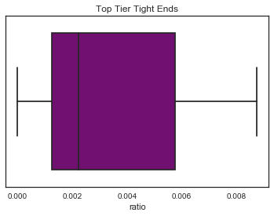
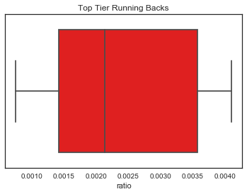
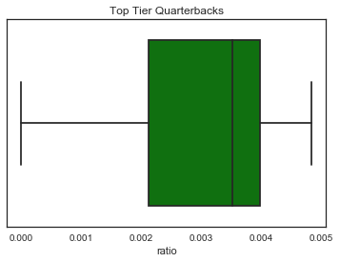
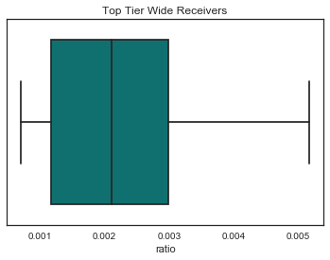
Now that we’ve looked at the dataset as a whole lets look at the top end players at each position:

I believe this visual dive into the data has given me enough to make a few inferences and hopefully I am close to a hypothesis to present for my RFC. The fact that the tight end position has so much variance gives me reason to eliminate them since I am looking to build around a cornerstone piece and if I miss on this selection my whole roster will have little chance of success. The wide receiver and running back positions look promising but when we look at the top end of the groupings in the box plot we can see that they are over 10% lower in their upside then the quarterback.

The combination between upside and consistency leads me to believe that I should focus on quarterbacks but I need an actual measurable variable to figure out their “cornerstone viability”. Since we want a good combination of upside and safety I took the mean of the ratio and subtracted the standard deviation of the ratio to get my new variable which is expressed in the “cornerstone ratio” column. The new list looks like this:

points salary cornerstone_ratio

position_status
qbt 15.830453 6660.546195 0.001281
rbt 6.831775 5498.788379 0.001009
wrt 7.689926 6644.949644 0.000906
tet 3.889356 4233.279573 0.000010

Since my desired outcome is to find the singular position that we will build around and the fact that we have a way to measure success I am comfortable in building my RFC to complete the research and add more data to analyze.

The Problem

How do we make ourselves consistently profitable in daily fantasy football? Daily fantasy sports is a very lucrative industry where 5% of the players are professional and there are millions of dollars invested into analytics sites and also the sites that hold the contests. If we can create a successful formula that gives us a roadmap for our lineup construction we can simplify our decisions and shrink the amount of data that we will need to process and analyze but we need a place to start.
We know that public bias and game to game ownership percentage plays a part in the algorithms that generate the prices. We also know from comparing “expensive” players from week 17 that quarterbacks had our desired combination of safety and performance.

The Potential Solution

Top tier quarterbacks are the building blocks for consistent winning DFF teams.

The Method of Testing the Solution

I will collect all of the players’ fantasy points as well as salaries for each week of the 2016 NFL season and filter them into the subgroups that we created when analyzing week 17. I will then convert their stats into the “cornerstone viability” metric which is finding the quotient of mean points divided by mean salary, and then by subtracting the standard deviation of the same formula.

This is a null-hypothesis test where the hypothesis is:

Top tier quarterbacks will finish the 2016 NFL season with a higher cornerstone viability score then all other top tier positions.

Null:

Quarterbacks do not finish the 2016 NFL season with a notably higher cornerstone viability.

If the higher cornerstone viability score for quarterbacks does not finish above all other positions and does not sufficiently meet the p-value threshold of .05 we can not definitively say that we should build our team based on a top tier quarterback.

