**== LogicCircuit ==**

**Report**

**<Assignment#3>**

**학과 :** 컴퓨터공학과

**학번 :** 20201100

**이름 :** 김태현

3-7.

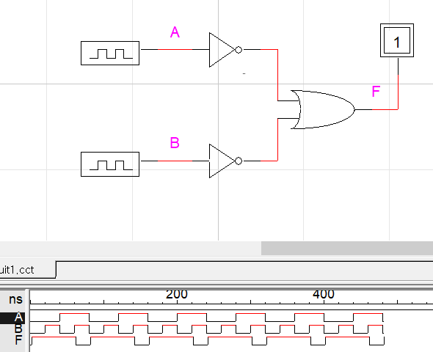

<논리식>

A’+B’ = (A*B)’

<진리표>

|  |  |  |
| --- | --- | --- |
| A | B | F |
| 0 | 0 | 0 |
| 0 | 1 | 0 |
| 1 | 0 | 0 |
| 1 | 1 | 1 |

3-8.

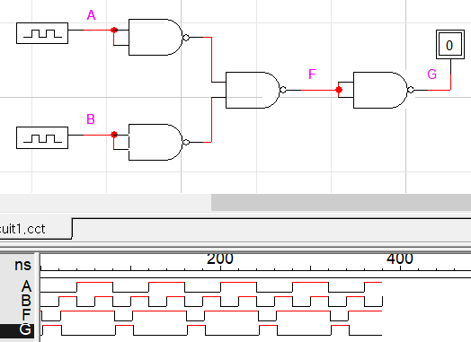

<논리식>

((A’*B’)’)’ = A’*B’ = (A+B)’

<진리표>

|  |  |  |  |
| --- | --- | --- | --- |
| A | B | F | G |
| 0 | 0 | 0 | 1 |
| 0 | 1 | 1 | 0 |
| 1 | 0 | 1 | 0 |
| 1 | 1 | 1 | 0 |

3-9.

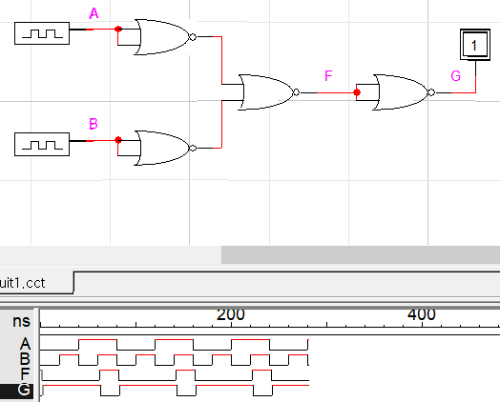

<논리식>

((A’+B’)’)’ = A’+B’ = (A*B)’

<진리표>

|  |  |  |  |
| --- | --- | --- | --- |
| A | B | F | G |
| 0 | 0 | 0 | 1 |
| 0 | 1 | 0 | 1 |
| 1 | 0 | 0 | 1 |
| 1 | 1 | 1 | 0 |

3-10.

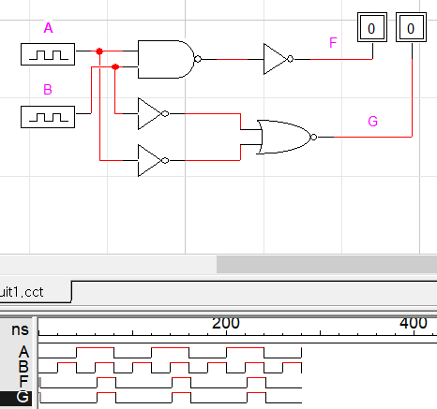

<논리식>

F = ((A*B)’)’ = A*B

G = (A’+B’)’ = ((A*B)’)’ = A*B

<진리표>

|  |  |  |  |
| --- | --- | --- | --- |
| A | B | F | G |
| 0 | 0 | 0 | 0 |
| 0 | 1 | 0 | 0 |
| 1 | 0 | 0 | 0 |
| 1 | 1 | 1 | 1 |

3-11.

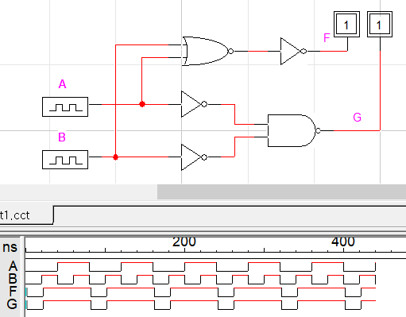

<논리식>

F = ((A+B)’)’ = A+B

G = (A’*B’)’ = ((A+B)’)’ = A+B

<진리표>

|  |  |  |  |
| --- | --- | --- | --- |
| A | B | F | G |
| 0 | 0 | 0 | 0 |
| 0 | 1 | 1 | 1 |
| 1 | 0 | 1 | 1 |
| 1 | 1 | 1 | 1 |