**== LogicCircuit ==**

**Report**

**<Assignment#1>**

**학과 :** 컴퓨터공학과

**학번 :** 20201100

**이름 :** 김태현

* 1. 7404 IC (NOT)

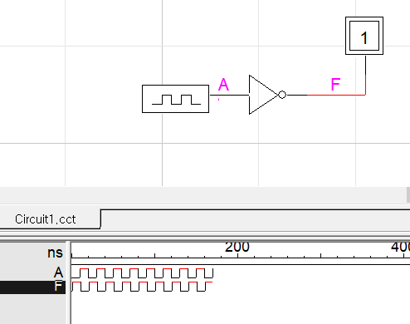

<진리표>

|  |  |
| --- | --- |
| **A** | **F** |
| 0 | 1 |
| 1 | 0 |

<논리식>

F = A’

* 1. 7408 IC (AND)

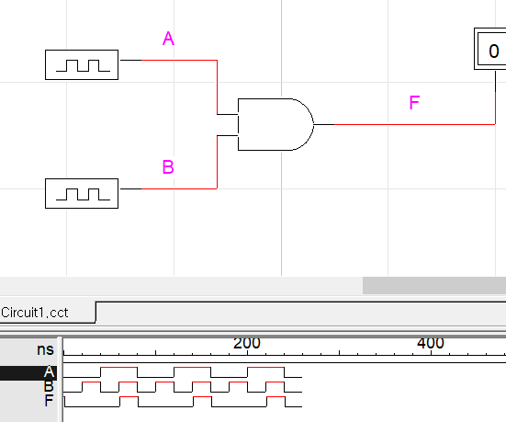

<진리표>

|  |  |  |
| --- | --- | --- |
| **A** | **B** | **F** |
| 0 | 0 | 0 |
| 0 | 1 | 0 |
| 1 | 0 | 0 |
| 1 | 1 | 1 |

<논리식>

F = A*B = AB

* 1. 7432 IC (OR)

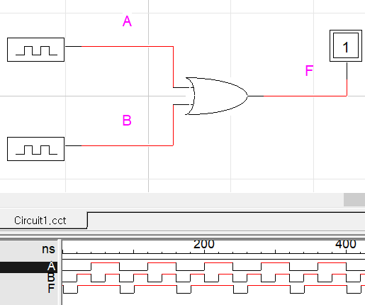

<진리표>

|  |  |  |
| --- | --- | --- |
| **A** | **B** | **F** |
| 0 | 0 | 0 |
| 0 | 1 | 1 |
| 1 | 0 | 1 |
| 1 | 1 | 1 |

<논리식>

F = A+B

* 1. 7400 IC (NAND)

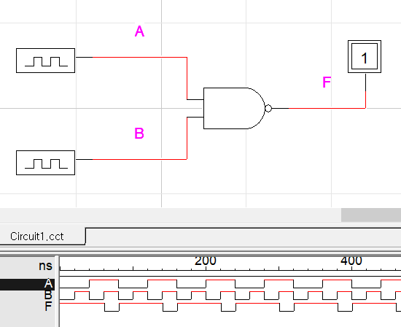

<진리표>

|  |  |  |
| --- | --- | --- |
| **A** | **B** | **F** |
| 0 | 0 | 1 |
| 0 | 1 | 1 |
| 1 | 0 | 1 |
| 1 | 1 | 0 |

<논리식>

F = (A*B)’ = A’+B’

* 1. 7402 IC (NOR)

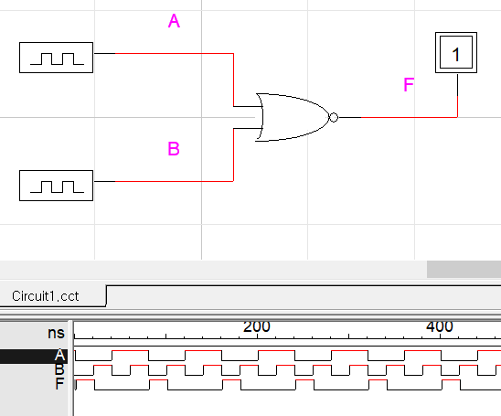

<진리표>

|  |  |  |
| --- | --- | --- |
| **A** | **B** | **F** |
| 0 | 0 | 1 |
| 0 | 1 | 0 |
| 1 | 0 | 0 |
| 1 | 1 | 0 |

<논리식>

F = (A+B)’ = A’*B’

* 1. 74125 IC(Tri-state buffer)

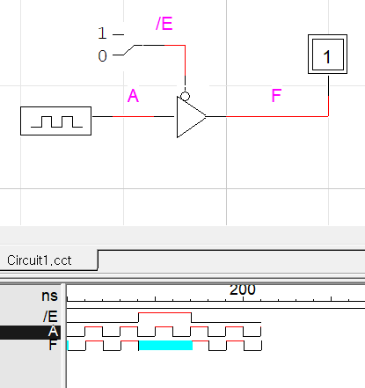

<진리표>

|  |  |  |
| --- | --- | --- |
| **/E** | **A** | **F** |
| 0 | 0 | 0 |
| 0 | 1 | 1 |
| 1 | 0 | - |
| 1 | 1 | - |

* 1. 7400 IC

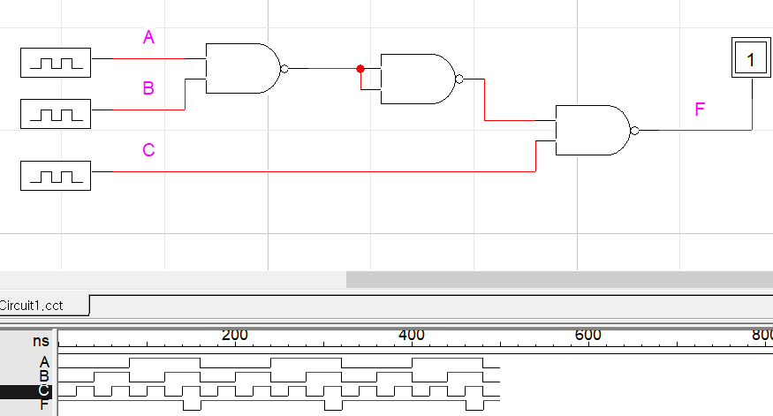

<진리표>

|  |  |  |  |
| --- | --- | --- | --- |
| **A** | **B** | **C** | **F** |
| 0 | 0 | 0 | 1 |
| 0 | 0 | 1 | 1 |
| 0 | 1 | 0 | 1 |
| 0 | 1 | 1 | 1 |
| 1 | 0 | 0 | 1 |
| 1 | 0 | 1 | 1 |
| 1 | 1 | 0 | 1 |
| 1 | 1 | 1 | 0 |

<논리식>

F = (((A*B)’)’*C)’ = ((A*B)*C)’ = (A*B)’+C’

2-9 7402 IC

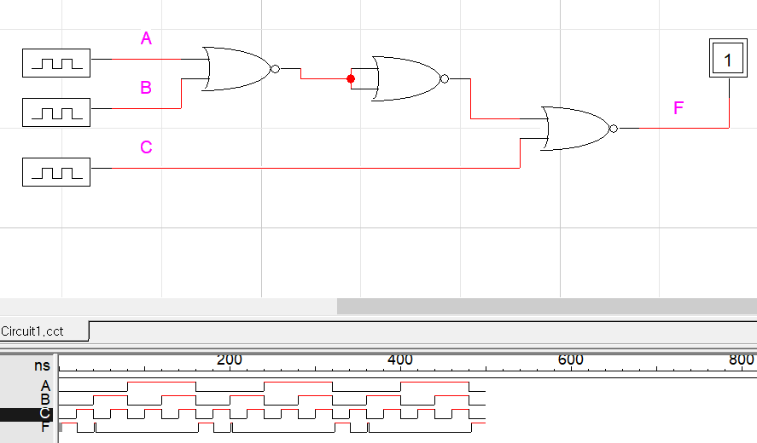

<진리표>

|  |  |  |  |
| --- | --- | --- | --- |
| **A** | **B** | **C** | **F** |
| 0 | 0 | 0 | 1 |
| 0 | 0 | 1 | 0 |
| 0 | 1 | 0 | 0 |
| 0 | 1 | 1 | 0 |
| 1 | 0 | 0 | 0 |
| 1 | 0 | 1 | 0 |
| 1 | 1 | 0 | 0 |
| 1 | 1 | 1 | 0 |

<논리식>

F = (((A+B)’)’+C)’ = ((A+B)+C)’ = (A+B+C)’